CSR Project Report
Community Service Project: Giving Back to Society

Course: Human Values and Professional Ethics (CLL120)
Student Name: Nitin Sharma
Roll No.: 23CSU224
Total Duration: 30 Hours

NGO Partners:, Sangarsh with the Soul(NGO) , Kul Devta Mandir , Shree Radha Krishan Gaushala

Introduction
As a part of the Human Values and Professional Ethics (CLL120) course, each student was required to complete 30 hours of community service. The objective of this project was to contribute positively to society through participation in socially beneficial activities while developing values such as mindfulness, empathy, and responsibility.
This report provides an overview of the community service activities I undertook in collaboration with various community organizations and NGOs, focusing on environmental sustainability, animal welfare, spiritual service, and care for the elderly.

Objectives of the Project
  - To engage in meaningful community-based service that promotes mindfulness and compassion.
  - To develop a sense of responsibility and empathy towards society and the environment.
  - To contribute to the well-being of animals, senior citizens, and local communities.
  - To foster leadership, teamwork, and communication skills through active participation.
  - To understand the importance of service as a foundation of human values and ethics.

NGO Collaboration
Organization / NGO Partner Nature of Work Focus Area
Shree Radha Krishan Gaushala Animal welfare & cleanliness Sustainability and
compassion

Sangarsh with the Soul (Golden Hours Care Centre)
Care for elderly citizens Empathy and community
support

Kul Devta Mandir, Basai Samiti Cleanliness, food distribution,
plant care
Environment and social welfare

Activities Completed
Activity 1: Volunteering and Social Service at Shree Radha Krishan Gaushala Date: September 29, 2025
Location: Sector 9B, Basai Chowk, Gurugram
Duration: 10 Hours

Objective:
To contribute to animal welfare and promote cleanliness within the Gaushala premises.

Role and Responsibilities:
- Assisted in feeding cows and maintaining hygiene within the premises.
- Helped in organizing the storage and cleaning of cattle sheds.

Impact:
- Improved cleanliness and animal care facilities.
- Learned compassion, responsibility, and the importance of mindful service.

Activity 2: Community Service under Varishth Nagrik “Golden Hours” Care Centre (Sangarsh with the Soul)
Date: October 5, 2025 Location: Sector 9B, Gurugram Duration: 10 Hours

Objective:
To support and engage with senior citizens, providing care and emotional companionship.

Role and Responsibilities:
- Assisted elderly residents with daily activities.
- Engaged in interactive sessions to promote mental well-being.

Impact:
- Enhanced the emotional and social well-being of elderly participants.
- Developed empathy, patience, and respect for senior citizens.

Activity 3: Volunteering at Kul Devta Mandir, Basai Samiti Date: October 6–16, 2025
Location: Basai near Flyover, Gurugram
Duration: 10 Hours

Objective:
To enhance community welfare and environmental cleanliness through voluntary service.

Role and Responsibilities:
- Participated in temple cleanliness drives and plant care.
- Distributed food and water to the needy visiting the temple.

Impact:
- Improved hygiene and environmental conditions around the temple.
- Fostered compassion and a spirit of selfless service among volunteers.

Key Learnings and Outcomes
Through these 40 hours of community service, I gained valuable life lessons and practical experience in social responsibility and ethical conduct.

Personal Development:
  - Enhanced empathy, patience, and mindfulness.
  - Improved communication and leadership abilities.
  - Learned teamwork and time management in real-world contexts.

Social Impact:
  - Promoted awareness of animal welfare, cleanliness, and environmental sustainability.
  - Contributed to improving the well-being of elderly citizens.
  - Inspired others to participate in community welfare initiatives.

Conclusion
The Community Service Project — Giving Back to Society was a deeply enriching experience that allowed me to engage directly with the community and understand the real meaning of Human Values and Professional Ethics.
Through this initiative, I realized that small acts of kindness can create significant positive change. I am committed to continuing such volunteer efforts in the future and contributing to building a more compassionate, mindful, and sustainable society.

Certificate and Documentation (Annexures)
  - Participation and appreciation certificates from collaborating organizations.

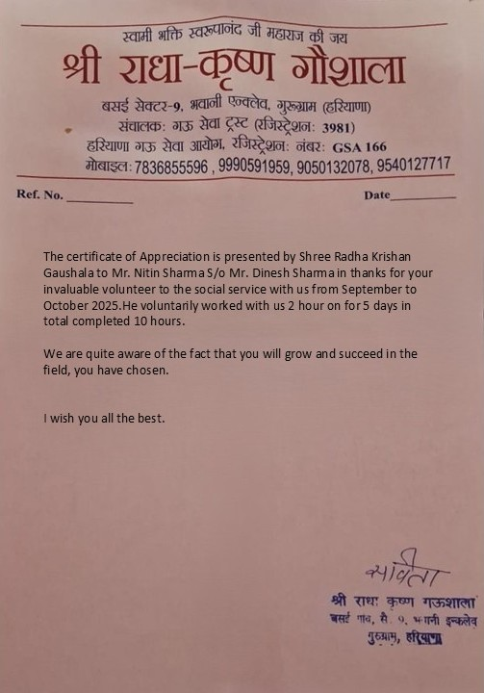

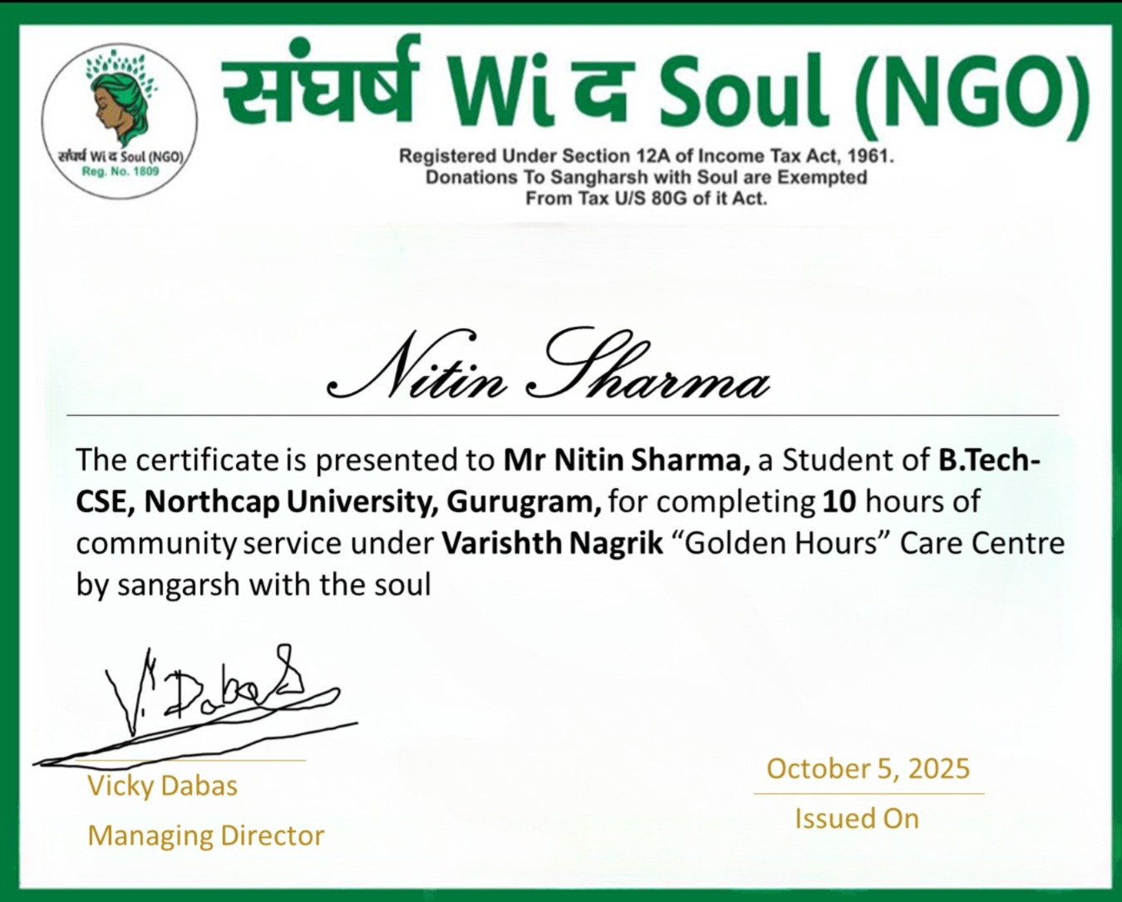

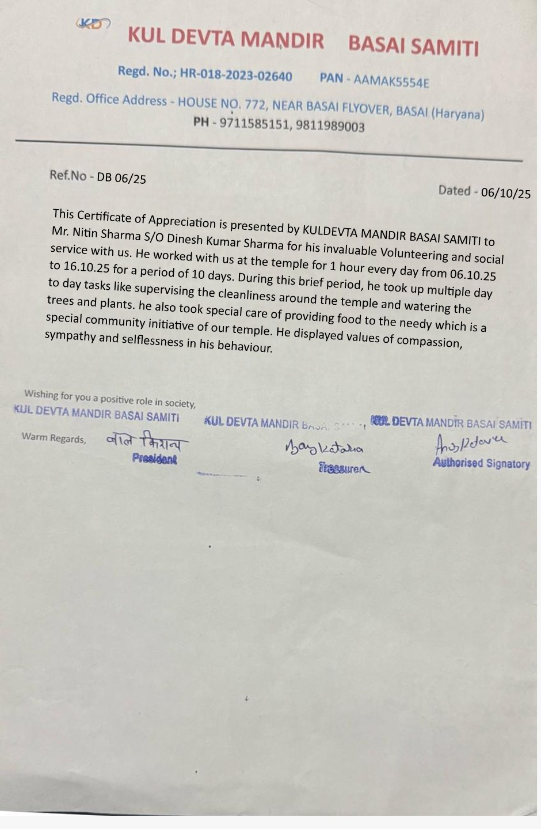
Activity-1

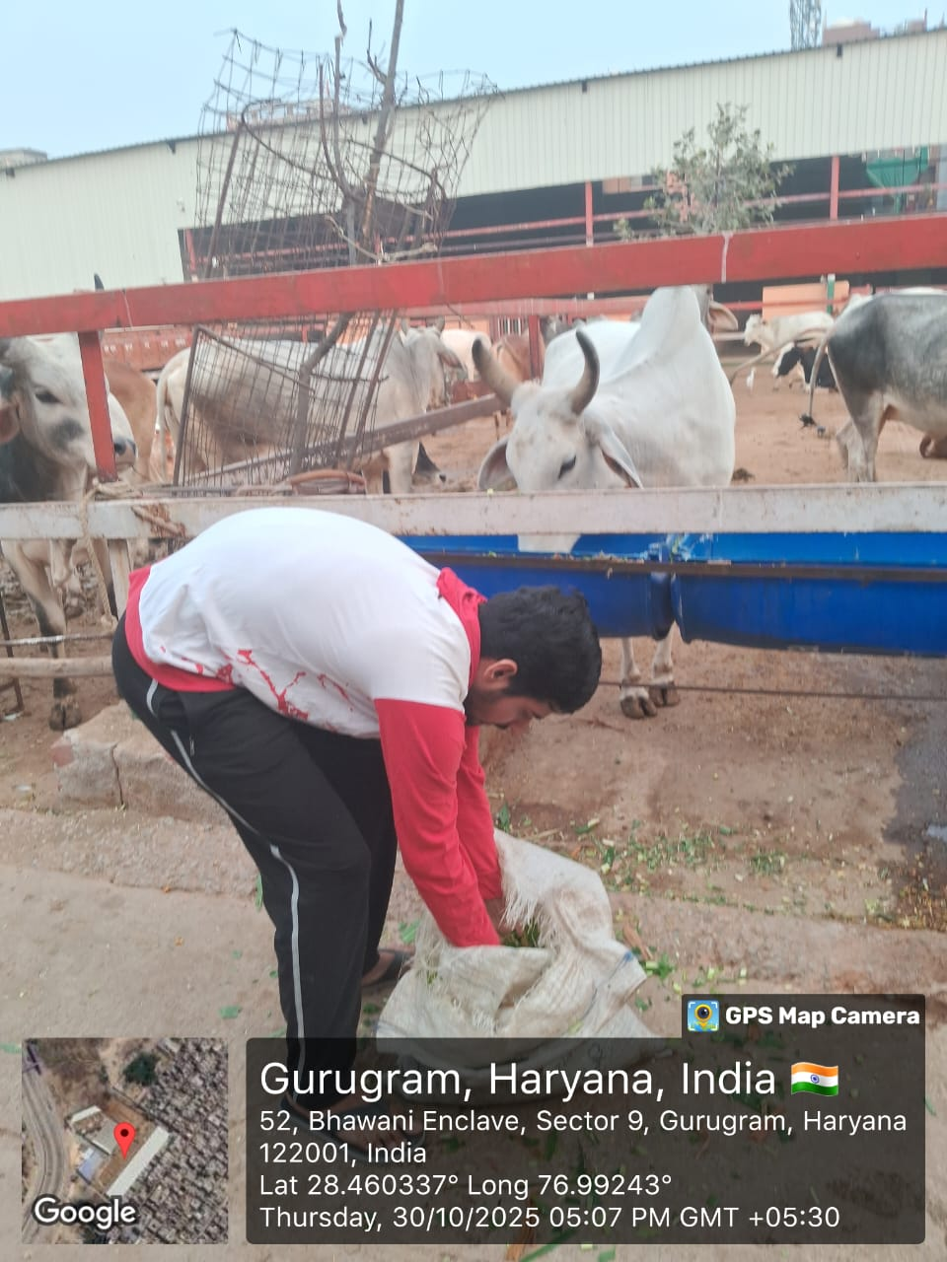
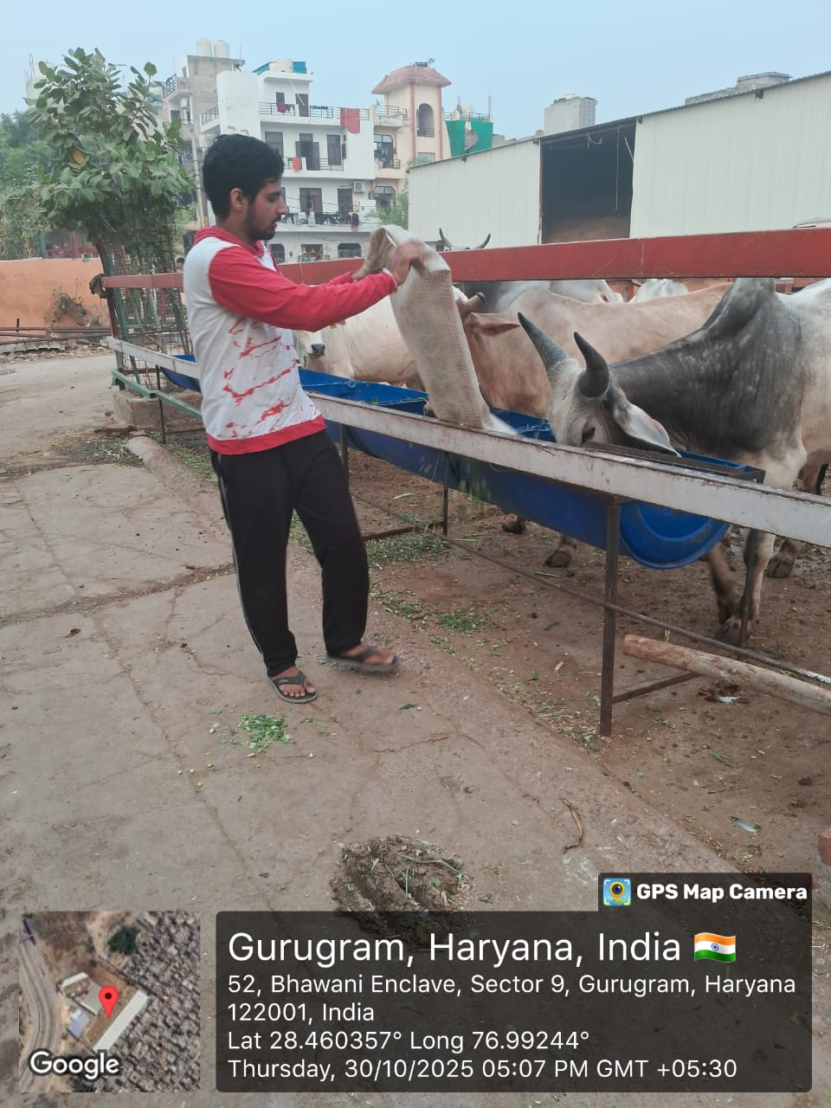
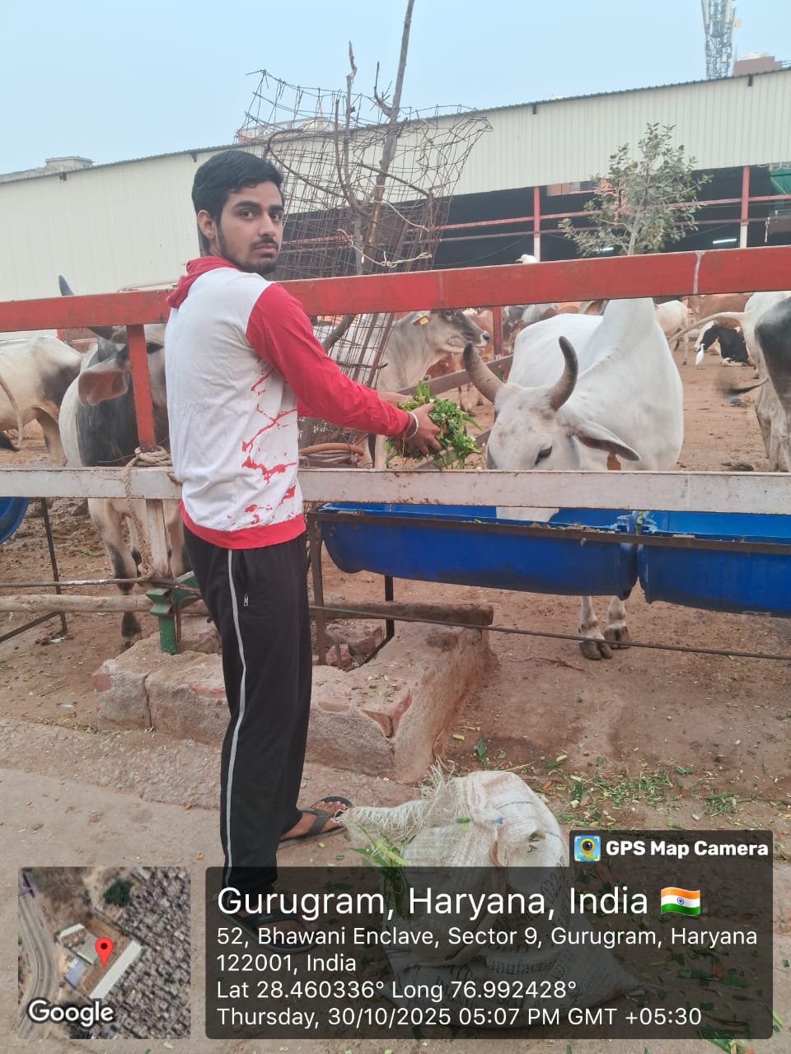

Activity -3
