Marwadi University
Faculty of Computer Applications

BCA 4E Python CSE Exam

Enrollment No. : 92400527291
Name : Nitin kumar
Class : BCA4E
Date : 03-04-2026

question– 1

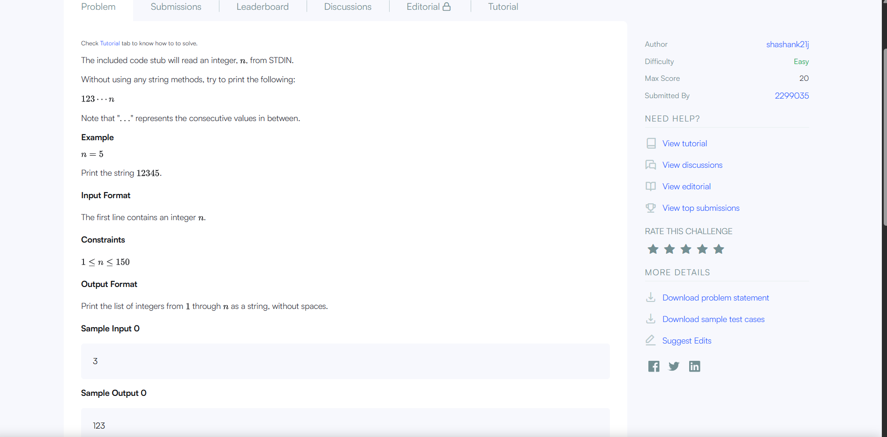

Answer:1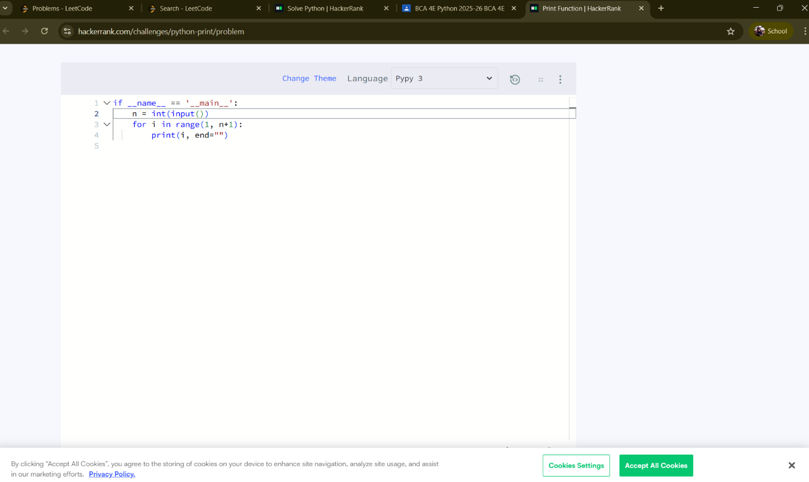

Answer - 5

