Marwadi University
Faculty of Computer Applications

BCA 4E Python Mid-1 Exam

Enrollment No. : 92400527291
Name : Nitin Kumar
Class : BCA 4D
Date : 12th march 2026

Answer – 1
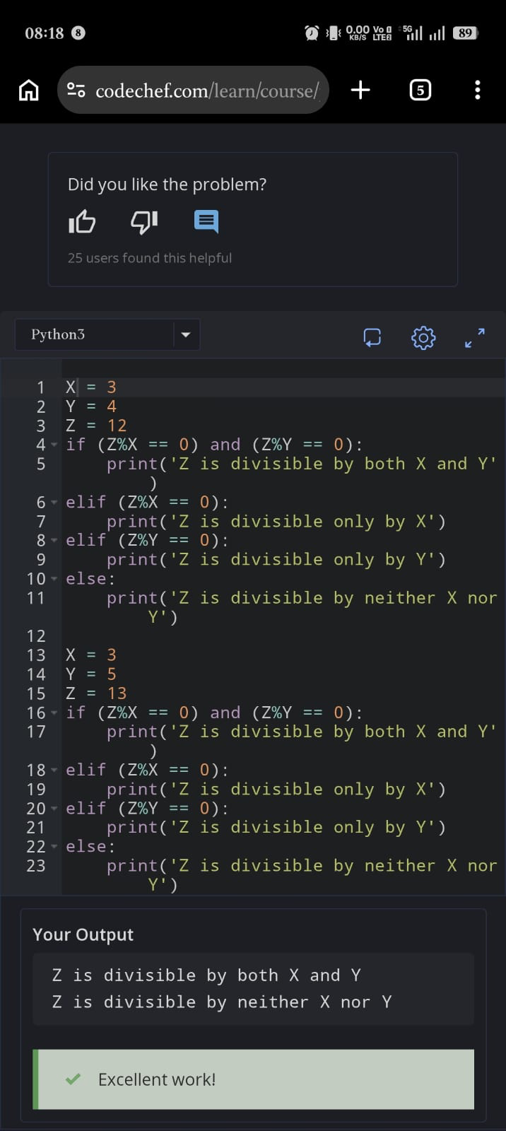

Answer – 2
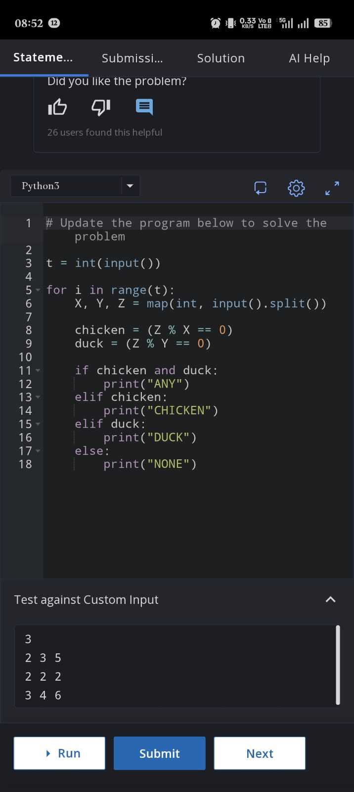

Answer – 3
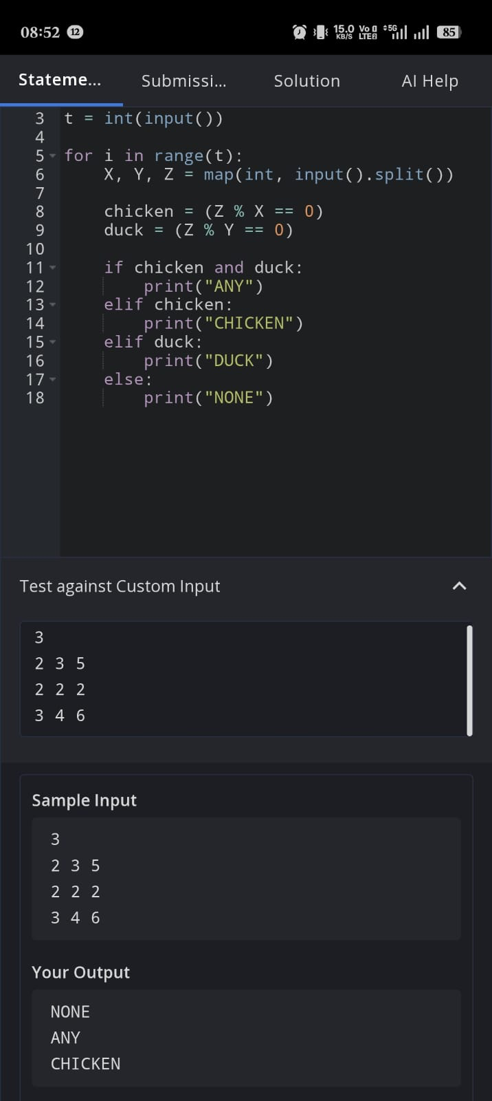

Answer – 4
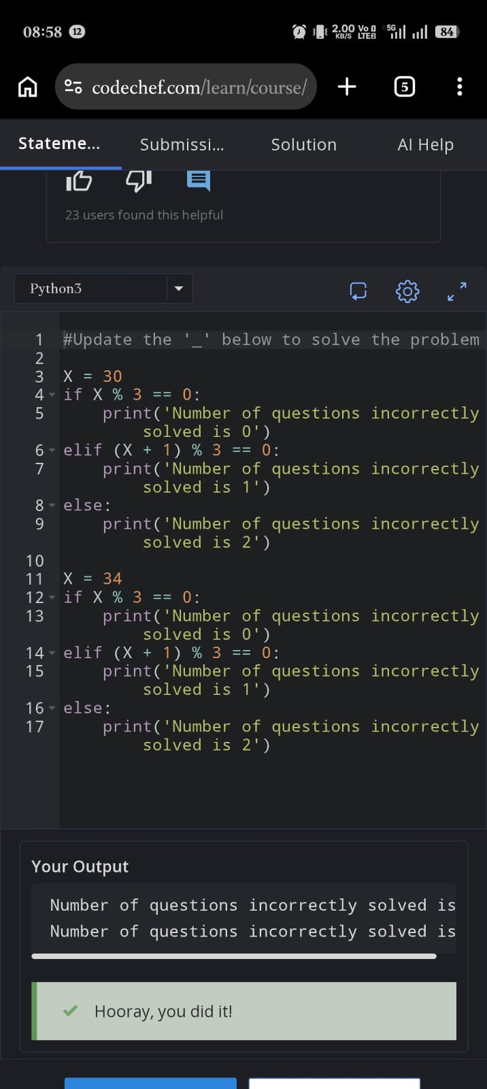

Answer – 5
