Neural Networks Nitin Surya
Assignment 2 nsurya3
660604663

Program:

import os, struct # to unpack binary data
from array import array as pyarray # for reading data into array
import numpy as np # for numeric computations
import matplotlib.pyplot as plt # plot graphs

# Function read labels from file and
# return the desired labels of all the input images
# converts each label e.g. '5' -> [0 0 0 0 1 0 0...]
# Partial code taken from : http://g.sweyla.com/blog/2012/mnist-numpy/
def getLabelsArray(fname, size_img, output_dim):
flbl = open(fname, 'rb')
magic_nr, size_label = struct.unpack(">II", flbl.read(8))
lbl = pyarray("b", flbl.read()) # signed integers
flbl.close()

desired_label = np.zeros((size_img, output_dim), dtype=np.int)
for i in range(size_label):
desired_label[i][lbl[i]] = 1

return desired_label

# Function to read the image details from the file and
# return image in [size, 1D-image-data] shape
# Partial code taken from : http://g.sweyla.com/blog/2012/mnist-numpy/
def getImagesArray(fname):
fimg = open(fname, 'rb')
magic_nr, size_img, rows, cols = struct.unpack(">IIII", fimg.read(16))
img = pyarray("B", fimg.read()) # reading unsigned integers
img = np.asarray(img).reshape(size_img, rows*cols)
fimg.close()
return img, size_img

# Returns after applying step function on V
def stepFunction(V):
for i in range (0,10):
value = V[i][0]
V[i][0] = 1 if value >= 0 else 0
return V

# Returns a matrix of size 10X1 with 1 at given index
def vectorWithOneOne(maxIndex):
V = np.random.rand(10,1)
V.fill(0)
V[maxIndex][0]=1
return V

# Returns index of maximum value in the output matrix
def findMaxIndex(V):
max_val, max_i = V[0][0], 0
for i in range (0,10):
if (V[i][0] > max_val):
max_val, max_i = V[i][0], i
return max_i

# Function to update weights and returns the new w
def updateWeights(train_img_count, img, desired_label, w, n):
for i in range(0, train_img_count):
input_val = img[i].reshape(img.shape[1], 1)
output = desired_label[i].reshape(desired_label.shape[1], 1)
w = w + n * (output - stepFunction(w.dot(input_val))) * np.transpose(input_val)
return w

# Returns the dot product of the img and label at index
def getDotProduct(img, desired_label, index, w):
input_val = img[index].reshape(img.shape[1], 1)
output = desired_label[index].reshape(desired_label.shape[1],1)
vals = w.dot(input_val)
return input_val, output, vals

# Function to train a multicategor perceptron
# which creates a weights set randomly and
# saves it to the global variable 'w'
def MulticategoryPerceptronTrainer(train_img_count, n, e, img, debug=False):
w = np.random.rand(desired_label.shape[1], img.shape[1])
ep, errors, error_epochs, continue_loop = 0, [], [], True

# Actual training section
while(continue_loop and ep < 20):
if debug:
print("epoch :: ", ep)
errors.append(0)

# Counting the errors
for index in range(0, train_img_count):
if debug and index % 5000 == 0:
print(index, " elements done")
output, V = getDotProduct(img, desired_label, index, w)[1:]

maxI = findMaxIndex(V)
V = vectorWithOneOne(maxI)
if (not(output == V).all()):
errors[ep] = errors[ep]+1

ep = ep + 1
error_epochs.append(ep)
w = updateWeights(train_img_count, img, desired_label, w, n)

# checking if the minimum error ratio is reached or not
prog_error = errors[ep - 1]/train_img_count
if (prog_error < e):
continue_loop = False
print(ep, " Error rate :: ", prog_error)
else:
print(ep, " Error rate :: ", prog_error, " should be below e: ", e)

if(continue_loop):
print("Program didn't terminate, so stopped after 20 epochs")

print("Epochs to convergence :: ", ep)
plot_graph(error_epochs, errors)

return w

def plot_graph(error_epochs, errors):
# Plotting the graph
plt.plot(error_epochs, errors, 'b')
plt.xlabel("Epochs")
plt.ylabel("Errors")
# plt.axis([0, ep, 0, max(errors)])
plt.show()

# Function to get the missclassifications on the test set
def tests(test_img, test_desired_label, w):
test_img_size = test_img.shape[0]
errors = 0
print("Testing : ")
for index in range(0, test_img_size):
if index%10000 == 0:
print(".")
output, V = getDotProduct(test_img, test_desired_label, index, w)[1:]

maxIndex = findMaxIndex(V)
V = vectorWithOneOne(maxIndex)
if (not(output == V).all()):
errors = errors + 1
print ("Missclassifications: ", errors)

# Train Data
img, size_img = getImagesArray("train-images.idx3-ubyte")
desired_label = getLabelsArray("train-labels.idx1-ubyte", size_img, 10)

# Test Data
testImg, test_size_img = getImagesArray("t10k-images.idx3-ubyte")
test_desired_label = getLabelsArray("t10k-labels.idx1-ubyte", test_size_img, 10)

# actual training and testing
train_img_count, n, er = 50, 1, 0.01
w = MulticategoryPerceptronTrainer(train_img_count, n, er, img)
tests(testImg, test_desired_label, w)

train_img_count, n, er = 1000, 1, 0.01
w = MulticategoryPerceptronTrainer(train_img_count, n, er, img)
tests(testImg, test_desired_label, w)

train_img_count, n, er = 60000, 1, 0
w = MulticategoryPerceptronTrainer(train_img_count, n, er, img)
tests(testImg, test_desired_label, w)

# Final 3 time testing
for i in range(3):
train_img_count, n, er = 60000, 0.5, 0.16 # more than min observed
print("Training started.. Learning rate: ", n)
w = MulticategoryPerceptronTrainer(train_img_count, n, er, img)
tests(testImg, test_desired_label, w)

Console Output:

Epoch 1 Error rate :: 0.92 Below e: 0.01
Epoch 2 Error rate :: 0.34 Below e: 0.01
Epoch 3 Error rate :: 0.1 Below e: 0.01
Epoch 4 Error rate :: 0.1 Below e: 0.01
Epoch 5 Error rate :: 0.0
Epochs to convergence :: 5
Testing :
.
Missclassifications: 5280
Epoch 1 Error rate :: 0.905 Below e: 0.01
Epoch 2 Error rate :: 0.252 Below e: 0.01
Epoch 3 Error rate :: 0.212 Below e: 0.01
Epoch 4 Error rate :: 0.136 Below e: 0.01
Epoch 5 Error rate :: 0.086 Below e: 0.01
Epoch 6 Error rate :: 0.105 Below e: 0.01
Epoch 7 Error rate :: 0.096 Below e: 0.01
Epoch 8 Error rate :: 0.121 Below e: 0.01
Epoch 9 Error rate :: 0.085 Below e: 0.01
Epoch 10 Error rate :: 0.054 Below e: 0.01
Epoch 11 Error rate :: 0.049 Below e: 0.01
Epoch 12 Error rate :: 0.043 Below e: 0.01
Epoch 13 Error rate :: 0.045 Below e: 0.01
Epoch 14 Error rate :: 0.049 Below e: 0.01
Epoch 15 Error rate :: 0.059 Below e: 0.01
Epoch 16 Error rate :: 0.044 Below e: 0.01
Epoch 17 Error rate :: 0.071 Below e: 0.01
Epoch 18 Error rate :: 0.028 Below e: 0.01
Epoch 19 Error rate :: 0.043 Below e: 0.01
Epoch 20 Error rate :: 0.034 Below e: 0.01
Epoch 21 Error rate :: 0.05 Below e: 0.01
Epoch 22 Error rate :: 0.012 Below e: 0.01
Epoch 23 Error rate :: 0.052 Below e: 0.01
Epoch 24 Error rate :: 0.007
Epochs to convergence :: 24
Testing :
.
Missclassifications: 2166
Epoch 1 Error rate :: 0.9106833333333333 Below e: 0
Epoch 2 Error rate :: 0.22763333333333333 Below e: 0
Epoch 3 Error rate :: 0.20841666666666667 Below e: 0
Epoch 4 Error rate :: 0.21191666666666667 Below e: 0
Epoch 5 Error rate :: 0.2342 Below e: 0
Epoch 6 Error rate :: 0.20801666666666666 Below e: 0
Epoch 7 Error rate :: 0.21411666666666668 Below e: 0
Epoch 8 Error rate :: 0.2148 Below e: 0
Epoch 9 Error rate :: 0.21166666666666667 Below e: 0
Epoch 10 Error rate :: 0.22218333333333334 Below e: 0
Epoch 11 Error rate :: 0.21876666666666666 Below e: 0
Epoch 12 Error rate :: 0.21101666666666666 Below e: 0
Epoch 13 Error rate :: 0.22891666666666666 Below e: 0
Epoch 14 Error rate :: 0.22156666666666666 Below e: 0
Epoch 15 Error rate :: 0.21763333333333335 Below e: 0
Epoch 16 Error rate :: 0.20935 Below e: 0
Epoch 17 Error rate :: 0.19905 Below e: 0
Epoch 18 Error rate :: 0.18128333333333332 Below e: 0
Epoch 19 Error rate :: 0.20531666666666668 Below e: 0
Epoch 20 Error rate :: 0.2112 Below e: 0
Epoch 21 Error rate :: 0.20651666666666665 Below e: 0
Epoch 22 Error rate :: 0.21006666666666668 Below e: 0
Epoch 23 Error rate :: 0.2278 Below e: 0
Epoch 24 Error rate :: 0.2083 Below e: 0
Epoch 25 Error rate :: 0.21366666666666667 Below e: 0
Epoch 26 Error rate :: 0.20608333333333334 Below e: 0
Epoch 27 Error rate :: 0.19205 Below e: 0
Epoch 28 Error rate :: 0.20195 Below e: 0
Epoch 29 Error rate :: 0.21963333333333335 Below e: 0
Epoch 30 Error rate :: 0.21075 Below e: 0
Program didn't terminate, so stopped after 30 epochs
Epochs to convergence :: 30
Testing :
.
Missclassifications: 2433

Training started.. Learning rate: 0.5
1 Error rate :: 0.8947833333333334 should be below e: 0.16
2 Error rate :: 0.17465 should be below e: 0.16
3 Error rate :: 0.16228333333333333 should be below e: 0.16
4 Error rate :: 0.16671666666666668 should be below e: 0.16
5 Error rate :: 0.14976666666666666
Epochs to convergence :: 5
Testing :
.
Missclassifications: 1612
Training started.. Learning rate: 0.5
1 Error rate :: 0.8586 should be below e: 0.16
2 Error rate :: 0.17701666666666666 should be below e: 0.16
3 Error rate :: 0.15586666666666665
Epochs to convergence :: 3
Testing :
.
Missclassifications: 1659
Training started.. Learning rate: 0.5
1 Error rate :: 0.8612333333333333 should be below e: 0.16
2 Error rate :: 0.17886666666666667 should be below e: 0.16
3 Error rate :: 0.15343333333333334
Epochs to convergence :: 3
Testing :
.
Missclassifications: 1755

Plots:
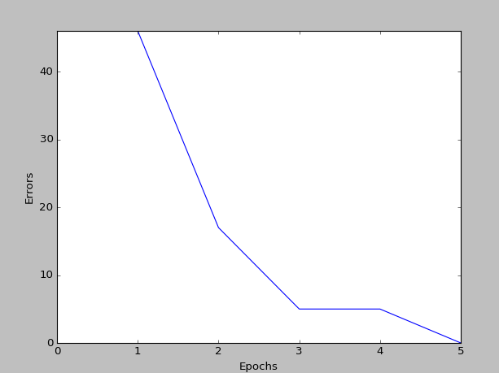
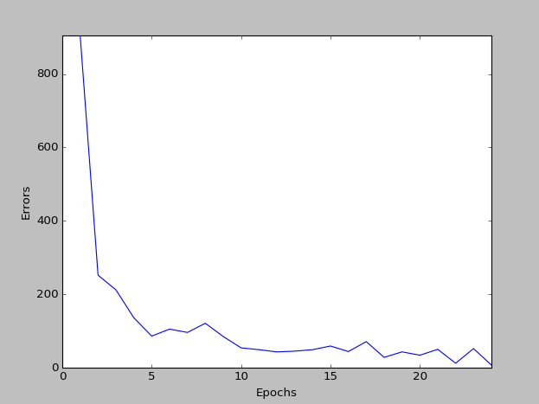

Train images size: 50 Train images size: 1000
Learning rate: 1 Learning rate: 1
Error rate: 0.01 Error rate: 0.01

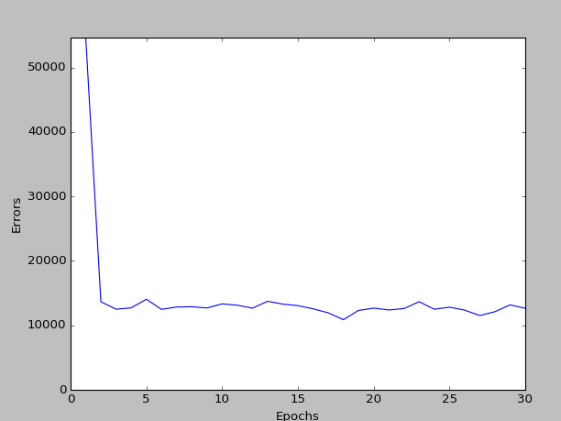

Train images size: 60000
Learning rate:
Error rate: 0

