Business Problem :
Hotel Booking Cancellation Analysis Using Python :
The hotel industry faces significant revenue loss due to booking cancellations. Understanding the reasons behind cancellations can help improve pricing strategies, marketing decisions, and customer retention.
This project performs exploratory data analysis (EDA) on hotel booking data to identify patterns and insights.
High cancellation rates negatively impact hotel revenue and resource planning. The goal of this project is to:
- Analyse booking patterns
- Identify factors affecting cancellations
- Provide actionable business insights
Abstract :
This project analyzes hotel booking data to understand customer behavior and identify patterns in booking cancellations. The dataset contains booking details such as hotel type, country, market segment, arrival date, and average daily rate (ADR). Using Python for data cleaning and visualization, the project uncovers trends that Impact cancellation rates. The insights generated can help hotels reduce revenue loss and improve booking management strategies.
Research question :

- What are the variable that affect hotel reservation cancellation?
- How can we make hotel reservation cancellation better?
- How will hotels be assisted in making pricing and promotional decision?

Hypothesis :
More cancellation occurs when prices are higher.
When there is a longer waiting list, Customer tend to cancel more frequently.
The majority of client are coming from offline travel agents to make their reservations.

Exploratory Data Analysis (EDA) :
Analysis and findings :
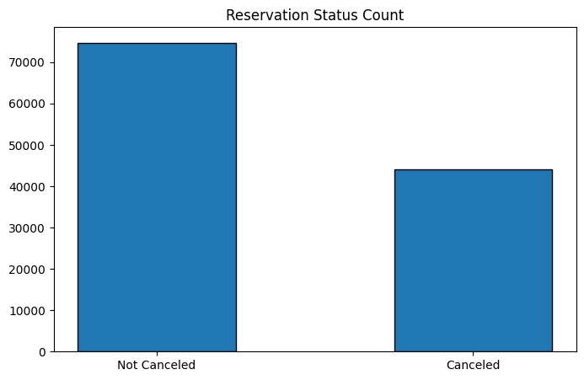

The above bar shows the percentage of reservations that are canceled and those that are not. It is obvious that there are still a significant numbers of reservation that have not been canceled. There are still 37% of clients who canceled their reservation, which has a significant impact on the hotels earnings.
Reservation Status by Different Hotels
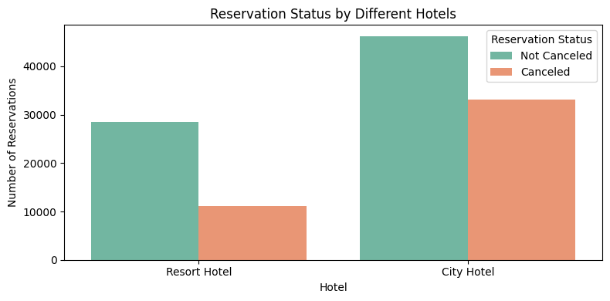
From the analysis, it is observed that:
- City Hotel has a higher number of total bookings compared to Resort Hotel.
- The number of Not Canceled reservations is greater than the number of canceled reservations in both hotel types.
- However, the City Hotel also shows a significantly higher number of cancellations compared to the Resort Hotel.
In numerical terms:
- City Hotel has approximately 46,000 confirmed (not canceled) bookings and about 33,000 canceled bookings.
- Resort Hotel has around 29,000 confirmed (not canceled) bookings and about 11,000 canceled bookings.
This indicates that while City Hotels attract more customers, they also face a higher cancellation rate. One possible reason could be that City Hotels mainly serve business travelers or short-term visitors who are more likely to change their travel plans. In contrast, Resort Hotels typically cater to leisure travelers who plan vacations in advance, resulting in comparatively fewer cancellations.
The findings suggest that cancellation management strategies may need to be stronger in City Hotels to reduce revenue loss and improve occupancy planning. Understanding customer behavior and implementing stricter booking policies or incentives for confirmed bookings could help minimize cancellations.
Overall, the chart highlights that hotel type plays an important role in reservation behavior and cancellation trends.

Average Daily Rate In City And Resort Hotels Over Time
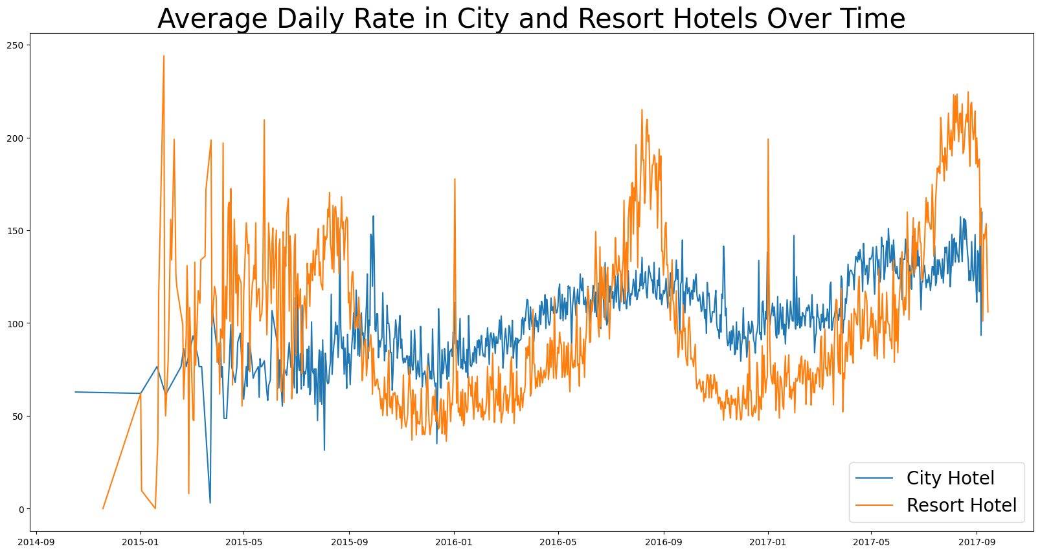

The graph highlights that Resort Hotels experience more seasonal price changes, while City Hotels maintain relatively stable pricing with steady growth over time.

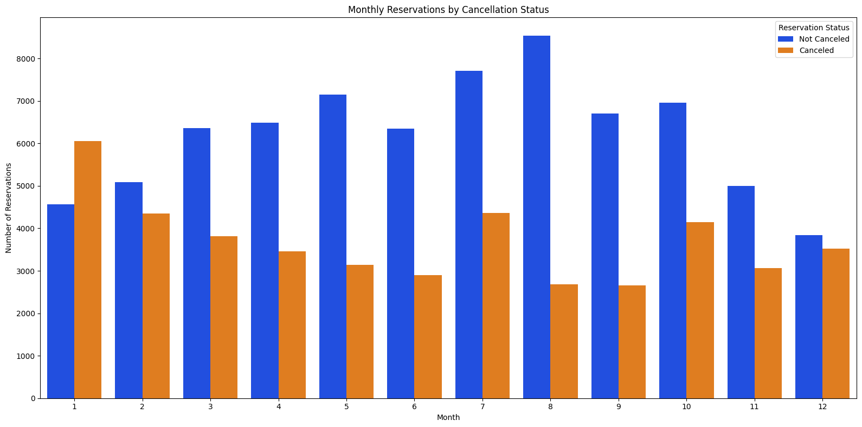

Monthly Reservations by Cancellation Status
We have developed the grouped bar graph to analyze the months with the highest and lowest reservation levels according to reservation status. As can be seen, both the number of confirmed reservation and the number of canceled reservations are largest in the month of August. Whereas January is the month with most canceled reservations.
ADR Per Month
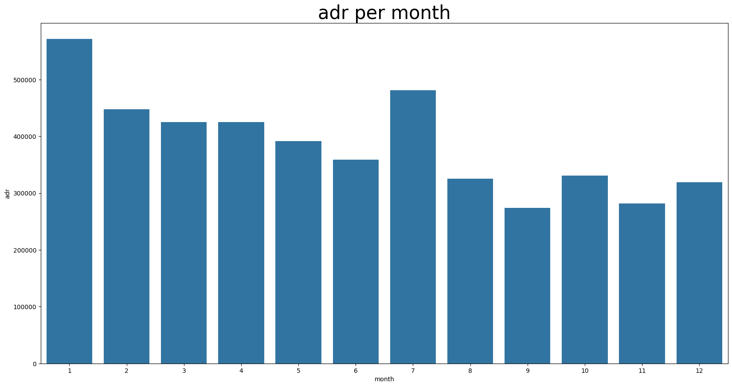

Average Daily Rate (ADR) per Month
7There is a noticeable increase again around Month 7, suggesting a seasonal peak, possibly due to holidays or increased travel demand. The lowest ADR values are observed around Months 8 and 9, indicating comparatively lower demand during that time.
The chart highlights clear seasonal variations in pricing, showing that room rates change depending on demand patterns across different months.
Now, let’s see which country has the highest reservation canceled. The top country is Portugal with the highest number of cancellations.
Top 10 contries with reservation cancelled

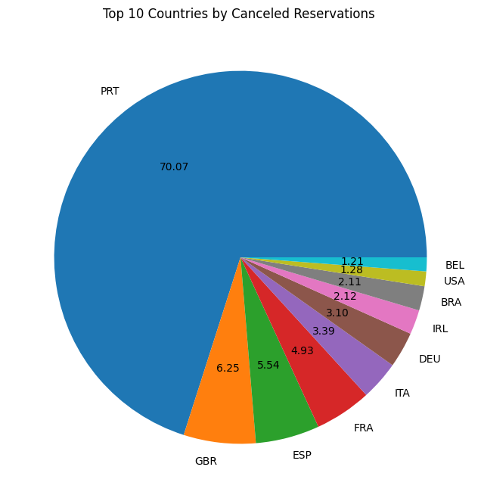

Let’s check the are from where guests are visiting the hotels and making reservations. Is it coming from Direct or Groups, Online or Offline Travel Agents? Around 46% of the clients come from online travel agencies, whereas 27% come from groups. Only 4% of clients book hotels directly by visiting them and making reservations.

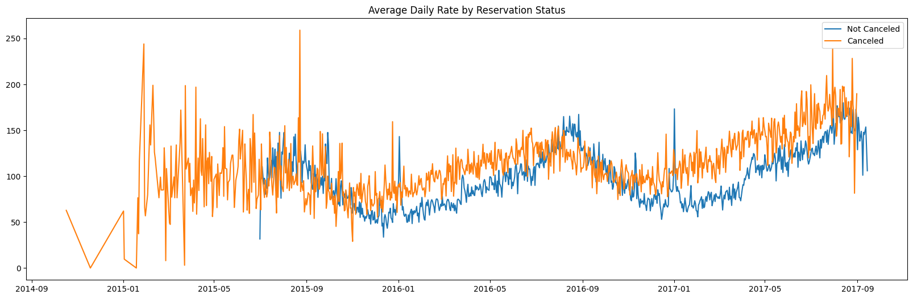

As seen in the graph, reservation are canceled when the average daily rate is higher than when it is not canceled. It clearly proves above all the analysis, that the higher price leads to higher cancellation.

Suggestions :
- Cancellation rate rise as the price does. In order to prevent cancellation of reservations, hotels could work on their pricing strategies and try to lower the rates of specific hotels based on locations. They can also provide some discounts to the consumers
- As the ratio of the cancellation and not cancellation of the resort hotel is higher in the resort hotel than the city hotels. So the hotels should provide a reasonable discount on the room prices on weekends or on holidays.
- In the month of January, hotels can start campaigns or marketing with a reasonable amount to increase their revenue as the cancellation is the highest in this month.
- They can also increase the quality of their hotels and their services mainly in Portugal to reduce the cancellation rate.

