ORACLE NORTH AMERICAN CLOUD ENGINEERING
Joint Engagement Plan
For
The U.S. Department of State

AI Pilot for PeopleSoft Time & Labor
Document date: INSERT DATE
Version 1.0

1. OVERVIEW
The U.S. Department of State is engaging with Oracle to conduct a technical and functional pilot using Oracle AI capabilities to improve PeopleSoft Time & Labor (T&L) workflows.
The pilot will demonstrate a limited-scope AI Agent and user experience that enables employees, supervisors, and administrators to query, validate, and act on T&L information through natural language. It is intended to show how Generative AI can modernize the Department of State PeopleSoft experience, improve compliance, and reduce administrative burden.
Evaluation will focus on ease of development, security compliance in a FedRAMP High environment, and measurable improvements to time entry and auditing work.
Pilot objectives
Validate secure AI and data-integration patterns for selected Department of State T&L workflows.
Demonstrate an employee-facing policy assistant grounded in approved policy content.
Demonstrate supervisor/admin anomaly detection for prioritized timecard exceptions.
Establish a fact-based roadmap for production-scale adoption.
2. SCOPE AND APPROACH
Environment
The pilot will be implemented in a new secure tenancy within Oracle US Government Cloud (OCI Gov). The pilot dataset will consist of approved non-PII or anonymized PeopleSoft T&L data and relevant policy content.
2.2. Core Activities
Workstream | Pilot activity | Primary output
Provisioning | Set up the OCI Gov tenancy, required network controls, and OCI Generative AI services. | Secure pilot environment
Data integration | Ingest approved PeopleSoft T&L data and policy documents into an OCI Vector Database. | Connected data foundation
Model configuration | Configure LLM and Retrieval-Augmented Generation (RAG) patterns for Department of State T&L terminology. | Grounded AI responses
Experience development | Deploy the Time & Labor Co-Pilot experience and the supervisor/admin review workflow. | Working AI prototype

3. PILOT USE CASES: TIME & LABOR
The pilot will focus on two high-value workflows that test employee self-service, policy interpretation, supervisory review, and audit-oriented exception handling.
USE CASE A  EMPLOYEE-FACING | Problem: Employees can struggle to apply complex leave codes or interpret overtime rules, resulting in errors and resubmissions.  AI solution: An embedded chat assistant answers natural-language questions using approved Department of State policy and relevant guidance.  Example interaction: User: “I worked two extra hours on Tuesday to finish an audit report. How should I code this?”  AI Agent: “Based on your bargaining-unit status, this may qualify as Credit Hours. I can open the Credit Hour entry screen for you. Would you like to proceed?”  Value: Reduces Tier 1 support requests and coding errors at the source.

USE CASE B  SUPERVISOR / ADMIN | Problem: Supervisors must manually review large volumes of timecards and may miss patterns of non-compliance, including overlapping leave and work hours.  AI solution: A predictive AI model scans finalized timecards against historical patterns and policy limits to flag high-risk exceptions for review.  Example interaction: User: “What timecards require priority review this week?”  AI Agent: “Alert: Employee X has claimed Sick Leave on four consecutive Mondays following a holiday. This exceeds the deviation threshold. Recommended action: request documentation.”  Value: Increases audit accuracy and reduces manual review time.

4. PROOF OF CONCEPT REQUIREMENTS
4.1. Oracle Pilot Team Responsibilities
Provide dedicated AI specialist(s) to guide the OCI environment architecture and configuration.
Assist with setup of OCI Generative AI Service and Vector Search capabilities.
Provide pre-built code accelerators for Retrieval-Augmented Generation (RAG) pipelines to speed development.
Conduct the final proof-of-value debriefing.
4.2. Department of State Team Responsibilities
Provide a cleansed, approved dataset of anonymized PeopleSoft time data and relevant policy PDFs, including policy manuals and union contracts.
Identify functional SMEs, including Time Administrators, to test the system and provide feedback.
Review and approve the pilot cloud-tenancy architecture and support the security-assessment process.
60-day pilot timeline
Phase | Duration | Key activities | Output
1. Discovery & Define | Days 1–10 | Kickoff, cloud tenancy activation, and use-case refinement workshop. | Signed pilot charter; architecture diagram
2. Develop & Deploy | Days 11–40 | Ingest policy data, connect sandbox data, configure models, and develop the user experience. | Working AI prototype; connected data pipeline
3. Test & Improve | Days 41–60 | UAT with SMEs, answer refinement, final readout, and ROI calculation. | Performance report; production roadmap

5. PROPOSED ARCHITECTURE
The solution will use Oracle Cloud Infrastructure services designed for secure AI workloads. All components will be deployed within a Virtual Cloud Network (VCN) with strict Identity and Access Management (IAM) policies aligned to Department of State security standards.
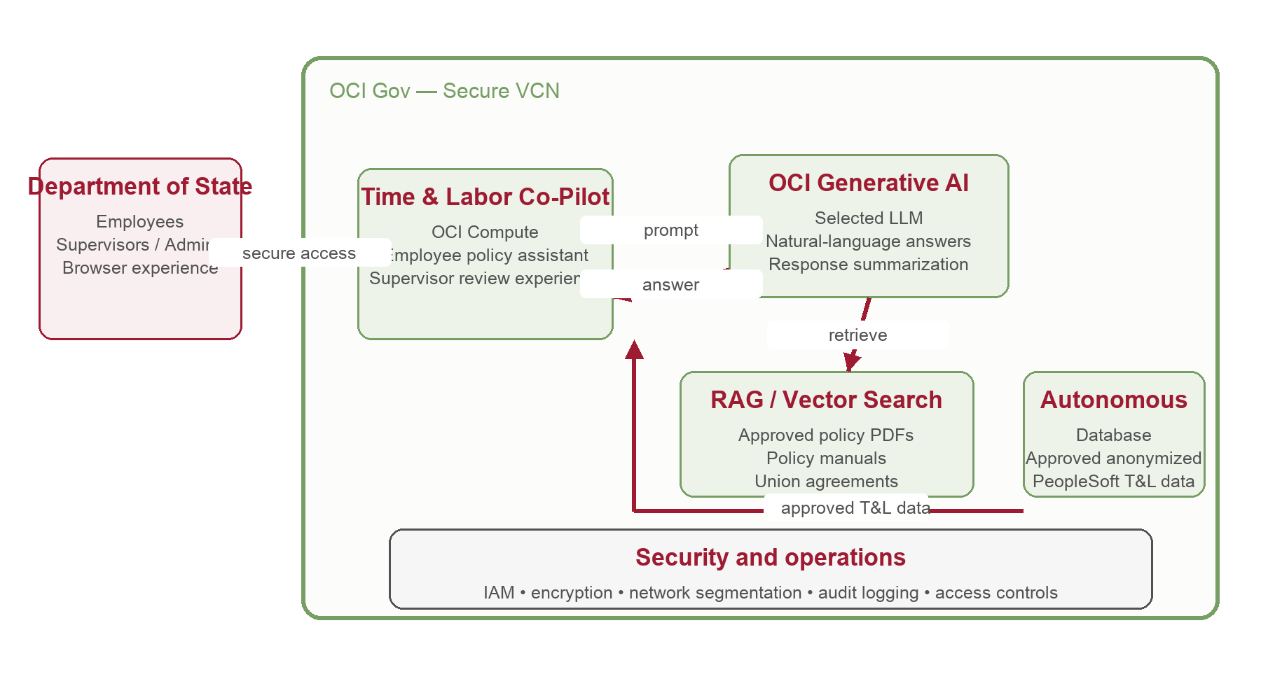
Component | Role in pilot
OCI Compute | Hosts application logic and the Time & Labor Co-Pilot user experience.
Autonomous Database | Stores approved structured PeopleSoft pilot data.
OCI Generative AI | Generates responses and summaries using selected large language models.
Vector Search / RAG | Grounds responses in approved policy documents and Department of State terminology.
VCN and IAM | Provides network segmentation, controlled access, encryption, and auditability.

6. SUCCESS CRITERIA
The pilot will be considered successful when the following outcomes are demonstrated and jointly reviewed:
Area | Criteria | Target metric
Accuracy | The AI Agent provides correct policy citations for T&L questions. | >90% accuracy in UAT feedback
Efficiency | Time required to audit a set of complex timecards is reduced. | >50% reduction versus manual process
Usability | End-user satisfaction during pilot testing. | 4/5 average rating
Security | Deployment meets FedRAMP High requirements with data encryption. | 100% security-control validation

Pilot ground rules and assumptions
Only approved non-PII or anonymized pilot data will be used for the pilot.
Department of State SMEs will validate policy interpretation and use-case outcomes during UAT.
Changes to scope, data sources, security architecture, or production integrations require joint agreement.
The pilot validates proof of value; production deployment decisions, operating model, and integration scope will be handled separately.

7. ROLES, CONTACTS, AND NEXT STEPS
Key roles
Party | Role | Contribution
Department of State | Program Manager | Own pilot priorities, stakeholder alignment, and decision-making.
Department of State | Functional Lead | Guide T&L use cases, policy content, and UAT feedback.
Department of State | Security / ISSO | Review architecture and security-assessment approach.
Oracle | Account Lead / AI Engineering Lead | Coordinate the engagement and technical delivery.

Contacts
Team | Name | Role / email
Department of State | [Name] | Program Manager
Department of State | [Name] | Functional Lead
Department of State | [Name] | Security / ISSO
Oracle | [Name] | Account Lead — [Email]
Oracle | [Name] | Enterprise Cloud Architect — [Email]
Oracle | [Name] | AI Engineering Lead — [Email]

Next steps
Confirm the two Time & Labor use cases, pilot users, and success-measurement approach.
Identify approved sample data and policy sources for ingestion.
Confirm the OCI Gov tenancy, security review path, and pilot kickoff date.
Conduct the discovery workshop and finalize the pilot charter.

