
ETUM

ELECTRONIC TOILET USAGE MONITORING

ETUM
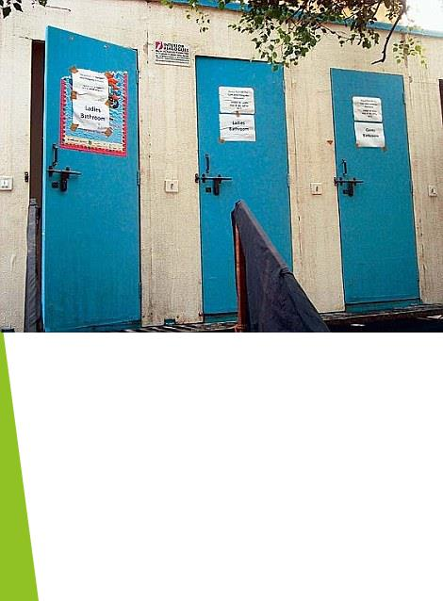

The government has made Millions of toilet for a clean India under the Swachh Bbharat Ahiyaan.

To have a effective usage of these toilets, we have developed ETUM.
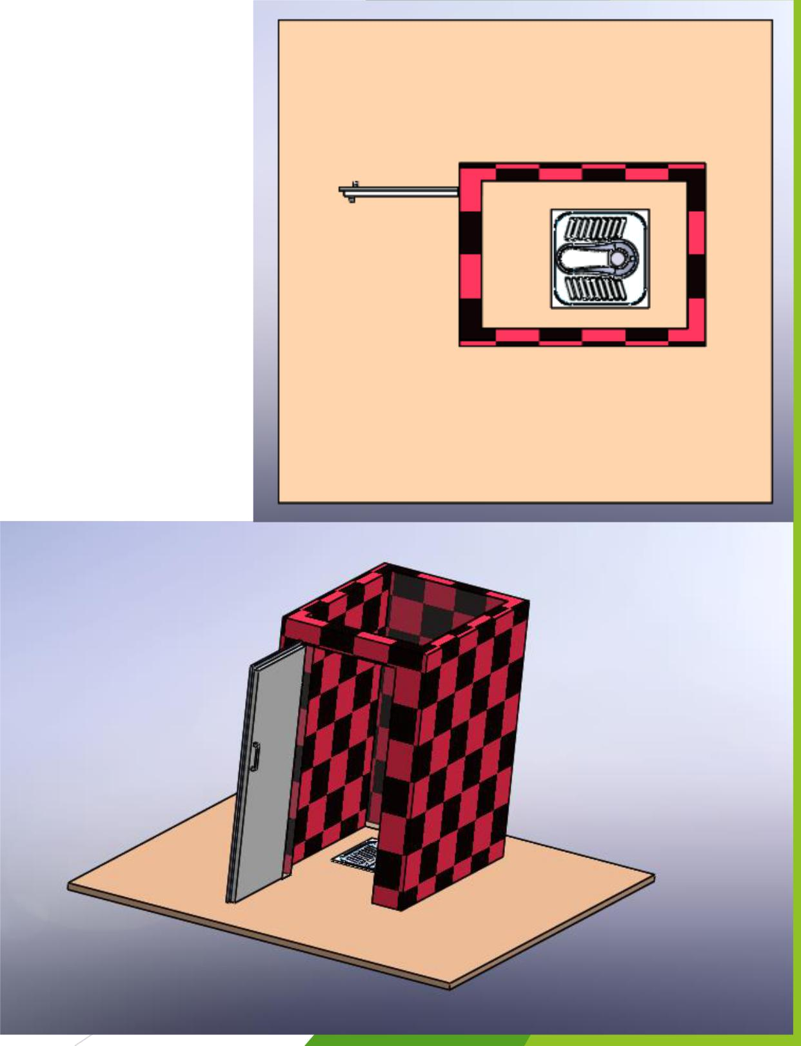
ETUM
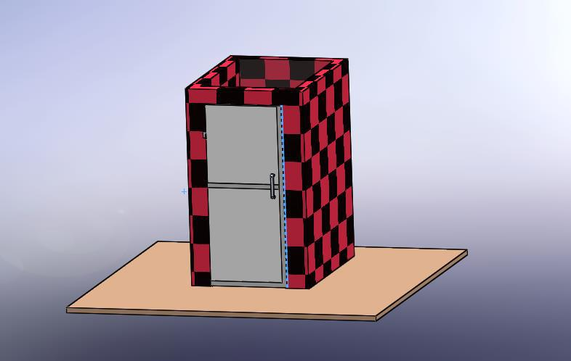

ETUM WORKING`
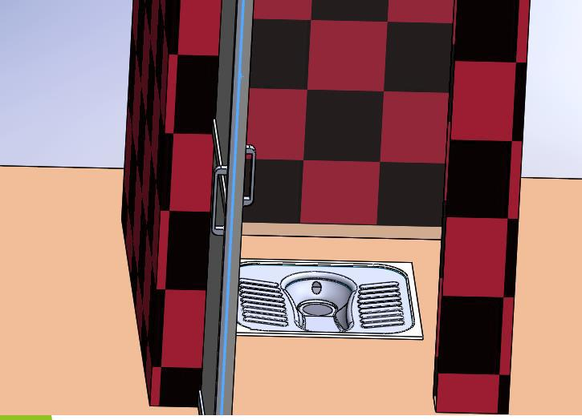

We have considered a standard 0.8 x1x1.9 m toilet room.


ETUM

PIR SENSOR
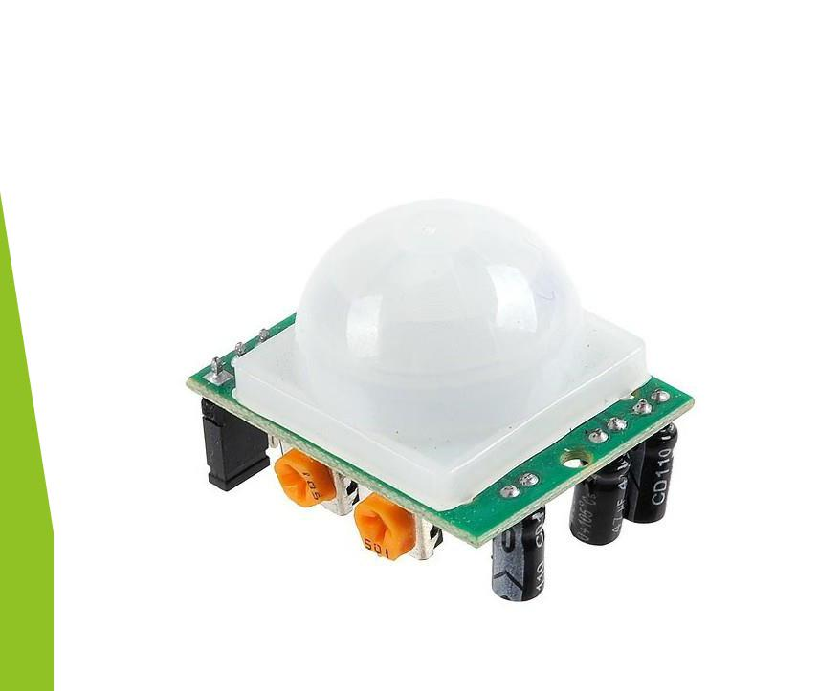

PIR sensors allow you to sense motion, almost always used to detect whether a human has moved in or out of the sensors range. They are small, inexpensive, low-power, easy to use and don't wear out. For that reason they are commonly found in appliances and gadgets used in homes or businesses. They are often referred to as PIR, "Passive Infrared", "Pyroelectric", or "IR motion" sensors.

ETUM

PIR SENSOR

PIRs are basically made of a pyroelectric sensor (which you can see above as the round metal can with a rectangular crystal in the center), which can detect levels of infrared radiation. Everything emits some low level radiation, and the hotter something is, the more radiation is emitted. The sensor in a motion detector is actually split in two halves. The reason for that is that we are looking to detect motion (change) not average IR levels. The two halves are wired up so that they cancel each other out. If one half sees more or less IR radiation than the other, the output will swing high or low.
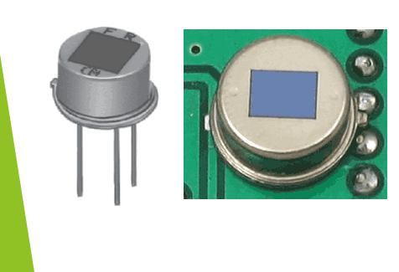
ETUM

PIR SENSOR WORKING
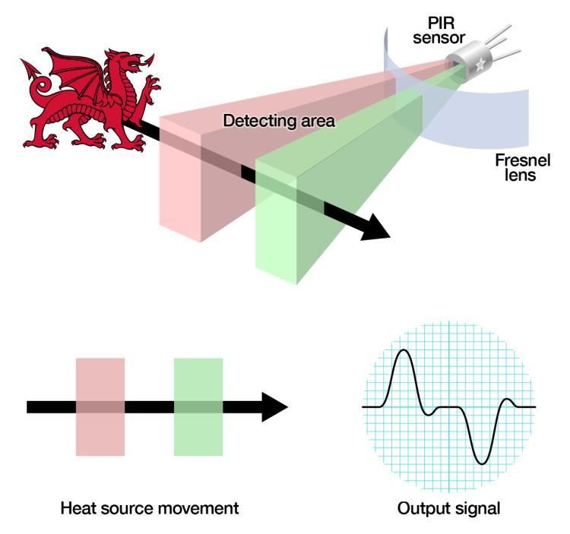

The PIR sensor itself has two slots in it, each slot is made of a special material that is sensitive to IR. When the sensor is idle, both slots detect the same amount of IR, the ambient amount radiated from the room or walls or outdoors. When a warm body like a human or animal passes by, it first intercepts one half of the PIR sensor, which causes a positive differential change between the two halves. When the warm body leaves the sensing area, the reverse happens, whereby the sensor generates a negative differential change. These change pulses are what is detected.

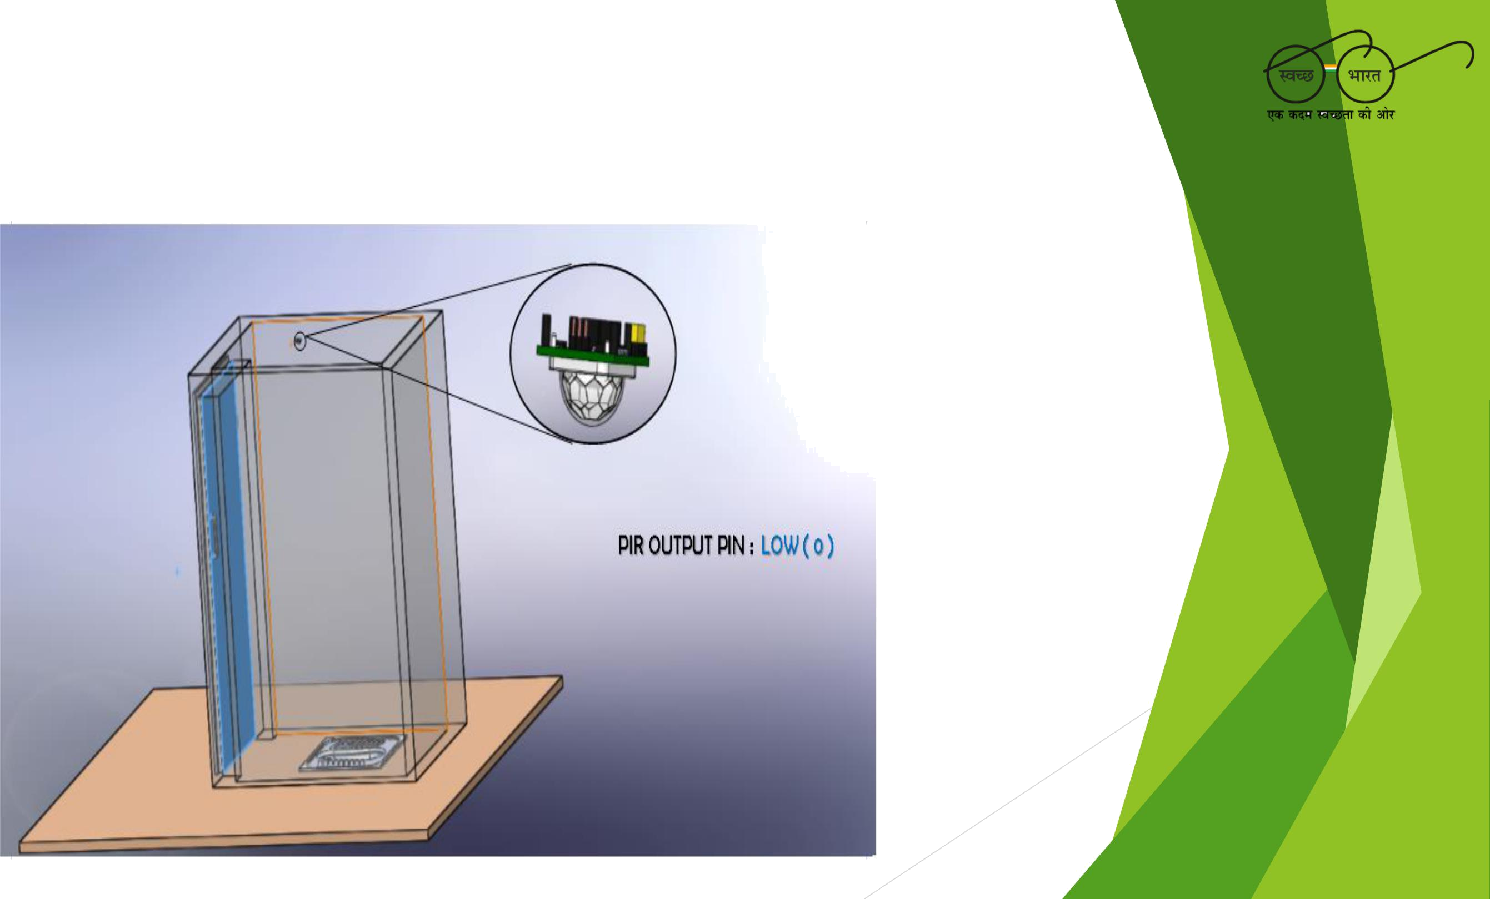
ETUM WORKING

When the toilet is not being used, the sensor reads low.

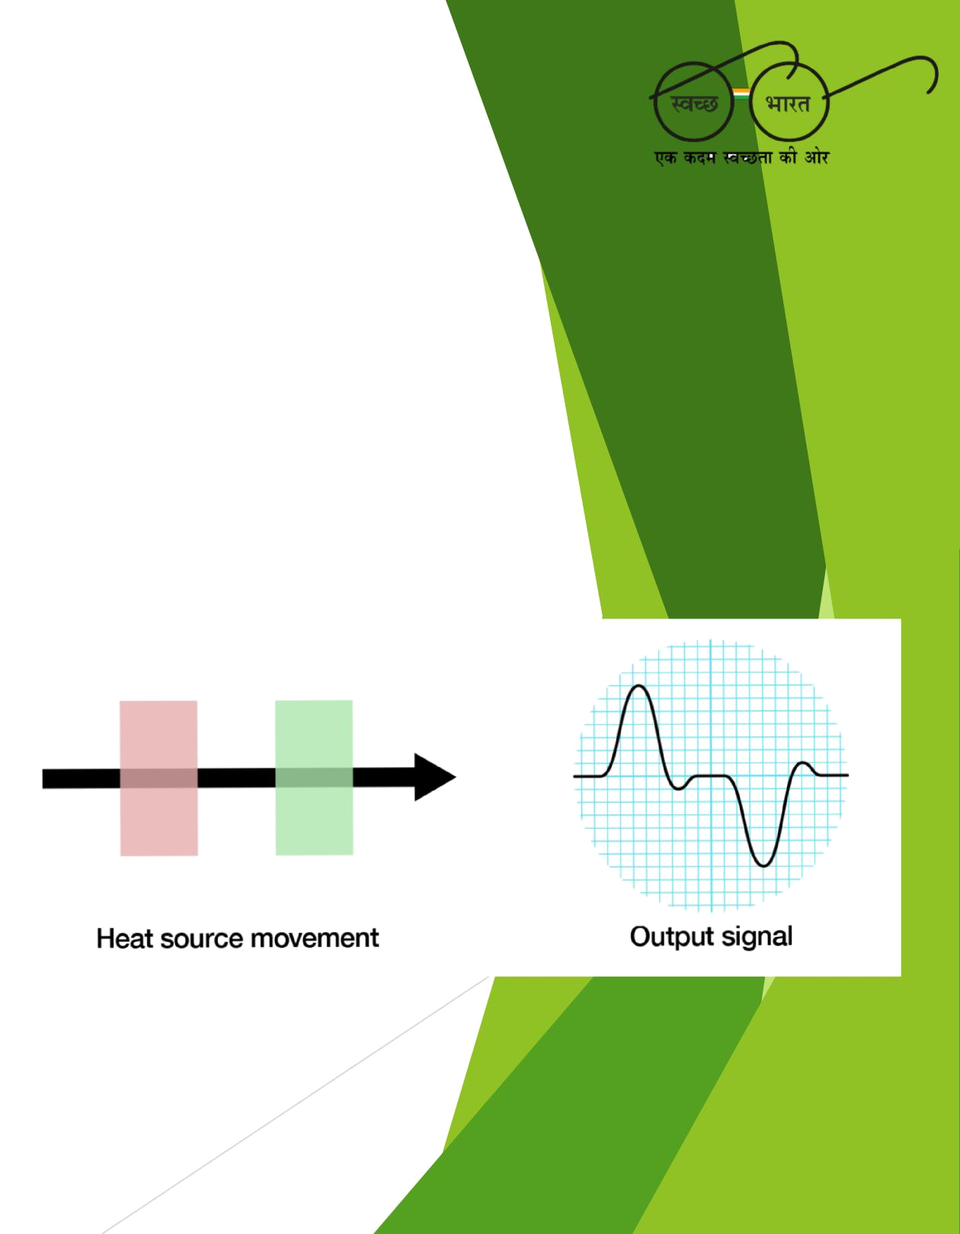
ETUM WORKING
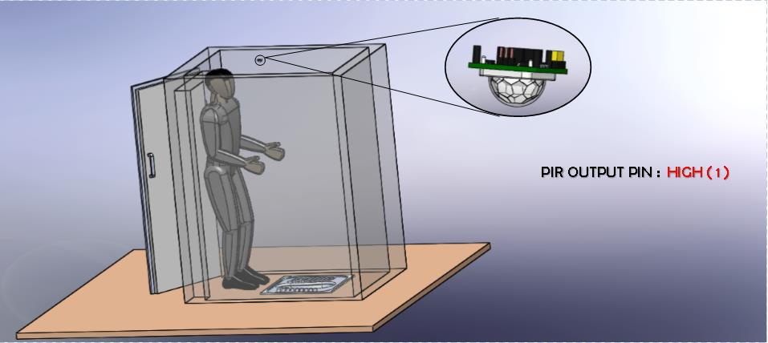

As soon as a person enters into the toilet, The sensor reads high for a small duration of About 2 to 3 seconds and comes back to low.

ETUM IDEA
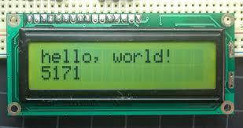

The device works on the principle of infrared rays detection by a PIR sensor. The device is designed to work continuously for about 5 months without any maintenance in between.

After duration of these 5 months, a person will have to record the data that Is stored in these 5 months by plugging in an LCD screen into the LCD pins Provided in ETUM.

A Standard 16x2 LCD screen.
ETUM IDEA

We instead of using a standard HC-SR501, have designed our own PCB module removing the unnecessary volta Regulator and potentiometer for minimum power dissipation. We in the PCB we have added a microcontroller(ATTINY 24A) for the processing of the data along with separate pins in which the LCD has to Plugged-in to read the data. A battery of 3000mAh is used in the device. Here is a list of the components used in the device:-

Resistor(ohms) | 3000mAh | Capacitor | ICs and PIR
47k -1 | Rechargeable battery 1 | 5nF -1 | ATTINY 24A
6.8k -1 |  | 47uF -1 | BISS0001 SMD
2k -1 |  | 22uF -2 | RE200B
10k -5 |  | 100nF -2
18k -3 |  | 10nF -5
470k -1
1M -3
1k -1
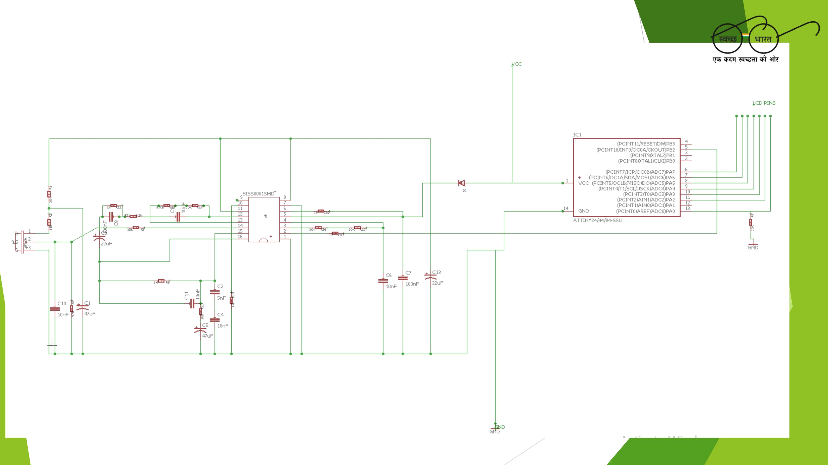
ETUM PCB SCHEMATIC
ETUM PCB BOARD
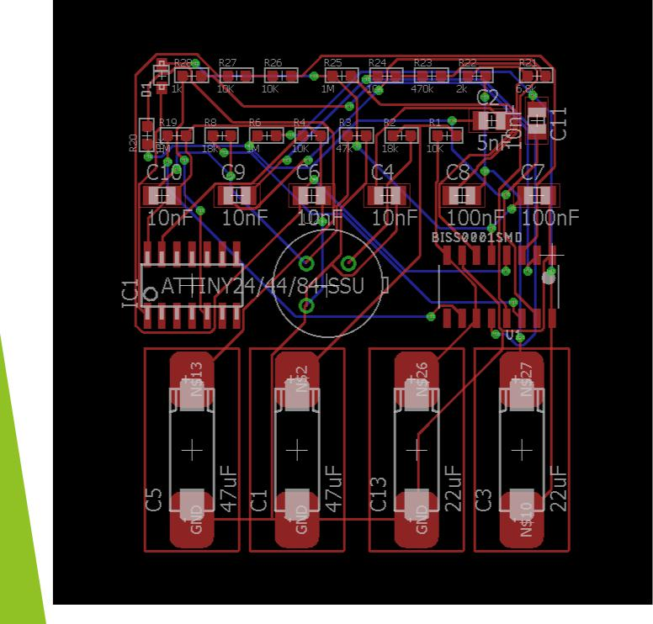

PCB design of ETUM

ETUM PCB BOARD
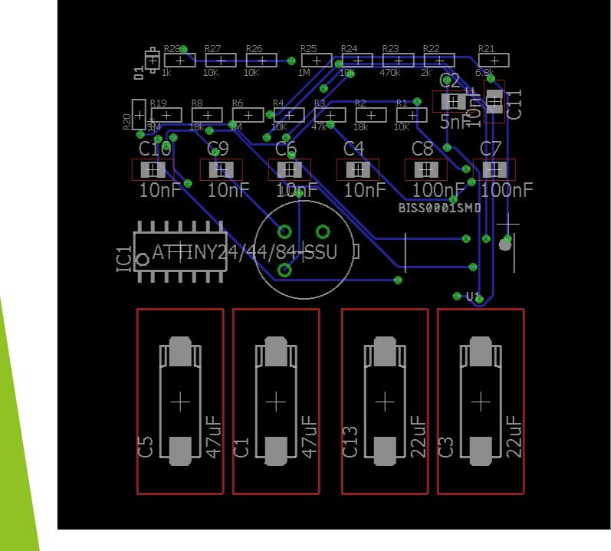

Bottom layer of PCB.

ETUM PCB BOARD
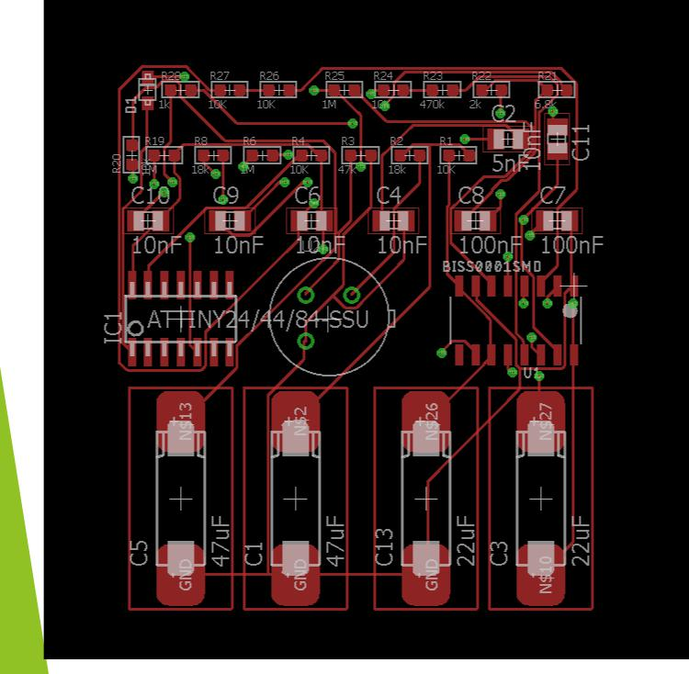

Top layer of PCB

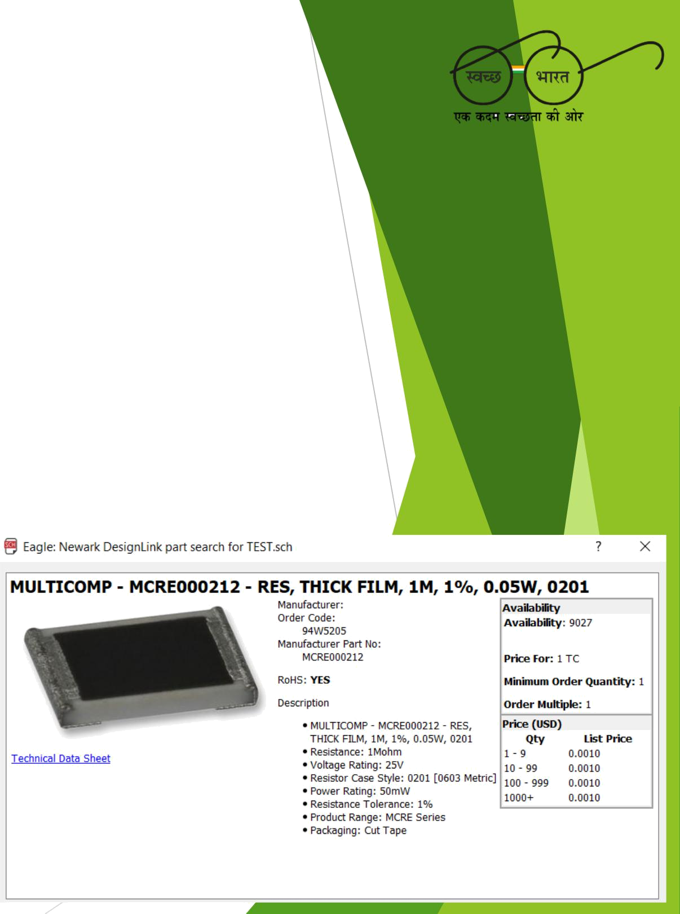
COST in ETUM manufacturing.
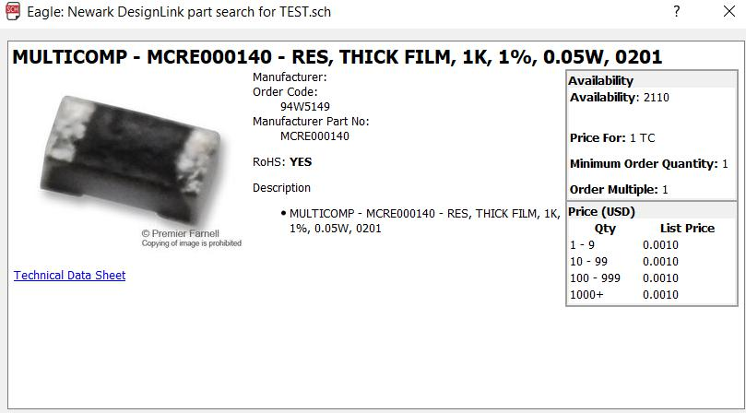

1K resistor cost= 0.001

1M resistor cost= 0.001

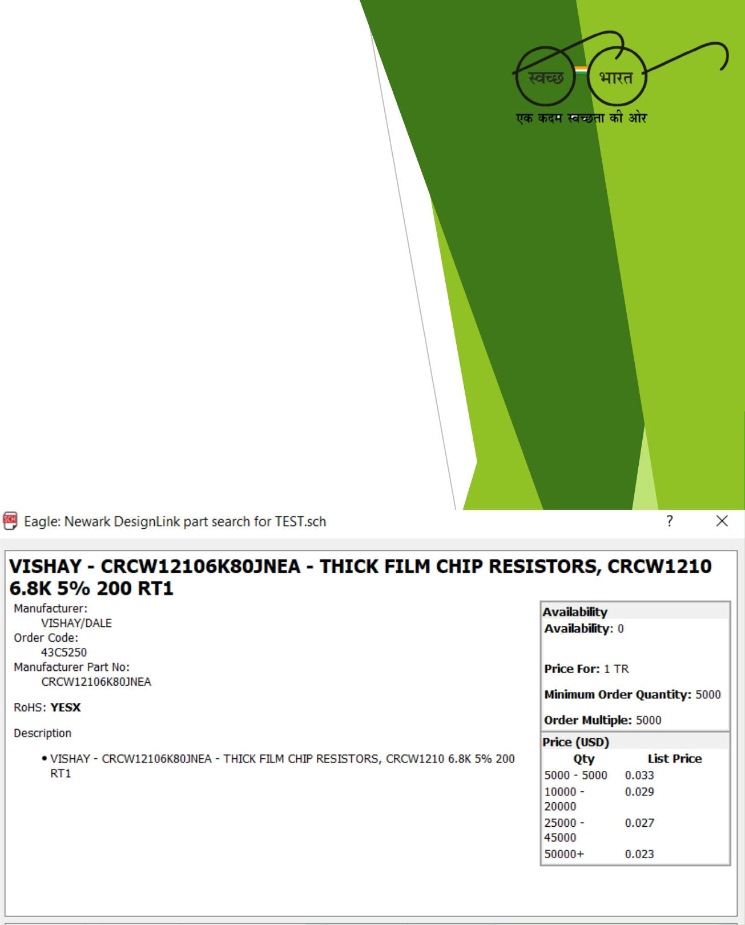
COST in ETUM manufacturing.
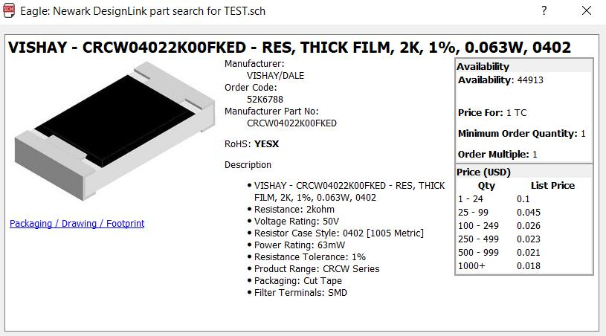

2K resistor cost=

0.018

6.8K resistor cost= 0.023

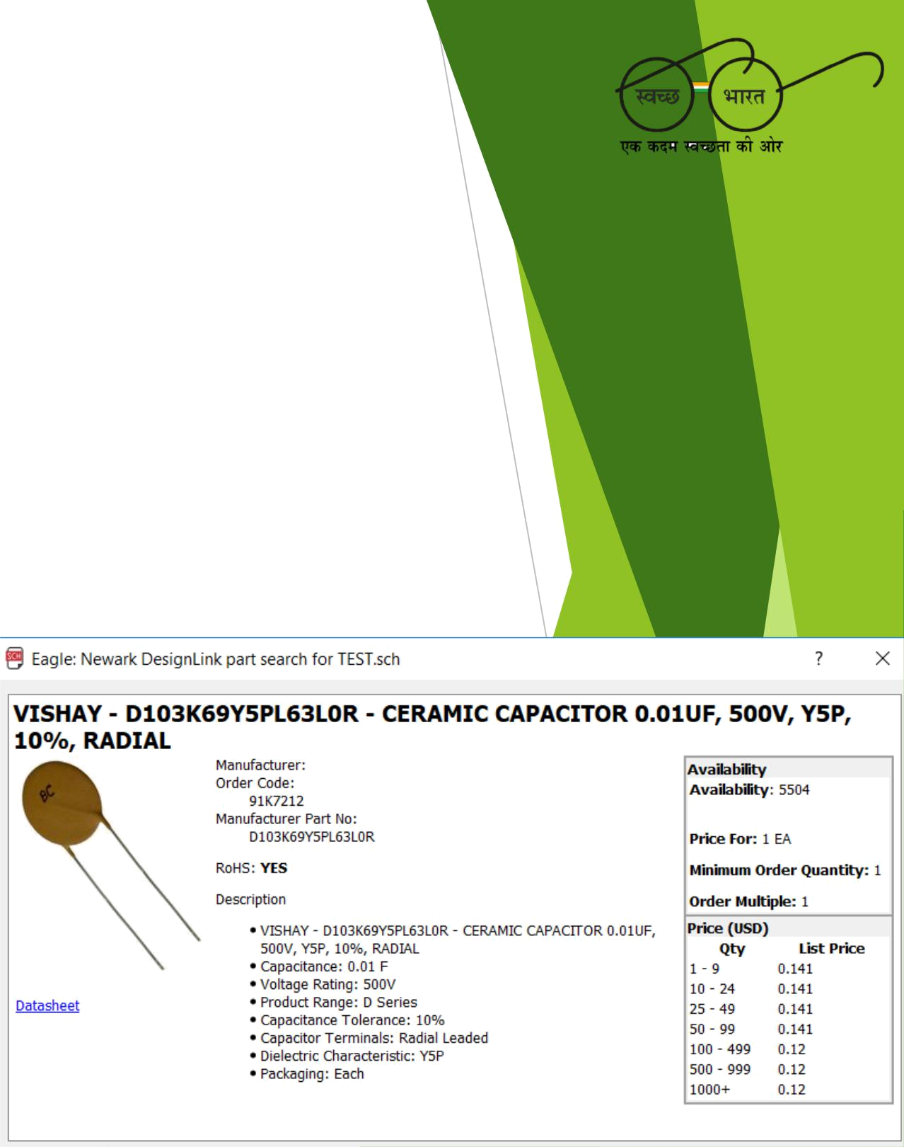
COST in ETUM manufacturing.
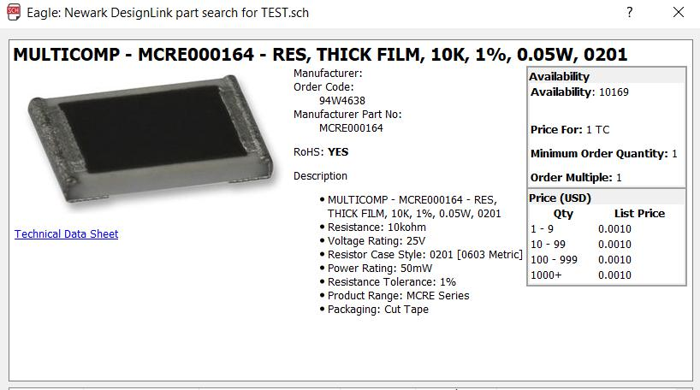

10K resistor cost= 0.001

0.01uF capacitor cost= 0.12

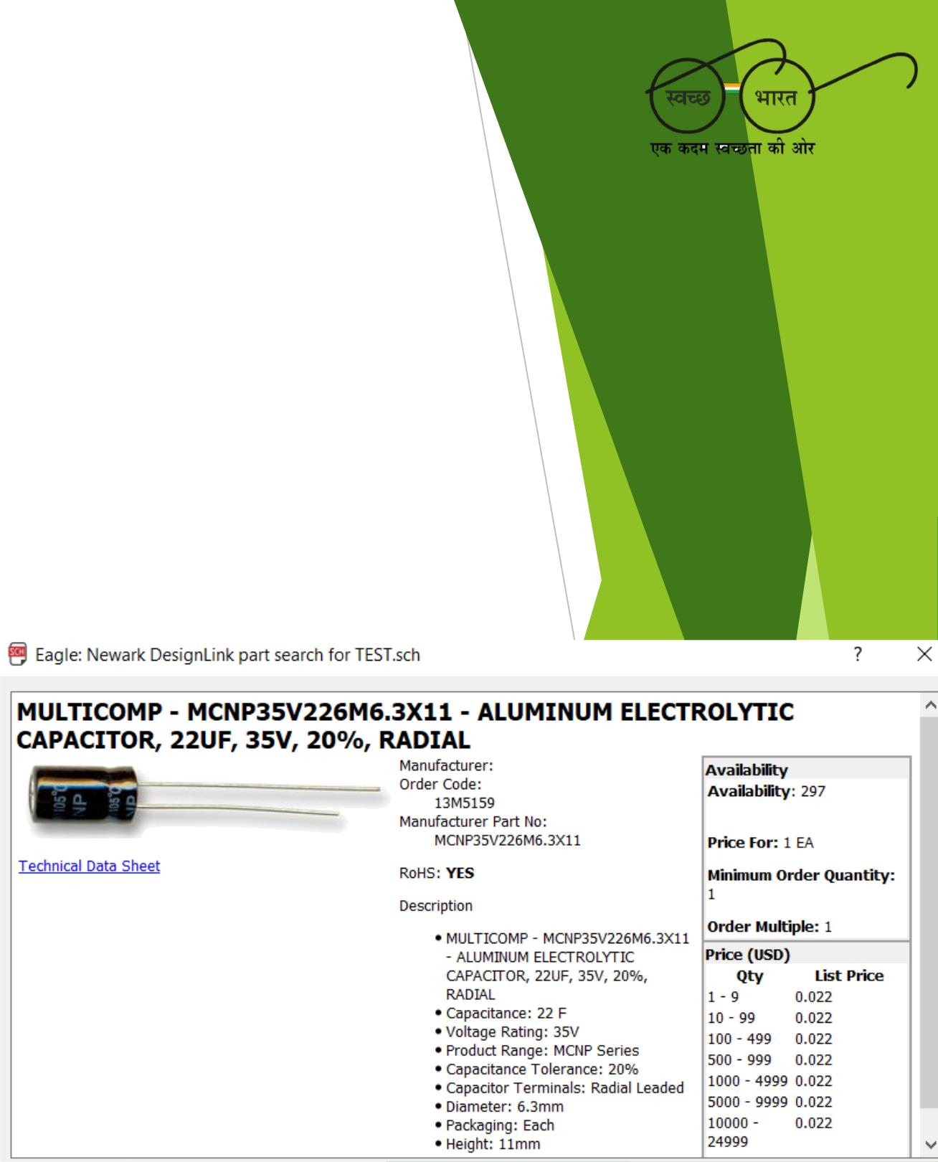
COST in ETUM manufacturing.
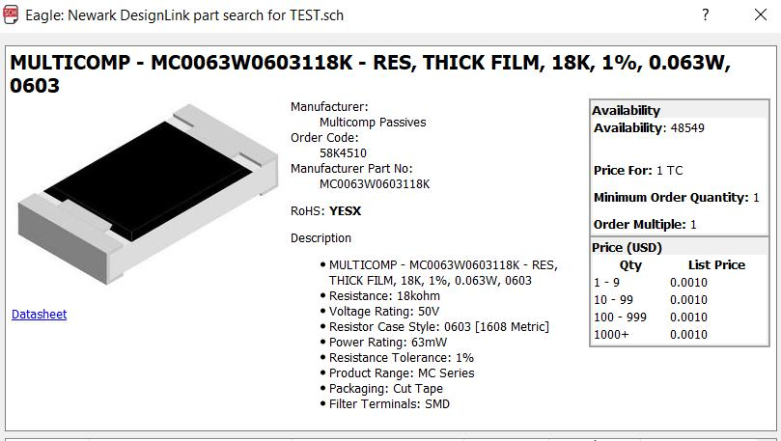

18K resistor cost= 0.001

22uF capacitor cost= 0.022

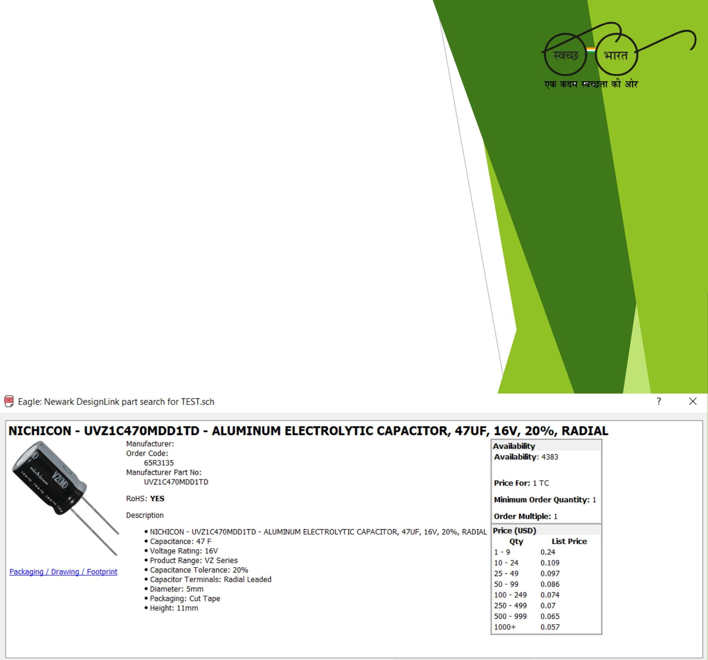
COST in ETUM manufacturing.
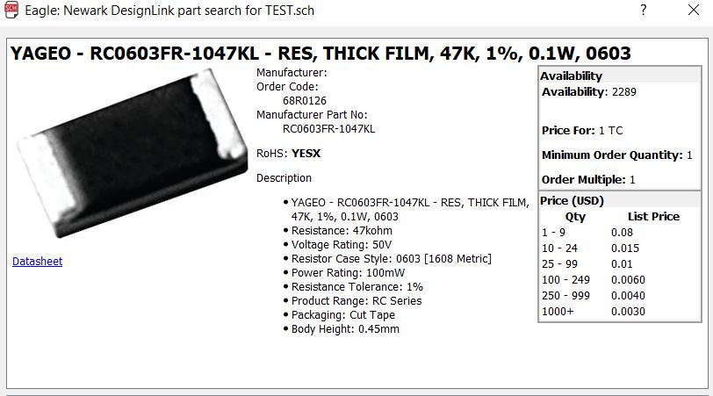

47K resistor cost= 0.003

47uF capacitor cost= 0.057

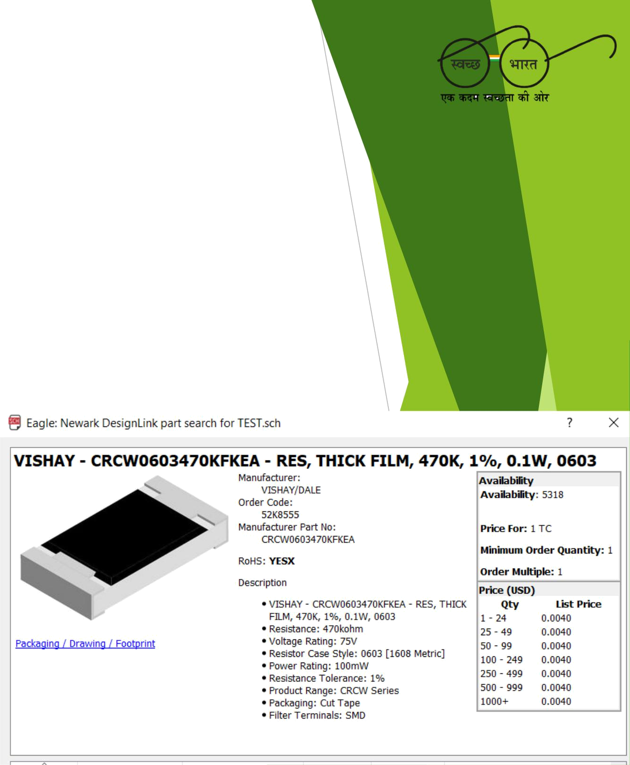
COST in ETUM manufacturing.
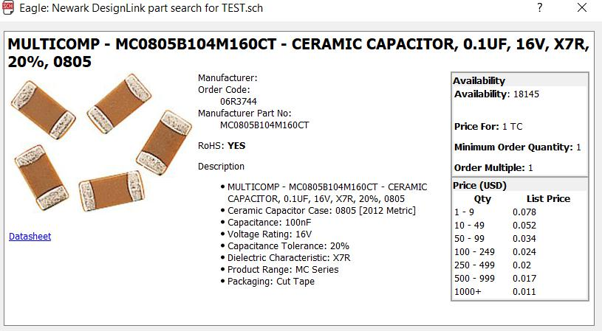

0.1uF capacitor cost= 0.001

470K resistor cost= 0.004

COST in ETUM manufacturing.

The link to the website we have referred to buy all these products mentioned above is given below:-www.newark.com

3000mAh Battery:-

"https://www.alibaba.com/product-detail/Full-Capacity-

original-lg-hg2-

3000mah_60503919326.html?spm=a2700.7724857.main07.2

07.2bd13975hQXAYq"

BISS0001 reference link to buy is:-

"https://www.aliexpress.com/item/BISS0001-smd-sop16-1000pcs-lot-sensors-

infrared-sensor-ic-Infrared-sensor-signal-processor-We-can-
offer/32624873306.html?spm=2114.search0301.4.62.xWAtZB"
ATTINY 24A(SSU) reference link to buy is:-

"https://l.facebook.com/l.php?u=http%3A%2F%2Fwww.microchipdirect.com%2FProductDetails

.aspx%3FCategory%3DATtiny24A&h=ATM6nKvu_pvcbGFTBmuNRUAGByPMpY_M7hWHq2KqCkus7r

TcDcn-

Xq5z2nCcVwqAmaUceGNCP1VwTRRyCmDyiaobLr_Lu3gfhr_9g98PFVk_CxLnTwbSWmDfCHd6nc3a

oxv1tuG0jaGUyg"

PIR sensor:-

"https://www.alibaba.com/product-detail/types-of-pir-sensor-pir-

sensor_60528709780.html?spm=a2700.7724857.main07.22.2bd1397500RBvO"
ETUM

How far we have reached?

ETUM is designed to detect human presence in a range of about 1m.

For toilet usage monitoring, it is an optimum amount of distance to be measured. The battery life of the device is about 5 months. To minimize the operating cost,

We have used a 2400mAh battery, but if we want to increase the battery life of the device, A higher mAh battery can be used (which will increase the cost).
For toilet usage monitoring, ETUM is a perfect device as 5 months is enough to determine how much the toilet is being used regularly and the future predictions can be made easily.
ETUM


We have a goal to make ETUM more efficient, accurate and cost-efficient. We will work further to increase The battery life and durability of the device and make it optimum for monitoring toilet usage.

Under proper guidance and with the help of the best minds of India, we have a goal to install ETUM in each and every Indian house. Swachh Bharat Abhiyaan, an initiative by Respectful PM Narendra Modi, has to be taken seriously for a clean and beautiful India. And using the best minds of the country in this is the need of the hour.

ETUM

- Link to the SolidWorks file, PCB design, ATtiny24A Code and other data is given below:-

https://drive.google.com/drive/folders/0B7fBHyx3akR_MkswR0VGWkpjUFk?usp=sharing

TEAM MEMBERS


Utkarsh Deepak Nitin Yadav
_{utkarsh230897@gmail.com} yadav.nitin558@gmail.com

Electronics, ATtiny24A code Electronics,PCB


THANK YOU!

