TEST 1 : test with single user only as could not create users on Humboldt server yet.

Number of Threads : 20

Ramp-up : 1 sec

Loop Count : 1

* all the failures are because of error between some proxy and ambari-server.
* Ambari server sends the data but proxy does not treats it as legal and reports error to the jmeter
* there were no errors in the ambari server logs.
* all the jobs successed from ambari side
* all the jobs succeeded in yarn cluster. (checked from yarn ui)

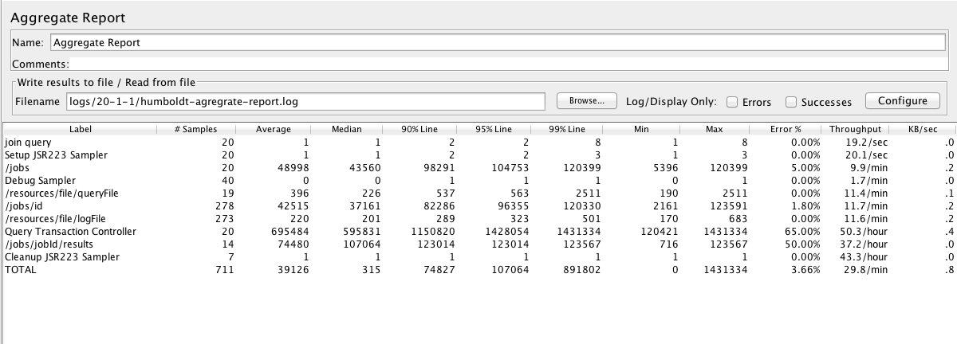

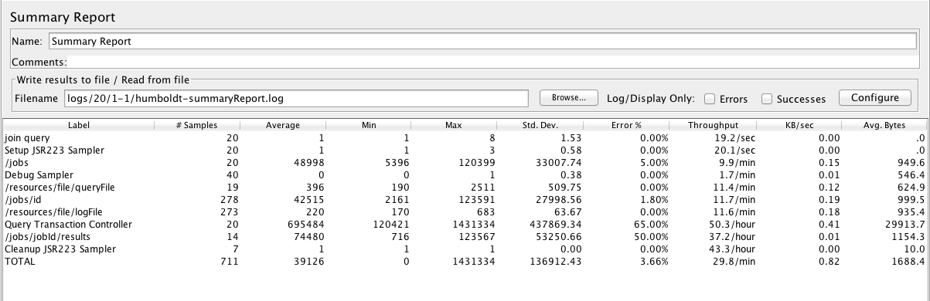

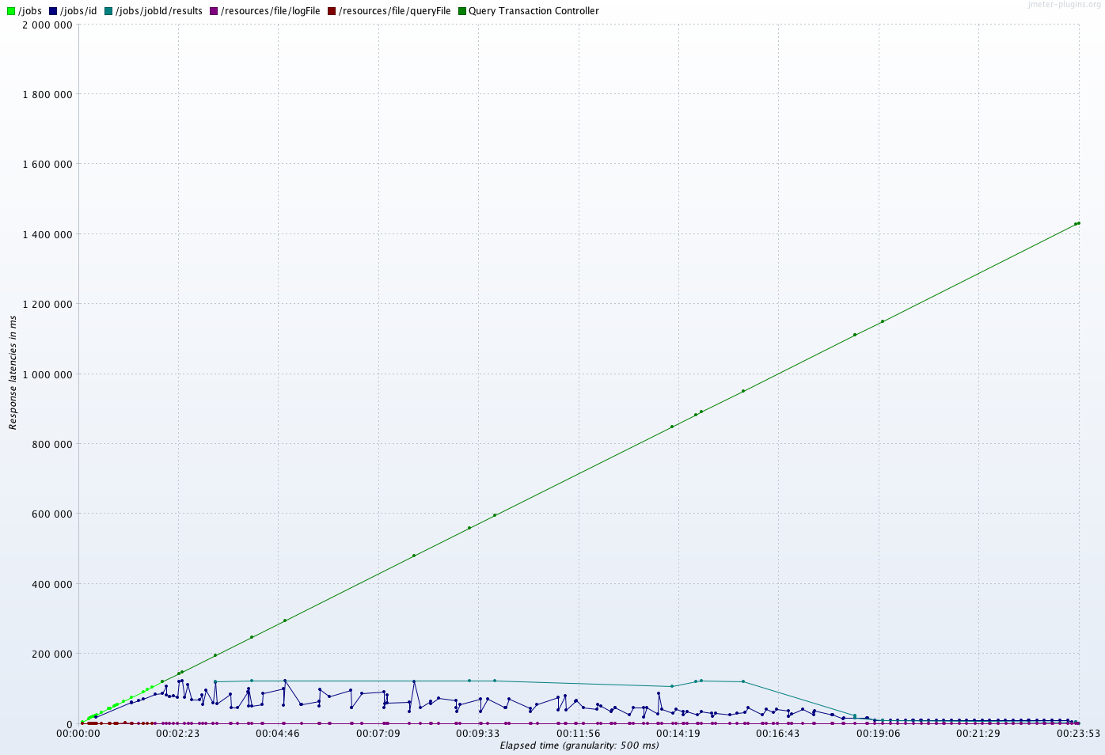

Below is the error that appeared for all the failures in Jmeter

ERROR1:

<!DOCTYPE html PUBLIC "-//W3C//DTD XHTML 1.0 Strict//EN" "http://www.w3.org/TR/xhtml1/DTD/xhtml1-strict.dtd">

<html xmlns="http://www.w3.org/1999/xhtml">

<head>

<meta http-equiv="Content-Type" content="text/html; charset=iso-8859-1"/>

<title>502 - Web server received an invalid response while acting as a gateway or proxy server.</title>

<style type="text/css">

<!--

body{margin:0;font-size:.7em;font-family:Verdana, Arial, Helvetica, sans-serif;background:#EEEEEE;}

fieldset{padding:0 15px 10px 15px;}

h1{font-size:2.4em;margin:0;color:#FFF;}

h2{font-size:1.7em;margin:0;color:#CC0000;}

h3{font-size:1.2em;margin:10px 0 0 0;color:#000000;}

#header{width:96%;margin:0 0 0 0;padding:6px 2% 6px 2%;font-family:"trebuchet MS", Verdana, sans-serif;color:#FFF;

background-color:#555555;}

#content{margin:0 0 0 2%;position:relative;}

.content-container{background:#FFF;width:96%;margin-top:8px;padding:10px;position:relative;}

-->

</style>

</head>

<body>

<div id="header"><h1>Server Error</h1></div>

<div id="content">

<div class="content-container"><fieldset>

<h2>502 - Web server received an invalid response while acting as a gateway or proxy server.</h2>

<h3>There is a problem with the page you are looking for, and it cannot be displayed. When the Web server (while acting as a gateway or proxy) contacted the upstream content server, it received an invalid response from the content server.</h3>

</fieldset></div>

</div>

</body>

</html>