**Test Description**: Hive view test for opening of hive view page.

**Test Info**:

Number of Threads: 30

Ramp-up: 10 sec

Loop Count: 1

**Cluster Information:**

Medium size (5 node) standard cluster on openstack.

**Hive Information:**

Number of DBs: 1

Number of Tables in DB: 3

Number of UDFs: 0

Number of Saved queries: 0

**Results:**

* No errors were encountered in jmeter.
* There were no errors in the ambari server logs.

1. Graph: 30-10-1-open-hive-view-details

Graph is plotted with Response Latencies in milliseconds on Y-axis and Elapsed time on X-axis.

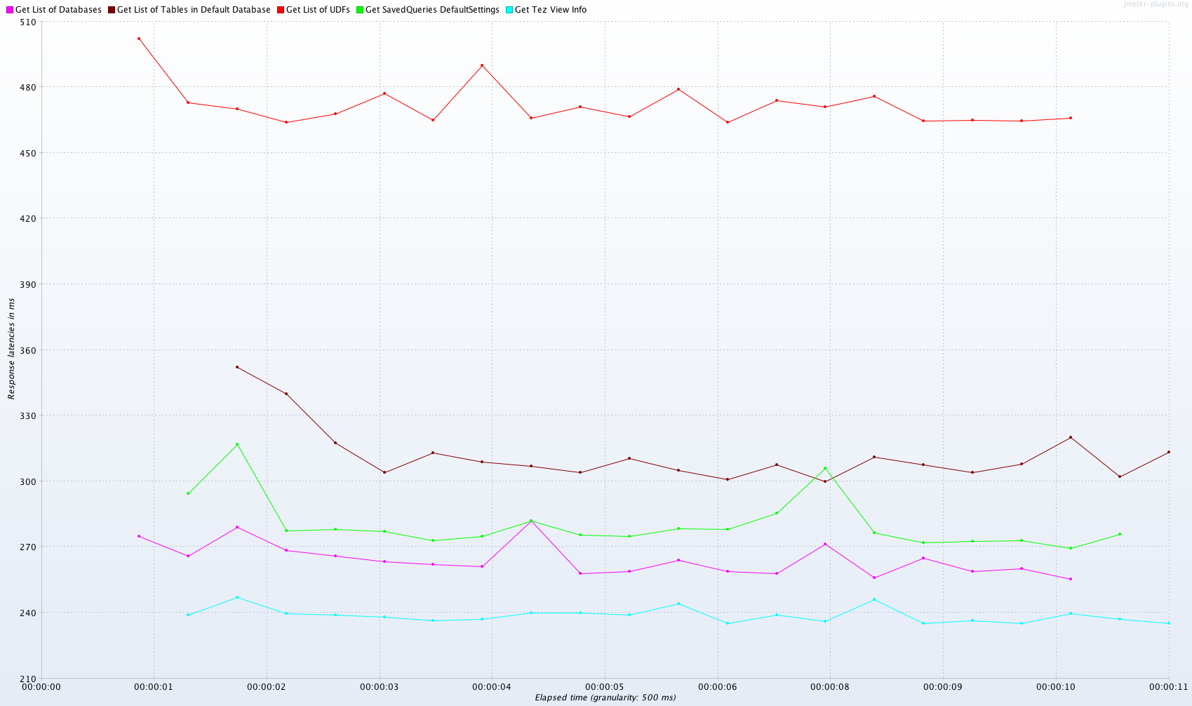

1. Graph: aggregrate_graph-30-10-1-open-hive-view.png

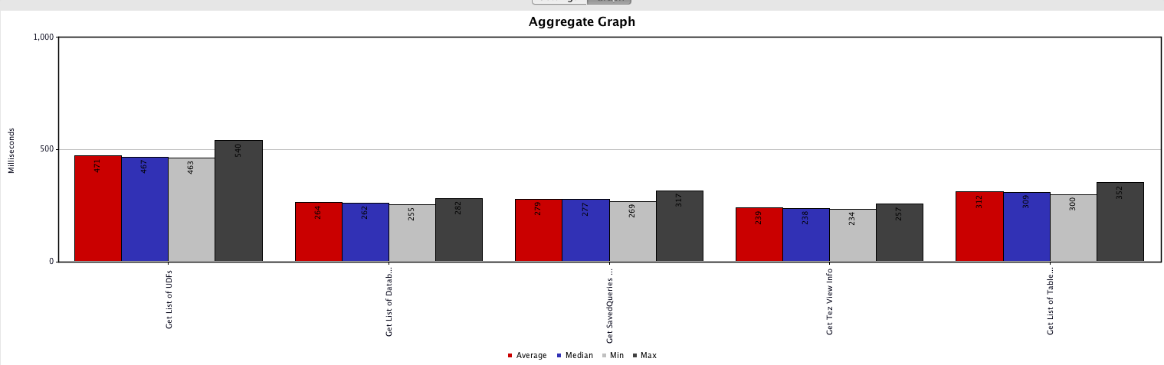

1. Table: aggregate_report-30-10-1-open-hive-view.png

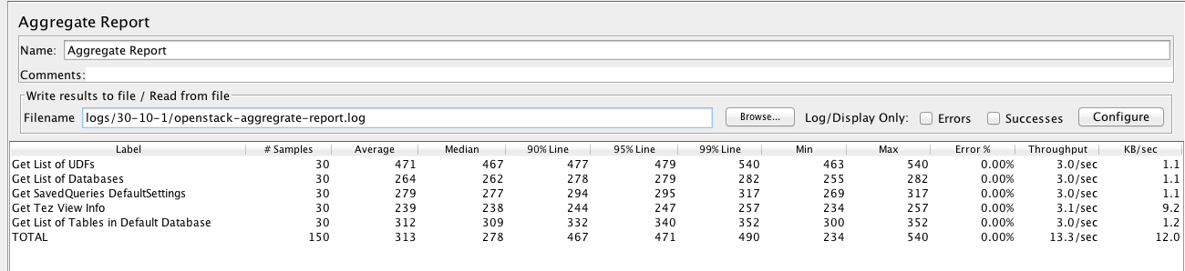

1. Table: summary_report-30-10-1-open-hive-view.png

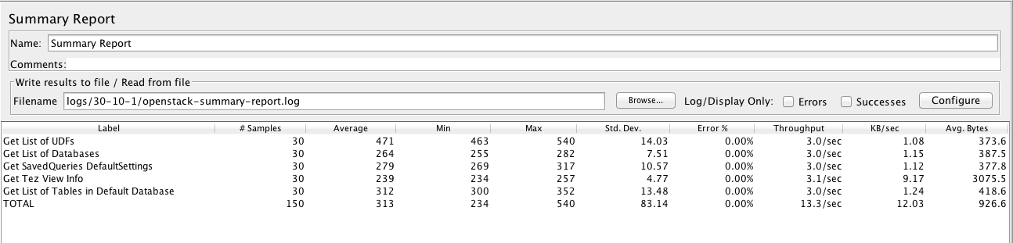

Details of Test:

30 threads were spawned. Each thread corresponds to a browser session of different user. In each session below the hive view page is opened 1 time.