**APPLICATION WORK FLOW**

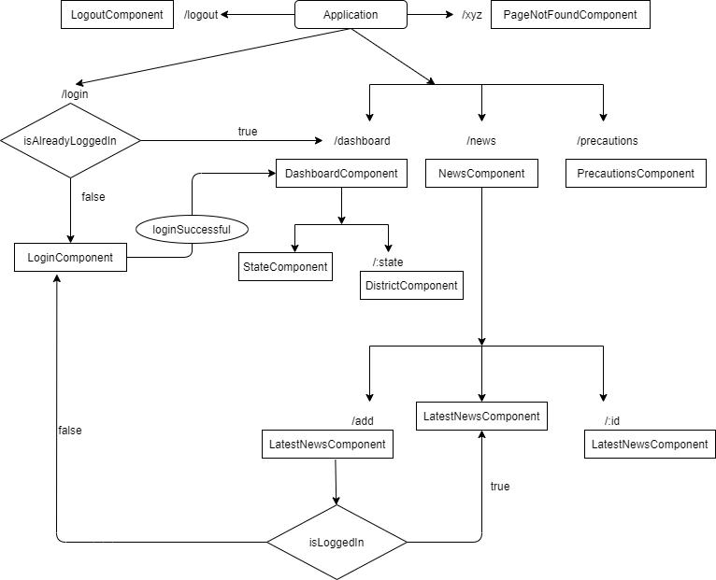

Application has three sections:

* Header: Appear on top on all pages. It consist of tabs and profile section. Tabs will be highlighted depending on route.
* Outlet: Depending on different route, page content will be loaded in this section between header and footer.
* Footer: Always appear on the bottom of browser window.

Header has three tabs:

* Dashboard: Dashboard has further two sections
  + *State Wise Data*: consist of state data. **Hovering** on state name will highlight the **background** with **blue** color and **clicking** on particular state cell will redirect user to **district** page.

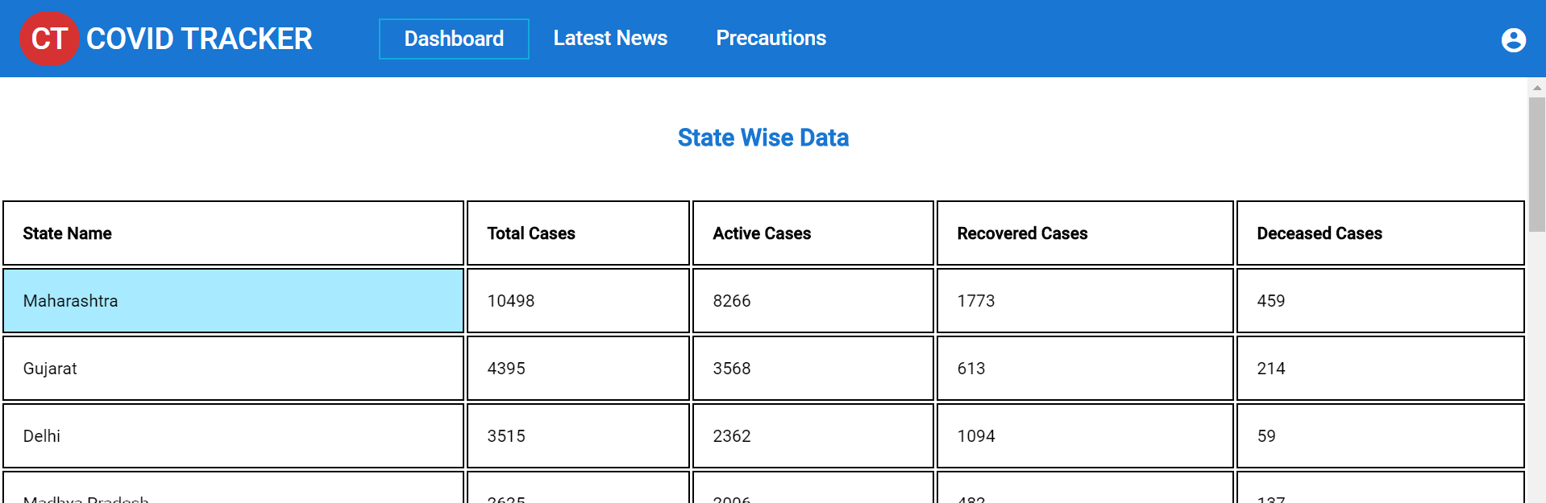

* + *District Wise Data*: consist of particular state data, district wise and has **back** button at bottom which redirect back to state data.
* Latest News: Latest News showing cards of news with **latest** one **first.** One new has been added as default which appear on this page initially.Latest News consist of two sections:
  + *Full News:* clicking on full news article will redirect the user to a page that has **full article** related to particular **news id**.

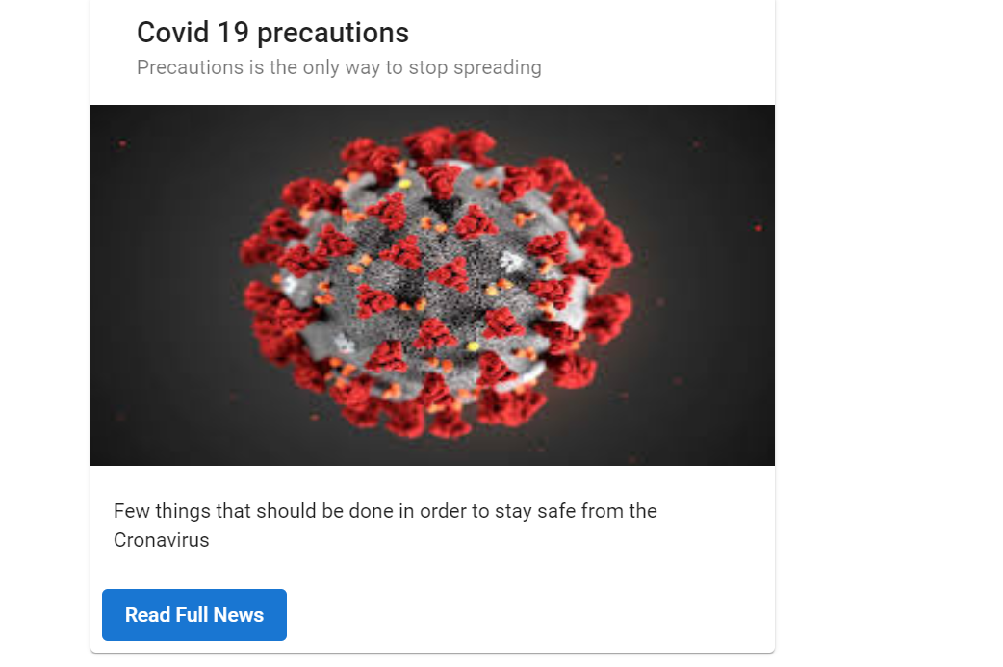

* + *Add News:* This is a **button** that will appear on the top right corner after **login** only. Clicking on button will redirect user to add news form page and has action to **save** and **cancel** the news. Saving on news will be redirect to latest news page and recently added news will appear **first** in list.

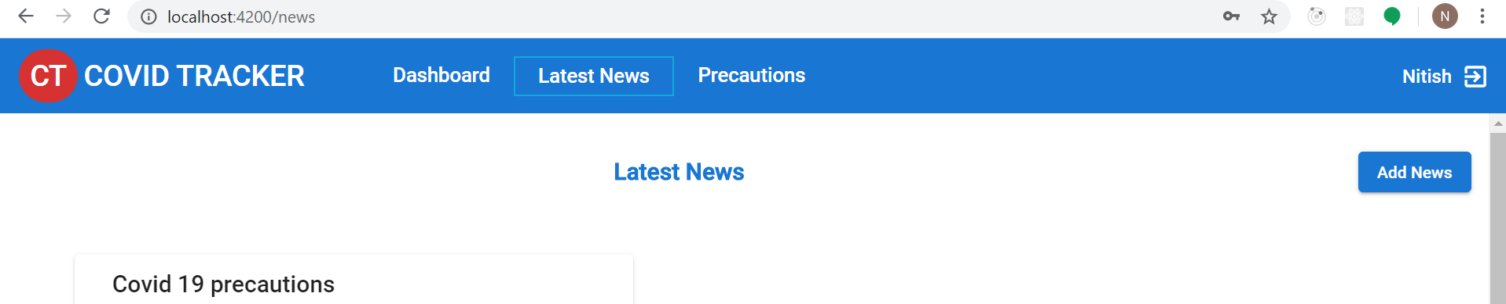

* Precautions: Precautions page consist of precautionary measure that every one should follow. It consist of **static** data.

Profile Section:

* Profile section appear on **top right** corner in header. Initially, it has icon clicking on which redirect to login page.
* After **successful** login, user will be redirected on dashboard page. Add News icon will also appear in latest news page.
* On clicking **logout** icon, user will be redirected to **Logout page** and has action for **login again** and go to **dashboard**.



Loader:

Application has loader, which appear above the header on hitting any http request.

Gaurds:

If user is already logged in and user try to hit the login url, user will be redirected to dashboard page, with message “already logged in” – LoginRouteGaurd

If user is not logged in and try to hit the url of adding news, user will be redirected to login page with message “please login to continue” – AuthGaurd

Credentials

Application can be logged in with any of two credentials below:

* Username – nitish

Password – nitish

* Username – tarun

Password – Tarun

Assumptions:

* Add news button will only appear after login on latest news page.
* User can hit the url directly of reading full news directly, that’s why hitting the api for getting the news with particular id.