Written Report on the System

@NITISH_APP.route('/SignIn', methods=['GET', 'POST']) This route handles the registration of a new user (patient, provider, or nurse). When a POST request is received, the user's information is extracted from the form data and stored in variables. Then, a connection is established with the MySQL database using the mysql.connector module. Based on the user type, a stored procedure is called to insert the user's information into the corresponding table in the database. Before inserting, the code checks if a user with the same ID already exists and returns an error message if so. If the insertion is successful, the user is redirected to the login page. If there is an error in the process, an error message is printed to the console. If the request method is GET, the user is directed to the registration page (SignIn.html).

@NITISH_APP.route('/login', methods=['GET', 'POST']) This route handles the login of an existing user. When a POST request is received, the user's email, password, and user type are extracted from the form data and stored in variables. A connection is established with the MySQL database using the mysql.connector module, and a SELECT query is executed to check if there is a match between the user's email, password, and user type in the database. If a match is found, the user is redirected to the appropriate page based on their user type (patient, provider, or nurse). If there is no match, the user is redirected back to the login page with an error message. If the request method is GET, the user is directed to the login page (login.html).

/logout: This route logs out the user by clearing their session and redirecting them to the login page.

* Run the database FinalOne.sql and also the stored procedures, audit tables and triggers, indexes to create the respective tables.
* Now install python, pip, flask and update the environmental variables.
* And run the NITIH_APP.py in the cmd prompt or in the python IDLE  
    
  This is a development server. Do not use it in a production deployment. Use a production WSGI server instead.[0m
* * Running on http://127.0.0.1:5000

In my system it is running on the local host 5000 port.

Run in in the website

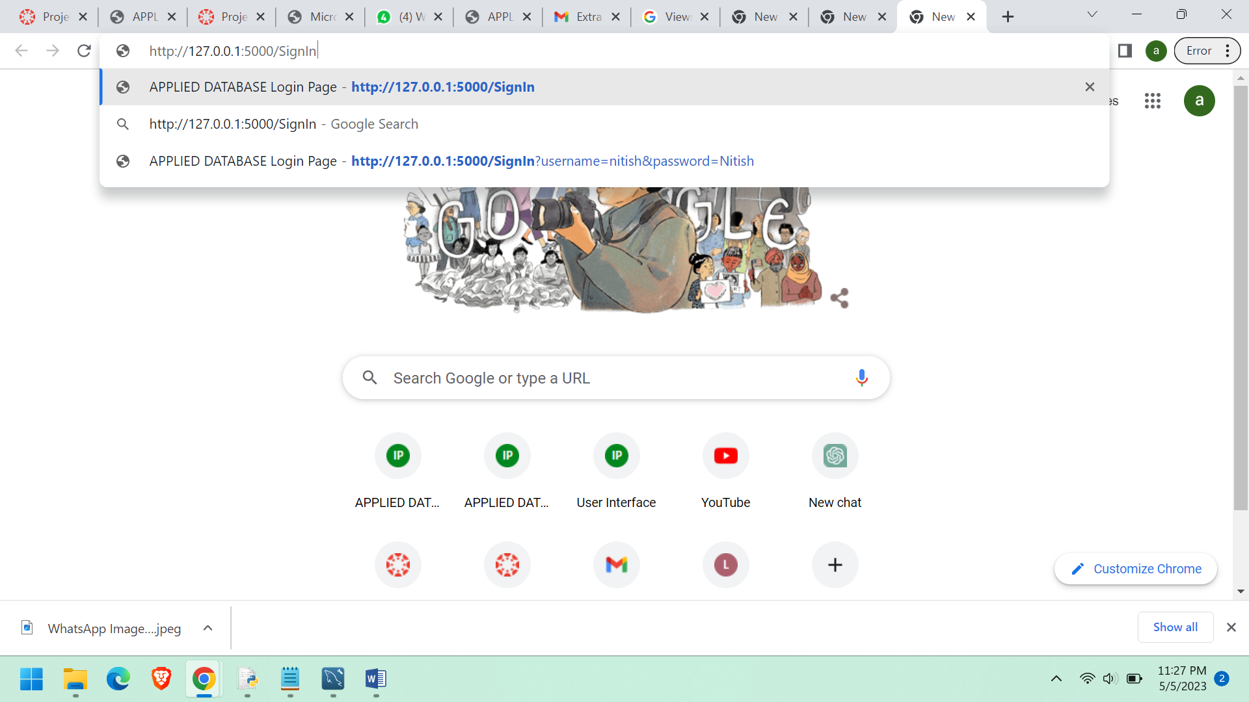

You can explore it as mentioned in the project report.

I have the following web pages.

Login.html

SignIn.html

UserInterface.html

UpdateDetails.html.