**System Analysis And Design Project**

**Submitted To:**

Dr. Anurag Shrivastava

(Faculty In- charge)

**Submitted By:**

Vishwa Prakash Gayasen – 2009IPG-95

Ravikiran Sahajan – 2009IPG-97

Neha Rajput – 2009IPG-117

Nitish Bhardwaj – 2009IPG-118

# System Analysis and Design

# Introduction:

Digitalization of Application system and related database management in the academic institutes.

This includes digital form processing of various forms such as

*Leave Application Form

*Travel Request Form

*Paper-sponsor Form For Faculty,

*Store requisition form  
* Photocopy Requisition Form   
* Indent cum Administrative Approval Sheet   
* Local Conveyance Form   
* Travelling Allowance Bill for Outstation Tours   
* Change in Home Town Address   
* Mediclaim Format  
* Performa for financial assistance for presentation of paper -faculty  
* Performa for attendance in conferences  
* Format for Upload of Information on Institute Website  
* Requisition for Vehicle   
* Requisition for Advance  
* Requisition for Reimbursement  
* Request for Cancellation of Admission  
* Settlement of Advance  
* Undertaking for Abroad Visit

In the present scenario, IT is the key to digitalization of data processing and management. This offers us faster updating, manipulation and interpretation of data and help extract some meaningful information from it. This also enables proper utilization of resources and tracking of the current statistics.

***Considering the current scenario of application system in our institute, form processing is still based on “paper and pen”*** which is very obsolete and time taking for the students, faculties and other staffs of the institute and extracting information from this for future use or further reference is very difficult.

***In this software, we are developing an online form processing system***. In this system, there will be pre-filled data in the form which will save our precious time. This will ***also keep records of the data and maintain database and help interpret data using pie-charts and graphs.***

***This shall also include the process of Feed Back submission by the students*** which now uses a lot of paper and the student’s time and peace of mind during the examination. This will also provide a proper platform for the analysis of the Feedbacks and other data like Leave management, Sponsored activities and their progress etc.

# Stakeholders:

The faculty, students and other staff will benefit from this system as an applicant and the administration of the institute would also benefit from this system in terms of data maintenance and analysis.

# Users:

* Administrators
* Faculties
* Students
* Other Staffs

# Approach:

**FORM PROCESSING:**

All the forms and application will be processed online through web portal . The applicant will login to his/her account and fill the form online. All the personal details and information such as name, post, will be *pre filled* and no printing of forms is required thus saving a lot of time. As the form is being digitally processed, this will also reduce paperwork thus making it an eco-friendly system. This form will be sent to the respective administrators, who will verify the data and process the form and approve or reject the forms. If the administrator rejects a form, a rejection notification is sent to the applicant. In case of approval ,a PDF will be generated at the administrator’s end. The applicant will be notified that approval letter can be obtained from administrator.

**DATA ABSTRACTION/INTERPRETATION:**

All the details obtained from the form will be stored in the database. Data can be interpreted and visualized graphically in the form of pie, graph etc. by Administrative bodies. This will enable administration to keep a track of the activities of all members of institute and derive conclusions from the data.

# Tools to be used:

**SERVER-SIDE SCRIPTING:** PHP(Hypertext Preprocessor)

**DATABASE HANDLING :** MySQL(Structured Query Language)

**CLIENT-SIDE SCRIPTING :** HTML(Hyper Text Markup Language)

Javascript

# Conclusion:

Implementation of this software will bring about the following changes in the present system

* Pre filled application forms
* Online form processing
* Data analysis E.g. Leave management module, Records of allowances given, Records of sponsored papers and their status (published/unpublished) etc.

Thus it makes the process of application submission an easier process for the applicants and helps the administrative bodies by keeping proper records of all the data from the form submissions and providing a platform to analyze and interpret this data for future reference and planning purposes. This can also help in studying the behavioral patterns of the staff as well as students in many regards. So it not only benefits the finance administration part but also in the constructive planning of the institute’s future policies and activities.

**WORKING:**

The working of this software is quite simple and user friendly .it makes the form filling so easy for all user that they do not have to get it printed and run to different people in authority from one place to another to get there form accepted. This application includes all kind of forms be it a leave form or a reimbursement form or any other form when the whole the thing will get automated then there will be no need of taking headache of getting the form accepted. Moreover, it will also create transparency in the system that the forms will get accepted or rejected on the basis of the information analaysed properly and can be reviewed anytime afterwards as it gets stored in the database every time you submit a form.

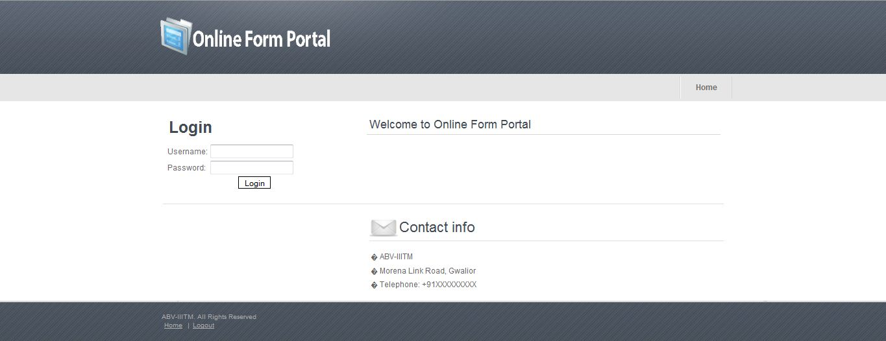

**ADMINSTRATOR:-**

* He generates forms according to the needs of the institutions.

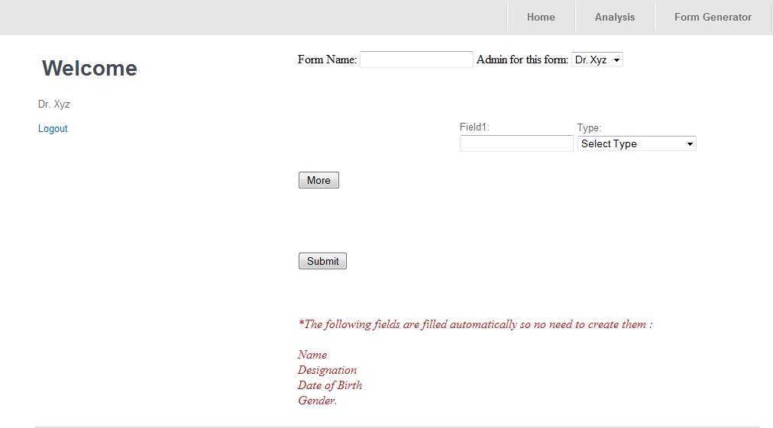

* While generating the form he marks up the field, which are necessary for analyzing the form.
* Whenever a user submits a form it directly goes to the administrator, where he maintains the list of the pending forms.

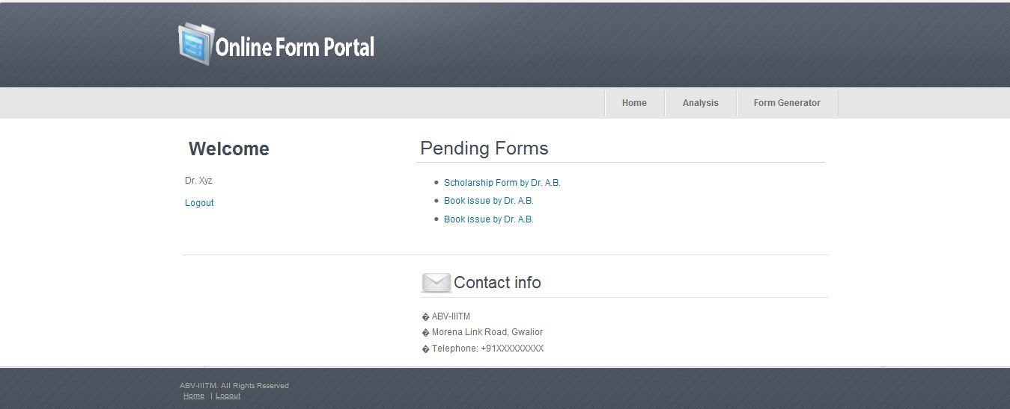

* He can view the analysis of the form data submitted by all on the basis of the field selected while form generation.

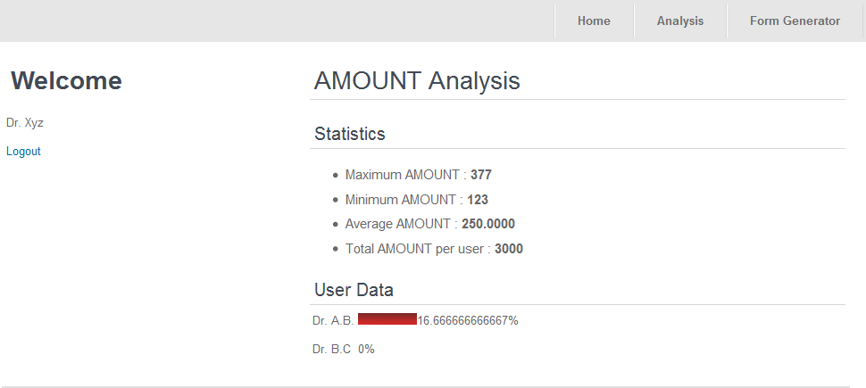

* He can either reject or accept the form on the basis of the analyzed information.

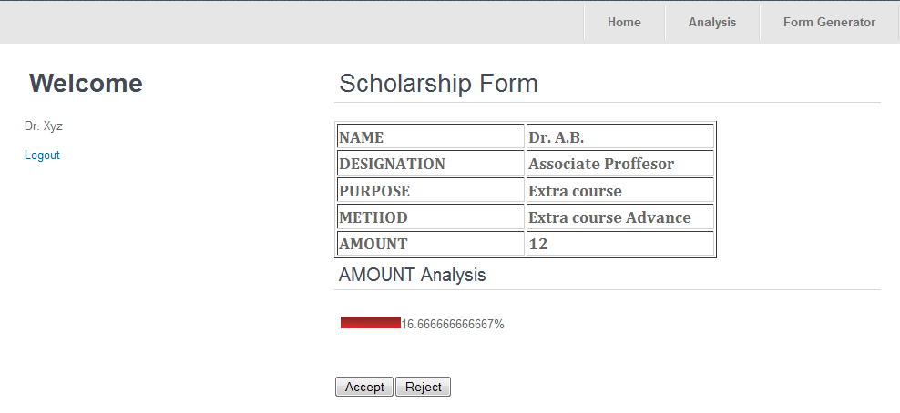

* Accepted Forms will be available in the pdf form for printout

**USER:-**

* He can see the links of different forms on the home page.

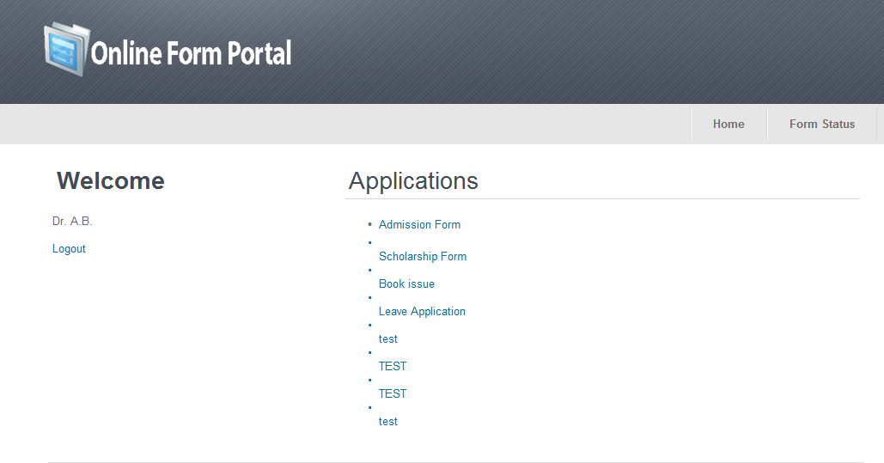

* He just has to click and select the required form from there.
* When he click on some form the required structure gets picked up from database and is shown to the user.

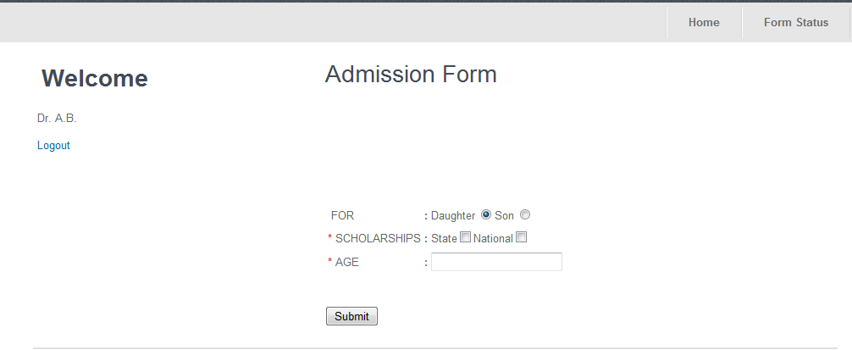

* He will get notified on the basis of whether his form has got selected or not by mail as well as on the Form Status Page.

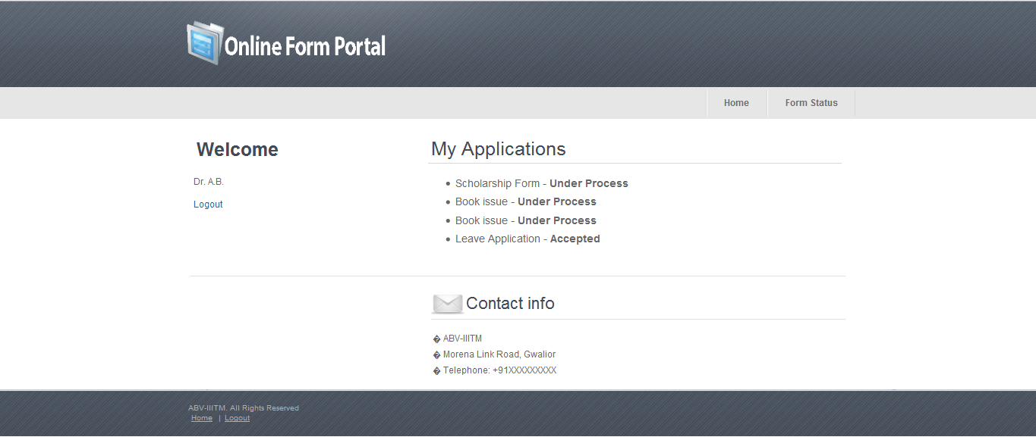

**USER'S GUIDE:-**

* When you open the home page you can see different form links there.
* You just have to select the form link based on your requirement.
* Then you have to fill the information asked in the form.
* Do not forget to fill to the mandatory fields because until and unless you fill these fields, your form will not get selected.
* After the action have been taken on your form by the administration you will get a notification that whether your form is accepted or rejected.