Nitish kumar m
6B
bda lab
cassandra
Program 1. Perform the following DB operations using Cassandra.

1. Create a key space by name Employee.

2. Create a column family by name Employee-Info with attributes Emp_Id Primary Key, Emp_Name, Designation, Date_of_Joining, Salary, Dept_Name.

3. Insert the values into the table in batch.

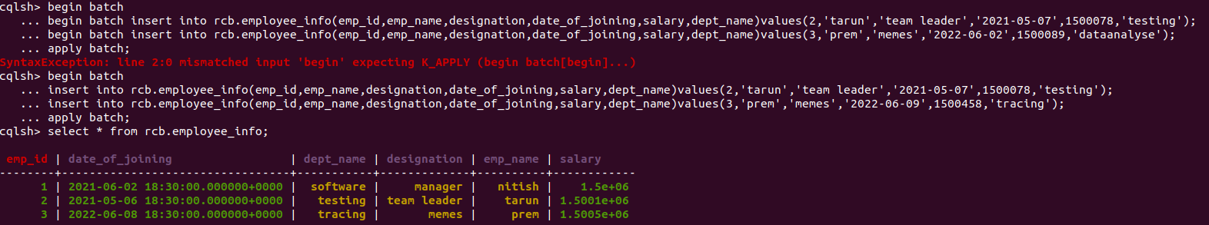

4. Update Employee name and Department of Emp-Id 2.
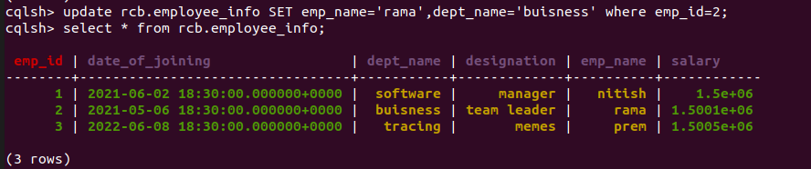

5. Sort the details of Employee records based on salary.

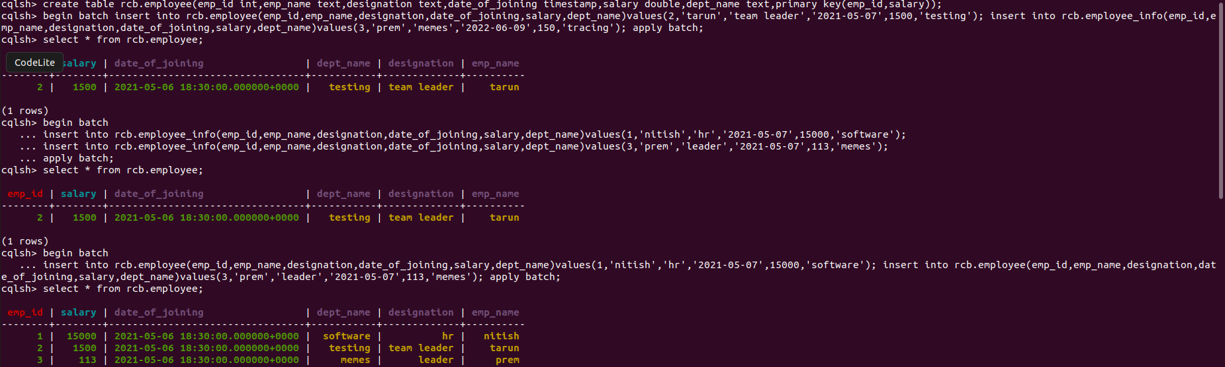
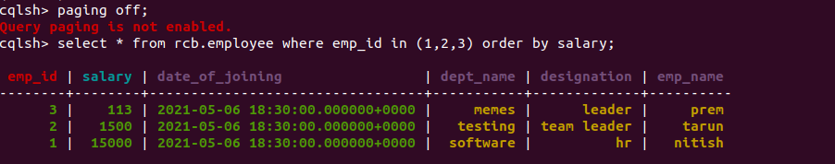

6. Alter the schema of the table Employee_Info to add a column Projects which stores a set of Projects done by the corresponding Employee.

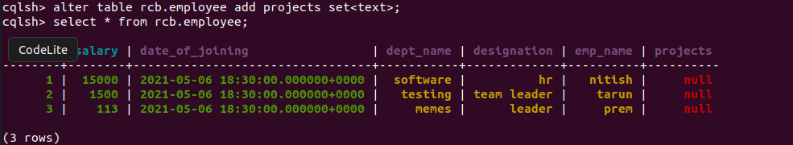
7. Update the altered table to add project names.

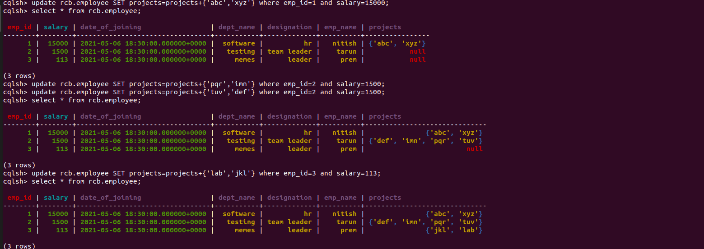
8 Create a TTL of 15 seconds to display the values of Employees.

