CS3235 Course Project — Requirements Document Template
Working with Large Language Models (LLMs) · Version 1.0 · September 2026

1. Project overview
Field | Details
Project title | KaushalDub: Regional-Language Skill Video Tutor
Team ID | [e.g. T07]
Team members (name, roll no., role) | [Name — Roll no. — e.g. LLM/prompt lead, backend, evaluation, UI]
Faculty mentor | [Name]
Primary course module | 3 Multimodal (video, speech and language)
Version / date | v0.1, 23-10-2026

Problem statement (3–5 sentences):
Vocational skills such as tailoring, welding, wiring and plumbing are mostly taught through short demonstration videos, and most of these are in English or Hindi. Learners who speak Kannada, Telugu or another regional language struggle to follow the fast, unstructured steps and cannot jump back to a particular step or check their understanding. Manual subtitling and dubbing of every video is slow and expensive, and generic auto-captioning only transcribes speech. It misses silent or lightly narrated demonstrations, ignores what is happening visually, and does not preserve the order of steps. As a result, learners in regional-language communities have little accessible, structured training material.

Why an LLM?
The step detection is a vision problem, and the CNN-LSTM with few-shot recognition handles it, because an LLM cannot reliably tell what action is happening in raw frames. The LLM is needed for the language work that follows, which rules and classical ML do not do well:
- Fusing messy inputs into clear instructions.
- Handling an open vocabulary.
- Producing natural regional-language narration.
- Generating quizzes.

“A regional-language video tutor that helps vocational learners understand short procedural demonstrations by using CNN-LSTM few-shot step recognition to detect steps in order, and an LLM to summarise, translate, narrate and quiz each step.”

2. Scope and users
In scope — what the finished system will do:
- Upload a short procedural video (up to 3 minutes) for one skill area and choose Kannada or Hindi.
- Detect the ordered steps with start and end times and a confidence score (CNN-LSTM, few-shot for new steps).
- Generate step instructions, translated captions and narration text; the trainer edits and approves.
- Produce a narrated video, a caption file and a quiz; add a new step type from about 5 example clips.
Out of scope — what you are deliberately not building this semester:
- Mobile app, voice cloning, lip-sync, live or real-time dubbing
- More than two languages; videos longer than 3 minutes
- Training or fine-tuning an LLM; skill areas beyond the one chosen domain
Target users
User type | What they need from the system | How they will interact (chat, API, CLI, web UI)
Vocational learner | Understand a demonstration in their own language, jump to a step, check understanding | Web UI on phone or laptop: watch with chapters, take quiz
Trainer / teacher | Upload a video, fix captions, publish a narrated version | Web UI: upload, review, publish
Annotator (team) | Label steps, add new step examples, review flagged steps | Web UI: labelling screen

Example user scenario: A trainer uploads a 90-second tailoring video and selects Kannada. The system detects five ordered steps with timestamps and confidence, transcribes the speech, and the LLM writes one instruction per step. IndicTrans2 and the LLM produce Kannada captions; step 3 is flagged at 58% confidence, so the trainer corrects it and approves. The system adds Kannada narration to the video and builds a quiz. The learner opens the link, jumps to a step from the chapter list and takes the quiz.

3. Functional requirements
List each thing the system must do as one testable statement. Priority uses MoSCoW: Must, Should, Could. Aim for 6–12 requirements, at least 4 of them Must.
ID | Requirement ("The system shall…") | Priority | How it will be verified
FR-1 | The system shall accept an uploaded video (mp4, up to 3 minutes) with a target language (Kannada or Hindi). | Must | Demo + 10 test uploads
FR-2 | The system shall detect the ordered steps in a video and return start time, end time, label and confidence for each; steps below 0.6 confidence shall be flagged. | Must | Step accuracy and boundary F1 on test clips
FR-3 | The system shall generate one instruction per detected step, with step count and order identical to the detected timeline. | Must | Automatic check on all test clips
FR-4 | The system shall produce captions in the target language that the trainer can edit and approve before publishing. | Must | Demo + chrF + native-speaker rating
FR-5 | The system shall produce a narrated video (target-language audio mixed in) and a .vtt caption file. | Must | Demo + narration fit rate
FR-6 | The system shall generate a quiz (5 multiple-choice questions and 1 step-ordering question) in the target language. | Should | 2 reviewers rate 30 questions
FR-7 | The system shall let a learner flag a wrong step and send it to the annotator queue. | Could | Demo
FR-8 | The system shall add a new step type from about 5 example clips. | Could | 5-shot accuracy on a held-out step

4. LLM design requirements
This section shows which course concepts your project applies. Fill every row; write "Not used — because …" where a technique does not apply.
Aspect | Your choice | Justification
Base model(s) | LLM: Gemini 2.5 Flash (hosted). Other models: Whisper small (speech), IndicTrans2 distilled 200M (translation), ResNet-50 + BiLSTM (steps). | A Flash-class model handles Kannada and Hindi, JSON output and image input at free-tier cost. Small open models fit CPU and T4 limits.
Access method | Hosted API for the LLM and TTS. Whisper, IndicTrans2 and the step recognizer run in our own container on CPU. Training on Colab/Kaggle T4. | No GPU budget for serving; free tiers. Only text and low-confidence keyframes leave the system.
Prompting strategy | Few-shot (2 examples) with structured JSON output and a fixed schema. Three prompts: step writer, narration rewrite, quiz. Temperature 0 (writer, narration), 0.3 (quiz). | Output must be machine-checkable so a validator can enforce step count and order.
Retrieval (RAG) | Not used. A trade-term glossary (about 100 terms) is added to the prompt by exact match. | All facts come from the uploaded video; there is no document collection to search. The glossary keeps terms consistent in Kannada and Hindi.
Fine-tuning | None for the LLM. Trained components: BiLSTM and few-shot head on frozen ResNet-50 features. | Prompting plus a validator meets the task; LLM fine-tuning needs GPU and data we do not have.
Agents and tools | Not used. Fixed pipeline; the LLM is called as a function at three points. | Step order must be preserved; an autonomous agent would add variation.
Protocols | Not used. | The backend calls the LLM API directly; no external tool servers.
Multimodal input | Audio: Whisper gives a timestamped transcript. Video: the trained recognizer reads frames; one keyframe per step below 0.6 confidence is sent to the LLM (image input) for a one-line description. | Many demos are silent, so vision is the source of truth for steps. The LLM only describes what the recognizer is unsure about.
Alignment and safety | System prompt: use only the supplied timeline and transcript; never add, drop or reorder steps; write "unclear" when unsure; add a safety note only if the source mentions it. Schema check, step-order validator, teacher approval before publishing, disclaimer for hazardous trades (welding, electrical). | Limits invented steps and unsafe advice; a human approves before learners see anything.

If you fine-tune with LoRA, show the trainable-parameter calculation for one adapted weight matrix of size d × k with rank r:
Trainable parameters = r × (d + k)
Not applicable: the LLM is not fine-tuned. The trained BiLSTM (input 2048, hidden 256, bidirectional) has about 4.7 M parameters plus a small linear head; ResNet-50 stays frozen.
LLM pipeline: Timeline JSON (step id, start, end, label, confidence) + aligned Whisper transcript + glossary terms → LLM call 1 (step writer, English JSON, one entry per step) → validator (step count and order must match the timeline; one retry, then template text) → IndicTrans2 (Kannada or Hindi) → LLM call 2 (narration rewrite, word budget about 2 words per second of step duration) → trainer edits and approves → Cloud TTS → ffmpeg mix. After approval, LLM call 3 writes the quiz (validated JSON). Keyframes of steps below 0.6 confidence go to the LLM as images for a one-line description. The system diagram is in Section 10.

5. Data requirements
List every dataset, document collection or API the project depends on, including test data you will build yourselves.
Dataset / source | Purpose | Size | Format | Licence / permission | Link
COIN | Base training of the step recognizer; test split subset | 11,827 videos, 180 tasks (use one domain subset) | Video links + JSON step annotations | Academic, non-commercial use | https://coin-dataset.github.io
Own clips (team-recorded) | Test set and novel steps for few-shot | 20–30 clips, 1–3 min | MP4 + CSV labels | Self-recorded with consent | Team repo
Glossary and reference translations | Prompt glossary; translation test | About 100 terms; 50 sentences | CSV | Team-created | Team repo

- Preprocessing: ffmpeg samples frames at 1–2 fps (224×224) and extracts 16 kHz audio; ResNet-50 features are computed once and cached. Labels: one row per step segment (video_id, start_s, end_s, step_label) from a fixed list of 10–30 steps plus "other", annotated in CVAT or ELAN; 20% of clips re-checked by a second annotator.
- Train / test separation: Split by video, never by clip; novel steps for few-shot testing are held out from base training. Test transcripts and labels never appear in prompts; few-shot prompt examples come from development videos only.
- Personal or sensitive data: Own clips are recorded with consent and stored privately; uploaded videos are deleted after 30 days. Only transcript text and low-confidence keyframes are sent to third-party APIs.

6. Non-functional requirements
Give each a measurable target. Delete rows that do not apply.
ID | Category | Requirement | Target
NFR-1 | Latency | Time from upload to draft captions for a 3-minute video | ≤ 5 min for 90% of uploads
NFR-2 | Cost | API and hosting spend for the whole project | Free tiers; ≤ ₹1,000 total
NFR-3 | Hardware | Inference on CPU; training on a free GPU | Inference: 2 vCPU, 16 GB RAM; training: single T4
NFR-4 | Reliability | Every stage cached by job ID; LLM retried once on invalid JSON, then template text; clear error message | A failed job resumes without rerunning finished stages
NFR-5 | Hallucination control | LLM may use only the timeline and transcript; validator rejects added, dropped or reordered steps | 100% order match; ≥ 90% instructions supported
NFR-6 | Safety | No invented safety advice; disclaimer for hazardous trades; trainer approval before publishing | 0 unsupported safety notes in manual review
NFR-7 | Privacy | Videos private and deleted after 30 days; only text and low-confidence keyframes go to external APIs; no personal data in logs | Policy as stated
NFR-8 | Usability | Trainer completes upload to publish without training; learner needs none | ≤ 5 min active effort for a 1-minute video

7. Evaluation plan and success metrics
The project succeeds if it meets the targets below on a held-out test set. Every Must requirement needs at least one metric.
Metric | What it measures | Method | Baseline | Target | Linked req.
Step accuracy | Frame-level accuracy on base steps; 5-way 5-shot accuracy on novel steps | Test videos; 600 episodes | Frozen CNN + kNN; X-CLIP zero-shot | ≥ 60% base; ≥ 50% 5-shot | FR-2, FR-8
Boundary F1 | Detected segments match ground truth (IoU ≥ 0.5) | Automatic, test videos | Frozen CNN + kNN; transcript-only | ≥ 0.50 | FR-2
Order and count preserved | LLM instructions match the detected timeline | Automatic, all test clips | LLM without validator | 100% | FR-3
Faithfulness | Instruction supported by timeline or transcript | LLM-as-judge + 30 manual checks | LLM given transcript only | ≥ 90% | NFR-5
Translation chrF | Translation quality against references | 50 sentences, native-speaker references | Raw IndicTrans2 | ≥ baseline | FR-4
Narration rating | Naturalness and correctness, 1–5 | 2 native speakers, 50 samples | Template + IndicTrans2 | ≥ 4.0 | FR-4, FR-5
Quiz validity | Question answerable with one correct answer | 2 reviewers, 30 questions | — | ≥ 85% | FR-6
User rating | Perceived usefulness, 1–5 | 5+ users incl. 1 trainer | — | ≥ 4.0 average | NFR-8

- Test set: 20–30 own clips (1–3 min) plus the COIN test split for the chosen domain; steps labelled by one annotator and 20% double-checked; 50 sentences with native-speaker reference translations; 30 outputs reviewed manually.
- Standard benchmark (if any): COIN test split (step recognition and segmentation); FLORES-200 devtest to sanity-check the translation model.
- Ablation: (1) Step segmentation from transcript only vs vision only vs fused; (2) CNN-LSTM vs frozen video encoder (X-CLIP or VideoMAE); (3) LLM + IndicTrans2 pipeline vs template + IndicTrans2.

8. Frontend — UI/UX specifications
Item | Your specification
Framework | React 18 + Vite (TypeScript); video.js player
Styling / component library | Tailwind CSS + shadcn/ui
Target devices | Desktop browser (trainer, annotator) and mobile browser (learner); minimum width 360 px
Response display | Progress bar from job polling every 2 s; full results shown when ready; no token streaming
Error and empty states | Failed stage shows a retry button; low-confidence steps highlighted; empty library shows an upload prompt
Accessibility | Keyboard navigation, WebVTT captions on all video, colour contrast WCAG AA
Design tool / wireframes link | To be added with the UI design

Screens
Screen | Purpose | Key UI elements | Linked req.
Upload | Choose video, language and domain | To be added with the UI design | FR-1
Review | Check detected steps, edit captions, approve | To be added with the UI design | FR-2, FR-4
Learner view | Watch with chapters and narration; take the quiz | To be added with the UI design | FR-5, FR-6
Annotation | Label steps, add examples, review flagged steps | To be added with the UI design | FR-7, FR-8

User flow: Trainer: upload → track progress → review and edit captions → publish. Learner: library → watch → quiz → flag a wrong step. Annotator: label examples → check → retrain. See Figure 1.
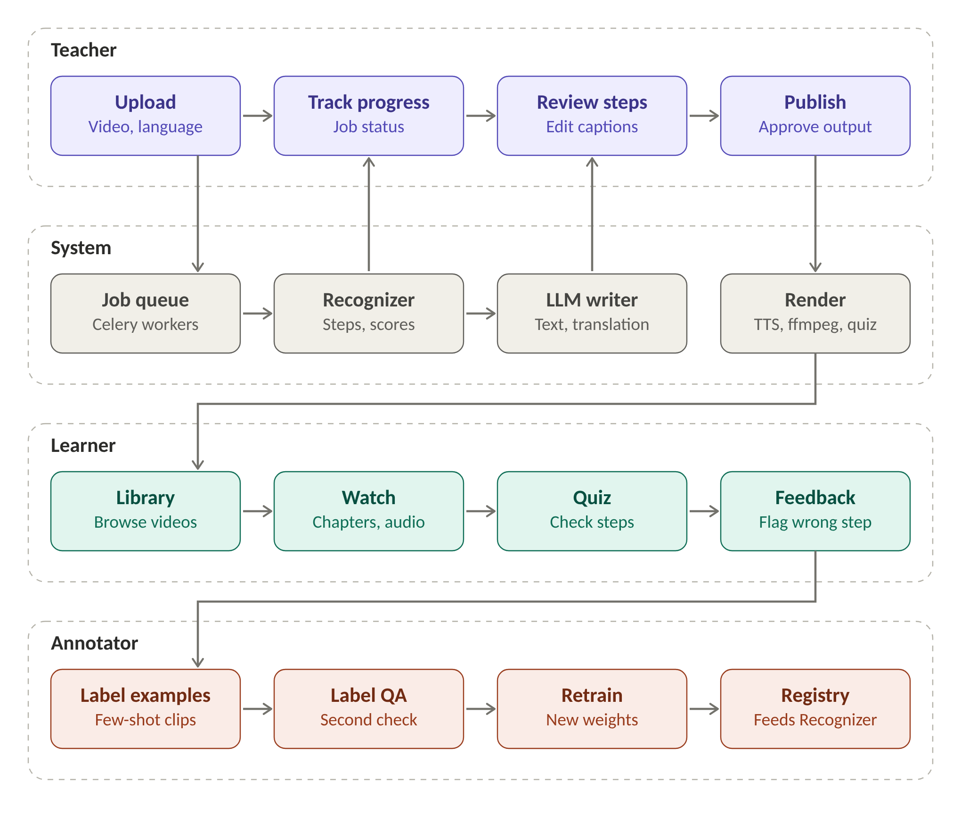
Figure 1. User flow across teacher, system, learner and annotator.
Wireframes: To be added with the UI design.

9. Backend specifications
Item | Your specification | Version
Language | Python 3.11 | 3.11
Web framework | FastAPI with Pydantic (JSON schemas) | ≥ 0.110
LLM orchestration | Direct SDK calls (Google GenAI SDK) with Pydantic schemas; no LangChain | Pinned in requirements.txt
Model serving | LLM and TTS: hosted APIs. Step recognizer, Whisper (faster-whisper small) and IndicTrans2 (200M): self-hosted on CPU in the backend container | PyTorch 2.x
Relational / document DB | PostgreSQL on Supabase: users, videos, jobs, steps, captions, quizzes, labels | 15+
Vector DB | Not used: no document retrieval; glossary is an exact-match lookup | —
Cache / queue | Redis + Celery: job queue; every stage cached by job ID | Redis 7, Celery 5
File / object storage | Supabase Storage: uploaded videos, audio, outputs | —
Authentication | Supabase Auth (JWT; email and Google); roles: trainer, learner, annotator | —
Secrets management | Hugging Face Space secrets and Vercel environment variables; .env never committed | —

API endpoints
Method | Endpoint | Purpose | Request → Response | Auth
POST | /api/videos | Upload a video and start the job | multipart {file, language, domain} → {job_id} | Yes
GET | /api/jobs/{id} | Job status and draft result | — → {stage, percent, steps[]} | Yes
PUT | /api/videos/{id}/steps | Save edited captions and approve | {steps[{id, text}], approved} → {status} | Yes (trainer)
POST | /api/videos/{id}/publish | Start narration, mixing and quiz | — → {job_id} | Yes (trainer)
GET | /api/videos/{id} | Get narrated video, .vtt and quiz | — → {video_url, vtt_url, quiz} | Yes
POST | /api/steps/{id}/flag | Learner flags a wrong step | {reason} → {ticket_id} | Yes
GET | /api/health | Health check for deployment | — → {status: ok} | No

Database schema: users(id, role) · videos(id, owner_id, language, domain, status, storage_path) · jobs(id, video_id, stage, status, error) · steps(id, video_id, idx, label, start_s, end_s, confidence, text_en, text_target, approved) · quizzes(id, video_id, items_json) · labels(id, video_id, start_s, end_s, label, annotator_id, status) · model_versions(id, name, metrics_json).

10. Architecture diagram
Your diagram must show:
- Every component: frontend, backend API, LLM (hosted or self-hosted), vector DB, main DB, object storage, external tools/APIs
- The cloud provider and service each component runs on (e.g. "FastAPI on Cloud Run")
- Data flow arrows for one request, numbered in order
- Where authentication and secrets sit
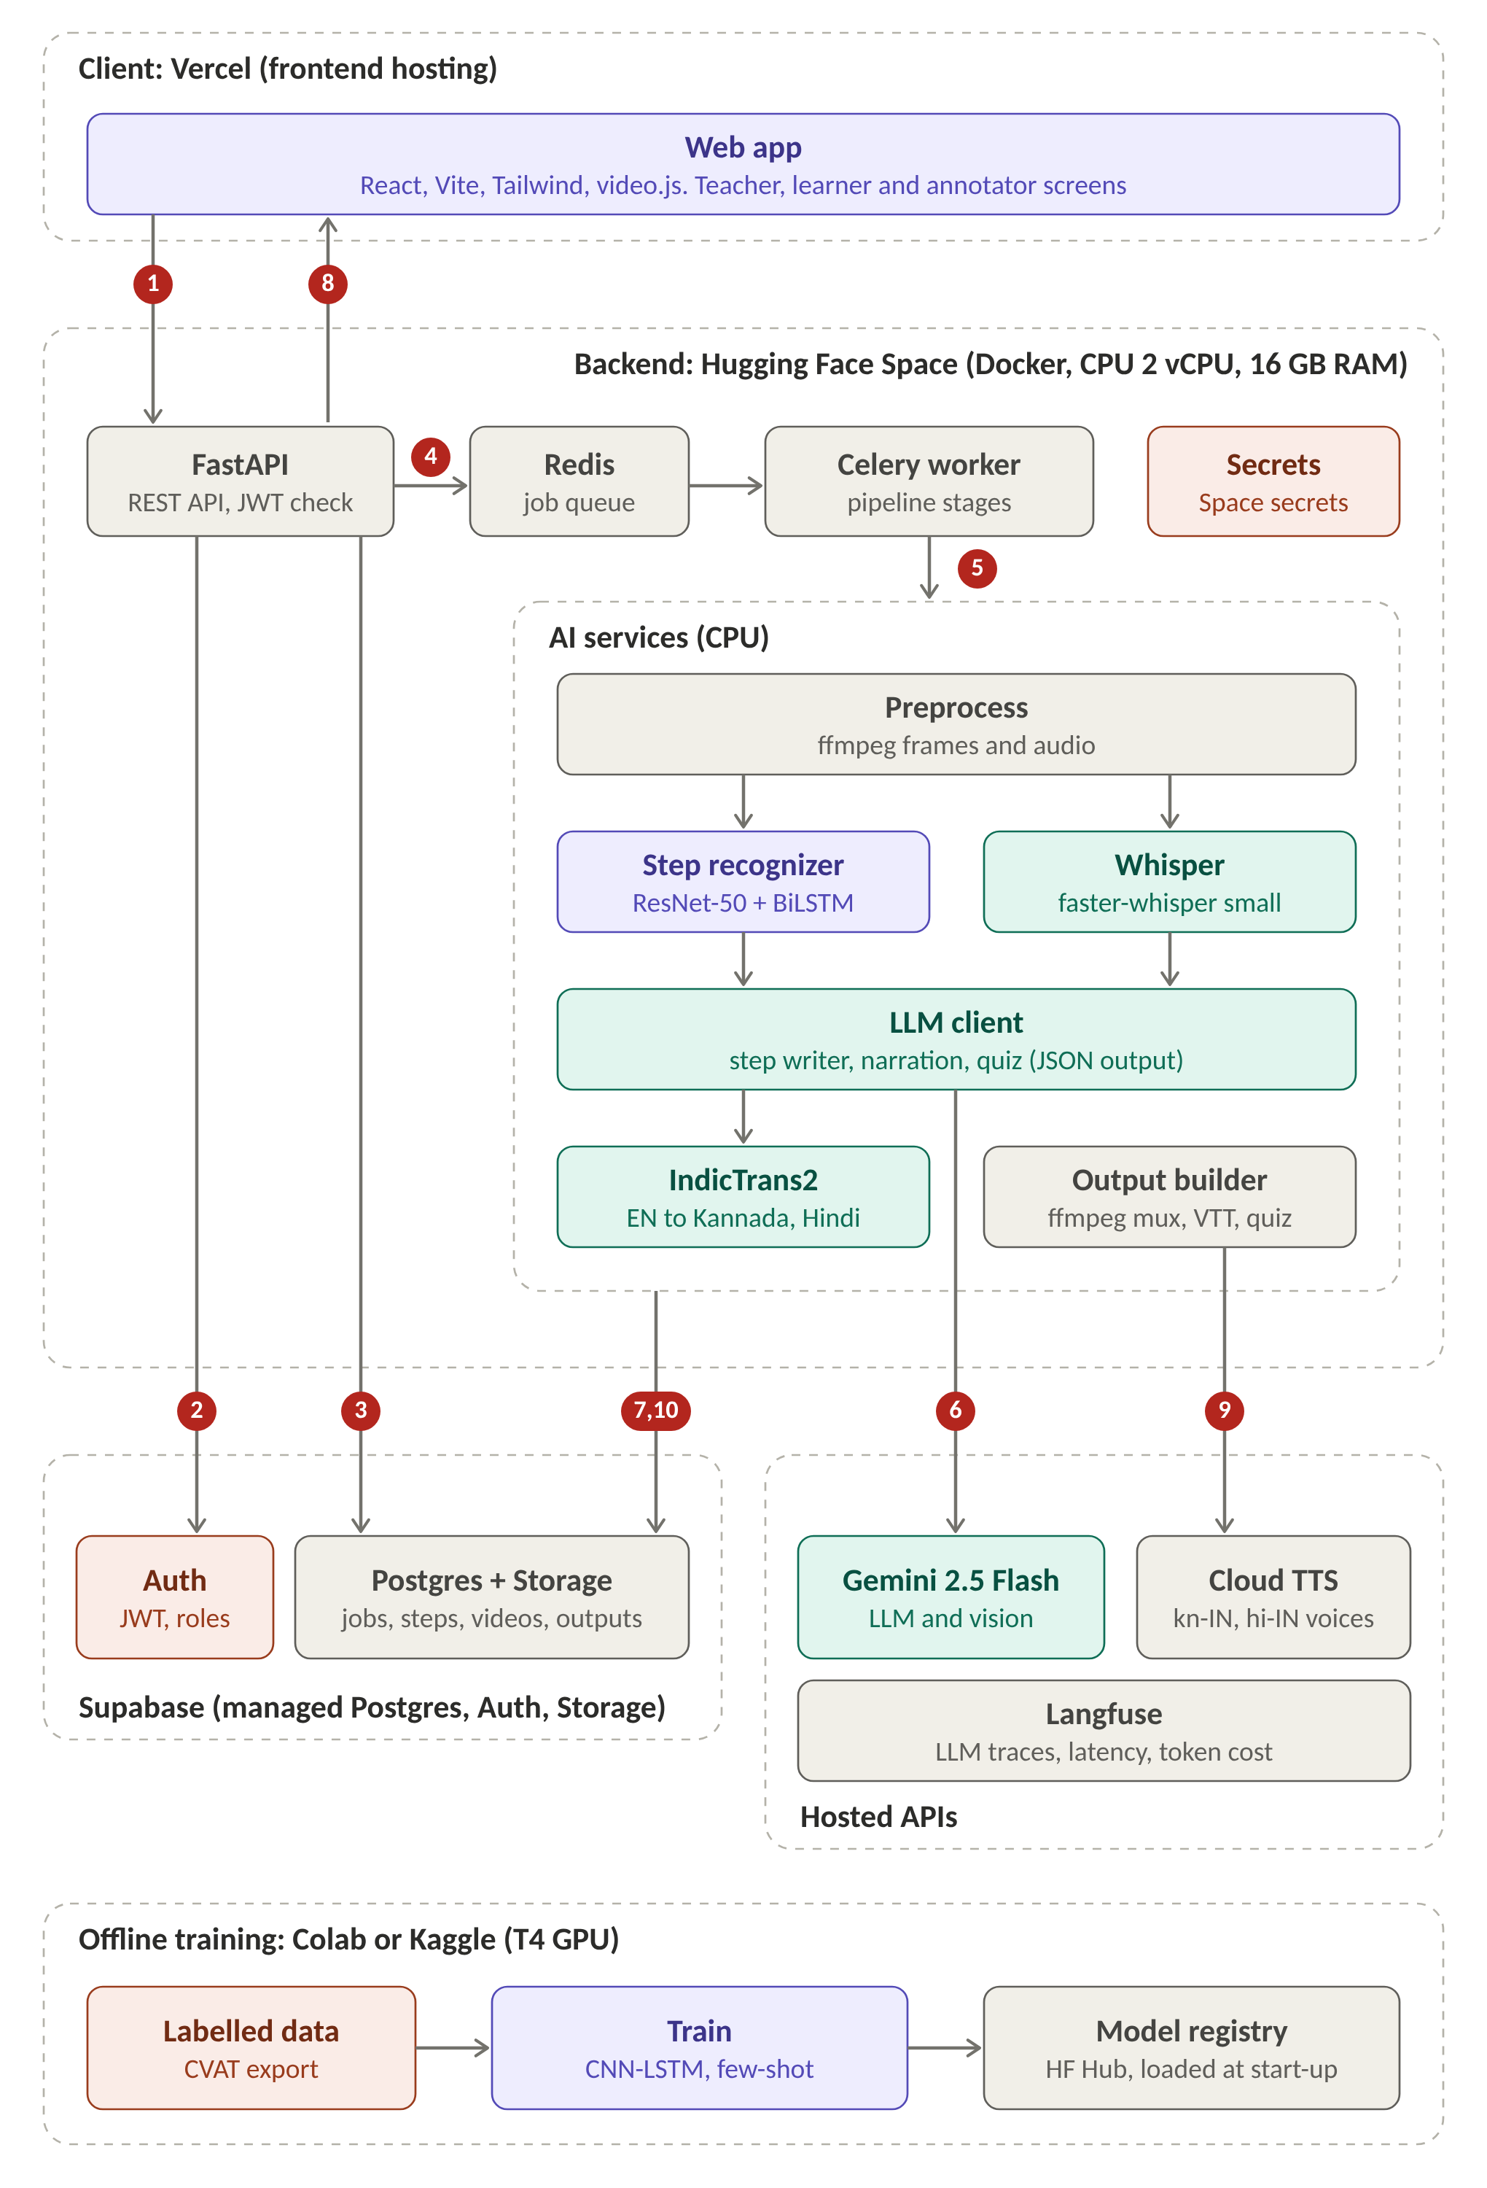
Figure 2. System architecture. Numbers trace one video: 1 upload with JWT; 2 token checked by Supabase Auth; 3 video and job row saved; 4 job queued in Redis; 5 worker runs preprocessing, recognizer, Whisper and translation; 6 LLM calls (step writer, narration; quiz after approval); 7 and 10 draft steps and final outputs saved; 8 trainer polls, edits and approves; 9 narration audio from Cloud TTS.
Component description:
- Web app (Vercel): trainer, learner and annotator screens; free static hosting with HTTPS.
- FastAPI (Hugging Face Space): REST API, JWT check, job creation; Python fits the ML libraries.
- Redis + Celery worker: long jobs run in the background; each stage is cached by job ID.
- Step recognizer (ResNet-50 + BiLSTM, few-shot head): vision source of truth for step order; weights loaded from the model registry.
- Whisper (faster-whisper small): transcript for narrated demos; runs on CPU.
- LLM client (Gemini 2.5 Flash): instructions, narration and quiz as validated JSON; describes keyframes of low-confidence steps.
- IndicTrans2: open English to Kannada and Hindi translation model.
- Cloud TTS: Kannada and Hindi narration audio after trainer approval; Output builder: ffmpeg mix, .vtt and quiz JSON.
- Supabase: Auth (JWT, roles), Postgres (jobs, steps, labels), Storage (videos, outputs).
- Langfuse: traces LLM latency, tokens and failures.
- Offline training (Colab/Kaggle T4): CVAT labels to trained weights, saved to Hugging Face Hub.
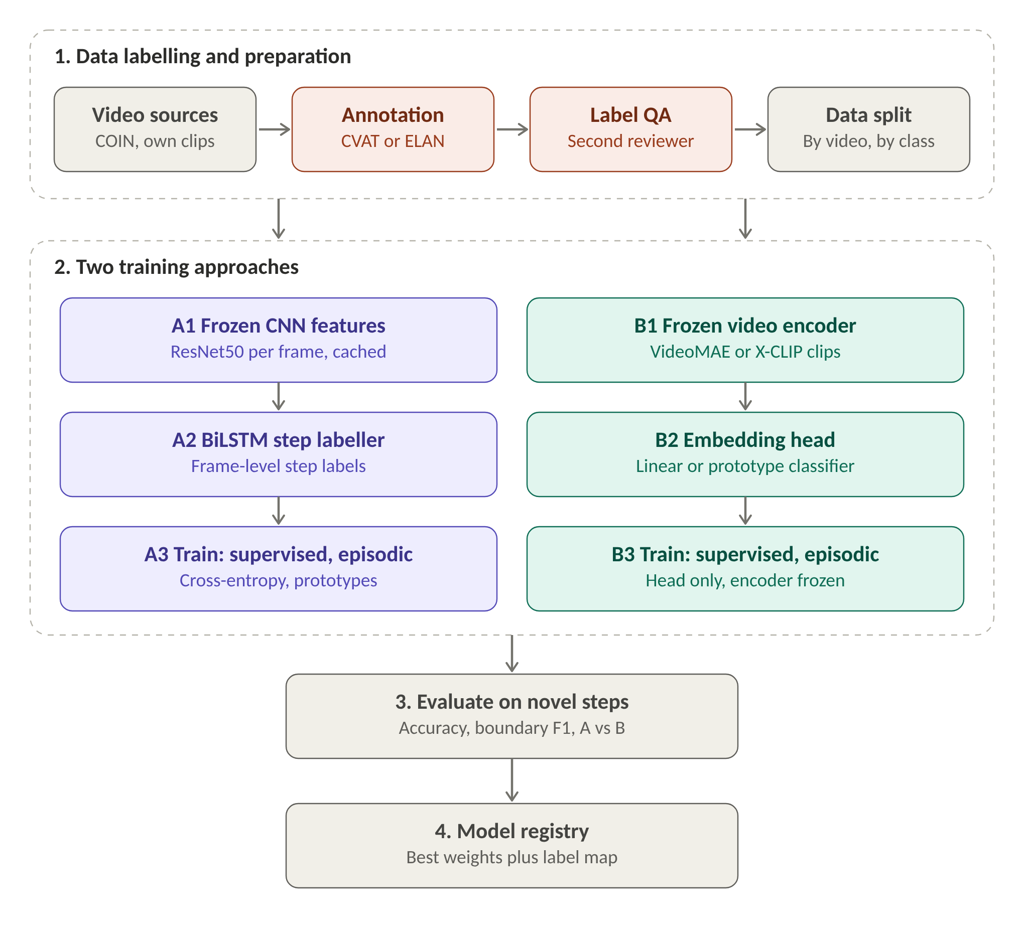
Figure 3. Training pipeline: data labelling, two training approaches, evaluation and model registry.

11. Cloud hosting and deployment (mandatory)
Every project must be deployed on a public cloud and reachable by a public URL for the final demo. A laptop-only or Colab-only demo does not meet this requirement.
Item | Your specification
Cloud provider | Hugging Face Spaces (backend), Vercel (frontend), Supabase (database, auth, storage)
Free tier / credits used | Free tiers only: HF CPU Space, Vercel Hobby, Supabase Free, Gemini API free tier, Google Cloud TTS free monthly quota
Frontend hosting | Vercel
Backend hosting | Hugging Face Space (Docker SDK, CPU basic: 2 vCPU, 16 GB RAM)
LLM hosting | Hosted API (Gemini 2.5 Flash via Google AI Studio)
Managed databases | Supabase Postgres + Storage (Free); Redis runs inside the Space container
Containerisation | Dockerfile in repo; base image python:3.11-slim with ffmpeg
CI/CD | GitHub Actions: test → push to the Space repo; Vercel deploys from main
Environment config & secrets | HF Space secrets and Vercel environment variables; never committed
Domain and HTTPS | *.hf.space and *.vercel.app (TLS provided)
Monitoring and logging (LLMOps) | Langfuse (LLM latency, tokens, errors) and HF Space logs
Estimated monthly cost | ₹0 at demo load (free tiers); hard cap ₹1,000
Public demo URL | To be filled after deployment

Deployment steps: 1) Clone the repo and set environment variables. 2) Create the Supabase project, run the schema SQL, create the storage bucket. 3) Create a Docker Space on Hugging Face, add secrets, push the backend. 4) Deploy the frontend to Vercel with the API URL. 5) Run the health check and one sample upload.
Shutdown plan: After evaluation: pause the Space, delete the Supabase project and storage, revoke API keys, disable the Vercel project.

12. Risks and mitigation
Risk | Likelihood (L/M/H) | Impact (L/M/H) | Mitigation / fallback
Free CPU too slow, or the Space sleeps | M | H | Limit clips to 3 minutes, cache every stage, pre-process demo clips, wake the Space before the demo
Too little labelled data for the chosen skill | H | M | Transfer from COIN, few-shot head, augmentation, 20–30 own clips
Kannada or Hindi translation and TTS quality is poor | M | M | Two languages only, glossary, trainer review step, native-speaker rating
LLM invents or reorders steps; API rate limit | M | H | Schema and order validator with one retry, template fallback, open-model fallback via another API
Scope creep (voice cloning, more languages) | M | M | Scope frozen in Section 2; weekly check against it

13. Timeline and milestones
Week | Milestone | Deliverable | Owner
1–2 | Requirements approved; skill domain and step list fixed | This document, signed off | [Name]
3–4 | Data labelled, features cached, baseline running | Baseline results (frozen CNN + kNN, X-CLIP zero-shot) | [Name]
5–7 | CNN-LSTM and few-shot training; LLM, translation and TTS pipeline; first cloud deployment | Working prototype on a public URL | [Name]
8–9 | Evaluation, ablations, review screen polish | Metrics table filled | [Name]
10 | Final submission | Live cloud demo URL, report, code, slides | All

14. Final deliverables
- Source code in a public or instructor-shared GitHub repo with a README and setup steps
- Working demo on the deployed public cloud URL (5–7 minutes), plus a backup recording
- Final report with evaluation results mapped to FR/NFR IDs
- Presentation slides
- Individual contribution statement from each member

15. Open questions
- Skill domain (for example tailoring or a cooking subset of COIN) and its step list: team, week 2.
- TTS choice: Google Cloud TTS free quota vs an open Indic TTS model; decide after a quality test: team, week 3.
- Confirm with the mentor that Kannada and Hindi are the two target languages: team, week 1.

16. Change log
Date | Version | Change | Reason
23-10-2026 | v0.1 | First draft of requirements | Initial version for review

17. Sign-off
Role | Name | Signature | Date
Team lead
Faculty mentor

