**MINOR PROJECT ON**

**Optical Mark Recognition using Computer Vision**

A minor project report for the evaluation and partial fulfilment of the requirement for the award of degree

**Master in Computer Application in Artificical Intelligence**

**SEMESTER: 3rd**

**UNIVERSITY SCHOOL OF INFORMATION AND COMMUNICATION TECHNOLOGY, GAUTAM BUDDHA UNIVERSITY, GREATER NOIDA-201312, UTTAR PRADESH INDIA**

**NOVEMBER,2023**



**Submitted By:**

**Name Roll No**

NITISH BHARDWAJ 225/PCA/007

PRASHANT KUMAR 225/PCA/009

BRIJ KISHORE SINGH YADAV 225/PCA/004

**Under the Supervision of: Ms. Sindhu Sujata**

**ACKNOWLEDGEMENT**

In the journey of exploring the intricate realms of “**OPTICAL MARK RECOGNITION USING COMPUTER VISION**", We are deeply indebted to us supervisor, **Mr.Sindhu Sujata**. His unwavering guidance and mentorship have been the compass that guided me through the python concepts. Sir, your expertise and support have been invaluable, and I am sincerely grateful for the effort you invested in enriching our understanding.

We extend us heartfelt appreciation to python for providing comprehensive and user-friendly documentation. This has been a beacon of knowledge, especially for students who may face challenges but aspire to learn and enhance their skills. The accessibility and clarity in the documentation have been pivotal in shaping my understanding of python libraries.

A special acknowledgment goes to the creators of the course that has been nothing short of excellent. The course's global availability has opened doors for countless learners worldwide, making complex concepts accessible through an engaging and interesting approach. Thank you for fostering an environment that encourages learning and growth.

Lastly, I want to express my gratitude to my team. Their unwavering support and encouragement have been the pillars of strength throughout this endeavor. Together, we have faced challenges, celebrated victories, and fostered a collaborative spirit that has made this learning experience even more enriching.

Thank you, one and all, for contributing to this journey of knowledge and growth. Your support has been instrumental, and I am truly fortunate to have such incredible individuals alongside us.



**SCHOOL OF INFORMATION AND COMMUNICATION TECHNOLOGY**

**GAUTAM BUDDHA UNIVERSITY, GREATER NOIDA, 201312, U. P., (INDIA)**

Candidate's Declaration

We, hereby, certify that the work embodied in this project report entitled "Optical Mark Recognition using Computer Vision" in partial fulfilment of the requirements for the award of the Degree of MCA (AI) submitted to the School of Information and Communication Technology, Gautam Buddha University, Greater Noida is an authentic record of our own work carried out under the supervision of Ms. Sindhu Sujata, School of ICT. The matter presented in this report has not been submitted in any other University / Institute for the award of any other degree or diploma. Responsibility for any plagiarism related issue stands solely with us.

Signature

NITISH BHARDWAJ 225/PCA/007

PRASHANT KUMAR 225/PCA/009

BRIJ KISHORE SINGH YADAV 225/PCA/004

This is to certify that the above statement made by the candidates is correct to the best of my knowledge and belief. However, responsibility for any plagiarism related issue solely stands with the students.

Signature of Supervisor

Ms. Sindhu Sujata

Top of Form

**ABSTRACT**

In the realm of automated data capture, Optical Mark Recognition (OMR) stands as a powerful technology for processing human-marked documents. This minor project explores the implementation of OMR through computer vision techniques. Leveraging image processing algorithms and machine learning methodologies, the system is designed to accurately detect and interpret marks made on paper forms. The project emphasizes the utilization of OpenCV, a popular computer vision library, to preprocess images, extract relevant features, and classify marks based on predefined templates.

Key objectives include the development of a robust algorithm capable of handling varying mark patterns, accommodating diverse document layouts, and delivering accurate results. The system is envisioned to find applications in educational assessments, surveys, and other scenarios where automated data extraction from marked documents is essential. The project also addresses challenges related to noise reduction, scalability, and real-world usability.

Through this endeavor, the project aims to provide a foundational understanding of OMR principles, demonstrate the capabilities of computer vision in automating mark recognition tasks, and contribute to the broader field of image processing and machine learning applications.

---

Table of Contents

Project Title 3

Technologies to be used 3

Software Platform 3

Hardware Platform 3

Problem Statement 4

Literature Survey 4

Project Description 4

Project Modules: Design/Algorithm 6

1. Input Image 6

Implementation Methodology 10

Result & Conclusion 11

Future Scope of the Project 11

Advantages of this Project 11

Outcome 12

References 12

# Project Title

Optical Mark Recognition using Computer Vision.

This project focuses on providing a portable and convenient solution to the OMR sheet checking with the help of Computer Vision and proposing a web-based application made with python that allows you to upload OMR and get it evaluated accurately without the hassle of huge OMR scanners. We propose a software where you can post image of OMR sheet taken from different angles yet our application can detect the bubbles marked and evaluate the answers accordingly as per the answer scheme. It generates a *.csv* file as output with all the necessary fields such as roll no., question no., etc.

**Team / Group Formation:**

|  |  |  |  |
| --- | --- | --- | --- |
| **S. No** | **Student Name** | **Roll Number** | **Role** |
| **1** | **Nitish Bhardwaj** | **225/PCA/007** | **Developer** |
| **2** | **Prashant kumar** | **225/PCA/009** | **Tester** |
| **3** | **Brij Kishore Singh Yadav** | **225/PCA/010** | **Developer** |

# Technologies to be used

## Software Platform

1. **Front-end**
   * Python 3
2. **OMR Checker**
   * Pyhton 3
   * Opencv
   * Rich – table generation
   * Numpy
   * Pandas
   * Matplotlib
   * Jsonschema
   * dotmerge

## 

## Hardware Platform

Camera for Capturing Images

# Problem Statement

In today’s world most of the competitive exams are based on MCQ (Multiple Choice Questions). The responses of these MCQ based exams are recorded in the Optical Mark Reader (OMR) sheet. Evaluation of the OMR sheet requires separate specialized machines for scanning and marking. The sheets used by these machines are special and costs more than a normal sheet.

OMR (Optical Mark Reader or Optical Mark Recognition) is the process of gathering information from human beings by recognizing marks on a document. OMR is accomplished by using a hardware device (scanner) that detects a reflection or limited light transmittance on or through a piece of paper. OMR analyzing is process of automatically analyzing human marked sheets used to record answers and interpreting their results. Candidates filling their OMR sheets using pencil or Ball-Point Pens. These hardware device lacks in portability and are expensive to use. Thus, limits the usage of OMRs widely which end up in lack of opportunities or say, we are unable to make the best out of this technology.

# Literature Survey

# Project Description

We propose a full-fledged OMR checking software that can read and evaluate OMR sheets scanned at any angle and having any color.

|  |  |
| --- | --- |
| **Specs** |  |
| **Accuracy** | Currently nearly 94% accurate on good quality document scans; and about 90% accurate on mobile images. |
| **Robustness** | Supports low resolution, xeroxed sheets. Minimum resolution **640x480** |
| **Fast** | Current processing speed without any optimization is 1**00 OMRs/minute.** |
| **Customizable** | Easily apply to custom OMR layouts, surveys, etc. |
| **Visually Rich** | Get insights to configure and debug easily. |
| **Lightweight** | Very minimal core code size. |
| **Large Scale** | Tested on a large scale. |

Once we capture and configure the OMR layout and image, we just need to throw images of the sheets at the software and you'll get back the marked responses in an excel sheet.

Images can be taken from various angles as shown below

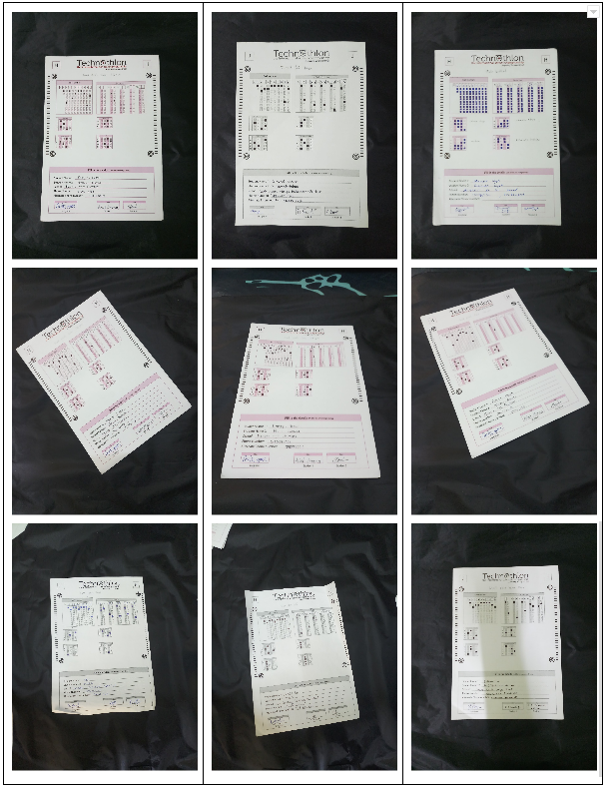*Figure 1: Input Images captured at various angles*

Output generated would be of the form of a .csv file which can be later on taken into various applications such as data analysis, surveys, etc.

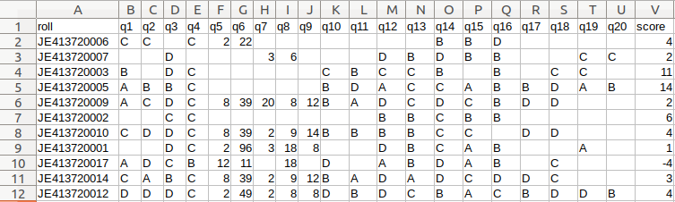

*Figure 2: Screenshot of Output .csv file generated from OMR sheet*

## Project Modules: Design/Algorithm

## 1. Input Image

To read an image, we simply call the imread function of the cv2 module. This will return an image as a NumPy array. We can confirm this by calling the type function and passing as input the object returned by the imread. function.

“cv2.imshow('test.png',image)”. 

Figure . Sample Input

**2. Detect the Image:**

We tested the code on the image of an OMR sheet. Multiple scanned images of the OMR sheet were taken for testing. The image on which the approach was tested. We also test our code on different inclinations. Current code works on OMR sheets with circles, it will not work with OMR sheets of other shapes. Though a variant of our code will work successfully on it, where the first step will be replaced with the respective transformation for detecting the new shapes.

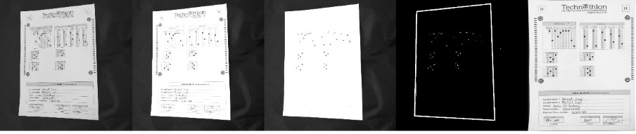

*Figure 3: Finding the Region of Interest (ROI) i.e., paper in the image*

**3. Extract the possible answer choices**

In order to detect the images of bubbles, we loop over each of the individual contours. Considering the aspect ratio of the contours we recognize a contour to be a bubble.Now, pre-process our input image as:

gray=cv2.cvtColor(image, cv2.COLOR_BGR2GRAY) blurred=cv2.GaussianBlur(gray,(5,5),0)

edged = cv2.Canny(blurred, 75, 200)

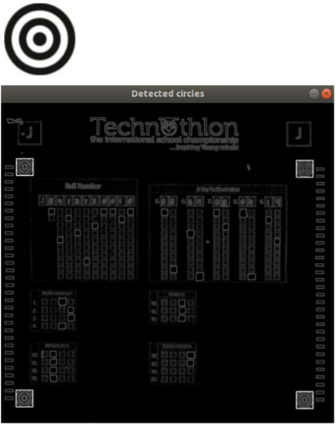

*Figure 4: Detecting Markers on Image in order to align template layout in next step*

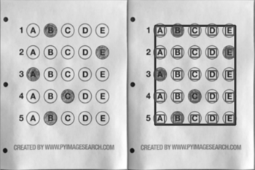

*Figure 5.1: Template layout setting*

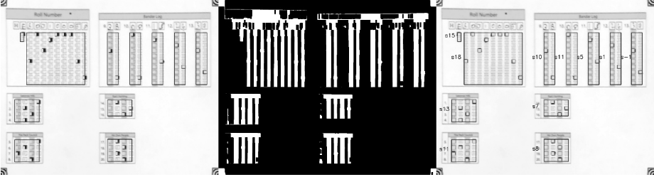

*Figure 5.2: Template Layout Alignment*

**4. Parallel Line Interpolation:**

When interpolating images, the image itself plays the role of an interpolated function, it means that if we interpolate four parallel lines passing through detected circles centres, it will pass through missing circles too. Based on the idea above, we come up with an error minimization method to find the four parallel lines passing through detected circles. Then we get the value which is the color of the pixel. Image pixels are Points where the value of the function (pixel colour) is known. Interpolation contains intermediate values of the function (Gives equation of lines), the image does not necessarily increase, the interpolation methods allow too arbitrarily

changing the image size and aspect ratio.

**Processing steps on various set of data items**

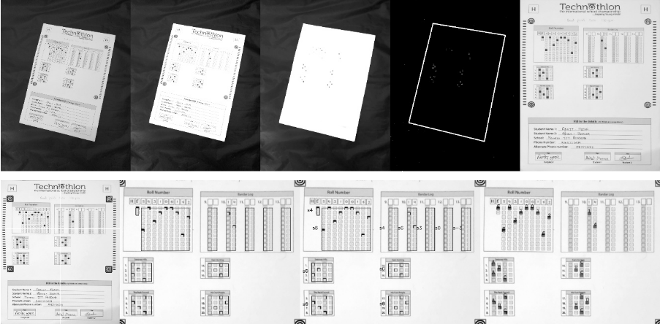

**Output module**

Output module has the main task to generate an image of OMR with the bubbles and their respective interpretation merged over image as shown in figure after the correction as well as generate a csv files.

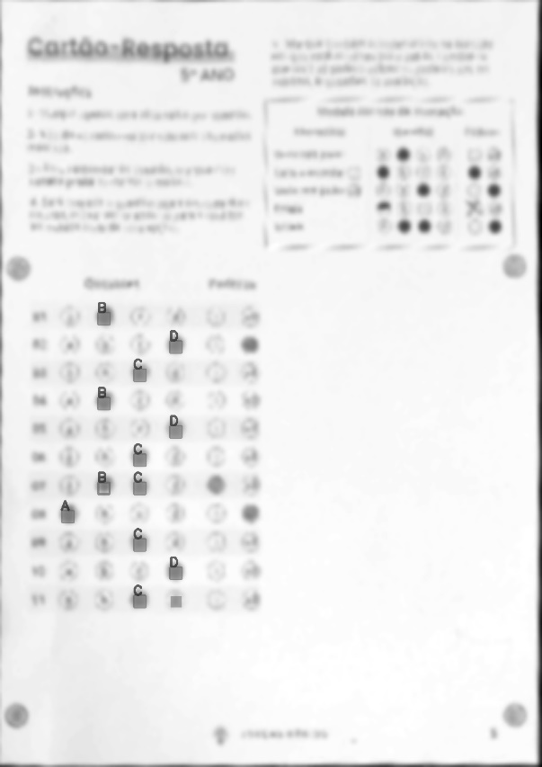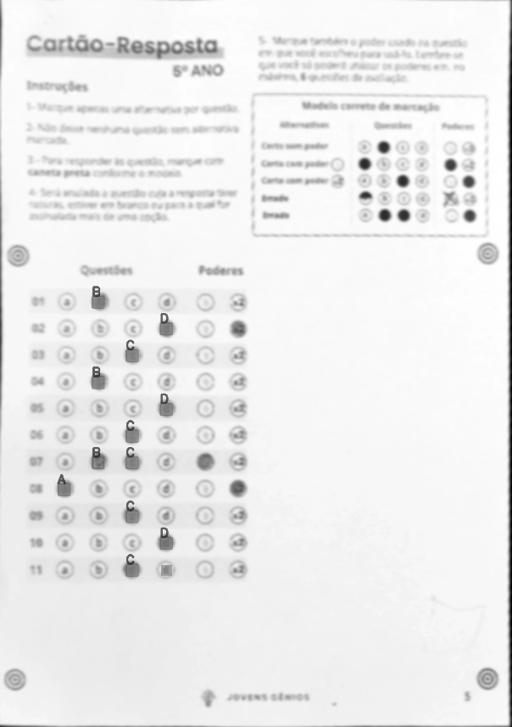

*Figure: Output OMR generated after checking*



*Figure: .csv file generated as output*

# Implementation Methodology

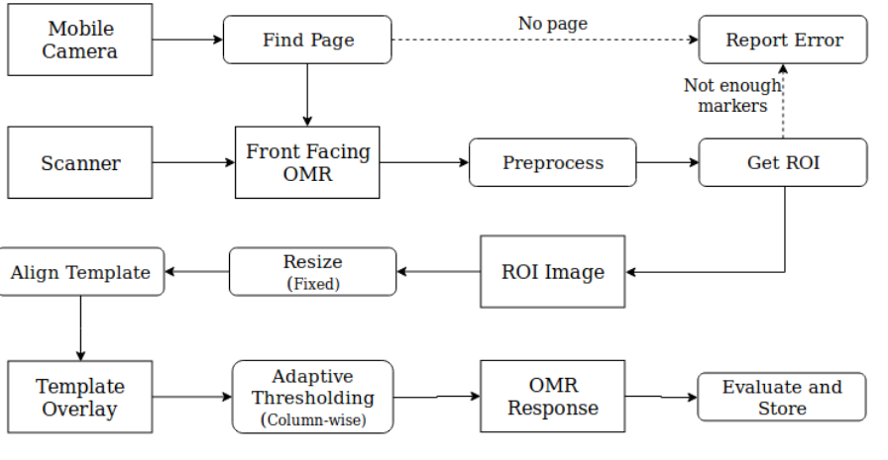

*Figure: Block Diagram of the OMR Checker*

The project leverages OpenCV, a powerful computer vision library, for image processing and analysis. OpenCV provides a rich set of tools and functions for tasks such as contour detection, thresholding, and template matching.

**Data Collection**

A diverse dataset is collected for training and testing the OMR system. This dataset includes samples of human-marked documents with variations in mark patterns, document layouts, and handwriting styles.

**Preprocessing**

Prior to analysis, input images undergo preprocessing steps to enhance the quality of data. Techniques include:

* Noise reduction to improve image clarity.
* Thresholding for effective separation of foreground and background.
* Feature extraction to identify relevant elements in the image.

**Algorithm Implementation**

The OMR system employs several computer vision algorithms, including:

Contour detection to identify marked regions on the document.

Template matching for comparing extracted features with predefined mark templates.

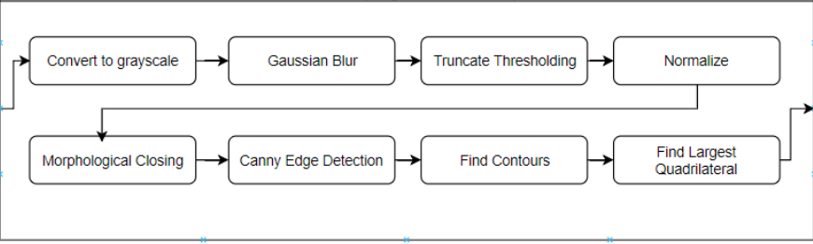

*Figure: Block Diagram of Find Page Algorithm*

# Result & Conclusion

Our Proposed model is Currently nearly 94% accurate on good quality document scans and about 90% accurate on mobile images.

OMR scanners are faster and more accurate than OCR scanners for processing OMR sheets, and that they can provide timely feedback to students. OMR scanning systems have been successfully implemented in various academic settings, with studies reporting high levels of accuracy and efficiency. These systems have the potential to save time and reduce the risk of errors compared to manual data entry or scanning. Additionally, OMR software that allows users to upload images directly without a scanner can offer convenience, flexibility, cost savings, improved accuracy, time savings, and data security. Overall, OMR checkers offer a reliable and efficient solution for grading multiple choice exams and evaluating student performance in large classes.

# Future Scope of the Project

* The integration of artificial intelligence (AI) with OMR software can significantly improve the accuracy and speed of processing OMR sheets. With AI, the software can learn from past data and optimize the processing of future sheets.
* Cloud-based OMR solutions can offer more flexibility, accessibility, and scalability. Users can access the software from anywhere and scale up or down as per their requirements.
* With the increasing use of smartphones and tablets, mobile-based OMR applications can be developed. Users can scan the OMR sheets using their mobile devices and process the data in real-time.
* With globalization, there is a growing need for OMR software that supports multiple languages. Multi-lingual support can help to process OMR sheets in different languages without any errors.
* OMR software can be integrated with other software such as data analytics tools, reporting tools, and data visualization tools. This integration can provide more insights into the data and help in making better decisions.
* OMR software can be used for advanced data analytics to gain insights into the data. With the help of machine learning algorithms, the software can detect patterns, trends, and anomalies in the data.

# Advantages of this Project

This project can offer several advantages, including convenience, flexibility, cost savings, improved accuracy, time savings, and data security.

* **Portable:** This project provides portability as it eliminates the need for huge hardware device such as scanners, one can use mobile application to get the OMR evaluated.
* **Convenience:** Users can easily upload images of OMR sheets without the need for a physical scanner. This can save time and effort, especially when working with large volumes of OMR sheets.
* **Flexibility:** Users can upload images from any location, as long as they have an internet connection. This can be particularly useful for remote work or when scanning OMR sheets from different locations.
* **Cost savings:** By eliminating the need for a physical scanner, users can save on the costs associated with purchasing, maintaining, and repairing scanners.
* **Improved accuracy:** OMR software that allows users to upload images directly can offer improved accuracy compared to manual data entry or scanning. This is because the software can automatically detect and interpret the marks on the OMR sheets with a high degree of accuracy.
* **Time savings:** By automating the scanning and processing of OMR sheets, users can save time and reduce the risk of errors. This can be particularly useful when processing large volumes of data.
* **Data security:** Uploading images directly to the OMR software can offer improved data security compared to physical scanners. This is because there is no risk of physical documents being lost, stolen, or damaged.

# Outcome

* Research Paper Publication
* Project to Product Development

# References

**Academic Papers:**

Lézin, J., Cheriet, M., & Suen, C. Y. (2008). "An Overview of Statistical and Structural Pattern Recognition Techniques in OCR." Pattern Recognition, 41(1), 394-413.

Ranzato, M., Huang, F. J., Boureau, Y. L., & LeCun, Y. (2007). "Unsupervised Learning of Invariant Feature Hierarchies with Applications to Object Recognition." Computer Vision and Pattern Recognition, 2007. CVPR '07. IEEE Conference on, 1-8.

Hanmandlu, M., & Arora, A. (2010). "OMR Sheet Reading using Image Processing Techniques." International Journal of Computer Applications, 1(5), 26-31.

**Books:**

Gonzalez, R. C., Woods, R. E., & Eddins, S. L. (2009). Digital Image Processing Using MATLAB. Gatesmark Publishing.

Szeliski, R. (2010). Computer Vision: Algorithms and Applications. Springer.

**Online Resources:**

OpenCV Documentation: https://docs.opencv.org/

Scikit-image Documentation: https://scikit-image.org/

**GitHub Repositories:**

OpenCV GitHub Repository: https://github.com/opencv/opencv

Scikit-image GitHub Repository: <https://github.com/scikit-image/scikit-image>

**Tutorials and Articles:**

Rosebrock, A. (2018). "OpenCV and Python K-Means Color Clustering." PyImageSearch: https://www.pyimagesearch.com/2014/05/26/opencv-python-k-means-color-clustering/

Otsu, N. (1979). "A Threshold Selection Method from Gray-Level Histograms." IEEE Transactions on Systems, Man, and Cybernetics, 9(1), 62-66.