Wireframe Documentation

**Deloitte Case Study**

**Homepage**



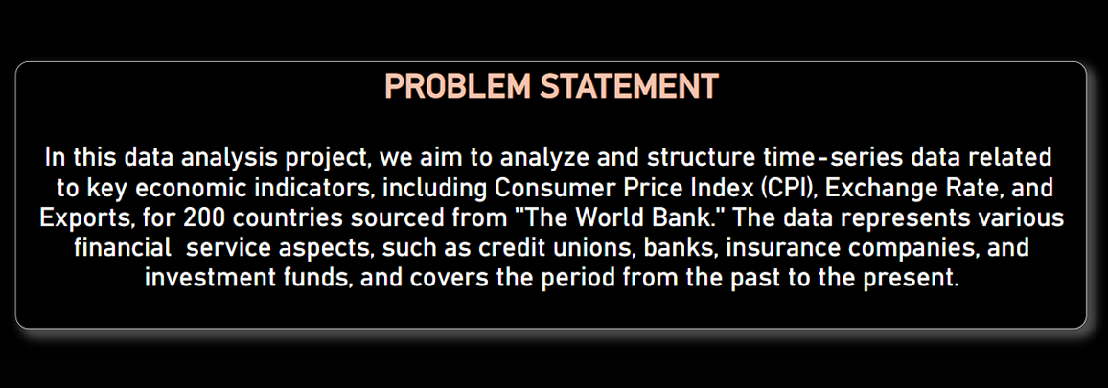

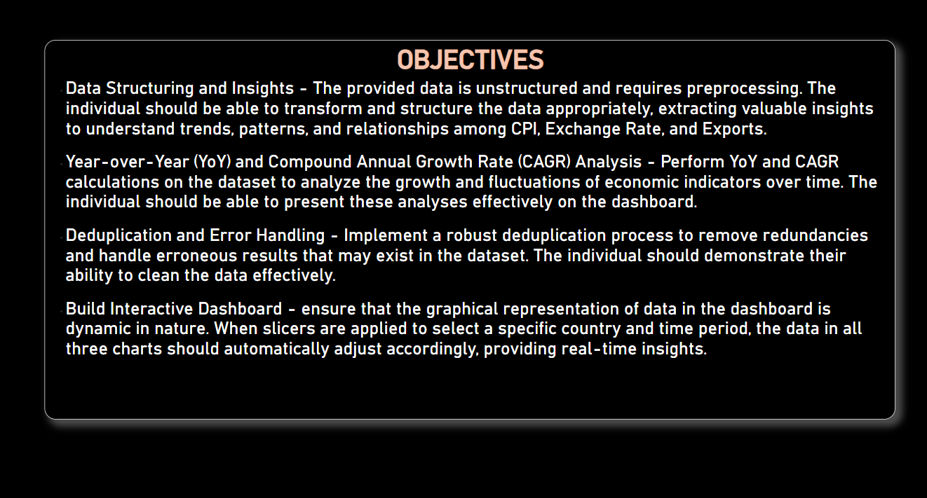

This is our overview

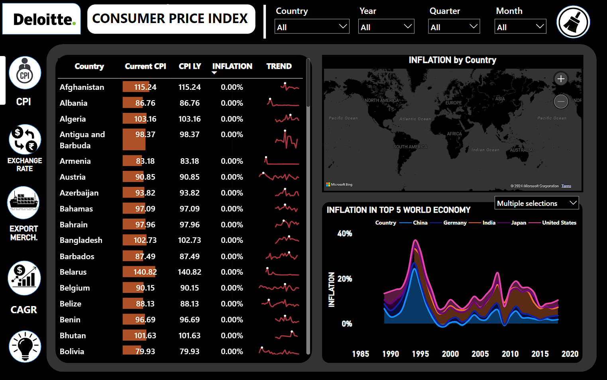

This is the cpi of every country from the year 1991 to 2017

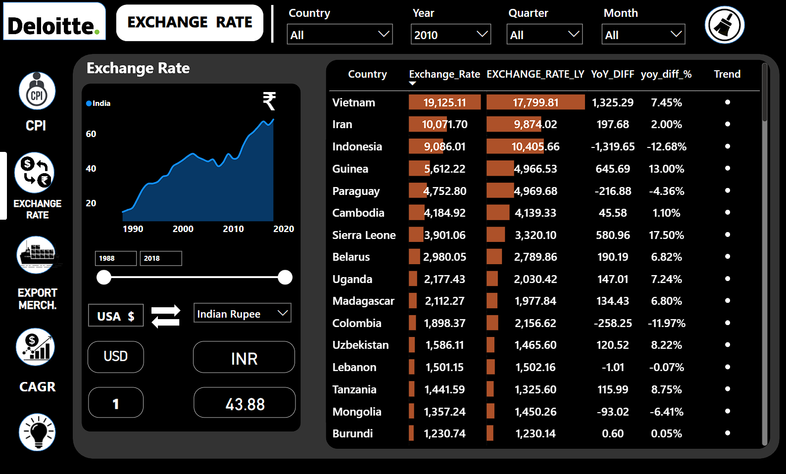

This is the Exchange Rate of every country from the year 1991 to 2017

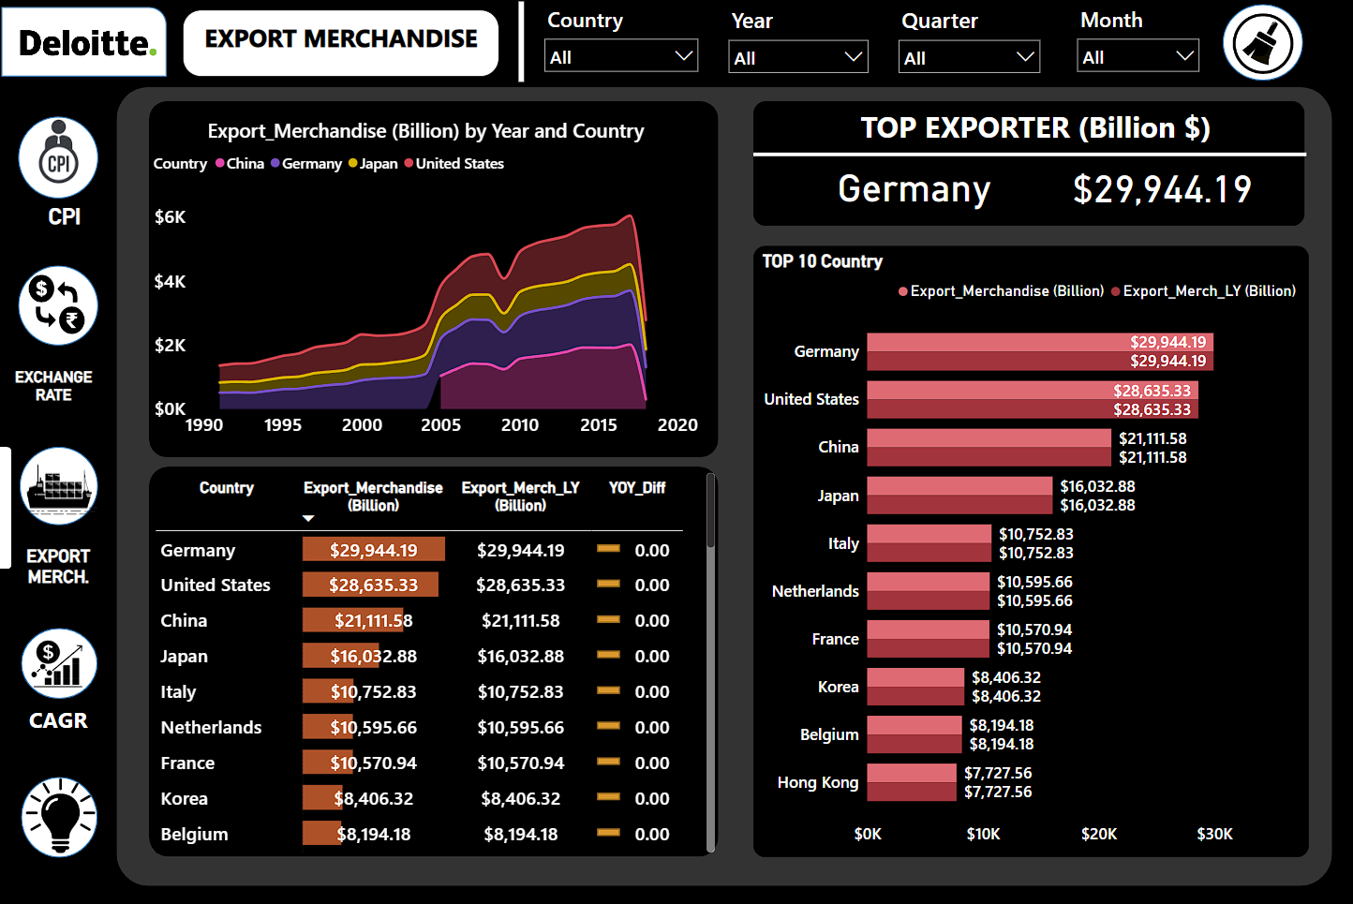

This is the Export Merchandise of every country from the year 1991 to 2017

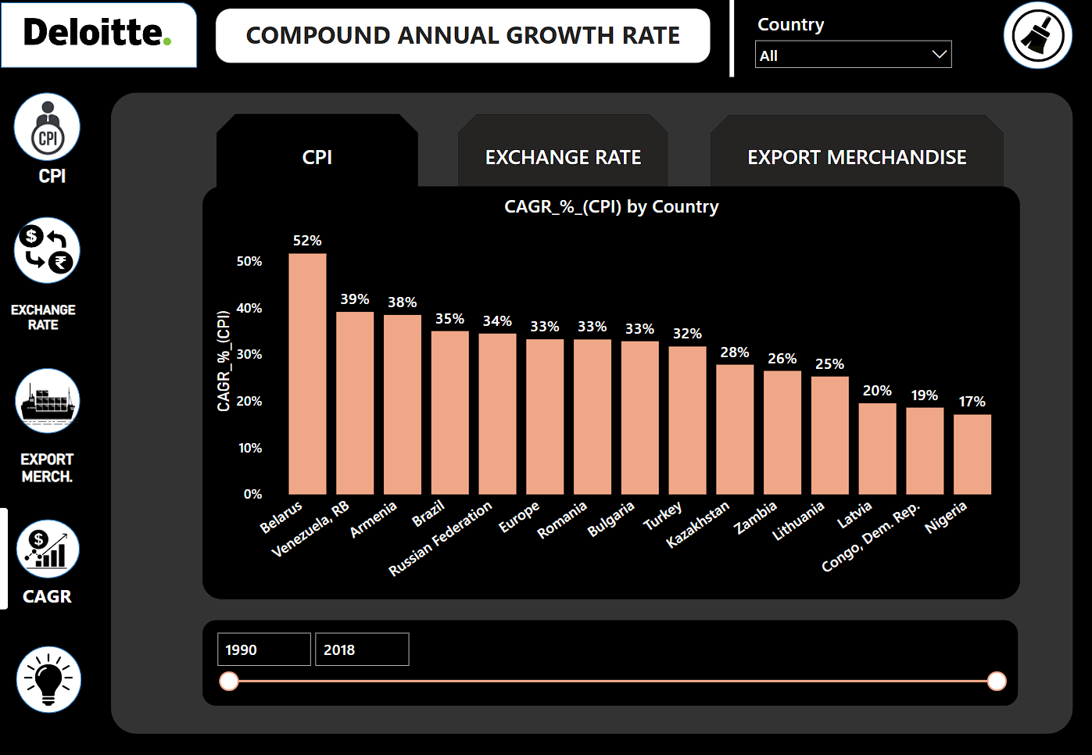

This is the CAGR CPI of every country from the year 1991 to 2017

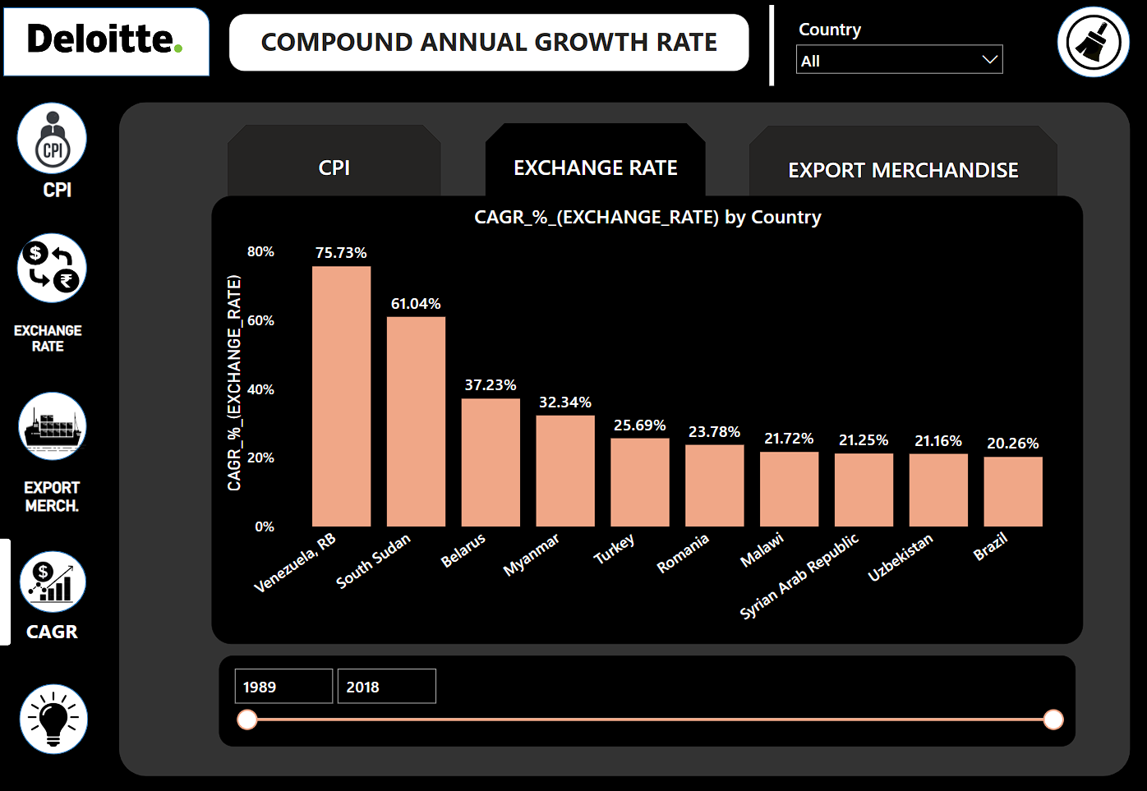

This is the CAGR exchange rate of every country

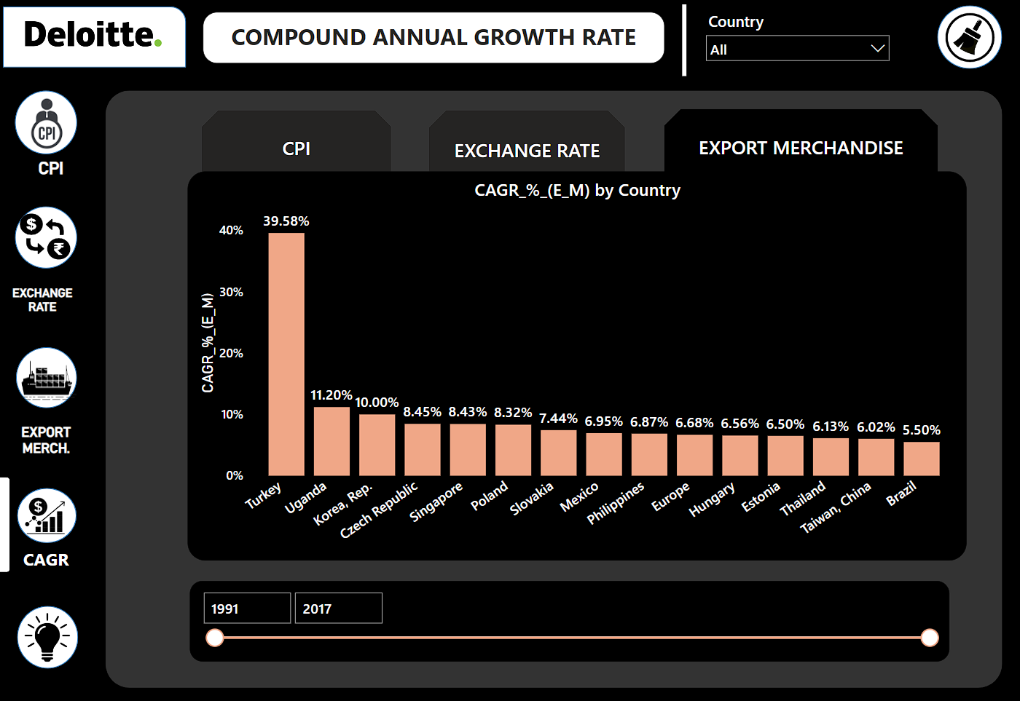

This is the CAGR exports of every country.

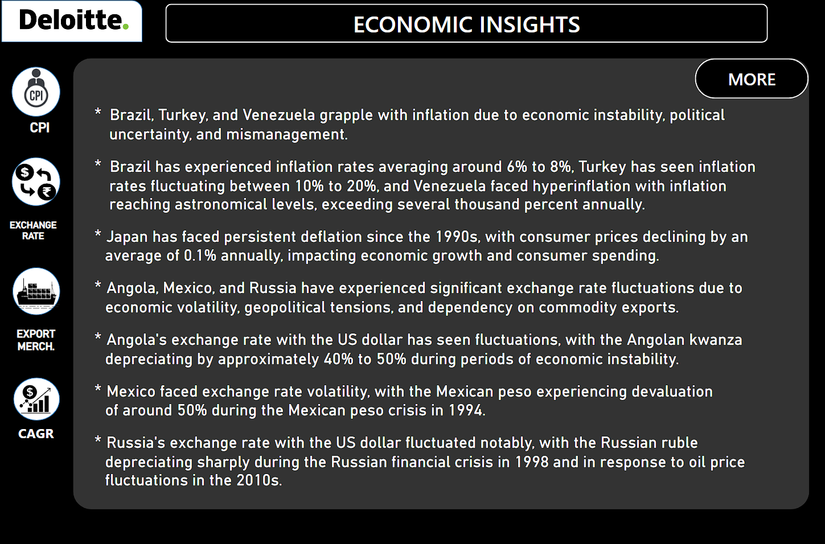

This are some insights from project.

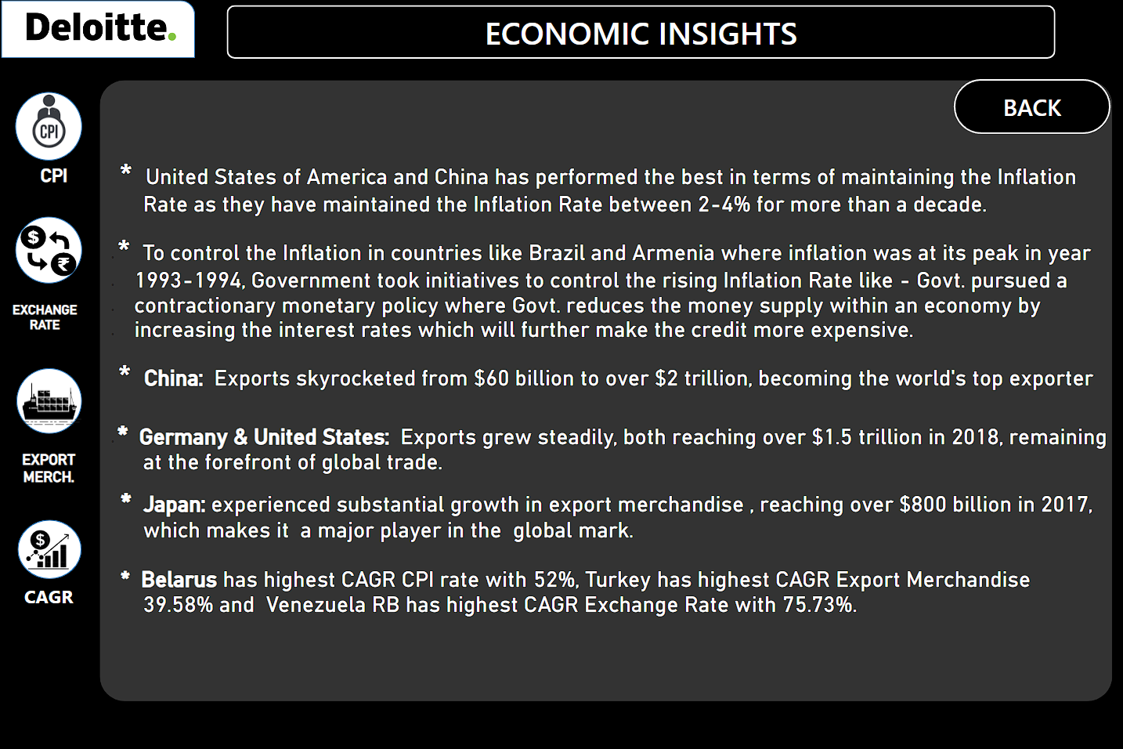

This are the insights from the project.