Low Level Design
AIR TRAVEL DATA ANALYSIS

Written By | Nitish Pandey
Document Version | 1.0
First Revised Date | 13/7/2024

DOCUMENT CONTROL

Change Record:
VERSION | DATE | AUTHOR | COMMENTS
1.0 | 13 JULY 2024 | Nitish Pandey

Reviews:
VERSION | DATE | REVIEWER | COMMENTS

Approval Status:
VERSION | REVIEW  DATE | REVIEWED BY | APPROVED  BY | COMMENTS

Contents

1. Introduction........................................................................................................................ 04
1.1 What is Low-Level Design Document? ....................................................................... 04
1.2 Scope ............................................................................................................................ 04
2. Functional Architecture...................................................................................................... 05
3. Architecture Description ................................................................................................... 07
3.1 Data Description .......................................................................................................... 07
3.2 Data Transformation .................................................................................................... 11
3.3 Power BI Configuration ............................................................................................... 11
3.4 Deployment ................................................................................................................. 12

Introduction

What is Low-Level design document?

The goal of the LDD or Low-level design document (LLDD) is to give the internal logic design of the actual program code for the Expenditure Data Analysis dashboard. LDD describes the class diagrams with the methods and relations between classes and programs specs. It describes the modules so that the programmer can directly code the program from the document.

Scope

Low-level design (LLD) is a component-level design process that follows a step-by step refinement process. The process can be used for designing data structures, required software architecture, source code and ultimately, performance algorithms. Overall, the data organization may be defined during requirement analysis and then refined during data design work.

Architecture

Power BI Desktop Architecture

- Get Power BI Desktop

With Power BI Desktop, you can build advanced queries, models, and reports that visualize data. You can also build data models, create reports, and share your work by publishing to the Power BI service. Power BI Desktop is a free download.

- BI solution architecture in the Centre of Excellence

BI solution architecture can consist of:

  - Data sources
  - Data ingestion
  - Big data / data preparation
  - Data warehouse
  - BI semantic models
  - Reports

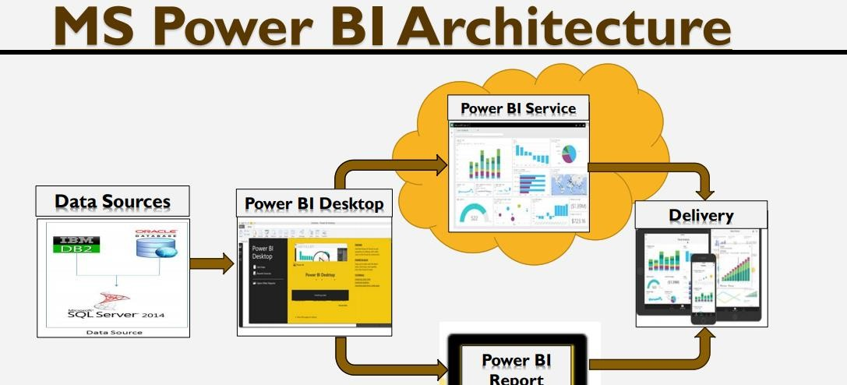

Fig: Power BI Architecture diagram

Microsoft Power BI Desktop is a companion desktop application to Power BI.

With Power BI Desktop, you can:

- Get data:
The Power BI Desktop makes discovering data easy. You can import data from a wide variety of data sources. After you connect to a data source, you can shape the data to match your analysis and reporting needs.

- Create relationships and enrich your data model with new measures and data formats:
When you import two or more tables, oftentimes you'll need to create relationships between those tables. The Power BI Desktop includes the Manage Relationships dialog and the Relationships view, where you can use Autodetect to let the Power BI Desktop find and create any relationships, or you can create them yourself. You can also very easily create your own measures and calculations or customize data formats and categories to enrich your data for additional insights.

- Create reports:
The Power BI Desktop includes the Report View. Select the fields you want, add filters, choose from dozens of visualizations, format your reports with custom colours, gradients and several other options. The Report View gives you the same great report and visualizations tools just like when creating a report on PowerBI.com.

- Save your reports:
With the Power BI Desktop, you can save your work as a Power BI Desktop file. Power BI Desktop files have a .pbix extension.

- Upload or publish your reports:
You can upload the reports you created and saved in the Desktop to your Power BI site. You can also publish them to Power BI right from Power BI Desktop.

3. Architecture Description

Data Description
The Air Travel dataset includes comprehensive details on various aspects of air travel, spanning multiple airlines, routes, and time periods. This dataset is crucial for analyzing trends, performance, and insights in the airline industry.

Data Components:
- Flight Information:
  - Flight Number: Unique identifier for each flight.
  - Airline: The airline operating the flight.
  - Departure and Arrival Airports: Airports from which flights depart and arrive.
  - Departure and Arrival Times: Scheduled and actual times of departure and arrival.
  - Flight Duration: The duration of each flight.
- Route Details:
  - Origin and Destination: Cities or airports between which the flights operate.
  - Distance: The distance between the origin and destination.
- Operational Metrics:
  - On-Time Performance: Metrics related to flight punctuality, including on-time arrival and departure rates.
  - Delay Information: Details on flight delays, including the duration and causes of delays.
- Traffic Volume:
  - Number of Flights: Total number of flights for specific routes, airlines, or time periods.
  - Passenger Count: The number of passengers carried on each flight.
- Financial Metrics:
  - Revenue: Earnings generated from ticket sales and other services.
  - Costs: Operational costs, including fuel, maintenance, and staffing.

Key Measures and Definitions:

Route Analysis
Route analysis focuses on the busiest routes, identifying key hubs and traffic patterns. It involves analyzing the number of flights, passenger counts, and operational efficiency on different routes.

Marketing Insight
Marketing insights involve understanding the promotional strategies and market positioning of different airlines. This includes analyzing the number of flights promoted, advertising efforts, and market share.

Operational Insight
Operational insights provide an in-depth look at the operational efficiency and performance of airlines. Metrics include the total number of flights operated, on-time performance, and average delay times.

Traffic Volume
Traffic volume analysis examines the number of flights and passengers during different periods, identifying peak travel times and trends. This includes daily, weekly, and seasonal variations in traffic.

Punctuality Analysis
Punctuality analysis evaluates the on-time performance of flights, highlighting airlines with the highest and lowest punctuality rates. It also examines the average delay duration and its impact on passengers and operations.

Benefits of the Dataset:
- Improved Decision-Making: Provides critical insights for airline operations, marketing, and strategic planning.
- Operational Efficiency: Helps identify areas for improving flight punctuality and reducing delays.
- Market Analysis: Offers a comprehensive view of market trends and competitive positioning of airlines.
- Customer Satisfaction: Enhances understanding of passenger preferences and service quality, contributing to improved customer satisfaction.

Pros of Using the Dataset:
- Comprehensive analysis of air travel trends and performance.
- Identification of key operational and marketing insights.
- Enhanced decision-making capabilities for airlines and stakeholders.

Cons of Using the Dataset:
- Requires extensive data cleaning and transformation for accurate analysis.
- Potential for incomplete or inconsistent data entries affecting analysis quality.

Analytical Tools and Techniques:

Data Cleaning:
- Ensuring the dataset is free from inconsistencies and errors for accurate analysis.

Data Transformation:
- Applying various techniques to prepare the data for in-depth analysis and visualization.

Data Modeling and Visualization:
- Leveraging tools like Power BI to create interactive and insightful visualizations for better decision-making.
By utilizing this dataset, analysts can derive valuable insights into the airline industry's operational performance, market trends, and customer satisfaction, enabling more informed decisions and strategic planning.

3.2. Data Transformation
In the Transformation Process, we will convert our original datasets with other necessary attributes format. Originally datasets are in the form of wide dataset we converted into long datatype which will be useful for analysis Removing of NaN values and duplicate values. Conversion of monthly data into quarterly and yearly data. Filtering data according to countries

3.3. Power BI Configuration

Step 1: Configuring Data Source

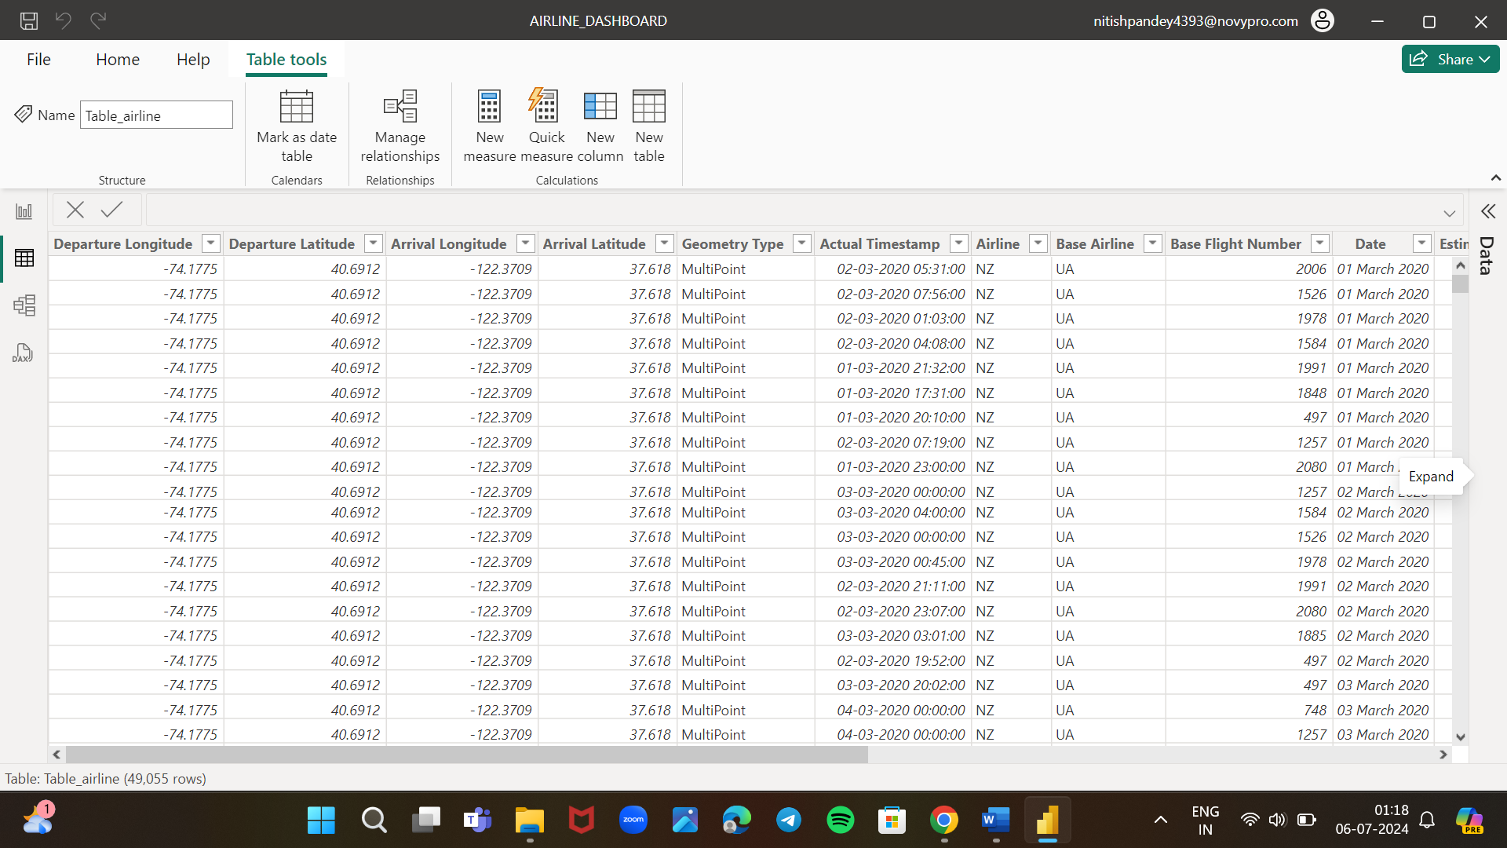

Step 2: Filtering the data

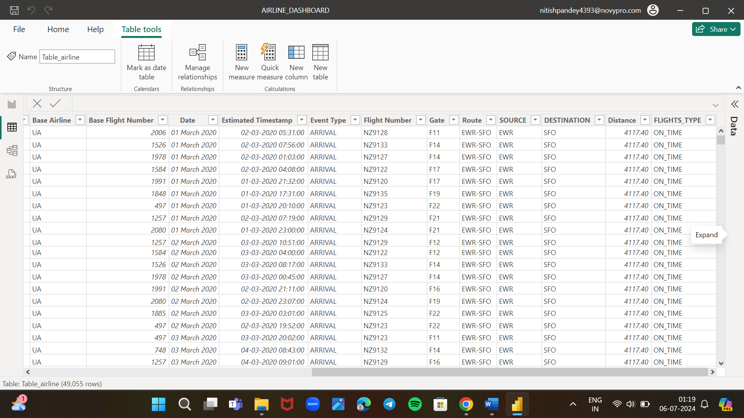

3.4 Deployment

To deploy the dashboard to the Power BI service, you need a Power BI Pro or Power BI Premium account. With the appropriate account, you can publish your Power BI Desktop file (.pbix) to the Power BI service directly from Power BI Desktop. Click on the "Publish" button, sign in with your Power BI account, and select the workspace where you want to deploy the dashboard.

