Wireframe Documentation

AIR TRAVEL DATA ANALYSIS

THIS IS DASHBOARD :-

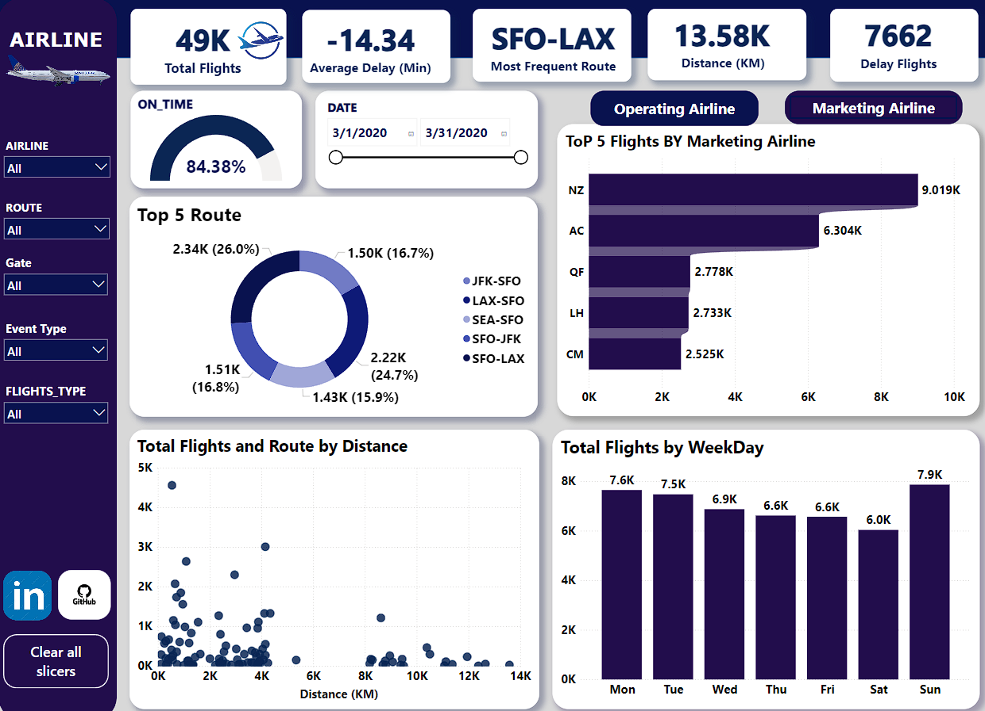

Key Insights from the Project:
🔍 Route Analysis:
💠 The route between Los Angeles and San Francisco is one of the busiest
in the United States.
💠 Los Angeles (LAX) has the most departing flights with a total of 2,220,
while San Francisco (SFO) receives the most arriving flights at 2,338. The
distance between these two major cities is approximately 543.95 Km.
🔍 Marketing Insight:
Air New Zealand is considered a top marketing airline with 4.5k flights,
likely referring to the number of flights they advertise or promote
heavily.
🔍 Operational Insight:
United Airlines is a top operating airline with 26.14k flights, indicating
they have a significantly larger network and handle many more flights
overall.
🔍 Longest Route:
The route between San Francisco and Singapore is the longest route,
spanning approximately 13,583.42 kilometers.
🔍 Traffic Volume:
Sundays see the highest volume of air traffic, with an average of
approximately 7,900 departing flights.
🔍 Punctuality Analysis:
💠 Singapore Airlines has an on-time arrival rate of 64.70%, but they have a
higher number of delayed flights compared to other airlines, with an
average delay of 40 minutes per delayed flight.
💠 New Zealand Airline shines with an on-time arrival rate of 91.035%,
making them a strong choice for travelers who prioritize punctuality.

