**3. Create a HBase Filter to filter out the customer information where location is AUS**

import org.apache.hadoop.hbase.filter.CompareFilter

import org.apache.hadoop.hbase.filter.SingleColumnValueFilter

import org.apache.hadoop.hbase.filter.SubstringComparator

import org.apache.hadoop.hbase.util.Bytes

hbase(main):014:0> scan 'customer', {LIMIT => 10, FILTER => SingleColumnValueFilter.new(Bytes.toBytes('details'), Bytes.toBytes('location'), CompareFilter::CompareOp.valueOf('EQUAL'), Bytes.toBytes('AUS')), COLUMNS =>'details'}

ROW COLUMN+CELL

3 column=details:age, timestamp=1494086673558, value=26

3 column=details:location, timestamp=1494086673558, value=AU S

3 column=details:name, timestamp=1494086673558, value=Rohit

1 row(s) in 0.1330 seconds

**4. Create a Python program that connects to HBase using Thrift protocol and gets names of all**

**HBase tables**

**Create script**

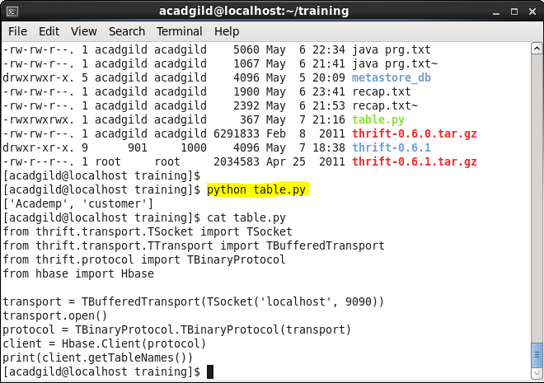

**Runnung python script:**

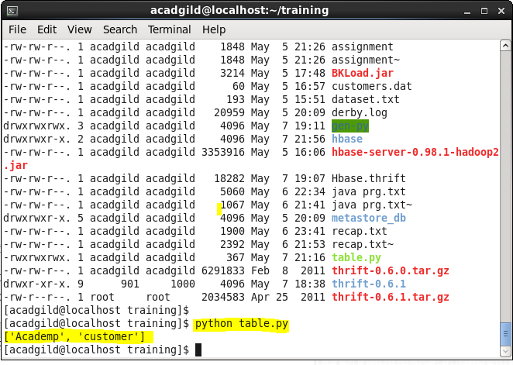

Login to hbase shell and check the list of tables present:

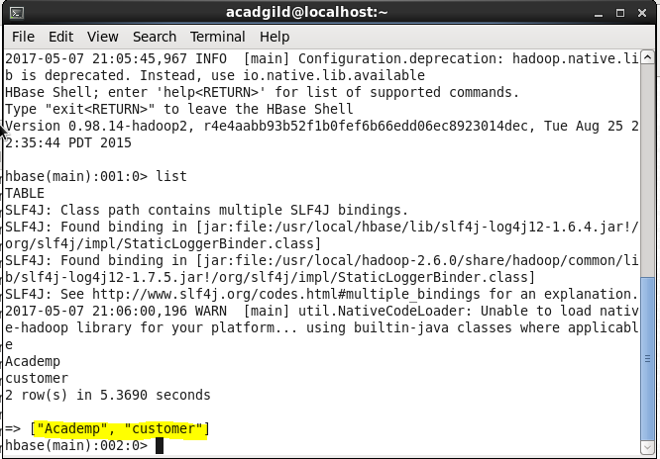

**Running thrift server:**

