1. We should have Login and Registration columns on the screen like below:

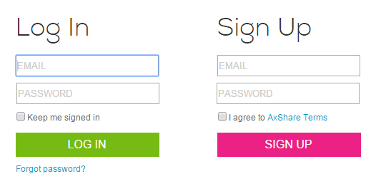

1. Allow login options using social media accounts like Google, Facebook etc. As now a days no one bothers to signup.

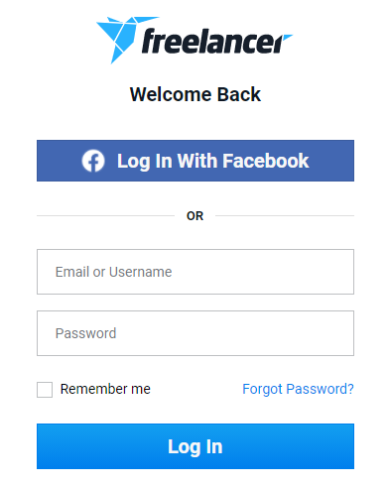

1. Allow users to check their passwords with the help of Show Password checkbox.

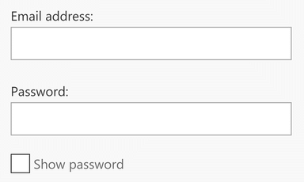

1. Allow users to see warning message if CAPS Lock key is on.