1. Cursor should remain either same or hand cursor while clicking or hovering on Login button after entering Username and Password but it is changing to red circle cursor.



1. Login button remains disable when we navigate back to Login page from Success page even after entering Username and Password.



Click on back button and Login Page appears. Now, username ideally should be clear from the field like password but it is still persist and after entering password Login button remains disable.



1. Consistency between the Buttons on different pages

On Login Page as soon as the User enters Username and Password, Login Button enables else it displayed as in disable state.



On Forgot Password page Submit Button seems to be disable all the time but actually it is enabled.



On Register Page both the button seems to be enable all the time whether user enters email/password or not.



1. While clicking on “Back to Login” link on Forgot Password page it should navigate to the Login Page, however it is navigating to the Register Page





1. Application is giving 500 Internal server error while clicking on the Submit button on Register page on following conditions:

* Without entering Username and Password
* Entering only Password
* Entering Password and Confirm Password

Ideally the Submit button should remain disable until user enters the Email.

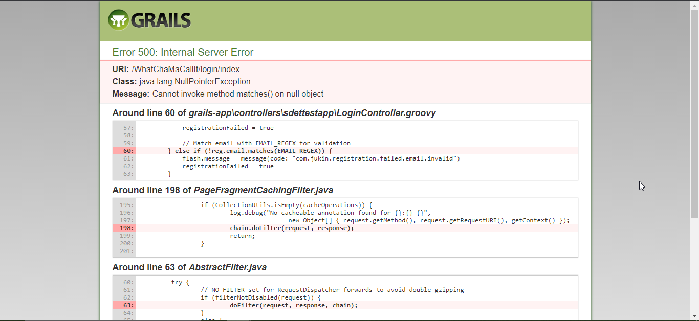

1. Password is not restricted to the mentioned rules. Any combination is working with the valid email.





1. **Please enter a valid email** message is there on the page all the time if user enter once the wrong email. Ideally, if the user enters a valid email then the message should not appear on the screen.

