**RESUME**

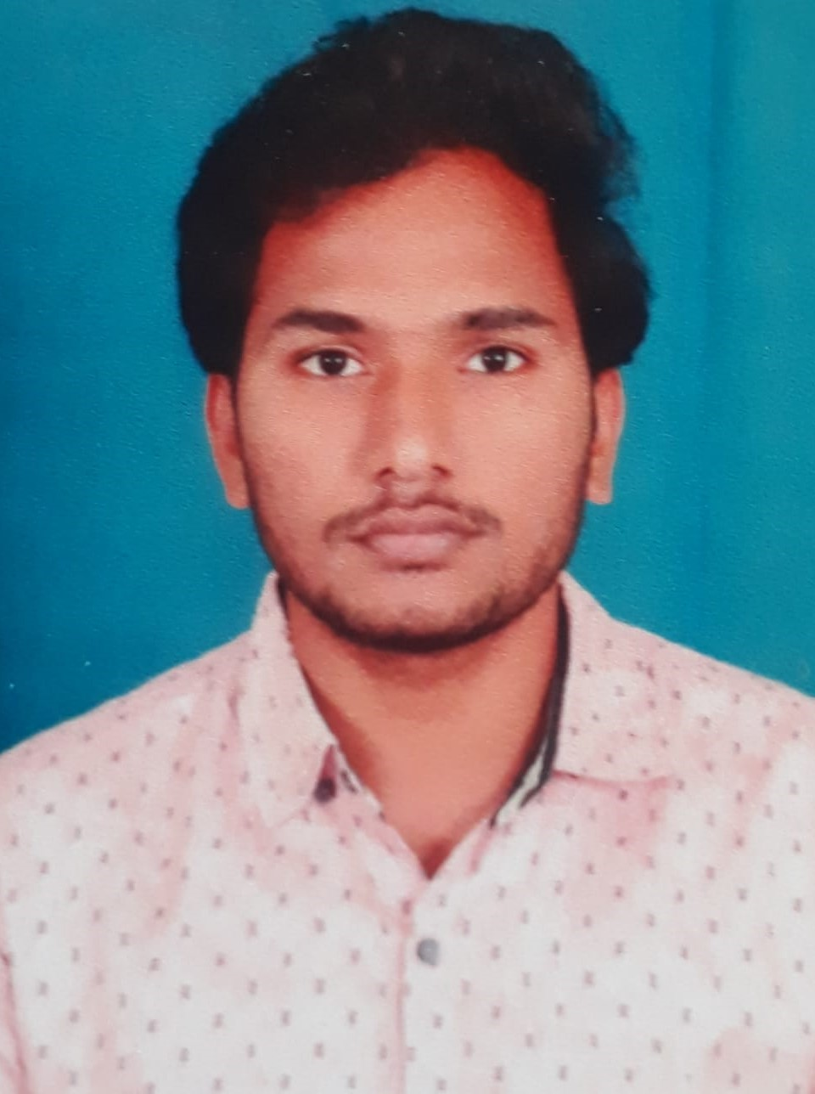

NAME: CHALLA NITISH KUMAR

MOBILE: +91-9701465279

EMAIL: [chnitishkumar160@gmail.com](mailto:chnitishkumar160@gmail.com)

**CAREER OBJECTIVE**

To pursue a challenging career with dedication and provide my efficiency to the fullest in profession organizational environment.

**QUALIFICATION**

|  |  |  |  |  |
| --- | --- | --- | --- | --- |
| **Qualification** | **School/College & City** | **Board/University** | **Year of Study** | **Percentage/**  **CGPA** |
| B.Tech(ECE) | R.V.R&J.C College of Engineering-Guntur | Acharya Nagarjuna University | 2019-2022 | 7.4 |
| Diploma  (ECE) | D.V.R&Dr.H.S MIC College of Technology-Kanchikacherla | State Board of Technical Education& Training  -AP | 2016-2019 | 88% |
| XthClass | SSK EM High School-Mylavaram | Board of Secondary Education –A.P | 2015-2016 | 8.7 |

**CERTIFICATIONS**

|  |  |  |
| --- | --- | --- |
| COURSE | ORGANISATION | Duration(mm/yy) |
| Python | NPTEL(IIT-MADRAS & SUN Technologies | 01/2021-04/2021 |
| Web Development | VERZEO | 05/2021-06/2021 |
| CCNA | CISCO | 11/2018-04/2019 |
| PCB Design | Microlink | 06/2017-09/2017 |

**PROJECTS**

* As a final year project worked in Wi-Fi Offloading using Q-learning approch
* A project on Home Automation using ardino
* Done a project on CDP&LLDP with the help of CISCO Packet tracer
* Mini project on Light Sensor using Photo Diode
* Automatic Bottle filling & Sorting using PLC

**STRENGTHS**

* Good Technical Knowledge
* Sound Technical Knowledge
* Quick decision taking capability at any situation
* Good team player
* Enthusiastic to learn

**HOBBIES**

* Playing sports like Cricket,Badmition
* Watching movies and Listening to Music
* Web browsing

**PERSONAL DETAILS**

* First Name : Nitish Kumar
* Last Name : Challa
* Father’s Name : Chandar Rao
* Mother’s Name :Lakshmi Tulsi
* Date of Birth :02/10/2000

**ADDRESS**

* D.NO :1-62/A
* Street : Near Muthyalamaa Temple Raod
* Village : Narayana puram
* District : Khammam
* State :Telangana
* Pin code : 507201

**DECLARATION**

I hereby, declare that the above mentioned information is true and correct to the best of my knowledge.

Place: Signature: Nitish Kumar Challa