Java: OpenJDK 1.8.0-262

IDE: Intellij 2020.3 Community Edition

Maven: 3.6.3

Spring boot: 2.4.4

URL: <http://localhost:8080/fileUpload>

Method: POST

Postman: 8.0.7

Github: https://github.com/nitishcm/fileapp

**How to Run application:**

1. Copy fileapp-0.0.1-SNAPSHOT.jar to desired directory
2. Run *java -jar fileapp-0.0.1-SNAPSHOT.jar*

**Request Details:**

1. Total file size <= 50 MB
2. Single file size <= 50 MB
3. File size > 0 KB will be considered
4. Request body type = form-data

*The file size limit is configurable in application.properties*

*All the error messages are in message.properties*

**File Naming convention** :

The request has input type as form*-data* with files and optional text input ***zipfilename****.* If *zipfilename* is provided and matching format [a-zA-Z0-9_].zip then final file name will be as given. If *zipfilename* is not present or invalid value then the final file name will be **compress_<timestamp>.zip**

**Scenarios**

1. Multiple files within given range of size and no zipfilename

Output: Zip file with all the files will be generated

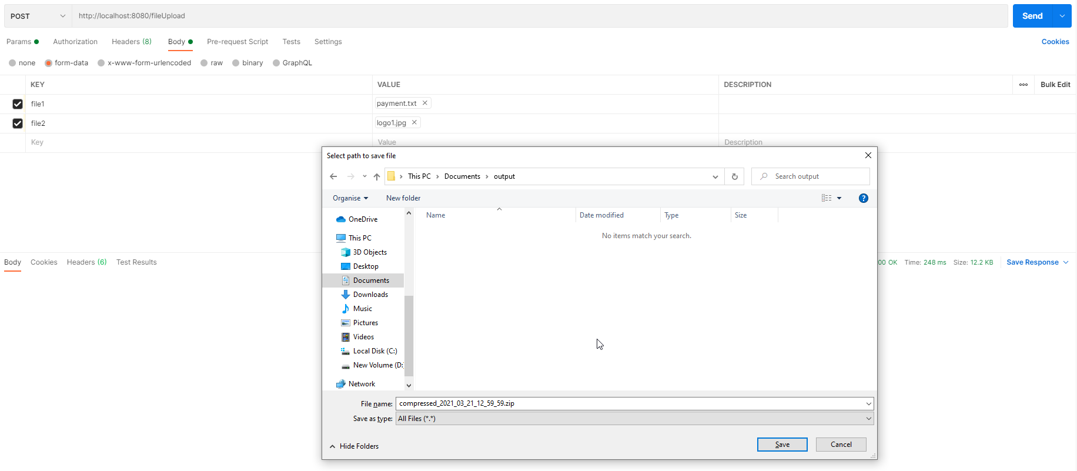

1. Multiple files within given range and *zipefilename*

Output: Zip file with given files generated

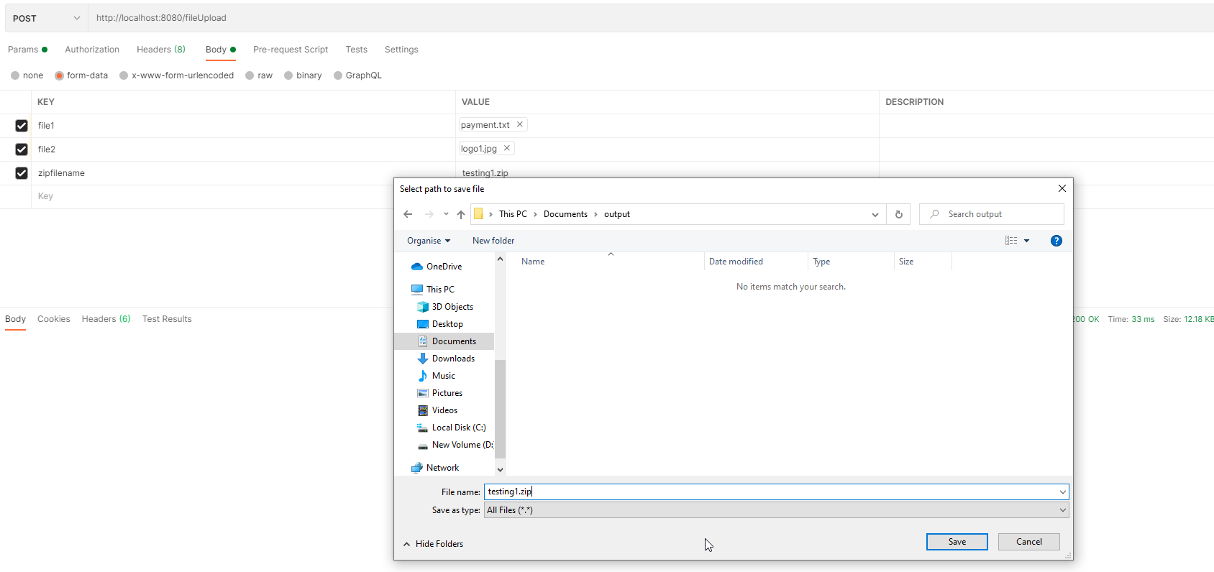

1. Multiple files with 1 file exceeding size limit

Output: Error message will be displayed

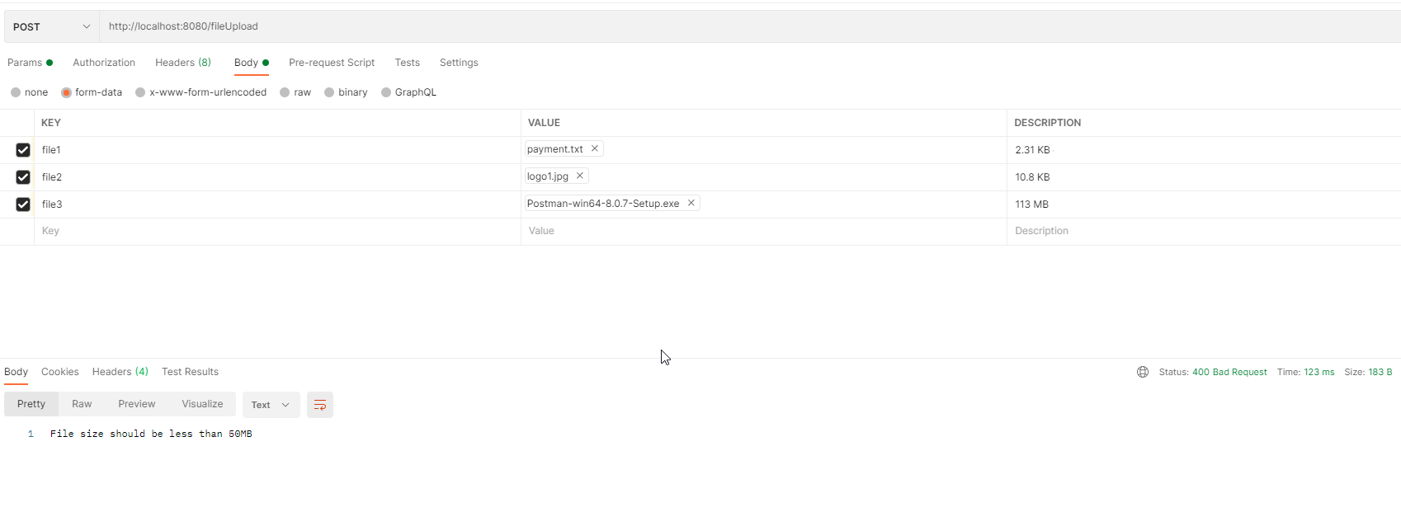

1. Multiple files are within size limit but exceeding overall size limit

Output: Error message will be displayed

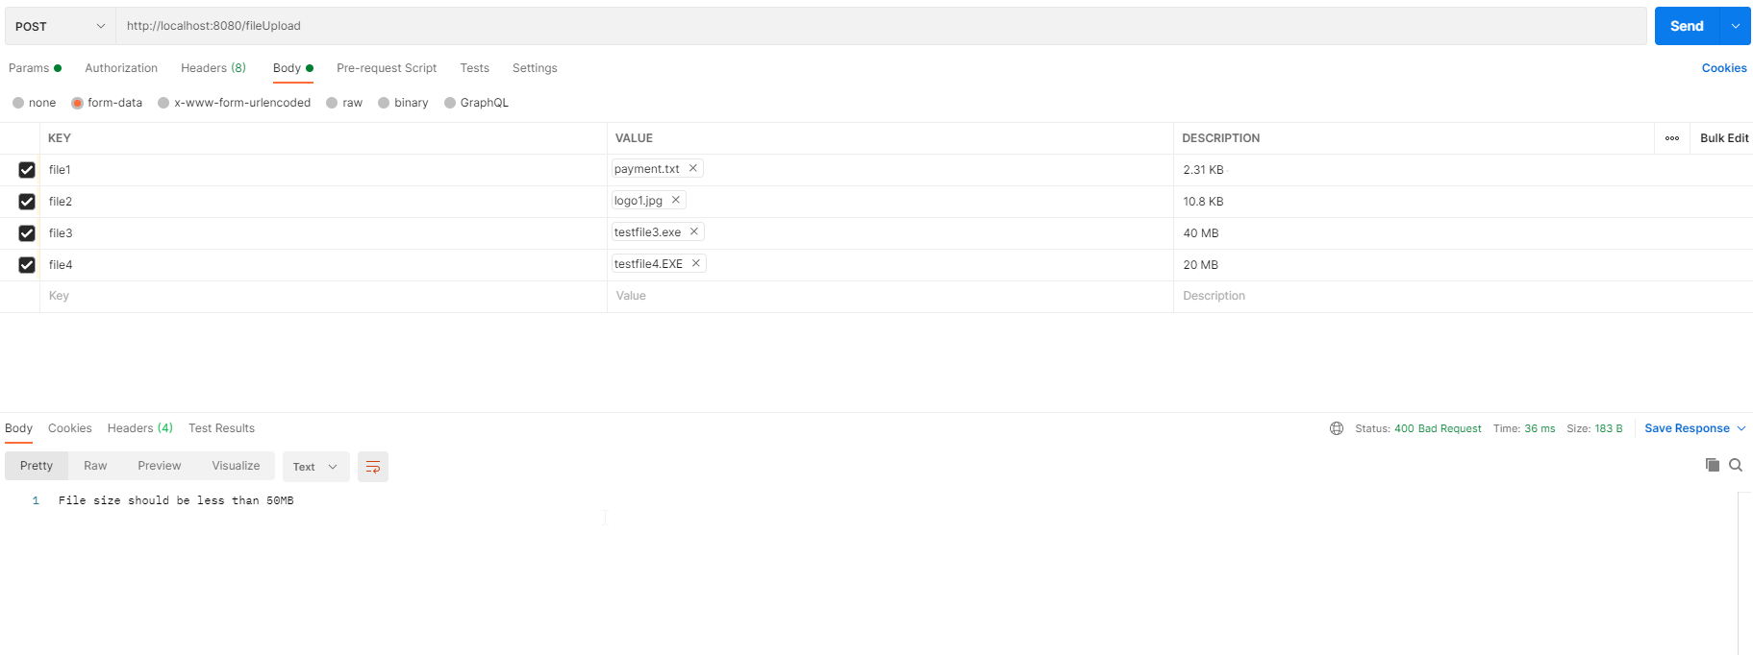

1. Multiple files with valid size limits and invalid *zipfilename*

Output: File generated with default naming convention

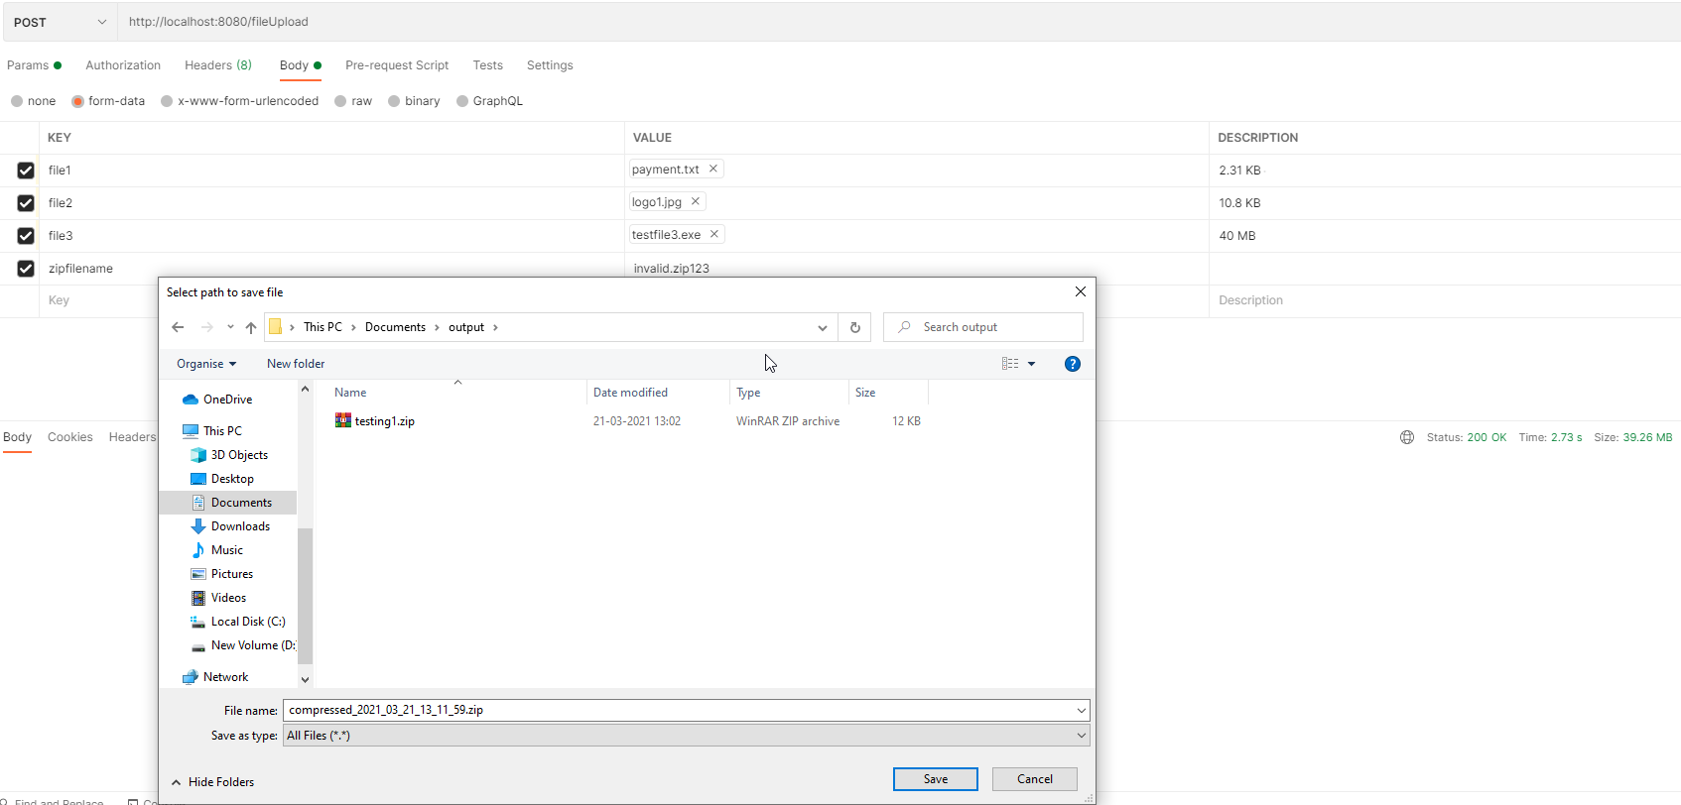

1. Multiple files with one file of 0 KB

Output: Final zip will not have testfile4.txt

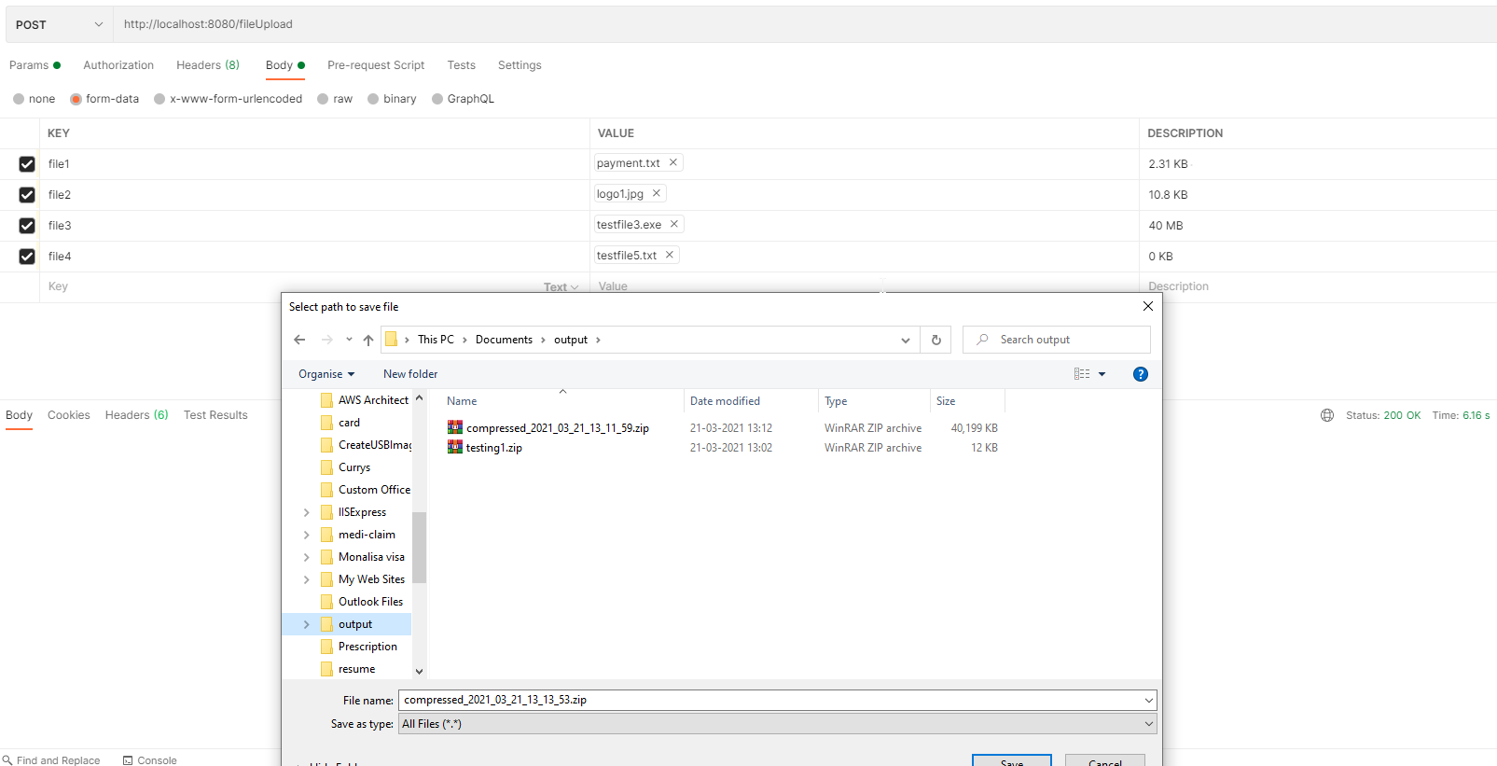

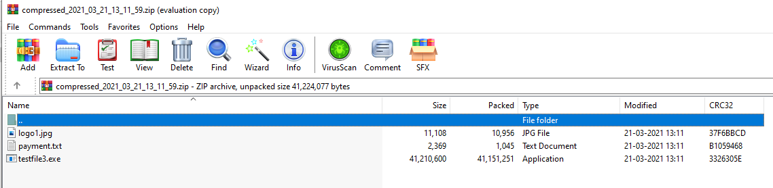

1. Other Request body type than *form-data*

Output: Error message

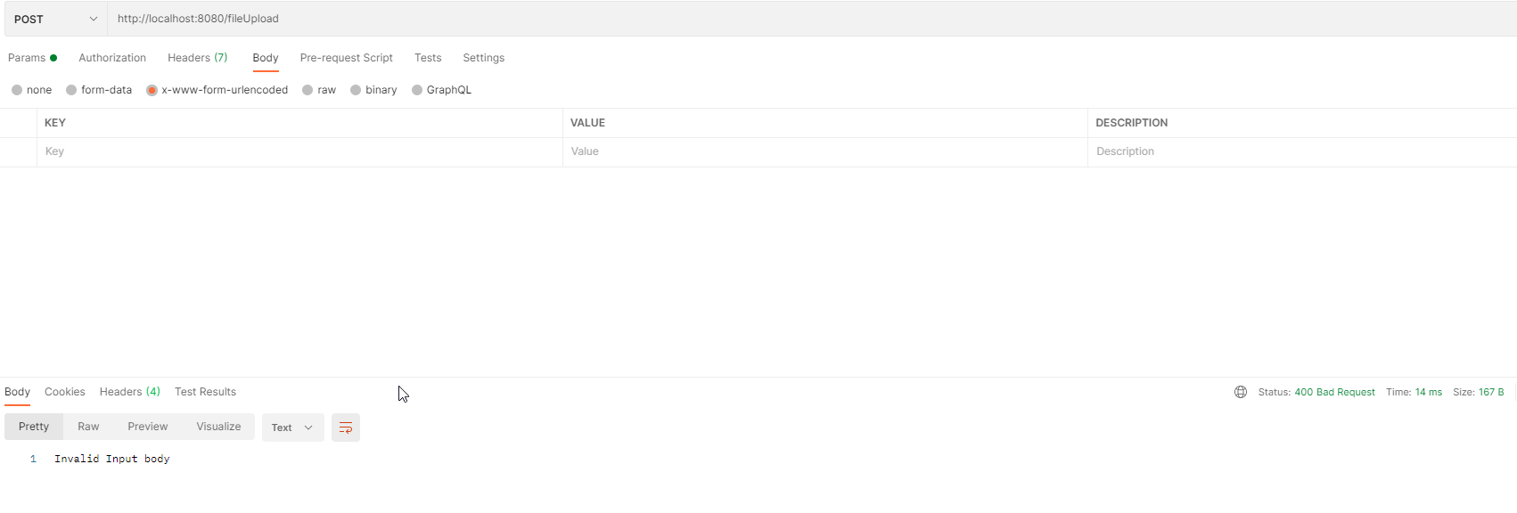

1. No files in request

Output: Error message will be displayed

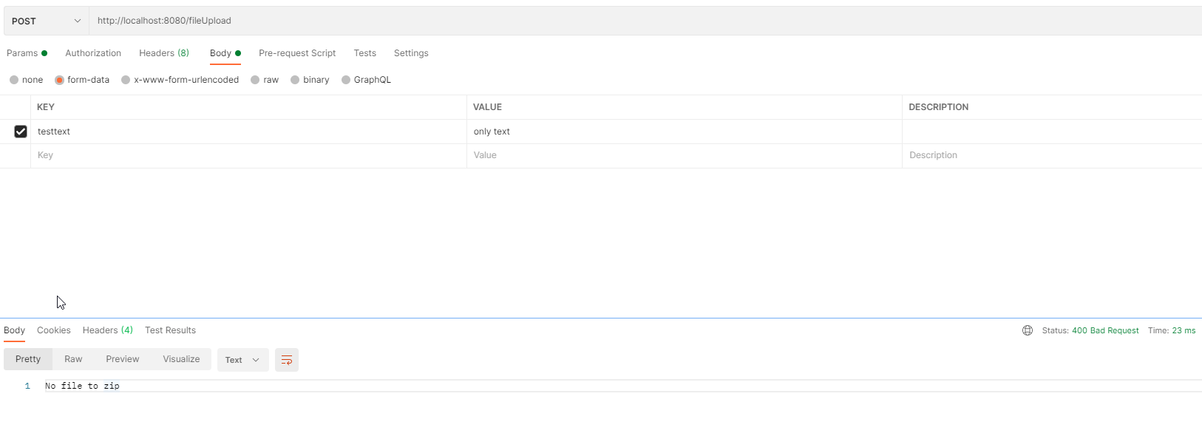

1. Request has file of size 0 KB

Output: Error message will be displayed

