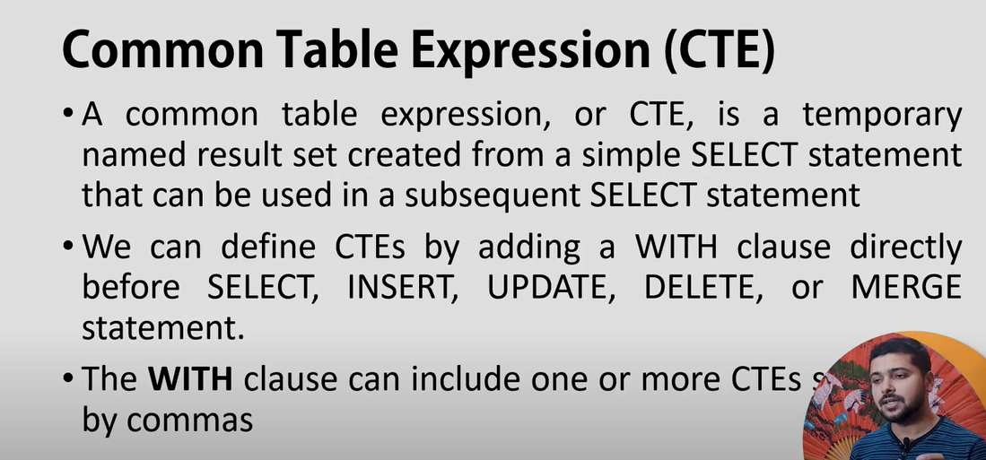

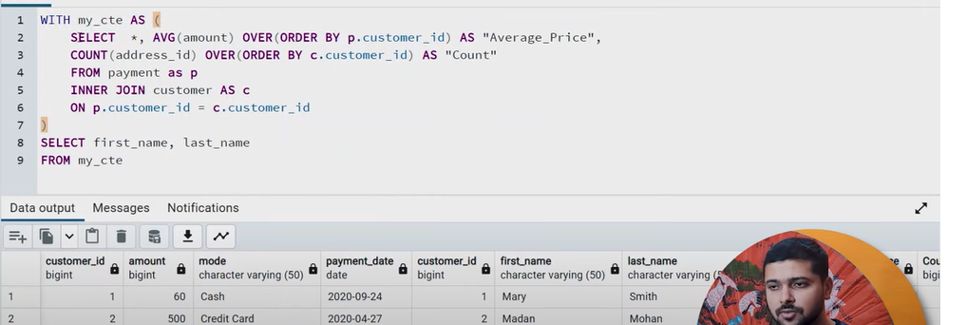

Join in CTE : -

