Cloud Concepts - Principles of cloud computing

Benefits of cloud computing

- It's cost-effective

- It's scalable

- Vertical scaling, also known as "scaling up", is the process of adding resources to increase the power of an existing server. Some examples of vertical scaling are: adding more CPUs, or adding more memory.
- Horizontal scaling, also known as "scaling out", is the process of adding more servers that function together as one unit. For example, you have more than one server processing incoming requests.

- It's elastic- As your workload changes due to a spike or drop in demand, a cloud computing system can compensate by automatically adding or removing resources.

- It's current- When you use the cloud, you're able to focus on what matters: building and deploying applications. Cloud usage eliminates the burdens of maintaining software patches, hardware setup, upgrades, and other IT management tasks. All of this is automatically done for you to ensure you're using the latest and greatest tools to run your business.

- It's reliable- When you're running a business, you want to be confident your data is always going to be there. Cloud computing providers offer data backup, disaster recovery, and data replication services to make sure your data is always safe. In addition, redundancy is often built into cloud services architecture so if one component fails, a backup component takes its place. This is referred to as fault tolerance and it ensures that your customers aren't impacted when a disaster occurs.

- It's global- Cloud providers have fully redundant datacentres located in various regions all over the globe. This gives you a local presence close to your customers to give them the best response time possible no matter where in the world they are.

- It's secure- Think about how you secure your datacentre. You have physical security – who can access the building, who can operate the server racks, and so on. You also have digital security – who can connect to your systems and data over the network.

Economies of scale
- Economies of scale is the ability to do things more efficiently or at a lower-cost per unit when operating at a larger scale. This cost advantage is an important benefit in cloud computing.

Capital expenditure (CapEx) versus operational expenditure (OpEx)

- Capital Expenditure (CapEx): CapEx is the spending of money on physical infrastructure up front, and then deducting that expense from your tax bill over time. CapEx is an upfront cost, which has a value that reduces over time.

- Operational Expenditure (OpEx): OpEx is spending money on services or products now and being billed for them now. You can deduct this expense from your tax bill in the same year. There's no upfront cost. You pay for a service or product as you use it.

CapEx computing costs
- Server Costs
- Storage Costs
- Network Costs
- Backup and archive costs
- Organization continuity and disaster recovery costs
- Datacentre Infrastructure code
- Technical personnel

OpEx cloud computing costs
- Leasing software and customized features
- Scaling charges based on usage/demand instead of fixed hardware or capacity.
- Billing at the user or organization level.

Benefits of CapEx
- With capital expenditures, you plan your expenses at the start of a project or budget period. Your costs are fixed, meaning you know exactly how much is being spent. This is appealing when you need to predict the expenses before a project starts due to a limited budget.

Benefits of OpEx
- Demand and growth can be unpredictable and can outpace expectation, which is a challenge for the CapEx model.
- With the OpEx model, companies wanting to try a new product or service don't need to invest in equipment. Instead, they pay as much or as little for the infrastructure as required.
- OpEx is particularly appealing if the demand fluctuates or is unknown. Cloud services are often said to be agile. Cloud agility is the ability to rapidly change an IT infrastructure to adapt to the evolving needs of the business. For example, if your service peaks one month, you can scale to demand and pay a larger bill for the month. If the following month the demand drops, you can reduce the used resources and be charged less. This agility lets you manage your costs dynamically, optimizing spending as requirements change.

Cloud deployment models

A cloud deployment model defines where your data is stored and how your customers interact with it – how do they get to it, and where do the applications run? It also depends on how much of your own infrastructure you want or need to manage.

Three deployment methods of cloud computing

Public cloud - In this case, you have no local hardware to manage or keep up-to-date – everything runs on your cloud provider's hardware. In some cases, you can save additional costs by sharing computing resources with other cloud users.

Private cloud - In a private cloud, you create a cloud environment in your own datacentre and provide self-service access to compute resources to users in your organization. This offers a simulation of a public cloud to your users, but you remain completely responsible for the purchase and maintenance of the hardware and software services you provide.

Hybrid cloud- A hybrid cloud combines public and private clouds, allowing you to run your applications in the most appropriate location. For example, you could host a website in the public cloud and link it to a highly secure database hosted in your private cloud (or on-premises datacentre).

Types of cloud services

Infrastructure as a service (IaaS)

Infrastructure as a Service is the most flexible category of cloud services. It aims to give you the most control over the provided hardware that runs your application (IT infrastructure servers and virtual machines (VMs), storage, and operating systems). Instead of buying hardware, with IaaS, you rent it. It's an instant computing infrastructure, provisioned and managed over the internet.
When using IaaS, ensuring that a service is up and running is a shared responsibility.

IaaS is commonly used in the following scenarios:

- Migrating workloads. Typically, IaaS facilities are managed in a similar way as on-premises infrastructure and provide an easy migration path for moving existing applications to the cloud.
- Test and development. Teams can quickly set up and dismantle test and development environments, bringing new applications to market faster. IaaS makes scaling development and testing environments, fast and economical.
- Storage, backup, and recovery. Organizations avoid the capital outlay and complexity of storage management, which typically requires skilled staff to manage data and meet legal and compliance requirements. IaaS is useful for managing unpredictable demand and steadily growing storage needs. IaaS can also simplify the planning and management of backup and recovery systems

Platform as a service (PaaS)

PaaS provides an environment for building, testing, and deploying software applications. The goal of PaaS is to help you create an application quickly without managing the underlying infrastructure. For example, when deploying a web application using PaaS, you don't have to install an operating system, web server, or even system updates.

PaaS is a complete development and deployment environment in the cloud, with resources that enable organizations to deliver everything from simple cloud-based apps to sophisticated cloud-enabled enterprise applications. Resources are purchased from a cloud service provider on a pay-as-you-go basis and accessed over a secure Internet connection.

PaaS is commonly used in the following scenarios:

- Development framework. PaaS provides a framework that developers can build upon to develop or customize cloud-based applications. Just like Microsoft Excel macro, PaaS lets developers create applications using built-in software components. Cloud features such as scalability, high-availability, and multi-tenant capability are included, reducing the amount of coding that developers must do.

- Analytics or business intelligence. Tools provided as a service with PaaS allow organizations to analyse and mine their data. They can find insights and patterns, and predict outcomes to improve business decisions such as forecasting, product design, and investment returns.

Software as a service (SaaS)

SaaS is software that is centrally hosted and managed for the end customer. It is usually based on an architecture where one version of the application is used for all customers, and licensed through a monthly or annual subscription. Office 365, Skype, and Dynamics CRM Online are perfect examples of SaaS software.
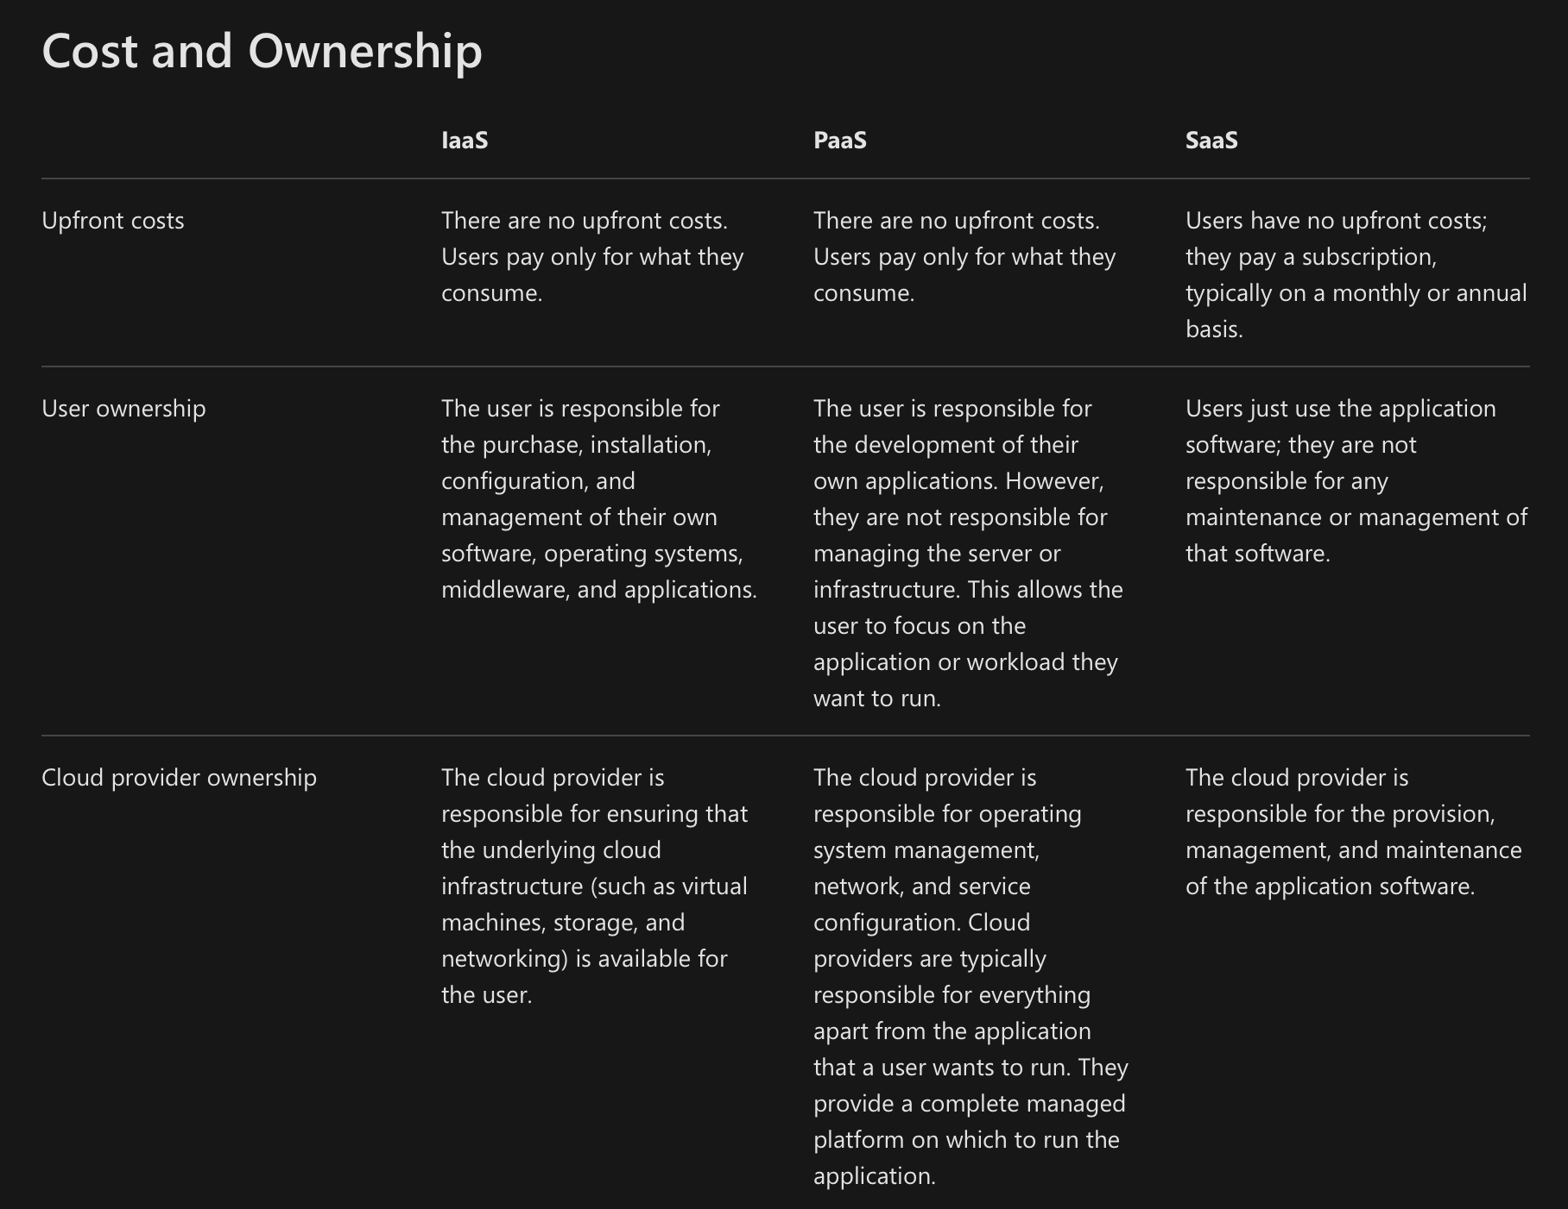
Management responsibilities

- IaaS requires the most user management of all the cloud services. The user is responsible for managing the operating systems, data, and applications.
- PaaS requires less user management. The cloud provider manages the operating systems, and the user is responsible for the applications and data they run and store.
- SaaS requires the least amount of management. The cloud provider is responsible for managing everything, and the end user just uses the software.

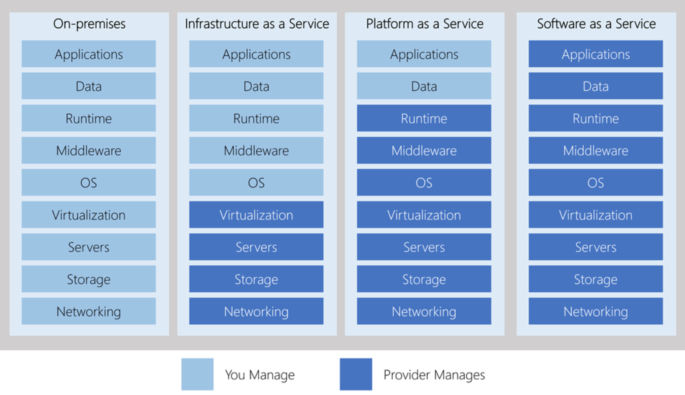

Introduction to Linux on Azure

What is Linux on Azure?

"Linux on Azure" broadly encompasses two different kinds of Azure support for Linux applications and workloads: infrastructure as a service (IaaS) and platform as a service (PaaS)

Linux infrastructure as a service (IaaS)
- Virtual machines can be provisioned and managed on an individual basis, or as virtual machine scale sets: groups of identical VMs managed through a central configuration interface. With scale sets, you can distribute your workloads to achieve high availability, redundancy, load balancing, and manual and automatic elastic scale.
- Azure virtual machines support most common Linux distributions. The Azure Marketplace has hundreds of preconfigured Linux disk images across many popular distributions, all of which have first-class Azure platform support baked in. You can also create or migrate your own disk images, upload them to Azure, and create virtual machines from them.
- IaaS is frequently the initial target for cloud migrations. The IaaS model allows you to reuse much of your on-premises architecture while taking advantage of many benefits provided by the cloud.

Linux platforms as a service (PaaS)

- Azure's Linux-based managed platforms allow you to confidently take advantage of the benefits of PaaS while retaining the technology foundation you're already familiar with. All of Azure's key PaaS offerings, including App Service, Functions, Azure Red Hat OpenShift, Azure Kubernetes Service, and Azure Container Instances support the use of Linux as their foundation and can host Linux-based applications and code natively.
- If your organization uses a Linux-powered development workflow and/or runs production applications on Linux, you can often deploy or migrate applications to a managed Azure platform and enjoy the full benefits of PaaS with a minimum of effort.

Additional Azure tools and services

- Azure Resource Manager provides a standard interface and set of concepts for managing every kind of Azure service and platform.
  - Automate resource provisioning and management from the command line with Azure PowerShell and the Azure CLI, available locally and in the browser via the Azure Cloud Shell, or from your own application code using libraries available for most common languages.

- Get durable, scalable, web-accessible storage with the core Azure storage services:
  - Blobs for unstructured cloud-native storage; Files for mountable file shares; and Queues for reliable messaging between applications. Mountable disk storage for virtual machines is managed just like other cloud resources, and Linux images in the Azure Marketplace have all of the needed drivers built in. Ultra-disk storage provides industry-leading throughput and sub-millisecond latency.
- Achieve flexible and secure communication between VMs, services, and the internet with Azure's virtual networking and network appliances:
  - Use network security groups and Azure Firewall for fine-grained control over the traffic in your virtual network. Direct web traffic to your applications with a comprehensive suite of load balancing and firewall services. Extend your on-premises network connectivity to Azure with VPN Gateway and ExpressRoute. Use HPC-grade VMs with Remote Direct Memory Access (RDMA) to drive demanding high-performance workloads like weather modelling and physical simulations.
- Azure's database services provide both familiar features and unique innovation in cloud-hosted databases.

- Improve the intelligence of your apps with AI and cognitive services
- Maintain control of your applications with a comprehensive set of governance and monitoring capabilities
- Build a secure foundation for your apps and workloads with Azure's security tools and capabilities
- Keep your data safe and your workloads online with an Azure-supported business continuity and disaster recovery strategy.
- Azure Migrate helps you migrate your business workloads from on-premises platforms - whether deployed on physical or virtual servers - to Azure.

How to use Linux on Azure

Every virtual machine you provision has a primary disk containing the boot volume with the VM's operating system, a temporary disk for short-term storage, and optional data disks for arbitrary persisted storage. Disks are available in four performance tiers:
- Standard HDD for latency-insensitive workloads at low cost
- Standard SSD for cost-effective, low-latency performance for workloads with relatively small data requirements
- Premium SSD for guaranteed speed and throughput
- Ultra-disk for data-intensive workloads such as databases

Scaling

Individual VMs can be scaled up and down simply by modifying their sizes, but true cost-effective elastic scale is achieved with Azure's virtual machine scale sets.
A scale set allows you to provision and manage a group of identical VMs. Azure can automatically provision and deprovision VMs within the scale set using auto scale rules based on traffic, load, and timed schedules that you define. Scale sets integrate with Azure Load Balancer to distribute traffic to the VMs in the scale set.

Virtual infrastructure and additional services

Provisioning for VM-based Linux workloads doesn't end with creating VMs:
- Virtual networks define how your VMs connect to each other and the internet
- Network appliances and services like load balancers and firewalls let you control how traffic moves through your virtual networks
- Cloud storage and database services like blob storage, Cosmos DB, Azure SQL, and Azure Cache for Redis can provide storage capabilities with features that can't be achieved in an IaaS-only architecture
- Application services such as Key Vault, Bot Service, and Cognitive Search add features and value to apps that are otherwise IaaS-based

Management

- All resources in Azure, including virtual machines, infrastructure and all the services you'd use as part of your solution, are provisioned, configured, and managed with Azure Resource Manager.

Core Cloud Services - Introduction to Azure

What is Azure?
Azure is Microsoft's cloud computing platform. Azure gives you the freedom to build, manage, and deploy applications on a massive global network using your favourite tools and frameworks.

What is cloud computing?
Cloud computing is the delivery of computing services over the Internet using a pay-as-you-go pricing model. Put another way; it's a way to rent compute power and storage from someone else's data centre. the real value of the cloud is that it enables you to quickly solve your toughest business challenges and bring cutting edge solutions to your users.

Why should I move to the cloud?
To power your services and deliver innovative and novel user experiences more quickly, the cloud provides on-demand access to:
- A nearly limitless pool of raw compute, storage, and networking components.
- Speech recognition and other cognitive services that help make your application stand out from the crowd.
- Analytics services that enable you to make sense of telemetry data coming back from your software and devices.

What can I do on Azure?
Azure provides over 100 services that enable you to do everything from running your existing applications on virtual machines to exploring new software paradigms such as intelligent bots and mixed reality.

Tour of Azure services

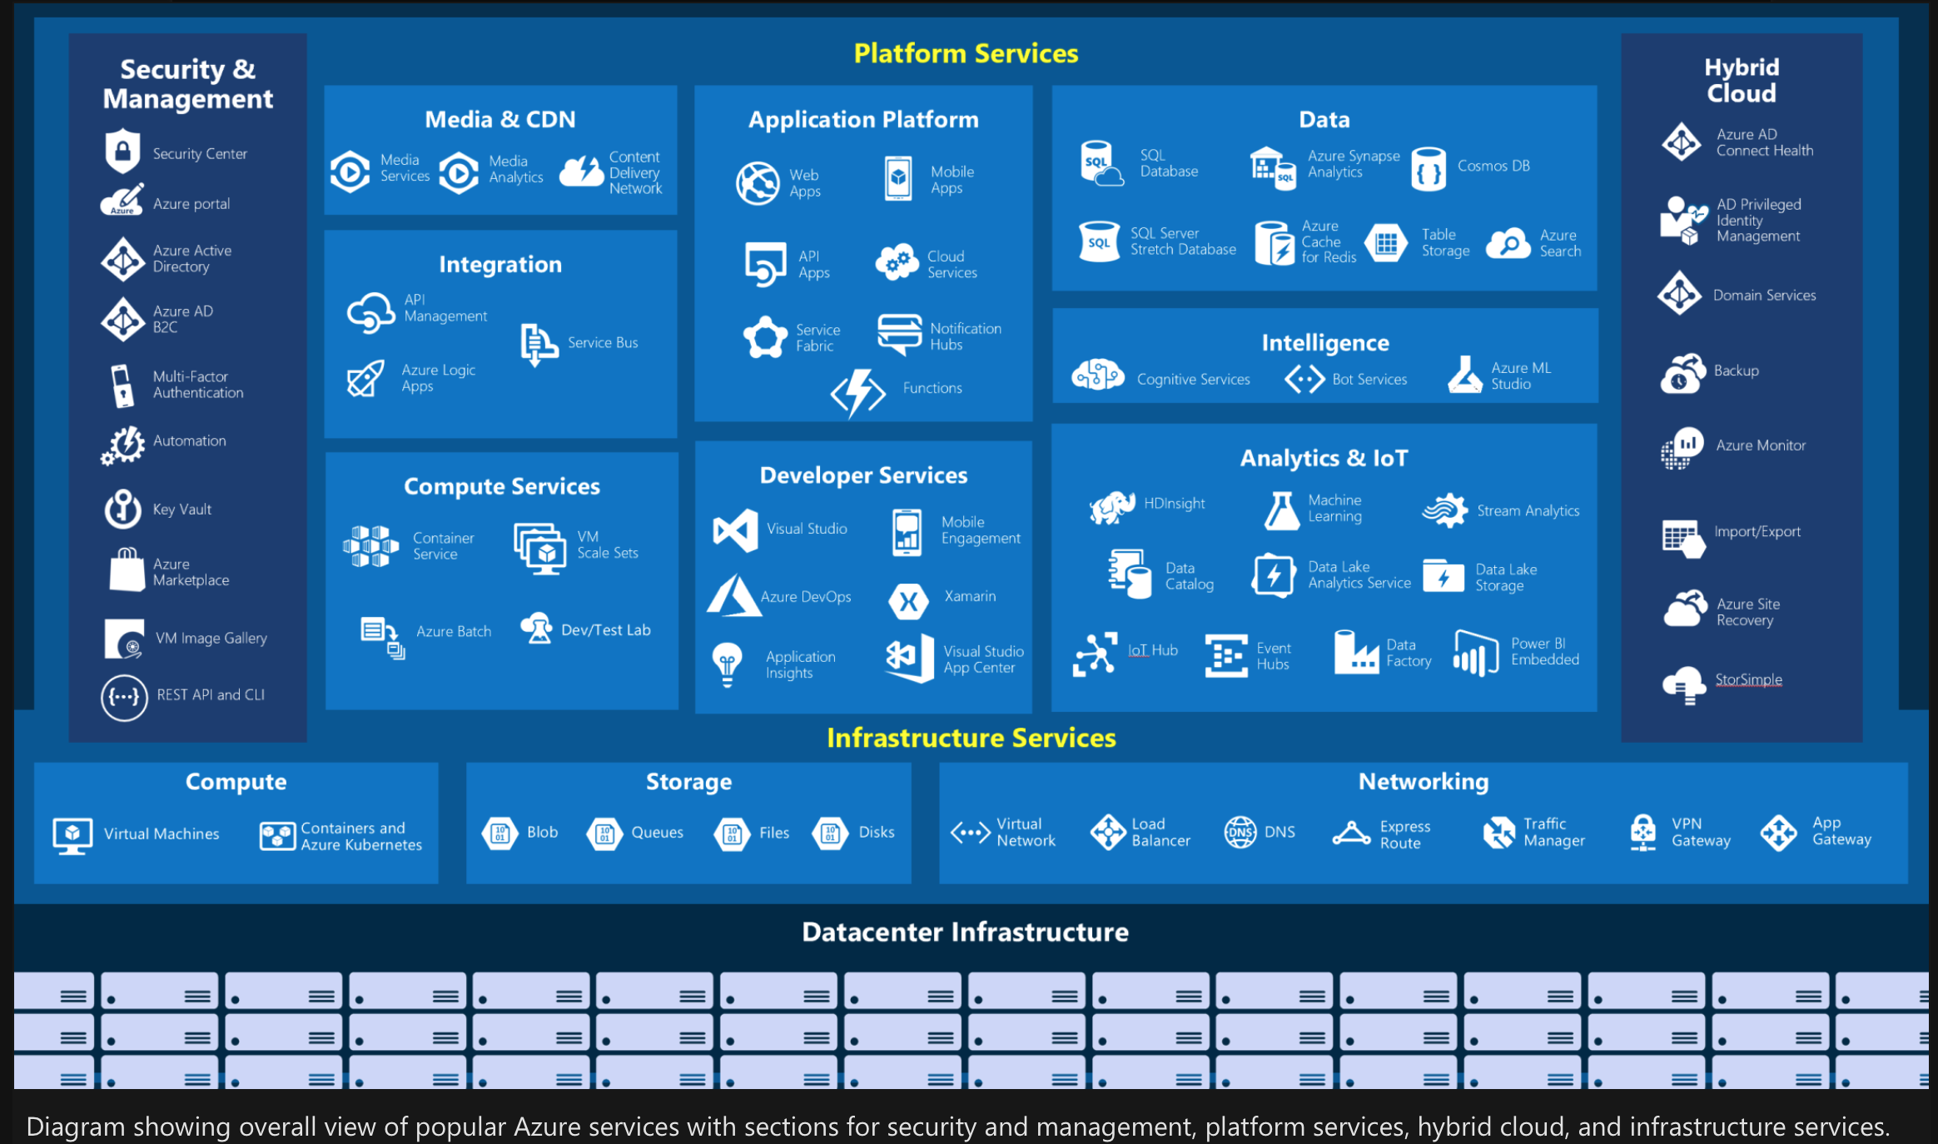

Compute
Compute services are often one of the primary reasons why companies move to the Azure platform. Azure provides a range of options for hosting applications and services. Here are some examples of compute services in Azure:

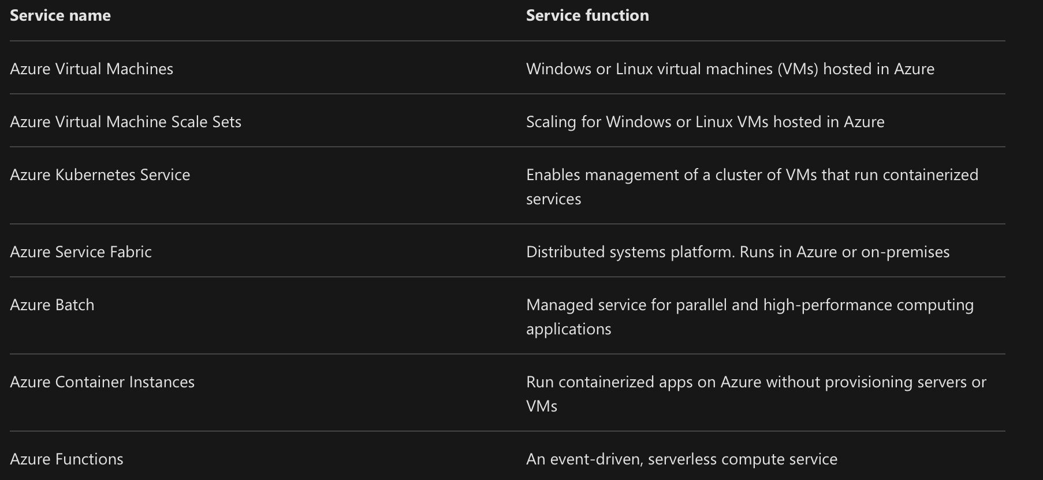

Networking
Linking compute resources and providing access to applications is the key function of Azure networking. Networking functionality in Azure includes a range of options to connect the outside world to services and features in the global Microsoft Azure datacentres.

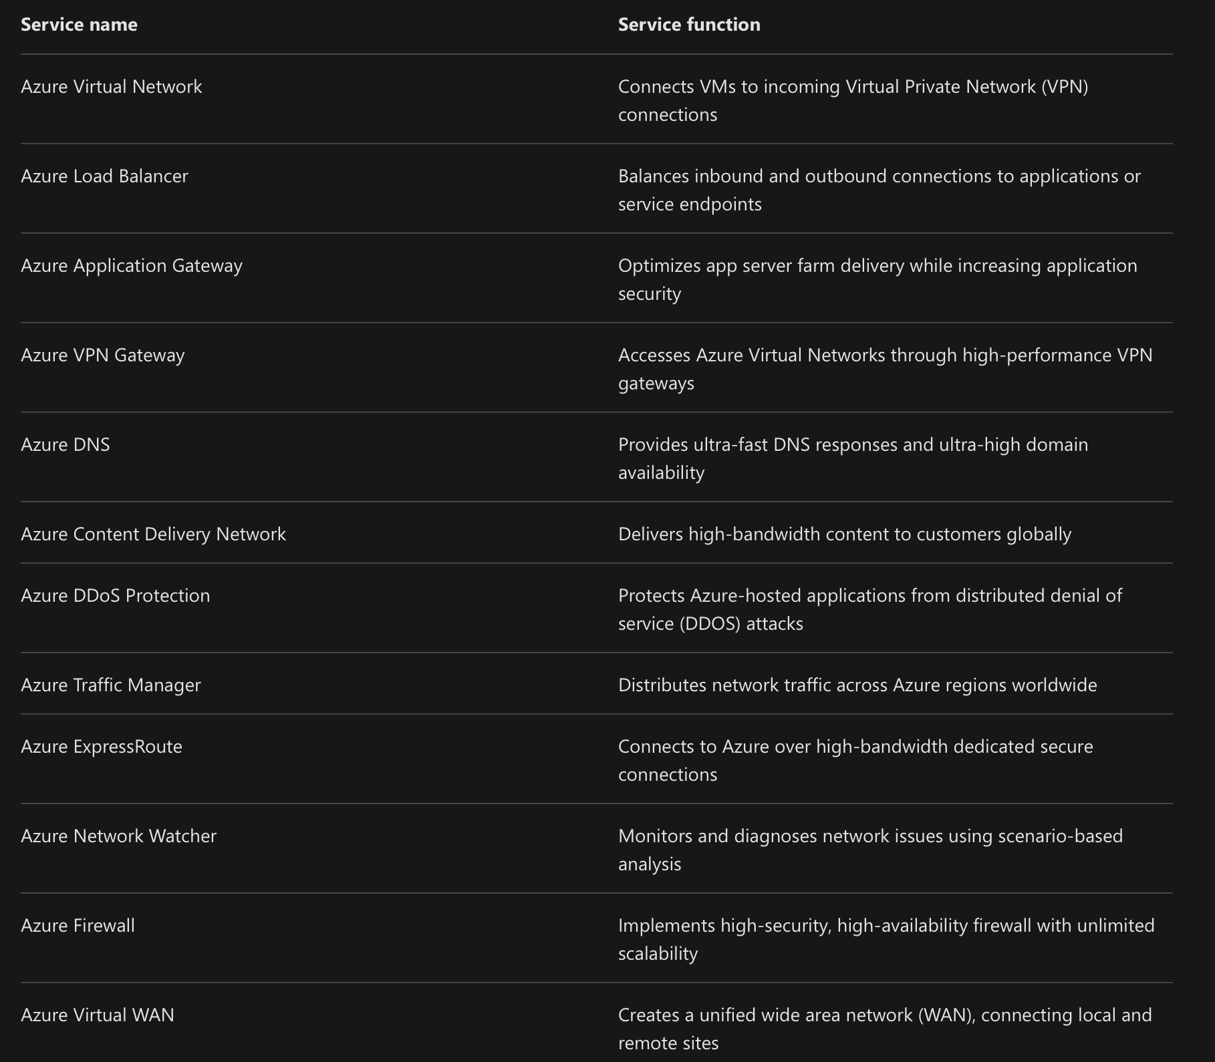

Storage
Azure provides four main types of storage services. These services are:

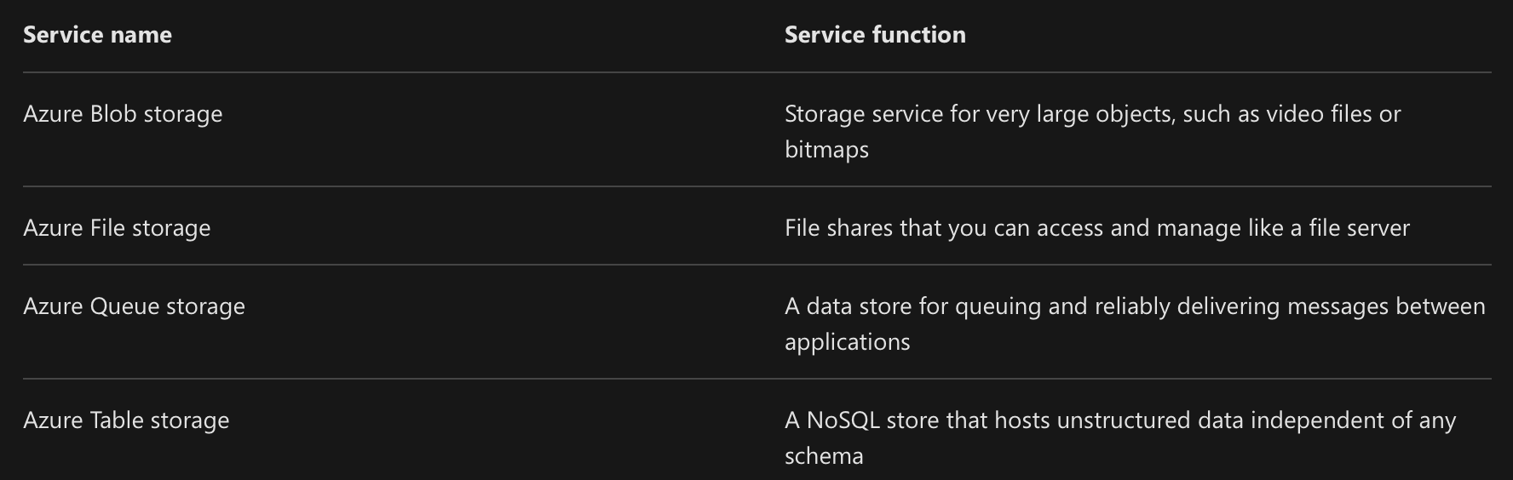

These services all share several common characteristics:
- Durable and highly available with redundancy and replication.
- Secure through automatic encryption and role-based access control.
- Scalable with virtually unlimited storage.
- Managed, handling maintenance and any critical problems for you.
- Accessible from anywhere in the world over HTTP or HTTPS.

Mobile

Azure enables developers to create mobile backend services for iOS, Android, and Windows apps quickly and easily. Features that used to take time and increase project risks, such as adding corporate sign-in and then connecting to on-premises resources such as SAP, Oracle, SQL Server, and SharePoint, are now simple to include.

Other features of this service include:
- Offline data synchronization.
- Connectivity to on-premises data.
- Broadcasting push notifications.
- Autoscaling to match business needs.

Databases

Azure provides multiple database services to store a wide variety of data types and volumes. And with global connectivity, this data is available to users instantly.

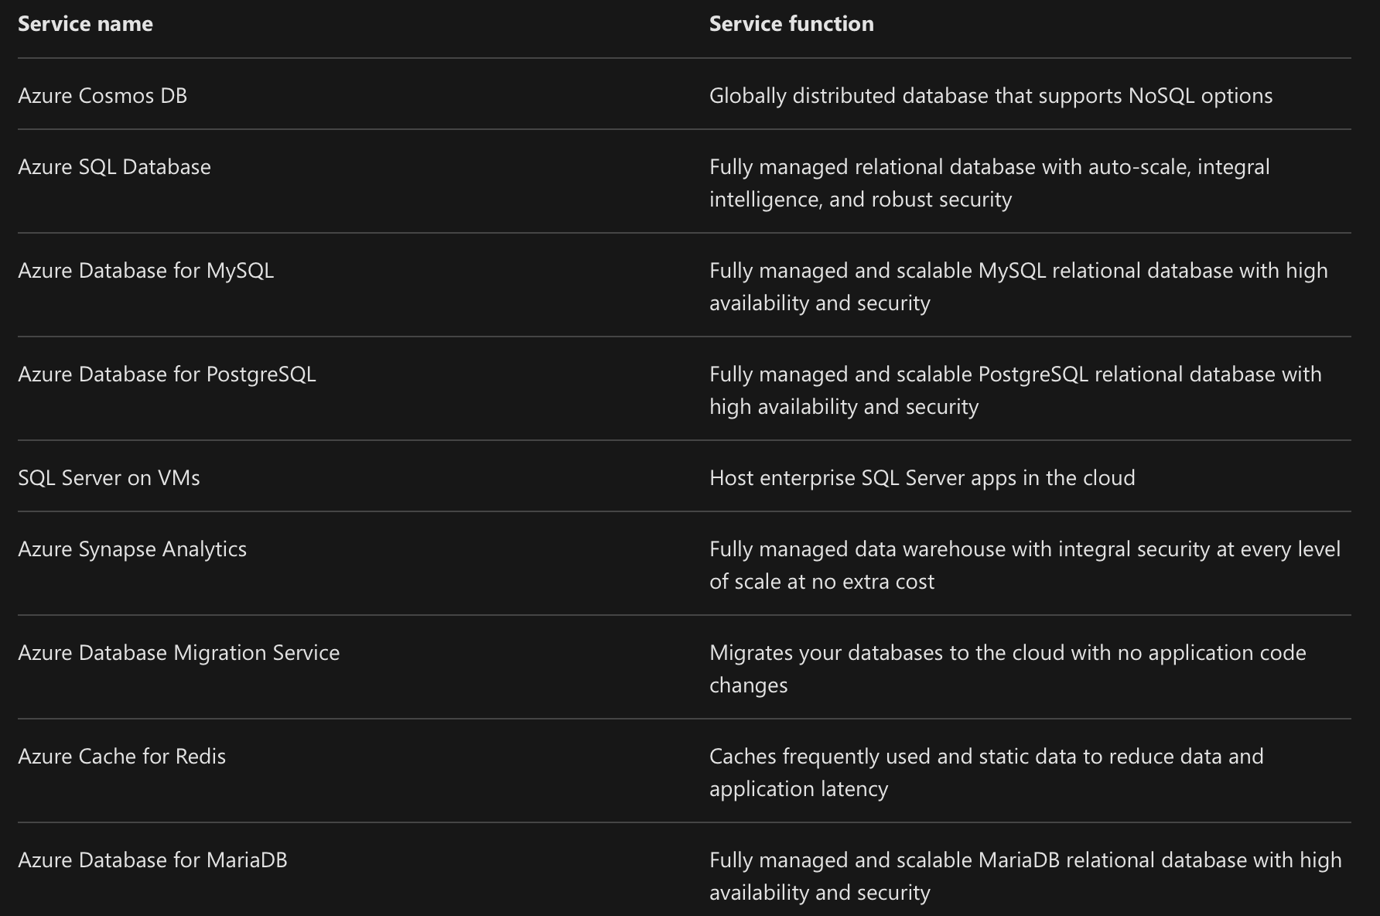

Web

Having a great web experience is critical in today's business world. Azure includes first-class support to build and host web apps and HTTP-based web services. The Azure services focused on web hosting include:

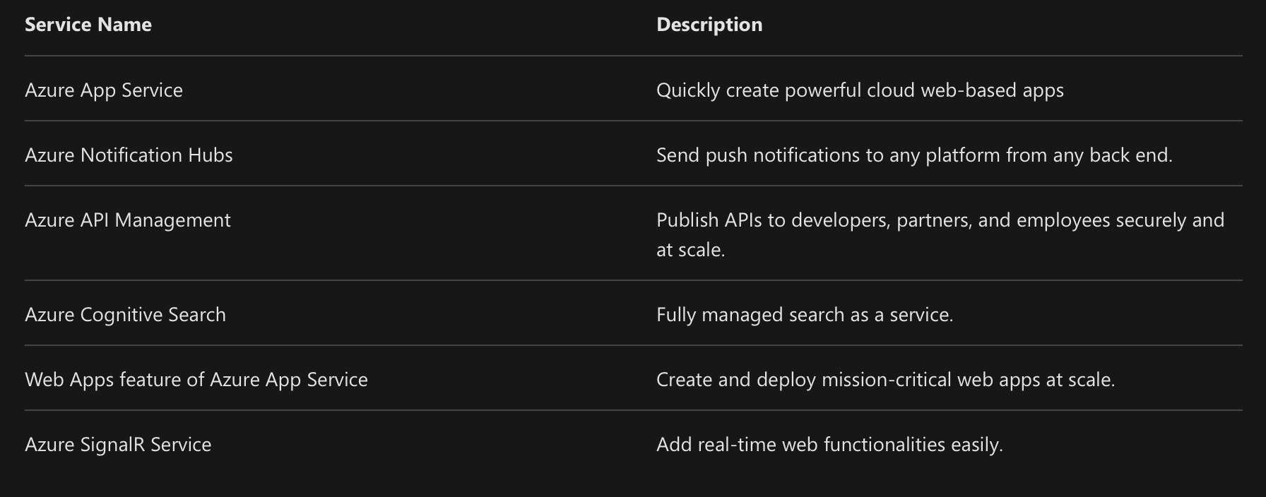

Internet of Things

People are able to access more information than ever before. It began with personal digital assistants (PDAs), then morphed into smartphones. Now there are smart watches, smart thermostats, even smart refrigerators. Personal computers used to be the norm. Now the internet allows any item that's online-capable to access valuable information. This ability for devices to garner and then relay information for data analysis is referred to as the Internet of Things (IoT).
There are a number of services that can assist and drive end-to-end solutions for IoT on Azure.

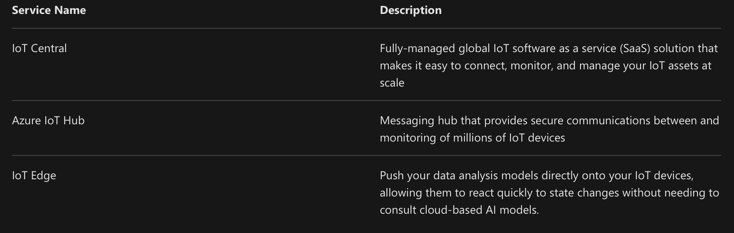

Big Data

Data comes in all formats and sizes. When we talk about Big Data, we're referring to large volumes of data. Data from weather systems, communications systems, genomic research, imaging platforms, and many other scenarios generate hundreds of gigabytes of data. This amount of data makes it hard to analyse and make decisions. It's often so large that traditional forms of processing and analysis are no longer appropriate.

Open source cluster technologies have been developed to deal with these large data sets. Microsoft Azure supports a broad range of technologies and services to provide big data and analytic solutions.

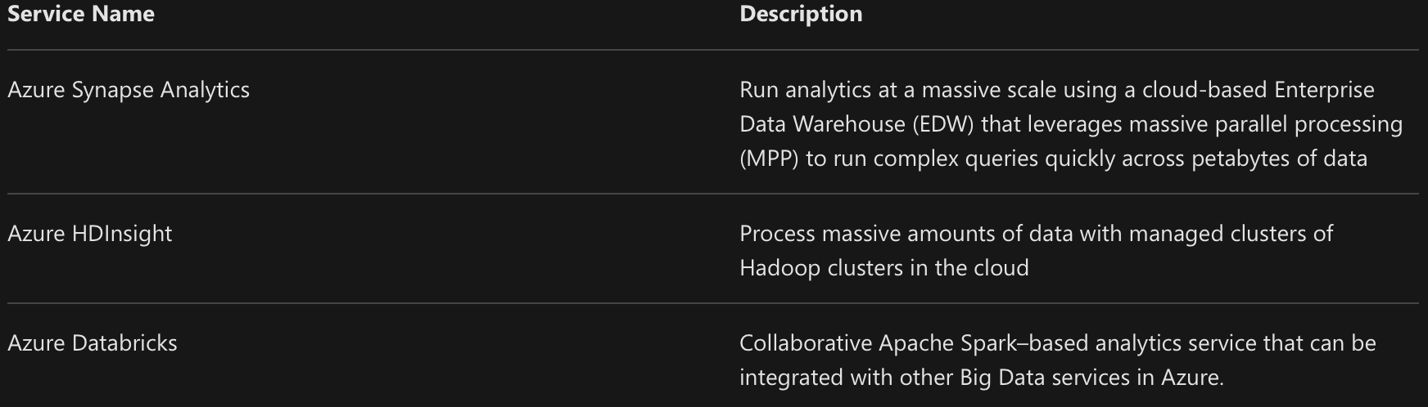

Artificial Intelligence

Artificial Intelligence, in the context of cloud computing, is based around a broad range of services, the core of which is Machine Learning. Machine Learning is a data science technique that allows computers to use existing data to forecast future behaviours, outcomes, and trends. Using machine learning, computers learn without being explicitly programmed.
Forecasts or predictions from machine learning can make apps and devices smarter. For example, when you shop online, machine learning helps recommend other products you might like based on what you've purchased. Or when your credit card is swiped, machine learning compares the transaction to a database of transactions and helps detect fraud. And when your robot vacuum cleaner vacuums a room, machine learning helps it decide whether the job is done.

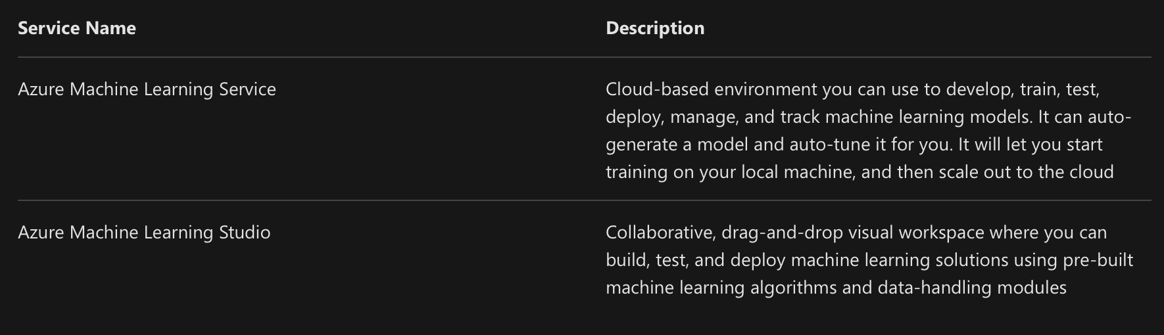

A closely related set of products are the cognitive services. These are pre-built APIs you can leverage in your applications to solve complex problems.

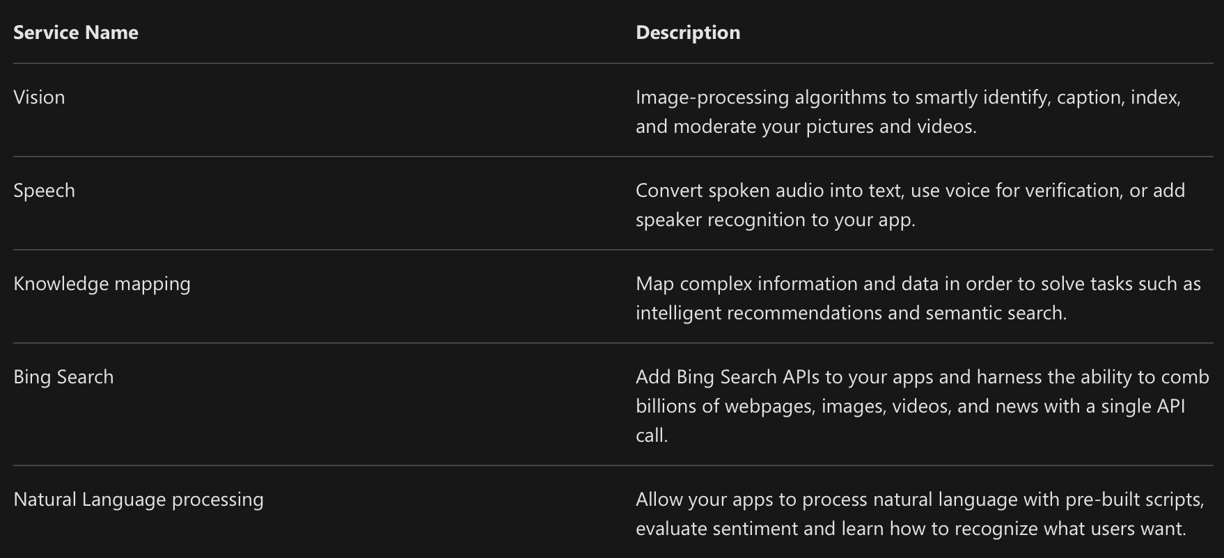

DevOps

DevOps (Development and Operations) brings together people, processes, and technology, automating software delivery to provide continuous value to your users. Azure DevOps Services allows you to create build and release pipelines that provide continuous integration, delivery, and deployment for your applications. You can integrate repositories and application tests, perform application monitoring, and work with build artifacts. You can also work with and backlog items for tracking, automate infrastructure deployment and integrate a range of third-party tools and services such as Jenkins and Chef. All of these functions and many more are closely integrated with Azure to allow for consistent, repeatable deployments for your applications to provide streamlined build and release processes.

