Name : P.Nitishkumar
C01-AT1
Reg : 192311408

EXP1:UPS product tracking information system
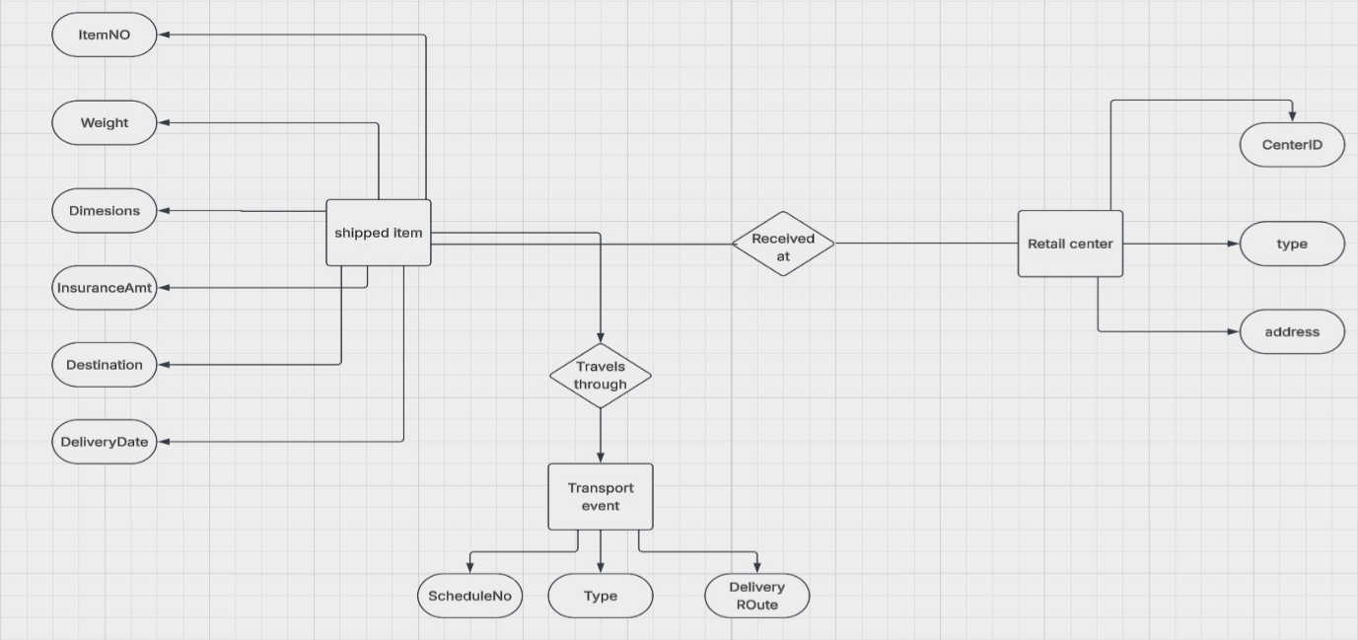

EXP 2 : Couse Management System
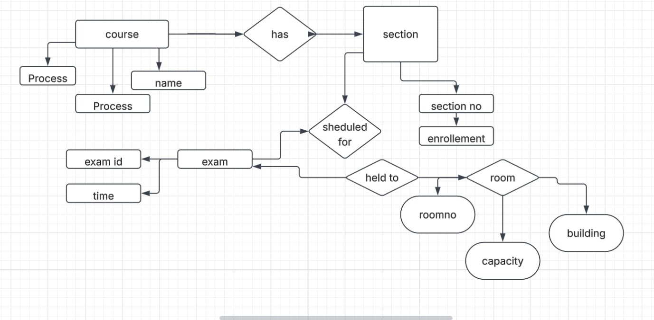

EXP 3 : University Registration office management system
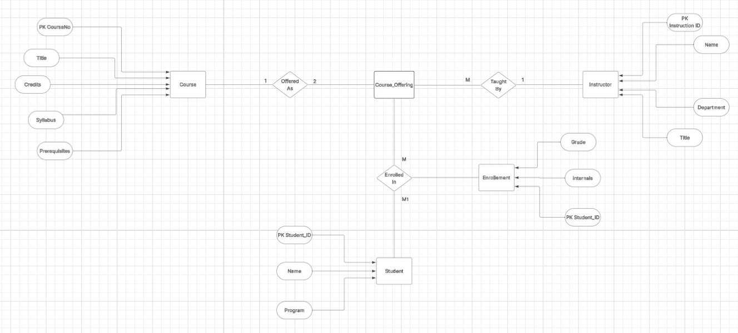

EXP4 : Hospital Management System
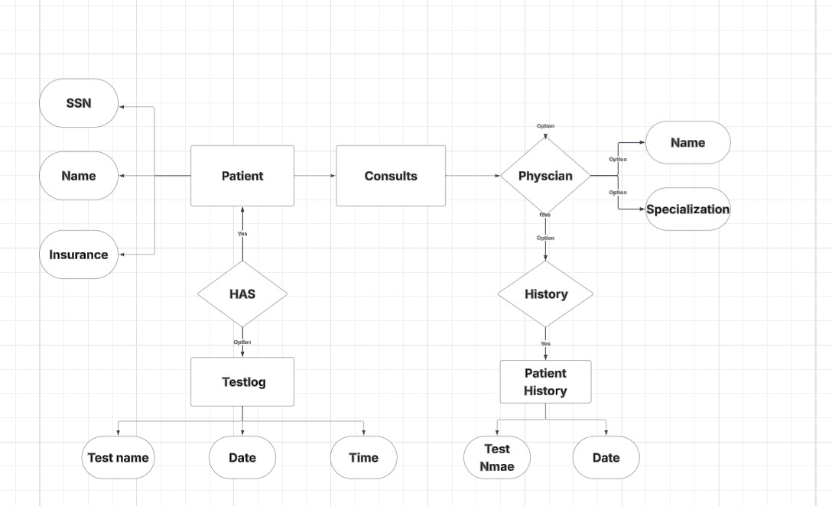

EXP5 : Company Project Management System
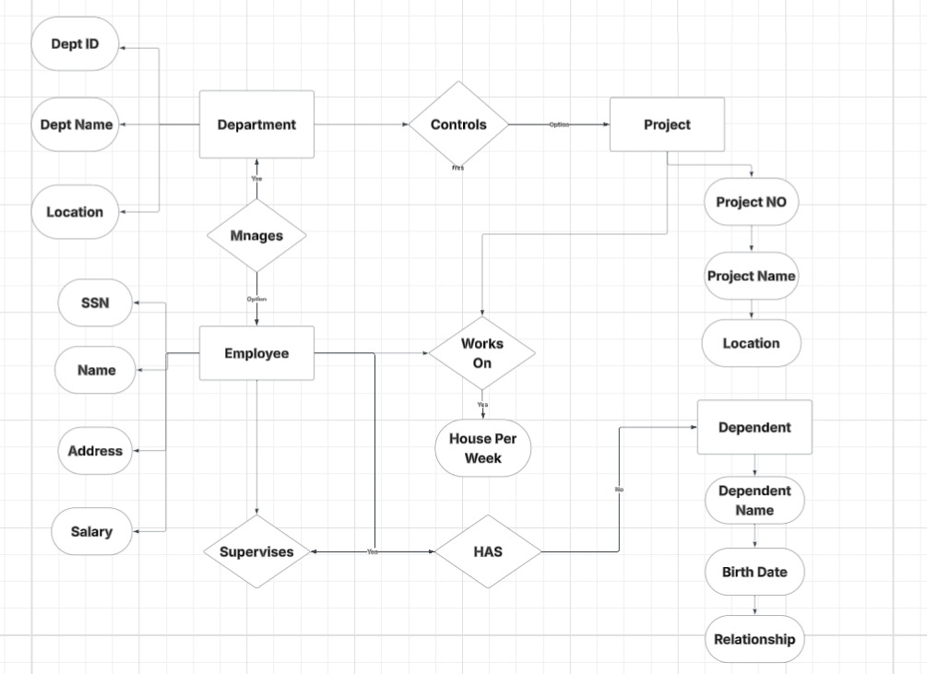

SExp7:Bank Management System
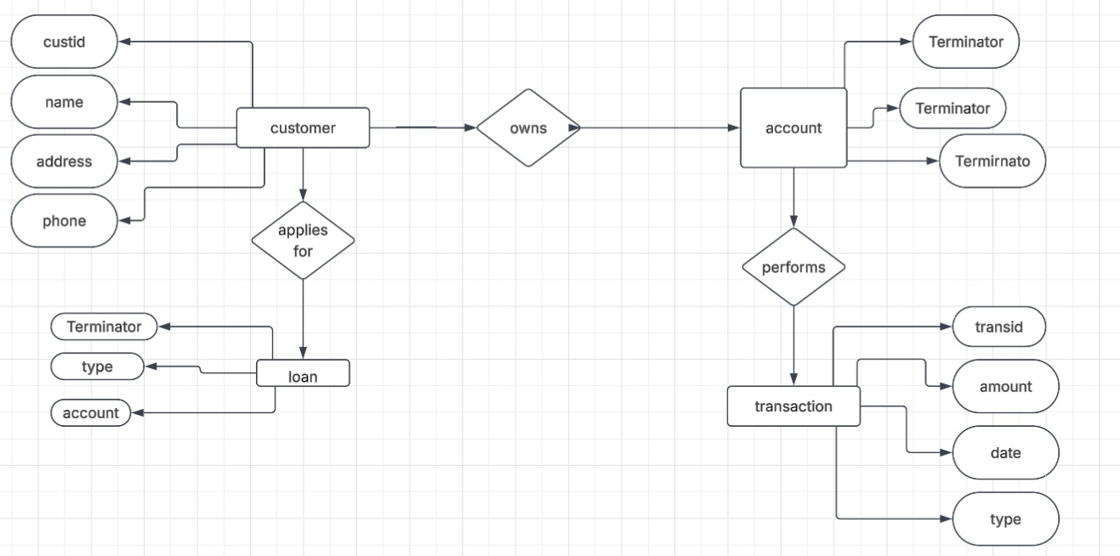

EXP 9: Management System (EER DIAGRAM)
