NAME: P.Nitishkumar
REG.NO: 192311408
- Identify and fix the error in the given SQL query that uses incorrect JOIN syntax and result duplicate results.
A] 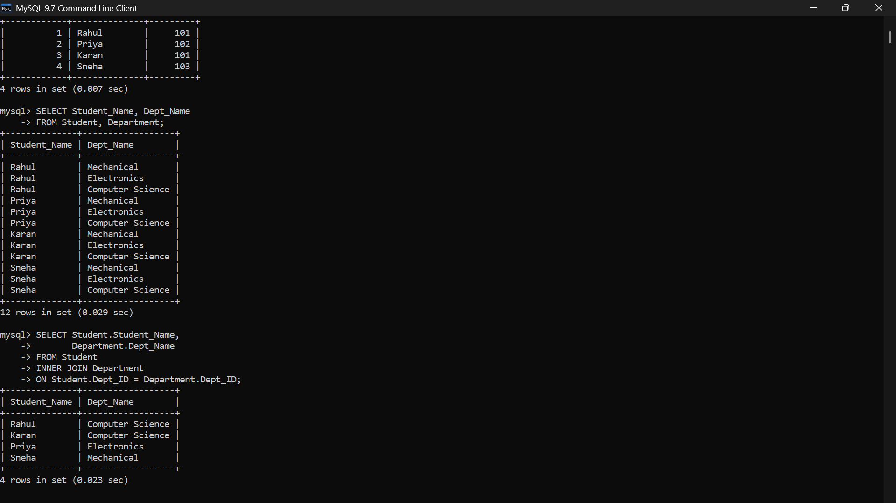
2] The following sub-query returns incorrect results due to a missing correlation. Debug and rewrite it correctly.
A] 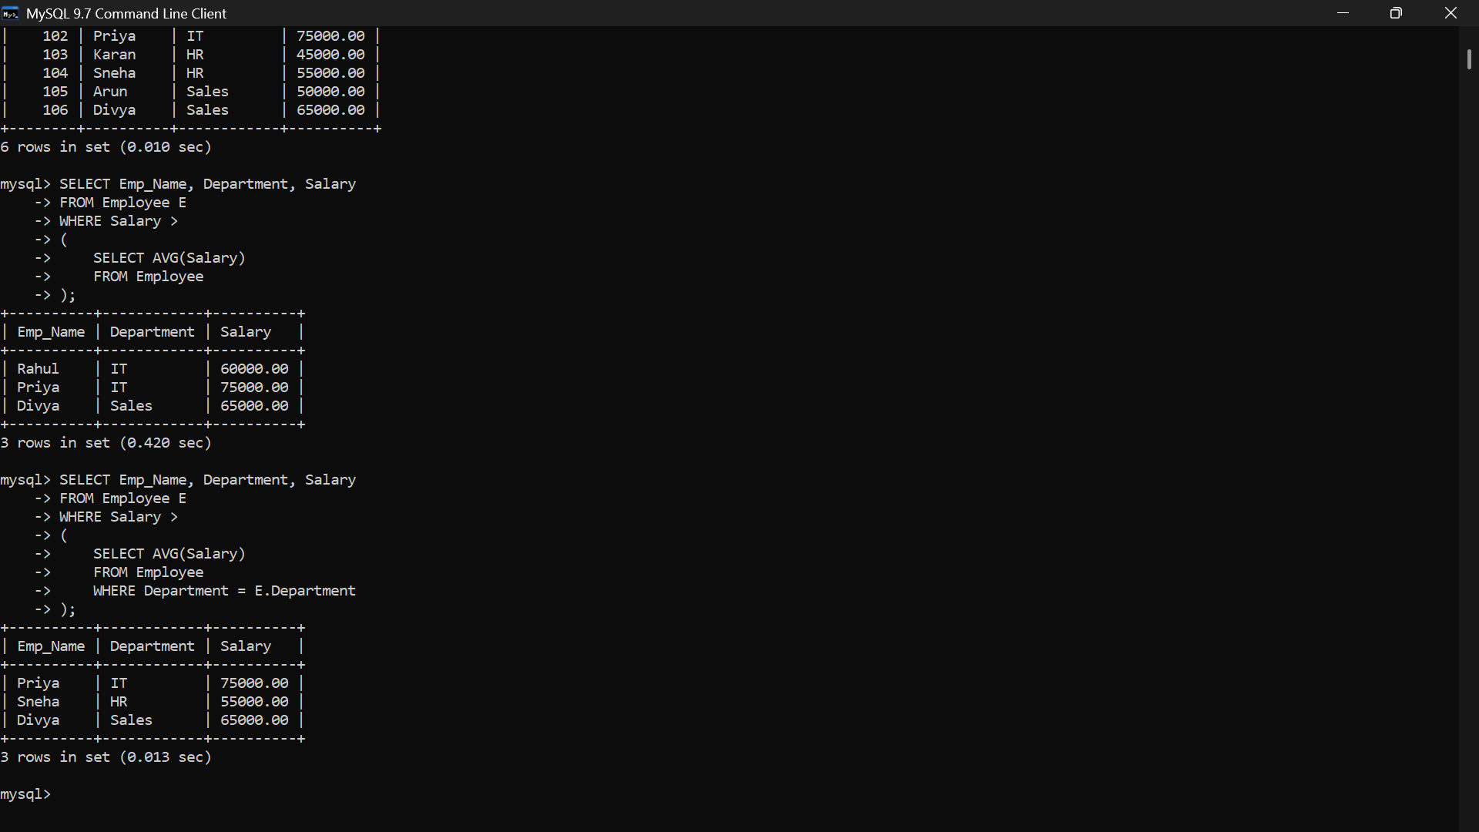
3] A given SQL view definition causes errors when queried. Identify the issue and rewrite a correct and optimized view.
A] 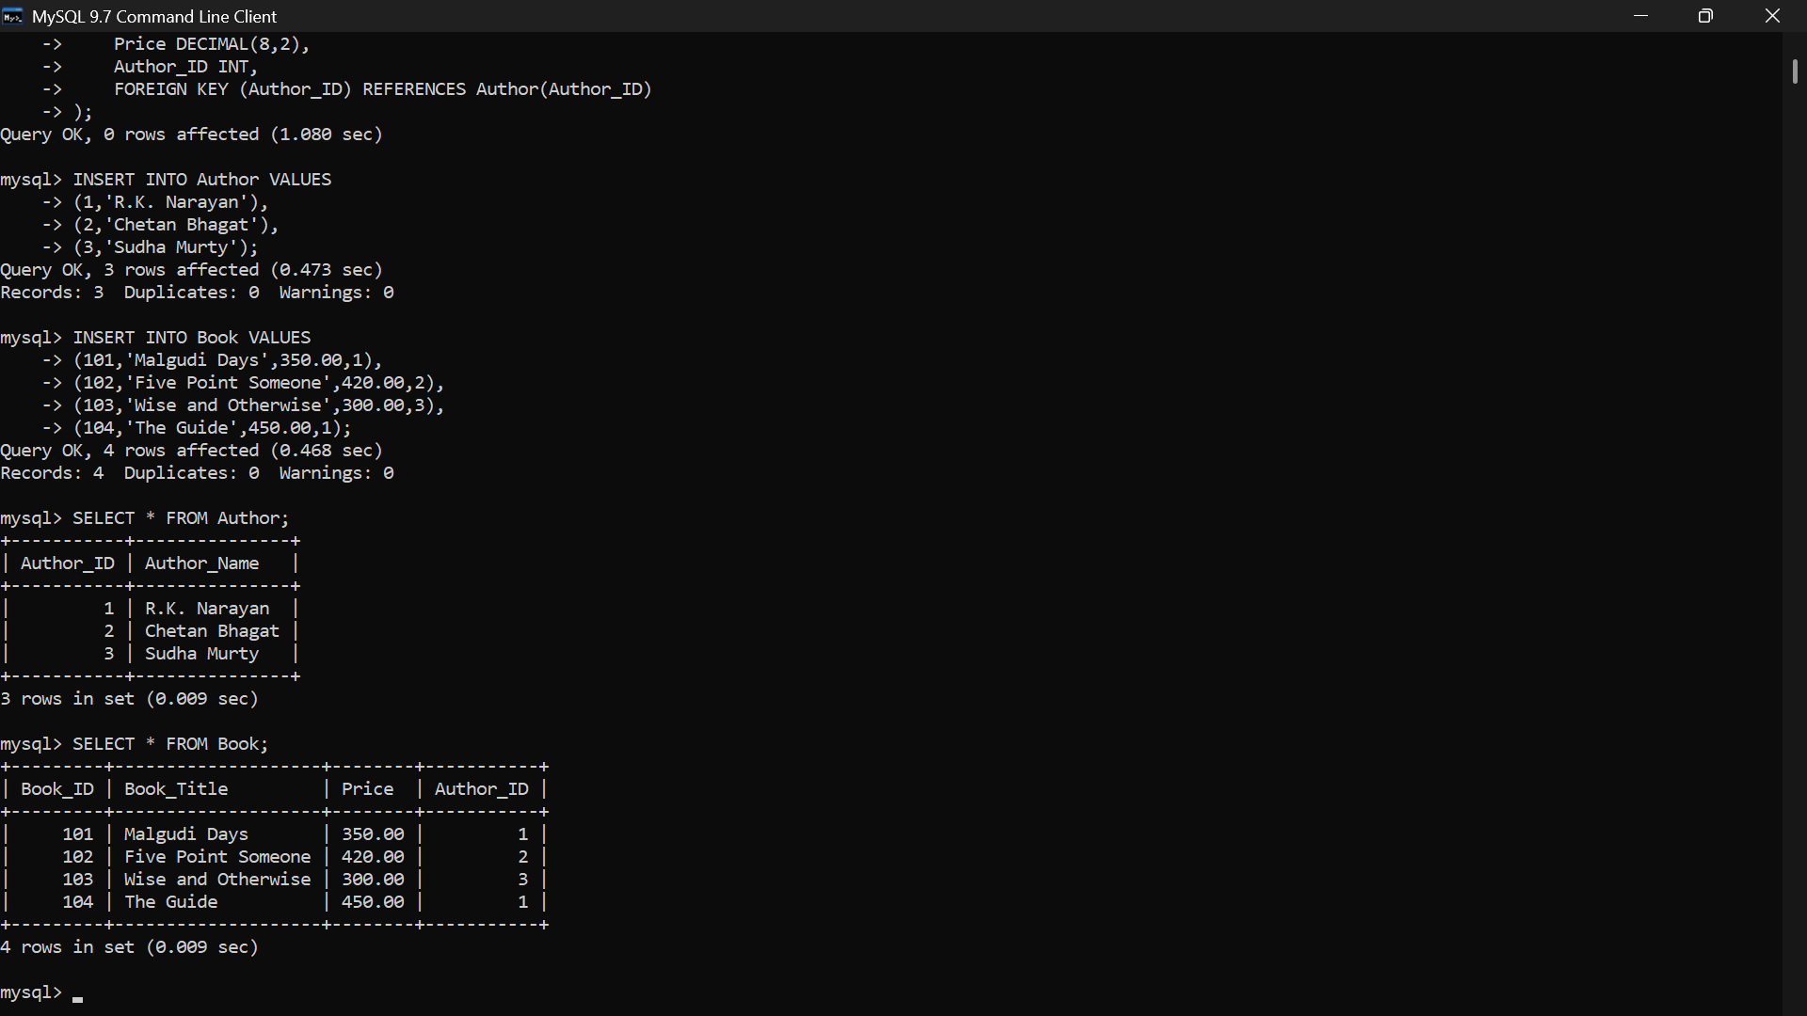
4] Debug the given relational algebra expression that produces incorrect output for a natural join operation.
A] 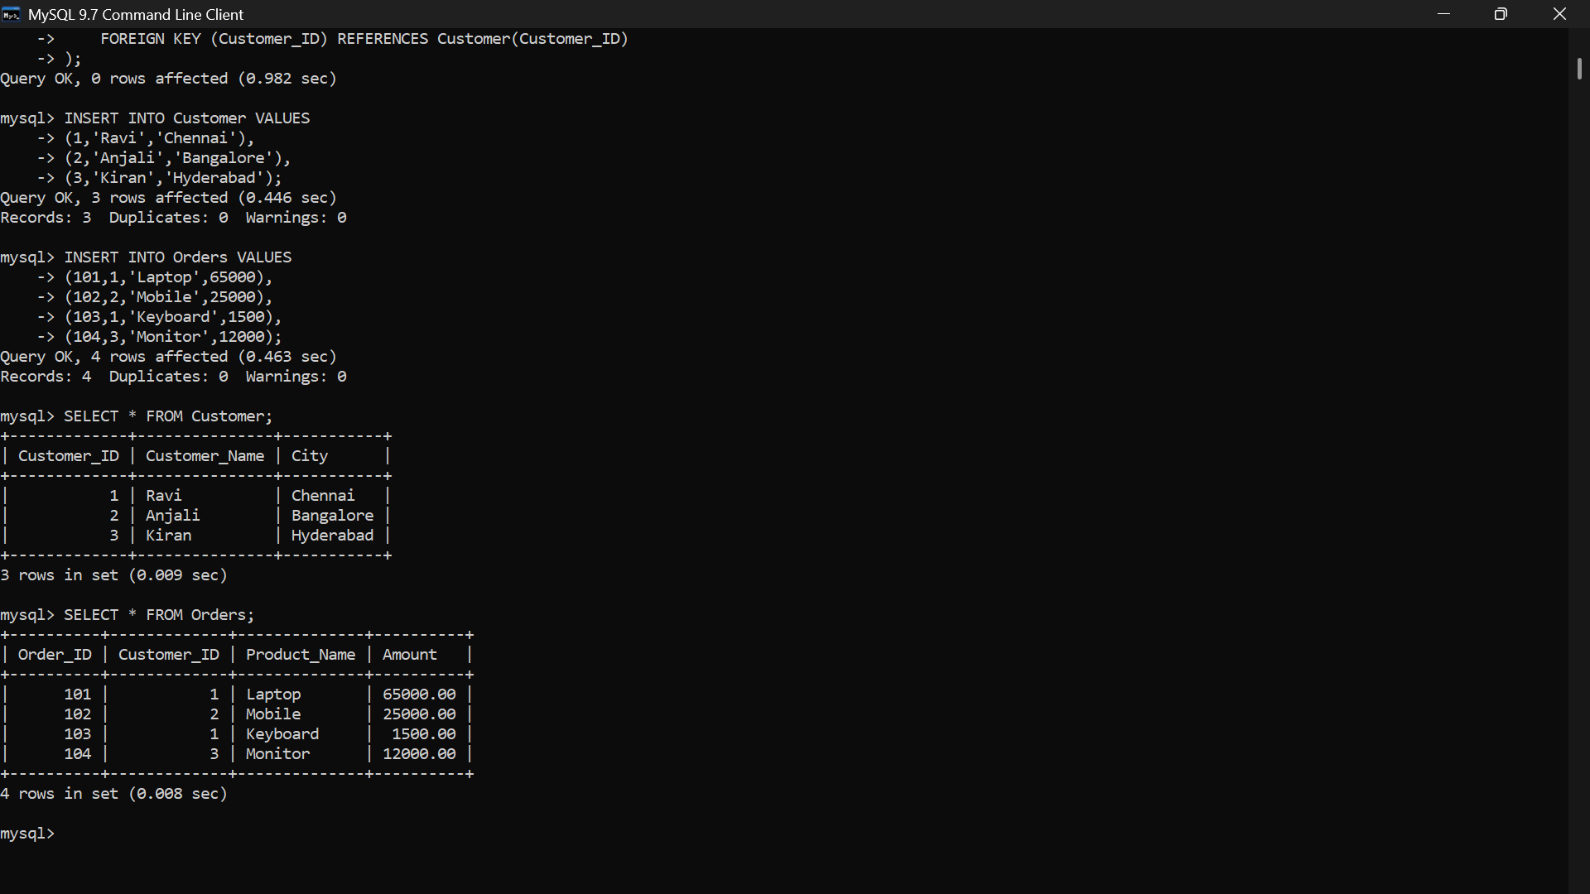

5] The SQL query below violates referential integrity. Identify the violation and modify the statements to enforce proper constraints.
A] 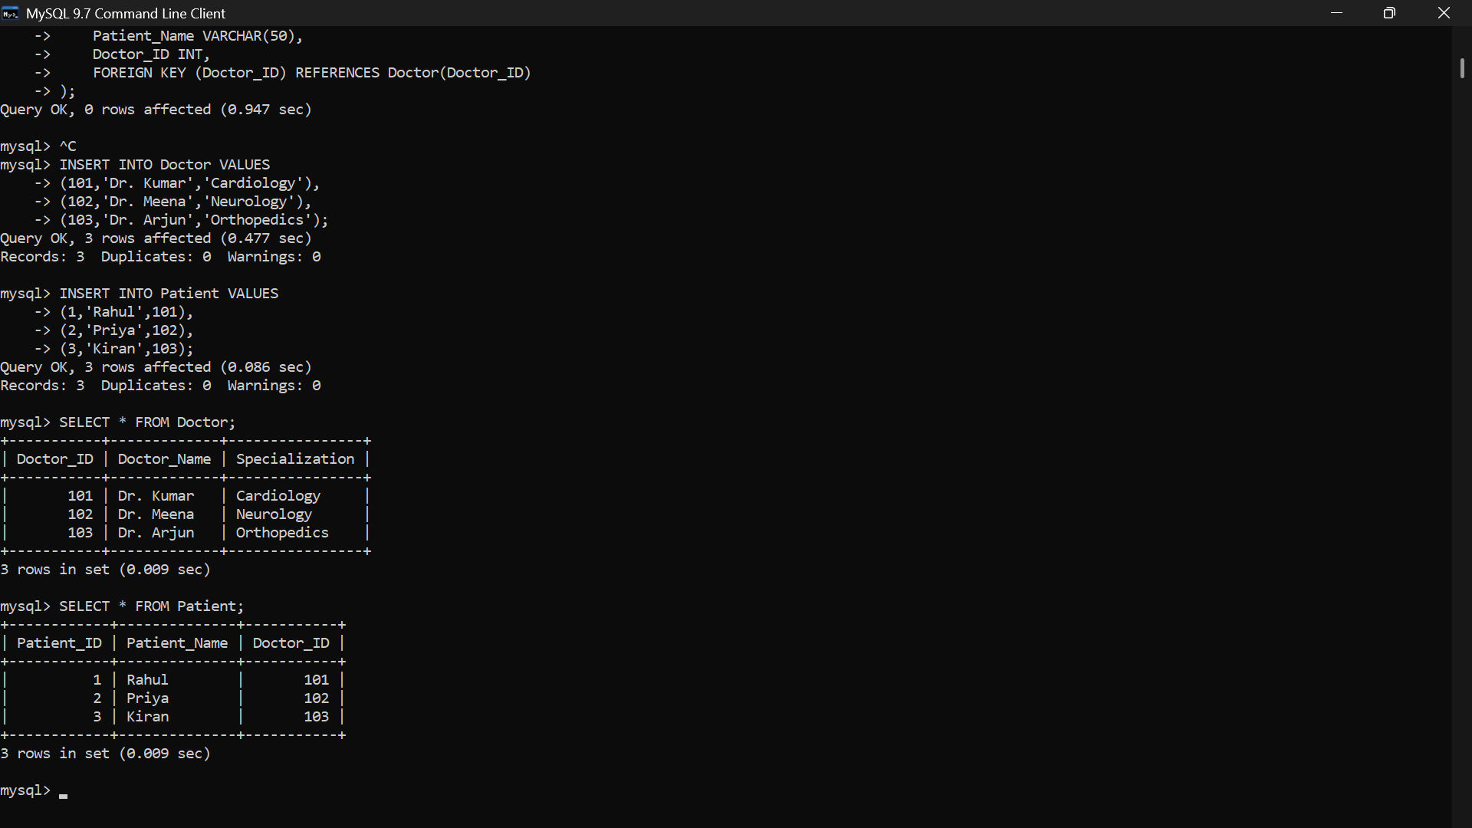
6] Given an inefficient SQL query with nested loops, rewrite it using JOIN to optimize performance.
A] 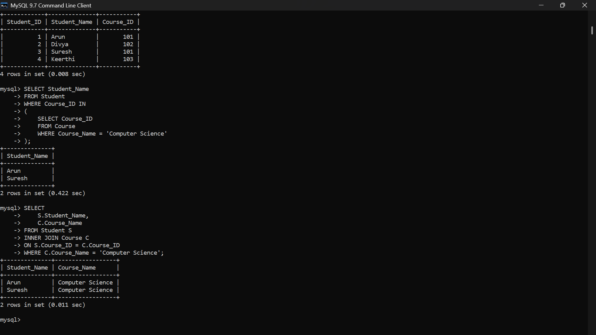

7] The GROUP BY query below produces wrong aggregation results. Debug the query and explain the error.
A] 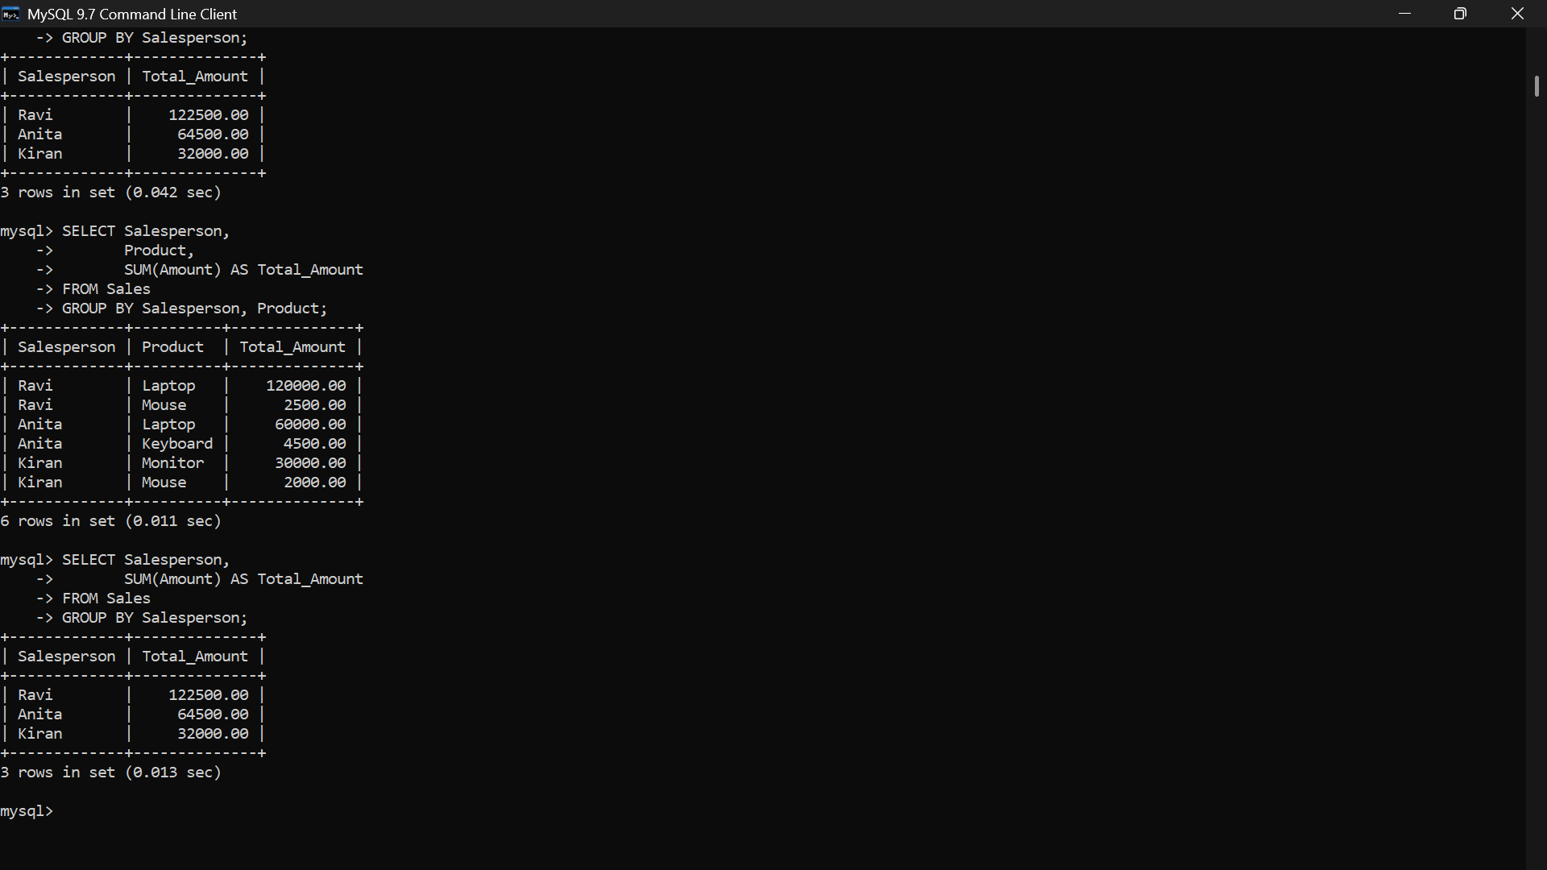
8] Identify and fix the logical error in a given SQL UPDATE statement that unintentionally modifies all rows in the table.
A] 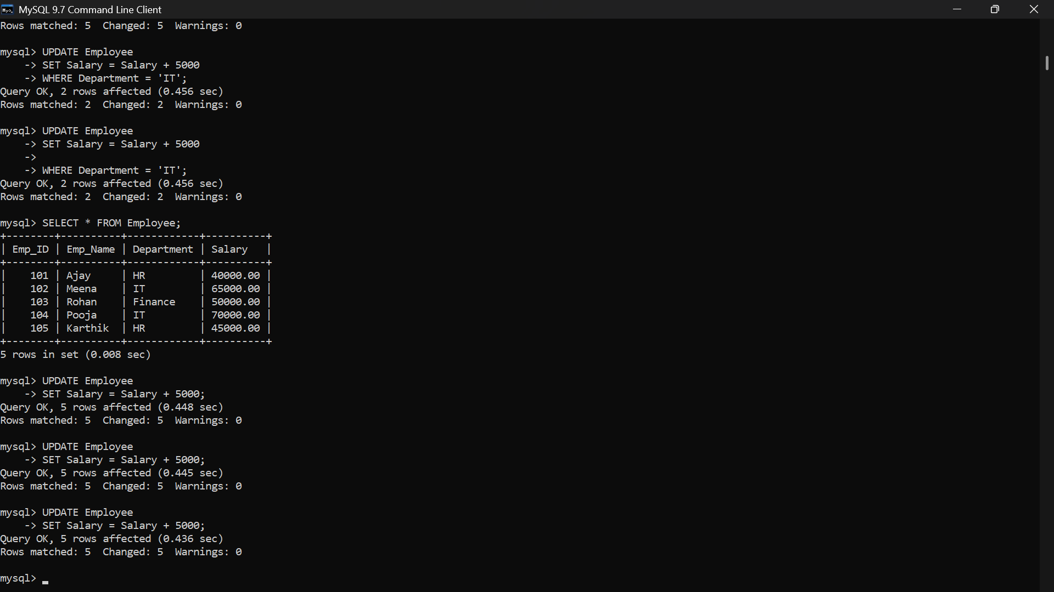

9] Optimize the given multi-table SQL query by restructuring sub-queries into JOINs and using appropriate indexes.
A] 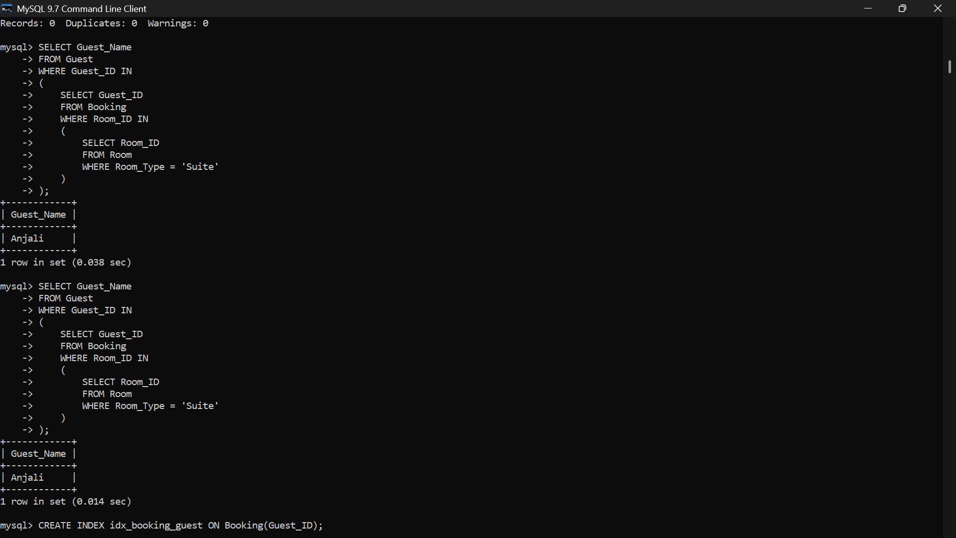
10] Debug a given relational calculus expression that returns an empty result set due to incorrect quantifier usage.
A] 