SIMATS ENGINEERING
ASSESSMENT TOOL 1

COURSE NAME: Database Management Systems COURSE CODE: CSA05

COURSE OUTCOME COVERED

CO4: Design database solutions incorporating file organization, indexing, and hashing techniques to optimize data storage and retrieval efficiency. (BL3, BL4)

Activity Tool : Code Challenge (High) Assessment Tool Weightage: 35%

Dr. Hemavathi

QUESTIONS Total Marks: 50
Q.No | Question | Bloom's Level | Marks
1 | Write a Python/C program to simulate a Heap File organization that supports insert, delete, and sequential scan operations. | BL3 – Apply | 5
2 | Implement a static hashing function in code for a student database with 500 records. Handle collisions using chaining. | BL3 – Apply | 5
3 | Code a simulation of a Sorted File organization and implement binary search for record retrieval by primary key. | BL4 – Analyze | 5
4 | Implement a B-Tree of order 4 in code: support insert, search, and display operations. Insert keys: 10, 20, 5, 6, 12, 30, 7, 17. | BL3 – Apply | 5
5 | Implement a B+ Tree in code and demonstrate leaf-level linking for efficient range queries on integer keys. | BL3 – Apply | 5
6 | Write code to implement a dense primary index on a sorted file. Support search by index key and display the index table. | BL4 – Analyze | 5
7 | Implement extendible hashing in code. Show directory doubling when overflow occurs during insertion of 8 records. | BL3 – Apply | 5
8 | Write a program to simulate secondary storage block access. Calculate the number of I/O operations for sequential vs. indexed retrieval. | BL4 – Analyze | 5

9 | Implement a sparse index on a sorted file in code and compare its search performance with a dense index using timing analysis. | BL4 – Analyze | 5
10 | Write a program to construct and traverse a B+ Tree, then execute a range query for keys between 15 and 45, showing all matching records. | BL4 – Analyze | 5

Code of Conduct:

I P.Nitishkumar (192311408) (Name / Reg No) certify that this submission is my original work and that I have adhered to the guidelines specified for this assessment. I understand that any violation of academic integrity rules will result in disciplinary action.

Question:1 Write a Python program to simulate a Heap File organization that supports insert, delete, and sequential scan operations.
class HeapFile:
def init (self): self.records = []

def insert(self, record): self.records.append(record) print("Inserted:", record)

def delete(self, record_id): for record in self.records:
if record["id"] == record_id: self.records.remove(record)
print("Deleted record with ID:", record_id) return
print("Record not found.")
def sequential_scan(self): print("\nSequential Scan:") for record in self.records:
print(record)

# Main program heap = HeapFile()

heap.insert({"id": 101, "name": "Ravi", "marks": 85})
heap.insert({"id": 102, "name": "Sita", "marks": 90})
heap.insert({"id": 103, "name": "Arun", "marks": 78}) heap.sequential_scan()
heap.delete(102) heap.sequential_scan()

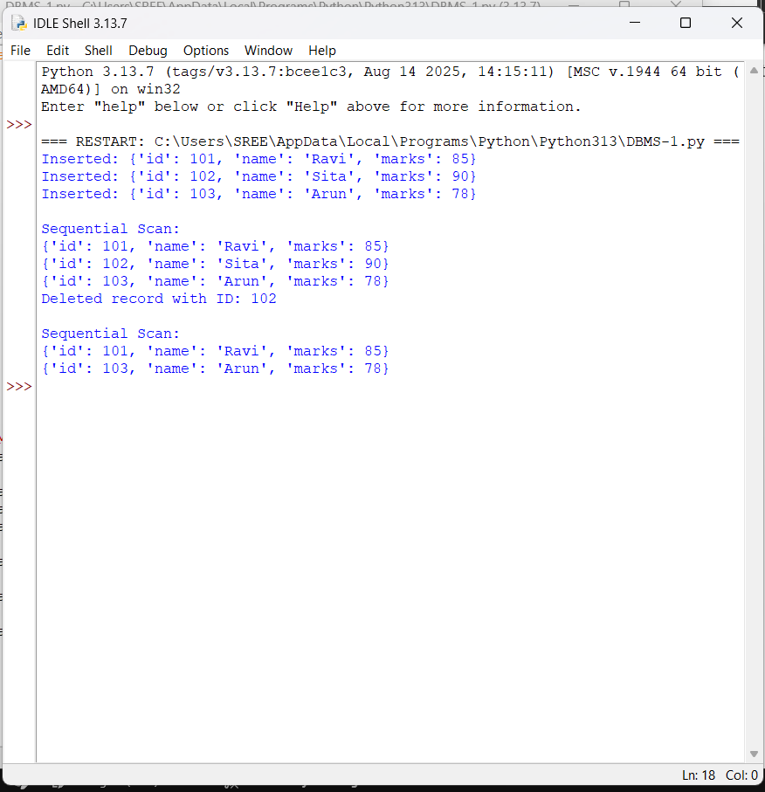

Question: 2-Implement a static hashing function in code for a student database with 500 records. Handle collisions using chaining.

class StaticHash:
def init (self, size=50): self.size = size
self.table = [[] for _ in range(size)]

def hash_function(self, student_id): return student_id % self.size

def insert(self, student_id, name):
index = self.hash_function(student_id) self.table[index].append((student_id, name))

def search(self, student_id):
index = self.hash_function(student_id)
for record in self.table[index]: if record[0] == student_id:
return record return None
def display(self):
for i, bucket in enumerate(self.table): if bucket:
print(i, ":", bucket)

# Main program
hash_table = StaticHash(50)

# Insert 500 student records for i in range(1, 501):
hash_table.insert(i, "Student" + str(i))

print("Student 125:", hash_table.search(125))
print("Student 450:", hash_table.search(450))

print("\nHash Table:") hash_table.display()

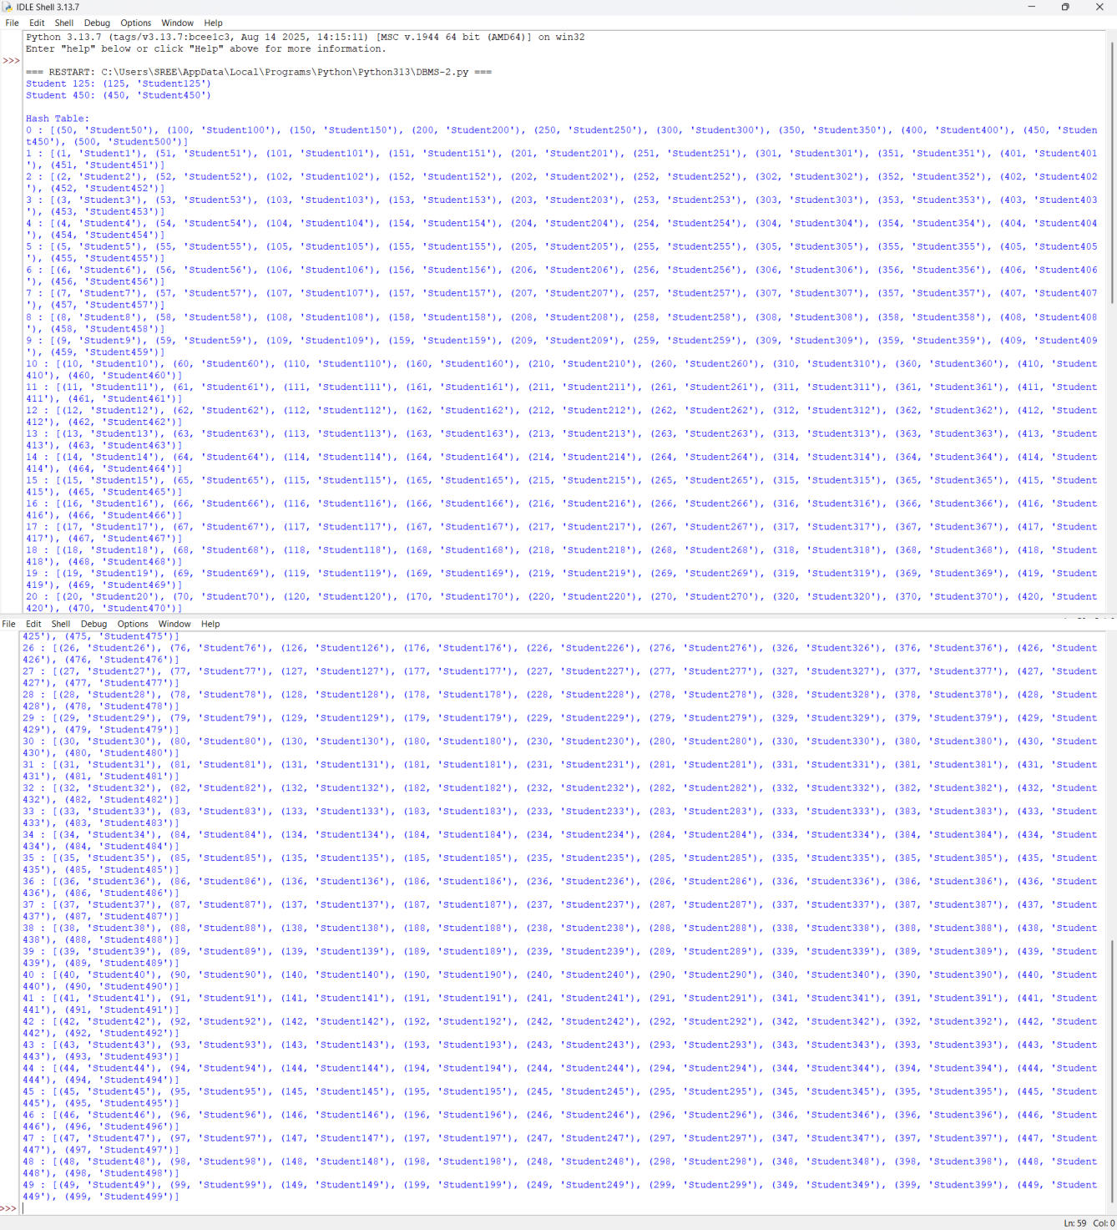

Question 3: Code a simulation of a Sorted File organization and implement binary search for record retrieval by primary key.
class SortedFile:
def init (self): self.records = []

def insert(self, student_id, name): self.records.append((student_id, name)) self.records.sort()

def binary_search(self, student_id): low = 0
high = len(self.records) - 1

while low <= high:
mid = (low + high) // 2
if self.records[mid][0] == student_id: return self.records[mid]

elif self.records[mid][0] < student_id: low = mid + 1

else:
high = mid - 1 return None
def display(self):
for record in self.records: print(record)

# Main program file = SortedFile()

file.insert(105, "Ravi") file.insert(101, "Arun") file.insert(110, "Sita") file.insert(103, "Kiran") file.insert(108, "Priya")

print("Sorted File:") file.display()

print("\nSearch Result:") print(file.binary_search(108))

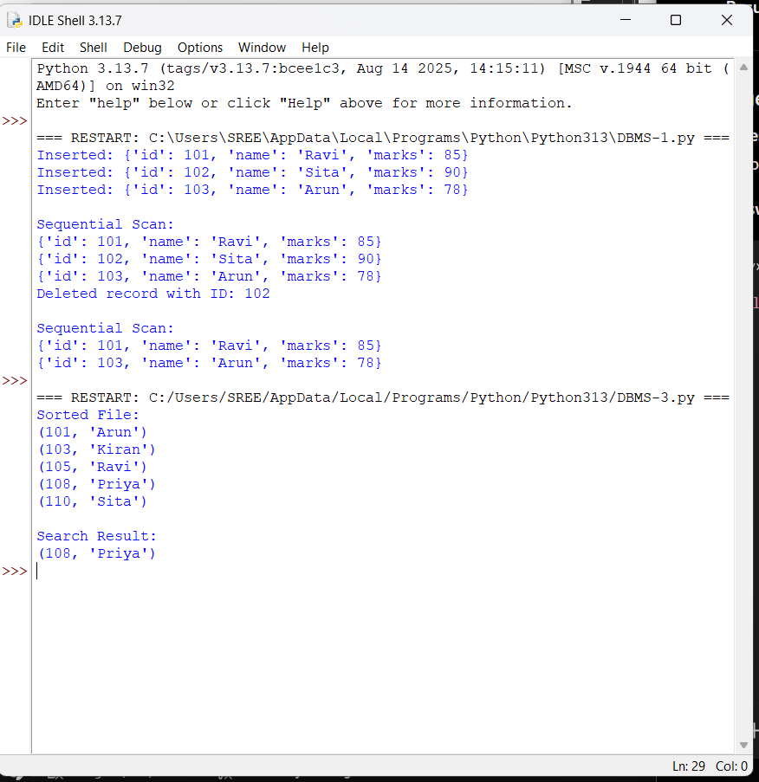

Question 4: Implement a B-Tree of order 4 in code. Support insert, search, and display operations. Insert keys: 10, 20, 5, 6, 12, 30, 7, 17..

class BTreeNode:
def init (self, leaf=False): self.keys = []
self.children = [] self.leaf = leaf

class BTree:
def init (self, order=4): self.root = BTreeNode(True) self.order = order

def search(self, node, key): i = 0
while i < len(node.keys) and key > node.keys[i]: i += 1

if i < len(node.keys) and key == node.keys[i]: return True
if node.leaf: return False
return self.search(node.children[i], key) def split_child(self, parent, index):
child = parent.children[index] new_node = BTreeNode(child.leaf)

middle = child.keys[1]

new_node.keys = child.keys[2:] child.keys = child.keys[:1]

if not child.leaf:
new_node.children = child.children[2:] child.children = child.children[:2]

parent.keys.insert(index, middle) parent.children.insert(index + 1, new_node)

def insert(self, key): root = self.root

if len(root.keys) == self.order - 1: new_root = BTreeNode(False) new_root.children.append(root) self.root = new_root

self.split_child(new_root, 0)

self.insert_non_full(new_root, key) else:
self.insert_non_full(root, key)

def insert_non_full(self, node, key): i = len(node.keys) - 1

if node.leaf: node.keys.append(0)

while i >= 0 and key < node.keys[i]: node.keys[i + 1] = node.keys[i]
i -= 1
node.keys[i + 1] = key else:
while i >= 0 and key < node.keys[i]: i -= 1
i += 1

if len(node.children[i].keys) == self.order - 1: self.split_child(node, i)

if key > node.keys[i]: i += 1
self.insert_non_full(node.children[i], key) def display(self, node=None, level=0):
if node is None: node = self.root
print("Level", level, ":", node.keys) if not node.leaf:
for child in node.children: self.display(child, level + 1)

# Main program tree = BTree(4)

keys = [10, 20, 5, 6, 12, 30, 7, 17]

for key in keys: tree.insert(key)

print("B-Tree:") tree.display()

print("\nSearch 12:", tree.search(tree.root, 12))
print("Search 25:", tree.search(tree.root, 25))

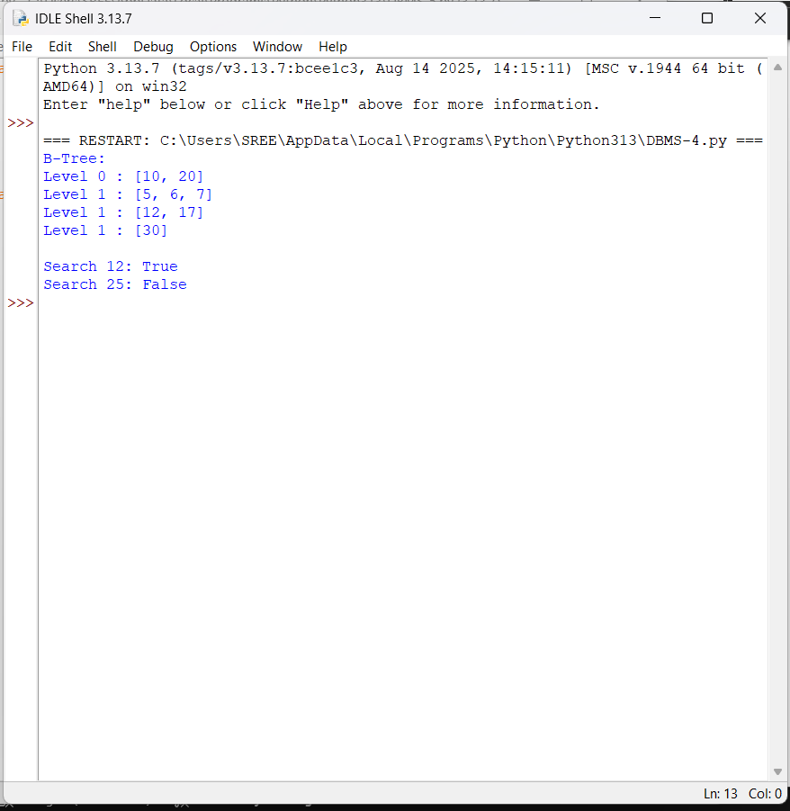

Question 5: Implement a B+ Tree in code and demonstrate leaf-level linking for efficient range queries on integer keys.

Answer:
class BPlusNode: else:
parent_key = child.keys[mid] new_node.keys = child.keys[mid + 1:] child.keys = child.keys[:mid]

new_node.children = child.children[mid + 1:] child.children = child.children[:mid + 1]

parent.keys.insert(index, parent_key) parent.children.insert(index + 1, new_node)
def insert_non_full(self, node, key): if node.leaf:
node.keys.append(key) node.keys.sort()
else:
i = len(node.keys) - 1

while i >= 0 and key < node.keys[i]: i -= 1

i += 1
if len(node.children[i].keys) == self.order: self.split_child(node, i)
if key >= node.keys[i]: i += 1
self.insert_non_full(node.children[i], key) def find_leaf(self, key):
node = self.root

while not node.leaf: i = 0

while i < len(node.keys) and key >= node.keys[i]: i += 1

node = node.children[i] return node
def range_query(self, start, end): node = self.find_leaf(start) result = []

while node:

for key in node.keys:
if start <= key <= end: result.append(key)

if key > end: return result

node = node.next return result
def display_leaves(self): node = self.root

while not node.leaf:
node = node.children[0] print("Leaf Level:")
while node:
print(node.keys, end=" -> ") node = node.next

print("None")

# Main program tree = BPlusTree()
for key in [10, 20, 5, 15, 25, 30, 35, 40, 45, 50]:
tree.insert(key) tree.display_leaves()
print("Range 15 to 40:")
print(tree.range_query(15, 40))

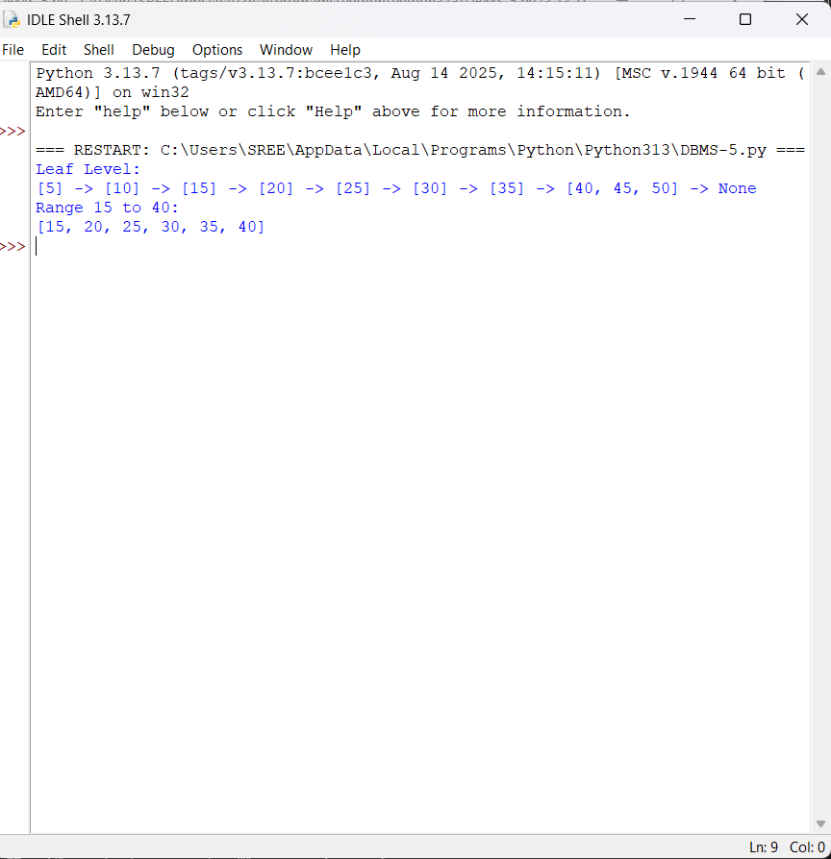

Question 6: Write code to implement a dense primary index on a sorted file. Support search by index key and display the index table.
class DenseIndex: def init (self):
self.records = [] self.index = []

def insert(self, key, value): self.records.append((key, value)) self.records.sort()

def build_index(self): self.index = []

for position, record in enumerate(self.records): self.index.append((record[0], position))
def search(self, key):
for index_key, position in self.index: if index_key == key:
return self.records[position] return None
def display_index(self):
print("Index Key | Record Position")

for key, position in self.index: print(key, " |", position)

# Main program file = DenseIndex()

file.insert(101, "Ravi") file.insert(105, "Sita") file.insert(110, "Arun") file.insert(115, "Kiran") file.insert(120, "Priya")

file.build_index() file.display_index()
print("\nSearch for 110:") print(file.search(110))

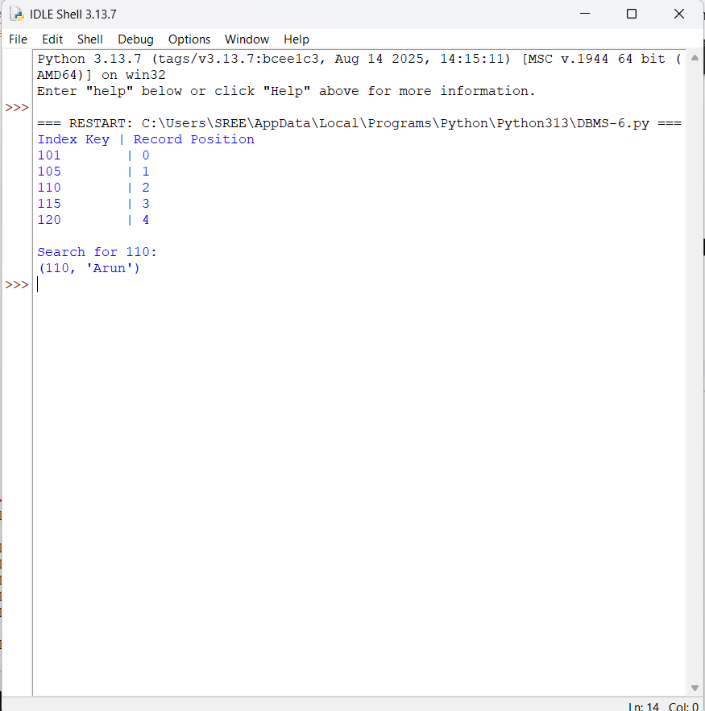

Question 7: Implement extendible hashing in code. Show directory doubling when overflow occurs during insertion of 8 records.

class Bucket:
def init (self, depth): self.depth = depth self.records = []

class ExtendibleHash:
def init (self, bucket_size=2): self.bucket_size = bucket_size self.global_depth = 1

self.directory = [ Bucket(1), Bucket(1)
]

def hash_function(self, key): return key

def insert(self, key):
index = key & ((1 << self.global_depth) - 1) bucket = self.directory[index]

if len(bucket.records) < self.bucket_size: bucket.records.append(key)
return

if bucket.depth == self.global_depth: old_directory = self.directory

self.global_depth += 1
self.directory = old_directory + old_directory.copy() print("\nDirectory doubled!")
print("Global depth:", self.global_depth) bucket.depth += 1
old_records = bucket.records bucket.records = []

new_bucket = Bucket(bucket.depth) index = self.directory.index(bucket)
split_index = index ^ (1 << (bucket.depth - 1)) self.directory[split_index] = new_bucket

for record in old_records:
new_index = record & ((1 << self.global_depth) - 1)

self.directory[new_index].records.append(record) self.insert(key)
def display(self): print("\nDirectory:")
for i, bucket in enumerate(self.directory): print(i, ":", bucket.records,
"Local Depth =", bucket.depth)

# Main program
hash_table = ExtendibleHash(2)

for key in [1, 2, 3, 4, 5, 6, 7, 8]: print("\nInserting:", key) hash_table.insert(key) hash_table.display()
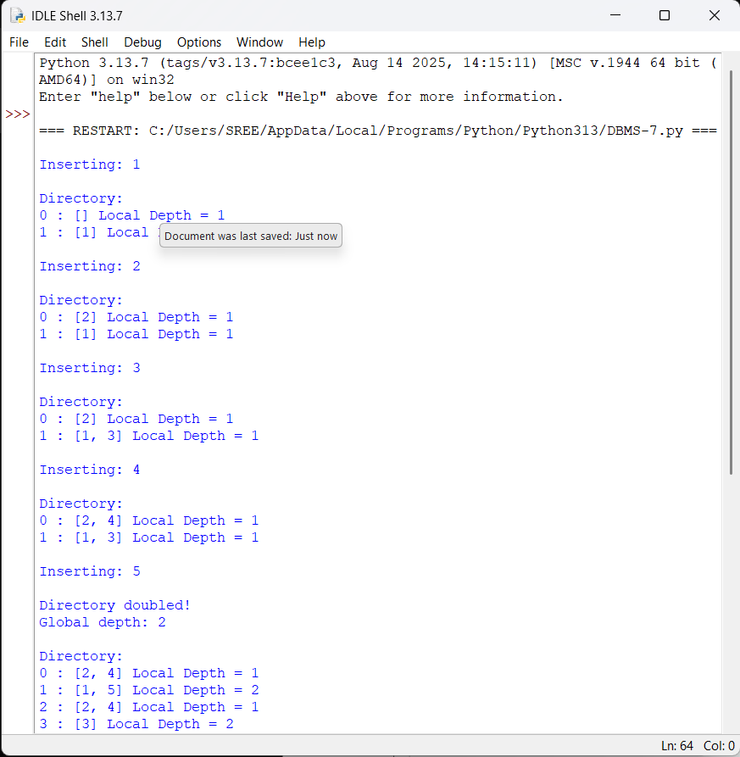

Question 8: Write a program to simulate secondary storage block access. Calculate the number of I/O operations for sequential vs. indexed retrieval.
import math

# Total records and records per block records = 1000
records_per_block = 10
total_blocks = math.ceil(records / records_per_block) # Sequential retrieval
sequential_io = total_blocks

# Indexed retrieval
# Assume one index block followed by one data block indexed_io = 2
print("Total Records:", records)
print("Records per Block:", records_per_block) print("Total Blocks:", total_blocks)

print("\nSequential Retrieval:") print("I/O Operations:", sequential_io)

print("\nIndexed Retrieval:") print("I/O Operations:", indexed_io)

print("\nI/O Reduction:", sequential_io - indexed_io)

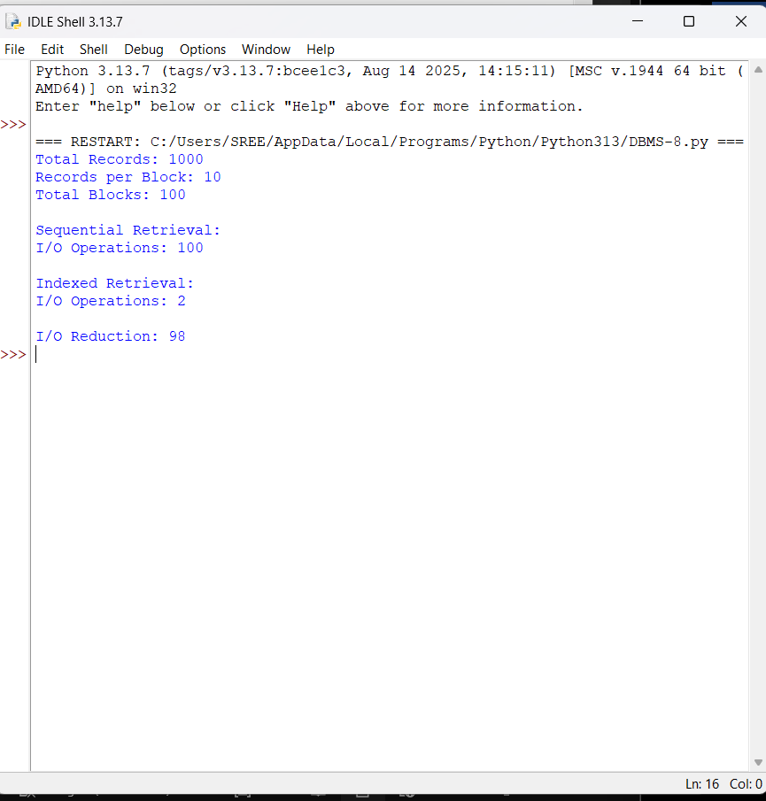

Question 9: Implement a sparse index on a sorted file in code and compare its search performance with a dense index using timing analysis.
import time import random import bisect

# Create sorted records
records = [(i, "Student" + str(i)) for i in range(1, 10001)]

# Dense index
dense_index = [(key, pos) for pos, (key, name) in enumerate(records)]

# Sparse index: one index entry for every 10 records sparse_index = [
(records[i][0], i)
for i in range(0, len(records), 10)
]

def dense_search(key):
keys = [x[0] for x in dense_index] pos = bisect.bisect_left(keys, key)

if pos < len(keys) and keys[pos] == key: return records[dense_index[pos][1]]

return None

def sparse_search(key):
keys = [x[0] for x in sparse_index]
pos = bisect.bisect_right(keys, key) - 1

if pos < 0: pos = 0

start = sparse_index[pos][1]
end = min(start + 10, len(records))

for i in range(start, end): if records[i][0] == key:
return records[i] return None

keys = [random.randint(1, 10000) for _ in range(1000)] start = time.perf_counter()
for key in keys: dense_search(key)
dense_time = time.perf_counter() - start

start = time.perf_counter()

for key in keys: sparse_search(key)

sparse_time = time.perf_counter() - start

print("Dense Index Entries:", len(dense_index)) print("Sparse Index Entries:", len(sparse_index))

print("\nDense Index Time:", dense_time)

print("Sparse Index Time:", sparse_time)
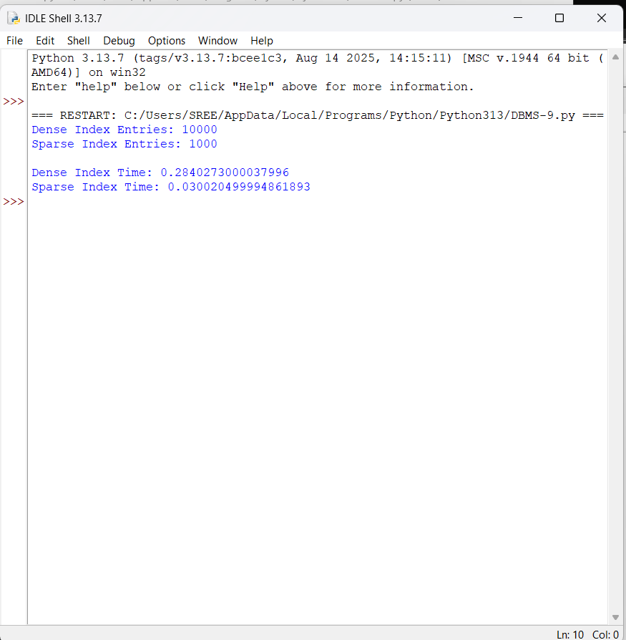

Question 10: Write a program to construct and traverse a B+ Tree, then execute a range query for keys between 15 and 45, showing all matching keys.
class Node:
def init (self, leaf=False): self.keys = []
self.children = [] self.leaf = leaf self.next = None

class BPlusTree:
def init (self, order=4): self.order = order self.root = Node(True)

def insert(self, key):
leaf = self.find_leaf(key)
leaf.keys.append(key) leaf.keys.sort()

if len(leaf.keys) >= self.order: self.split_leaf(leaf)
def find_leaf(self, key): node = self.root

while not node.leaf: i = 0

while i < len(node.keys) and key >= node.keys[i]: i += 1

node = node.children[i] return node
def split_leaf(self, leaf): new_leaf = Node(True)

mid = len(leaf.keys) // 2

new_leaf.keys = leaf.keys[mid:] leaf.keys = leaf.keys[:mid]

new_leaf.next = leaf.next leaf.next = new_leaf

if leaf == self.root: new_root = Node(False)

new_root.keys = [new_leaf.keys[0]] new_root.children = [leaf, new_leaf]

self.root = new_root

def traverse(self): node = self.root

while not node.leaf:
node = node.children[0] print("Leaf Nodes:")
while node:
print(node.keys, end=" -> ") node = node.next

print("None")

def range_query(self, start, end): node = self.find_leaf(start) result = []
while node:
for key in node.keys:
if start <= key <= end: result.append(key)

if key > end: return result

node = node.next return result

# Main program tree = BPlusTree()

keys = [
5, 10, 15, 20, 25,
30, 35, 40, 45, 50
]

for key in keys: tree.insert(key)

print("B+ Tree Traversal:") tree.traverse()

print("\nRange Query: 15 to 45") result = tree.range_query(15, 45) print("Matching Keys:", result)

