NAME: P.Nitishkumar
REG.NO:192311408
1] Apply relational algebra operations (σ, π, ∪, -, ×, ⋈) on the given Employee and Department relations to retrieve required records.
A] 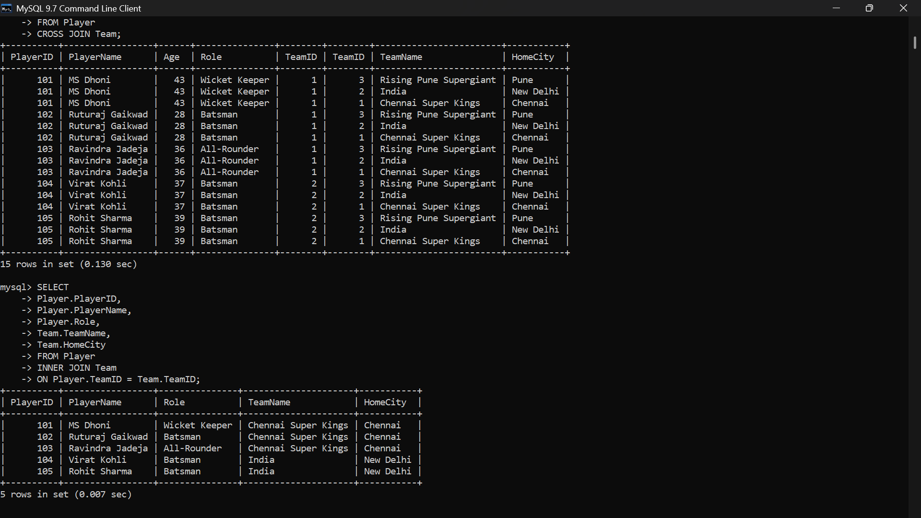
2] Write SQL DDL statements to create STUDENT(SID, Name, DOB,DeptID) and DEPARTMENT(DeptID, DeptName) tables with all appropriate constraints.
A] 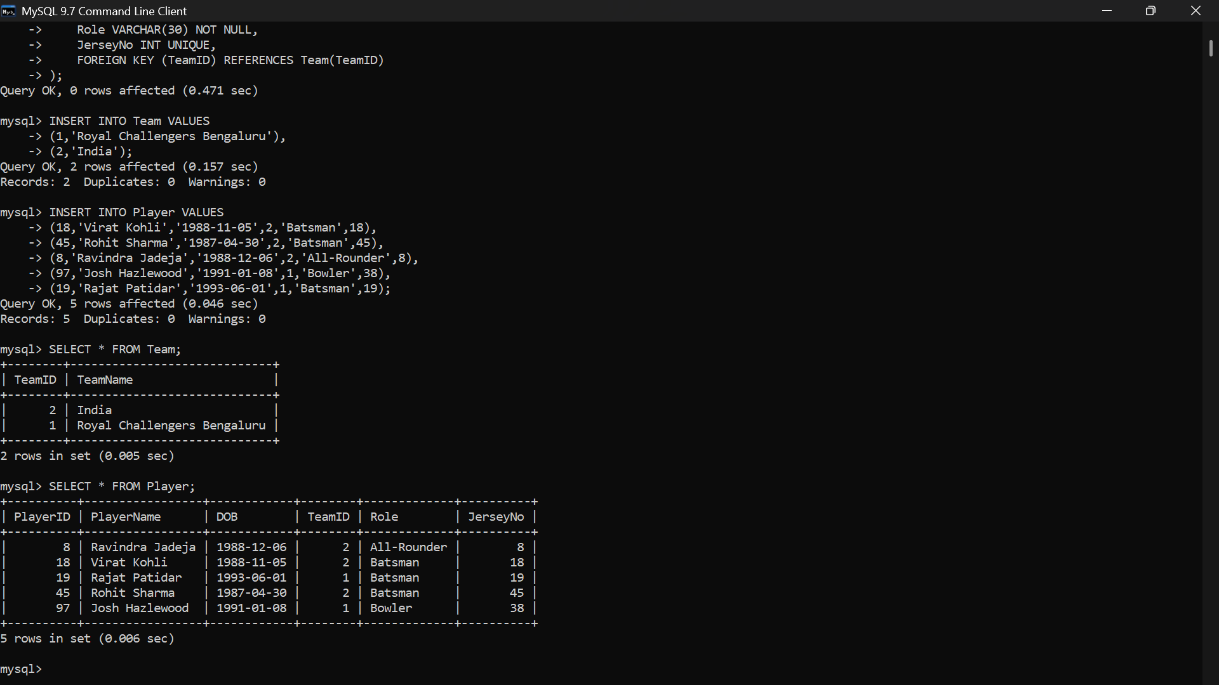
3] Formulate SQL queries using GROUP BY, HAVING, and aggregate functions (COUNT, SUM, AVG, MAX, MIN) on a given Sales dataset.
A] 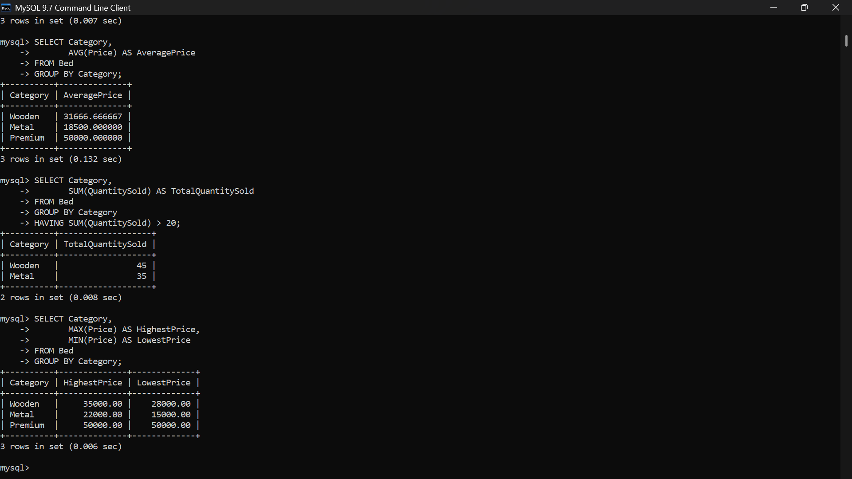
4] Write a correlated sub-query to find employees earning more than the average salary of their own department.
A] 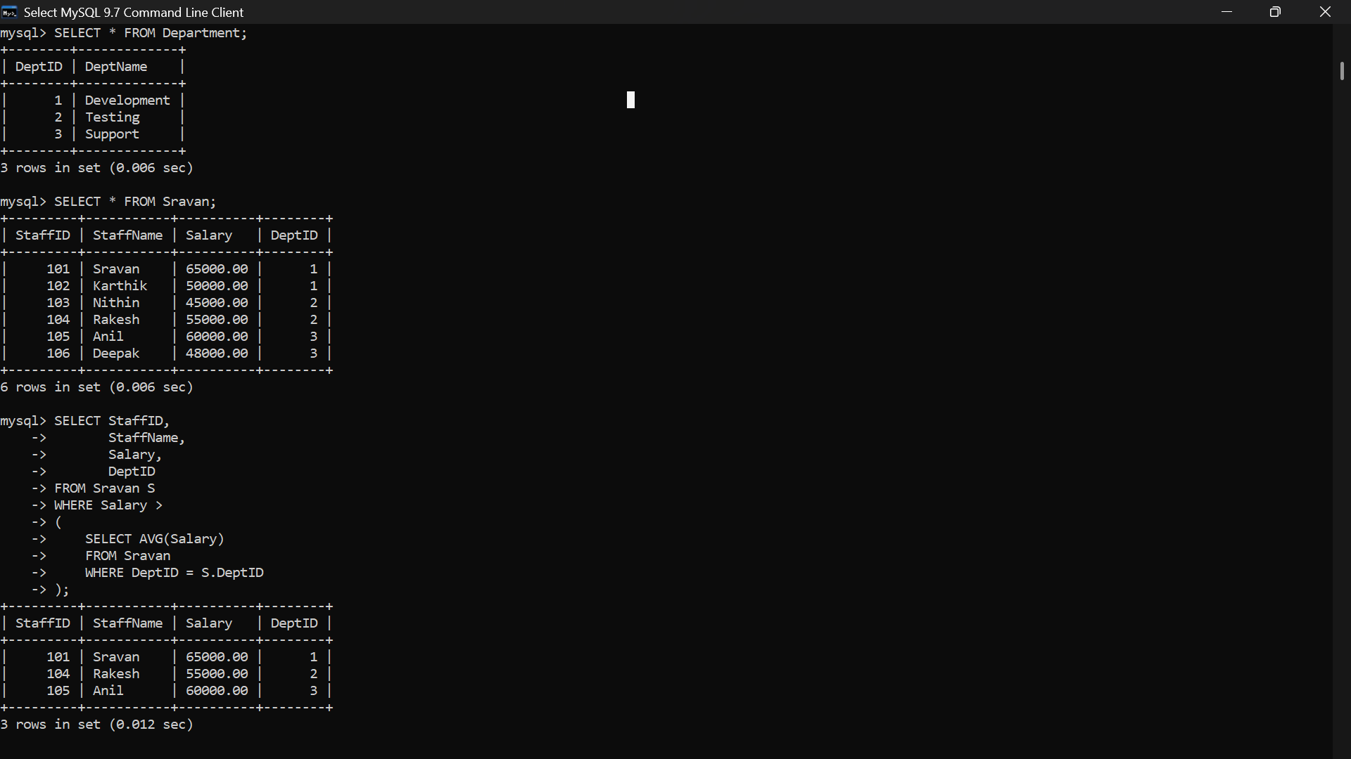

5] Apply all types of JOIN operations (INNER, LEFT OUTER, RIGHT OUTER, FULL OUTER, CROSS) on Employee and Project tables.
A] 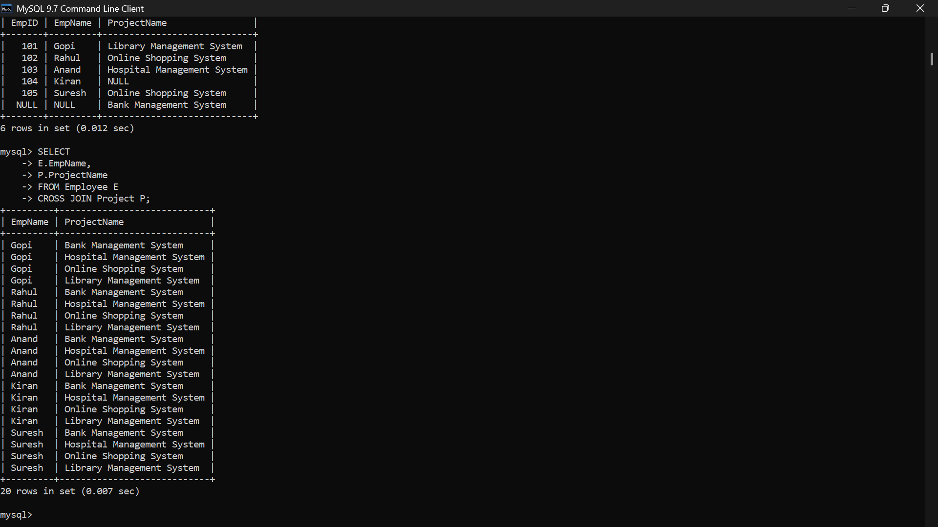
6] Create a view &#39;DeptSalaryView&#39; that displays department name,total employees, and average salary. Write a query on this view.
A] 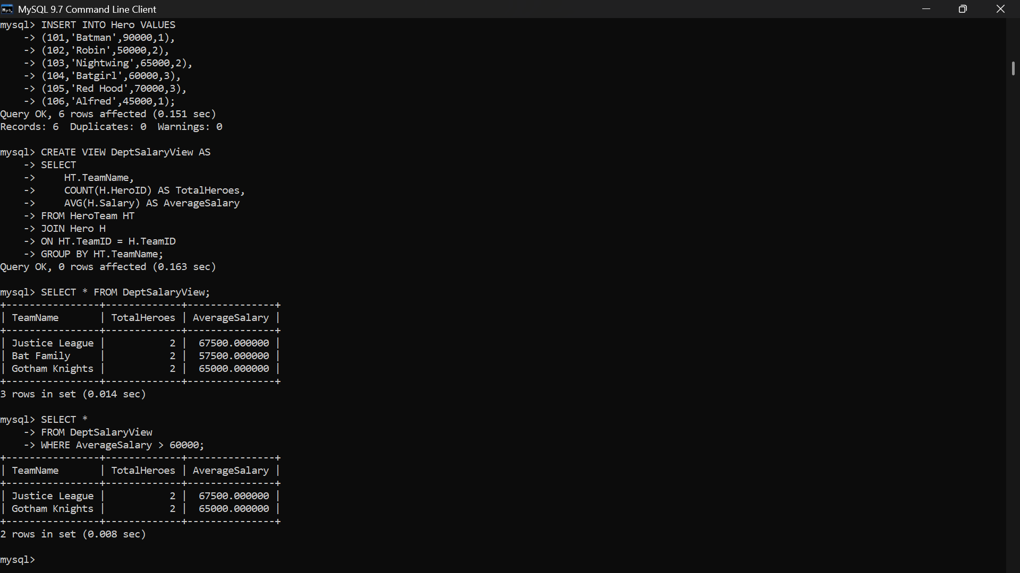

7] Construct a relational algebra expression for the following: Find names of students who are enrolled in all courses offered.
A] 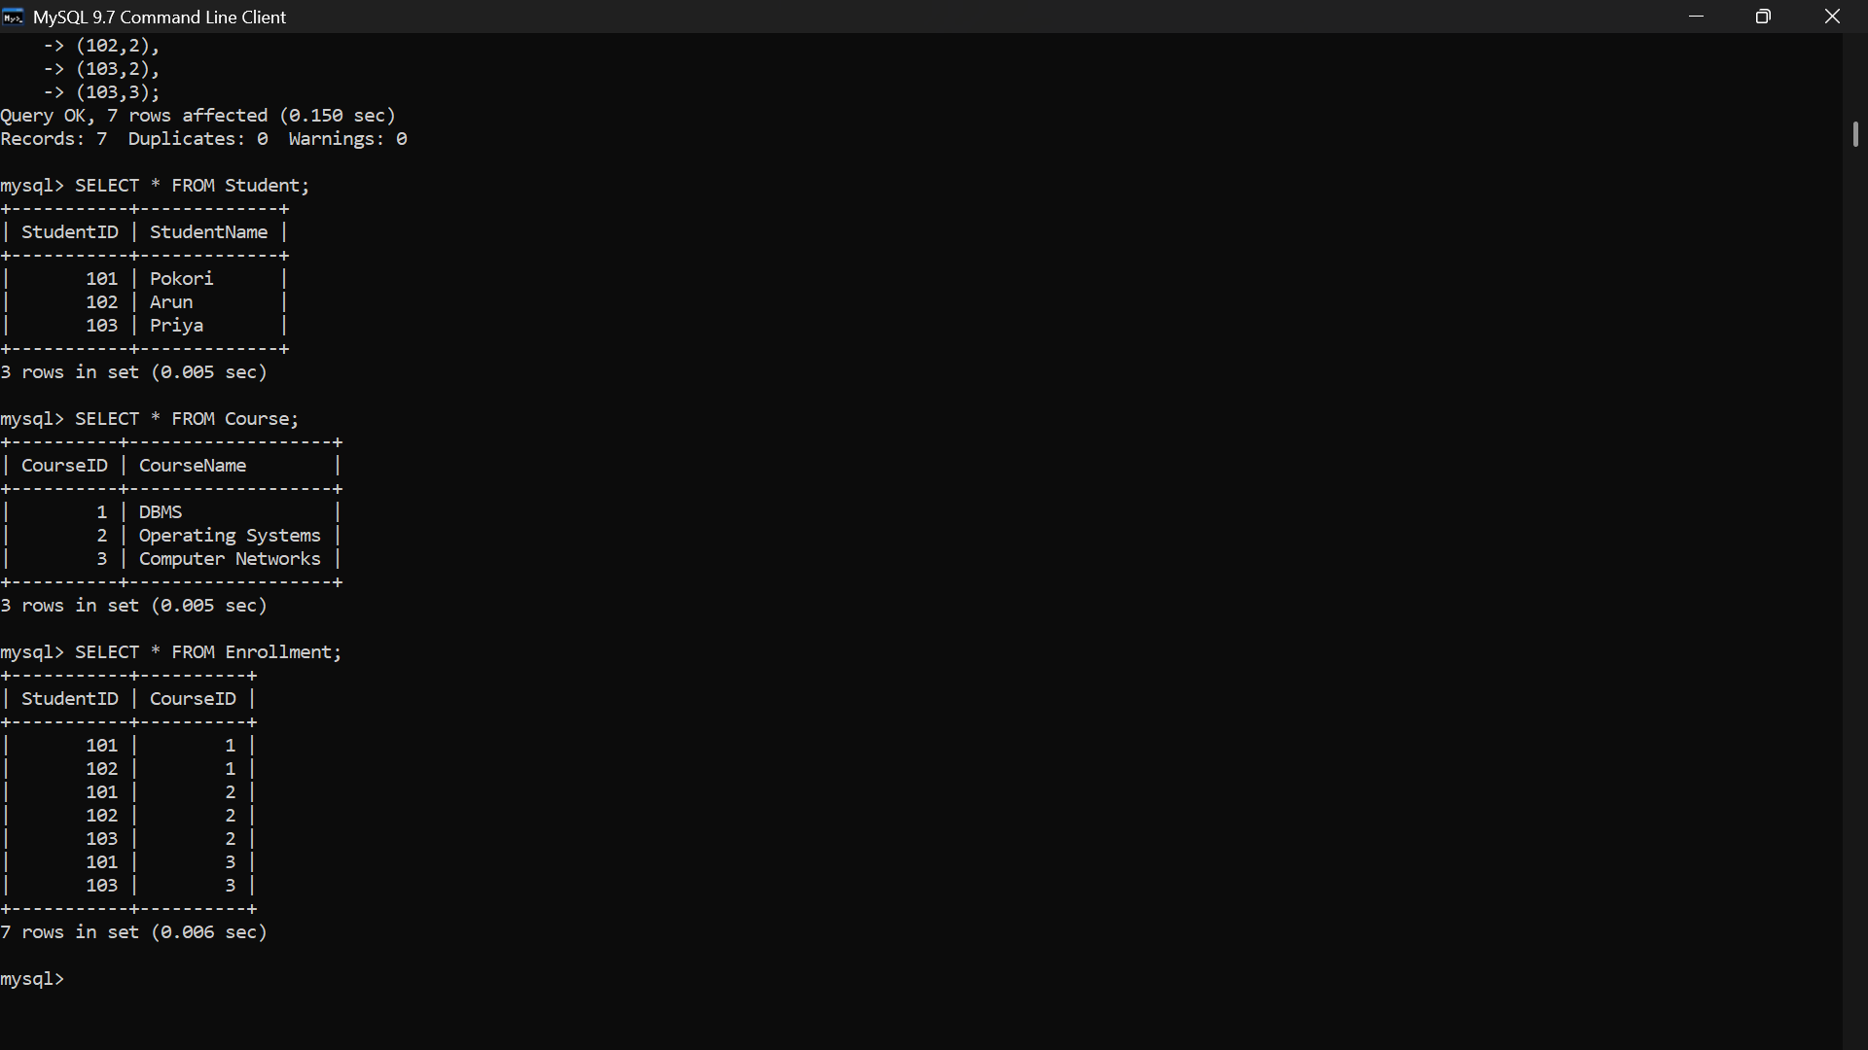
8] Write SQL DML statements (INSERT, UPDATE, DELETE) with integrity constraint enforcement for a given scenario.
A]


9] Apply tuple relational calculus to express a query: Find all employees who work in the &#39;IT&#39; department and earn more than 50000.
A] 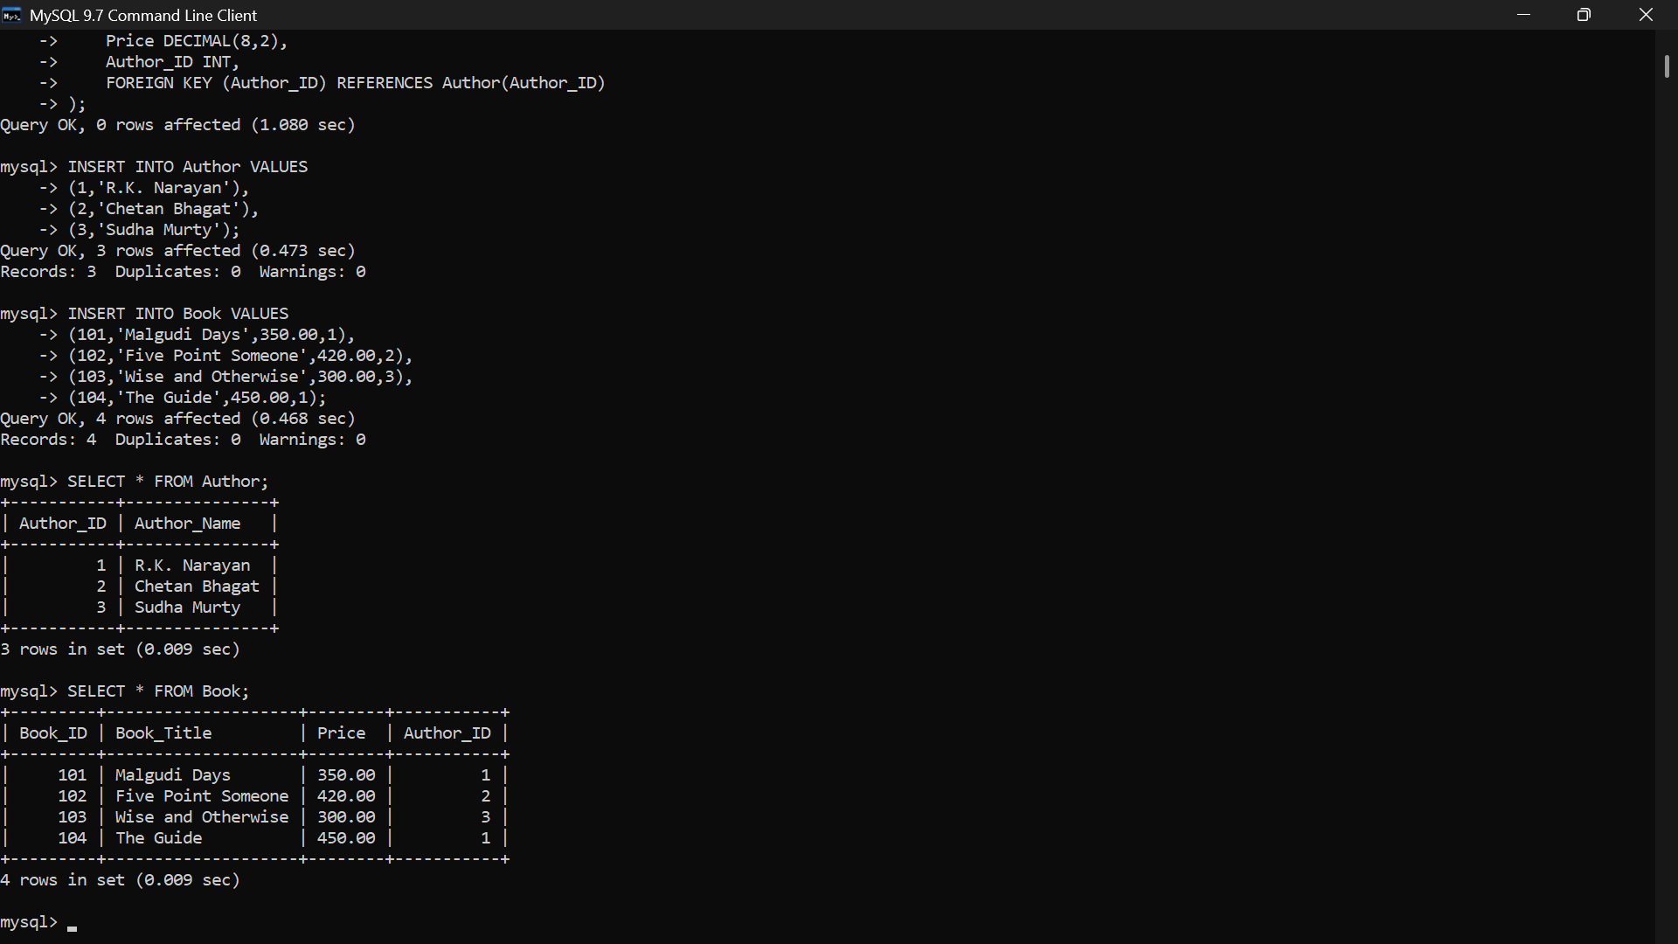
10] Design a relational schema for an Airline Reservation System and write 5 SQL queries demonstrating joins, sub-queries, and views.
A] 