NAME: P.Nitishkumar
REG.NO:192311408
1] Given the scenario of a School Management System, identify relations and write SQL to list all students with their class teacher and grade.
A] 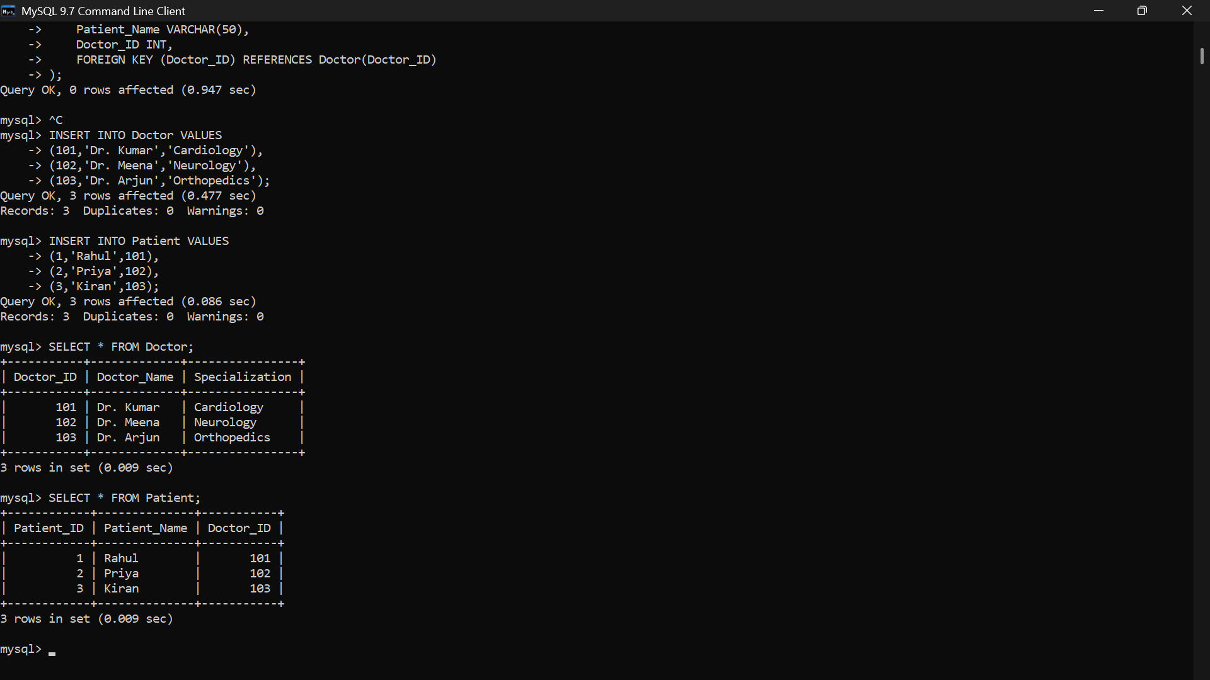
2] A hospital wants to track patient appointments. Design the relational schema and write SQL to find doctors with more than 10 appointments this month.
A]
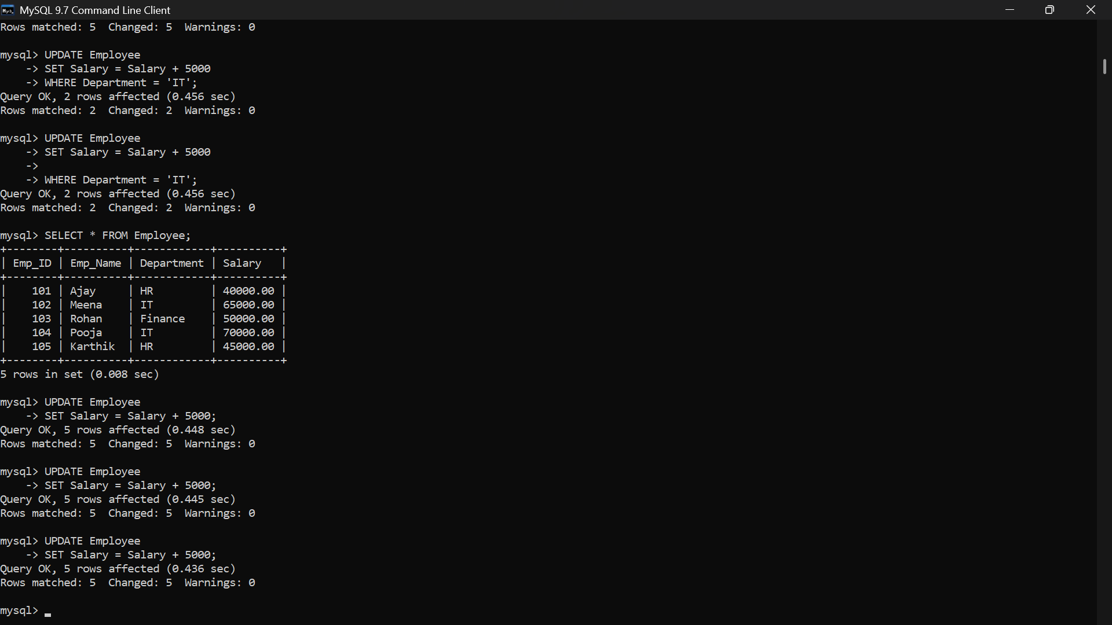
3] In an e-commerce scenario, write SQL queries using sub-queries to find products that have never been ordered.
A] 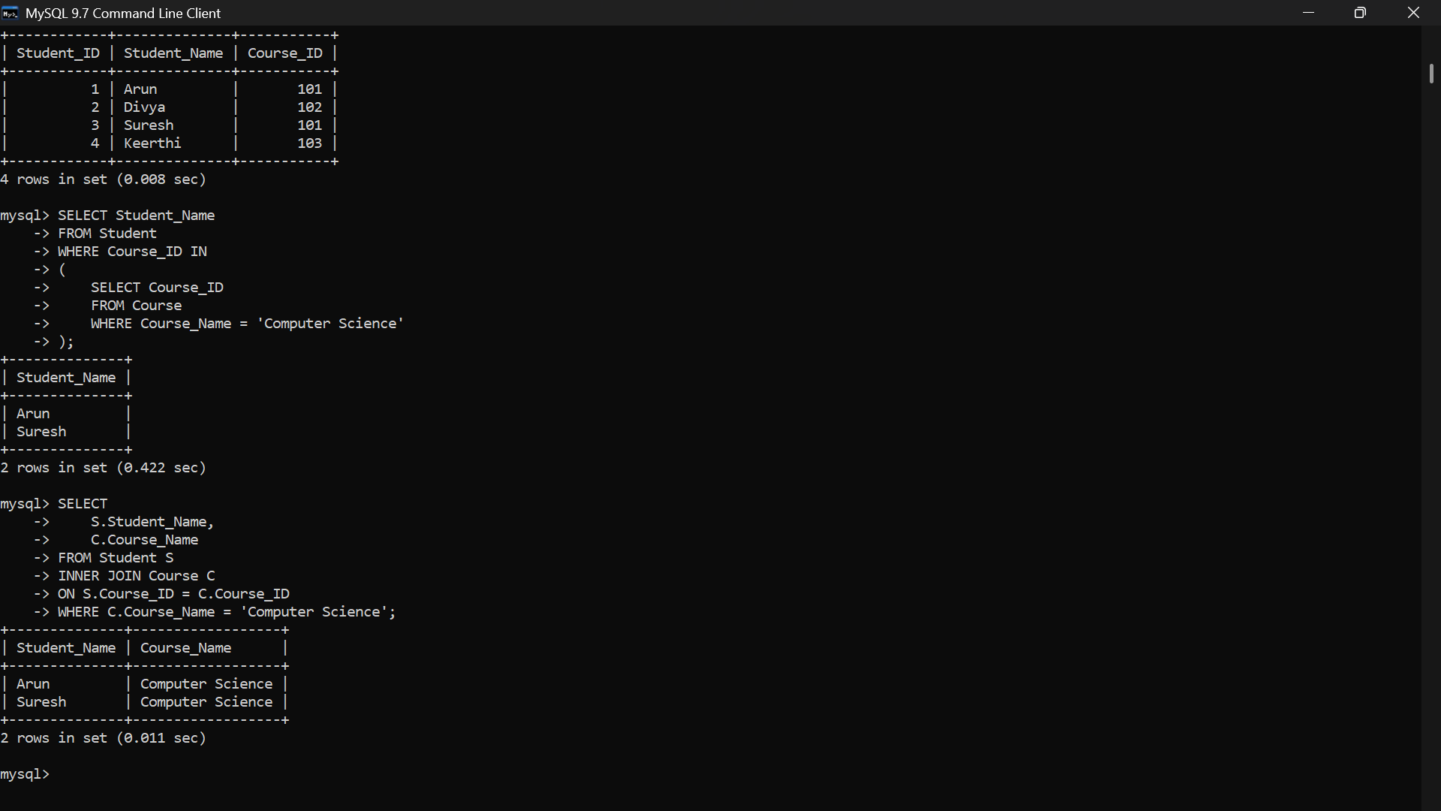
4] For a university database, write relational algebra expressions to find students enrolled in both &#39;DBMS&#39; and &#39;OS&#39; courses.
A] 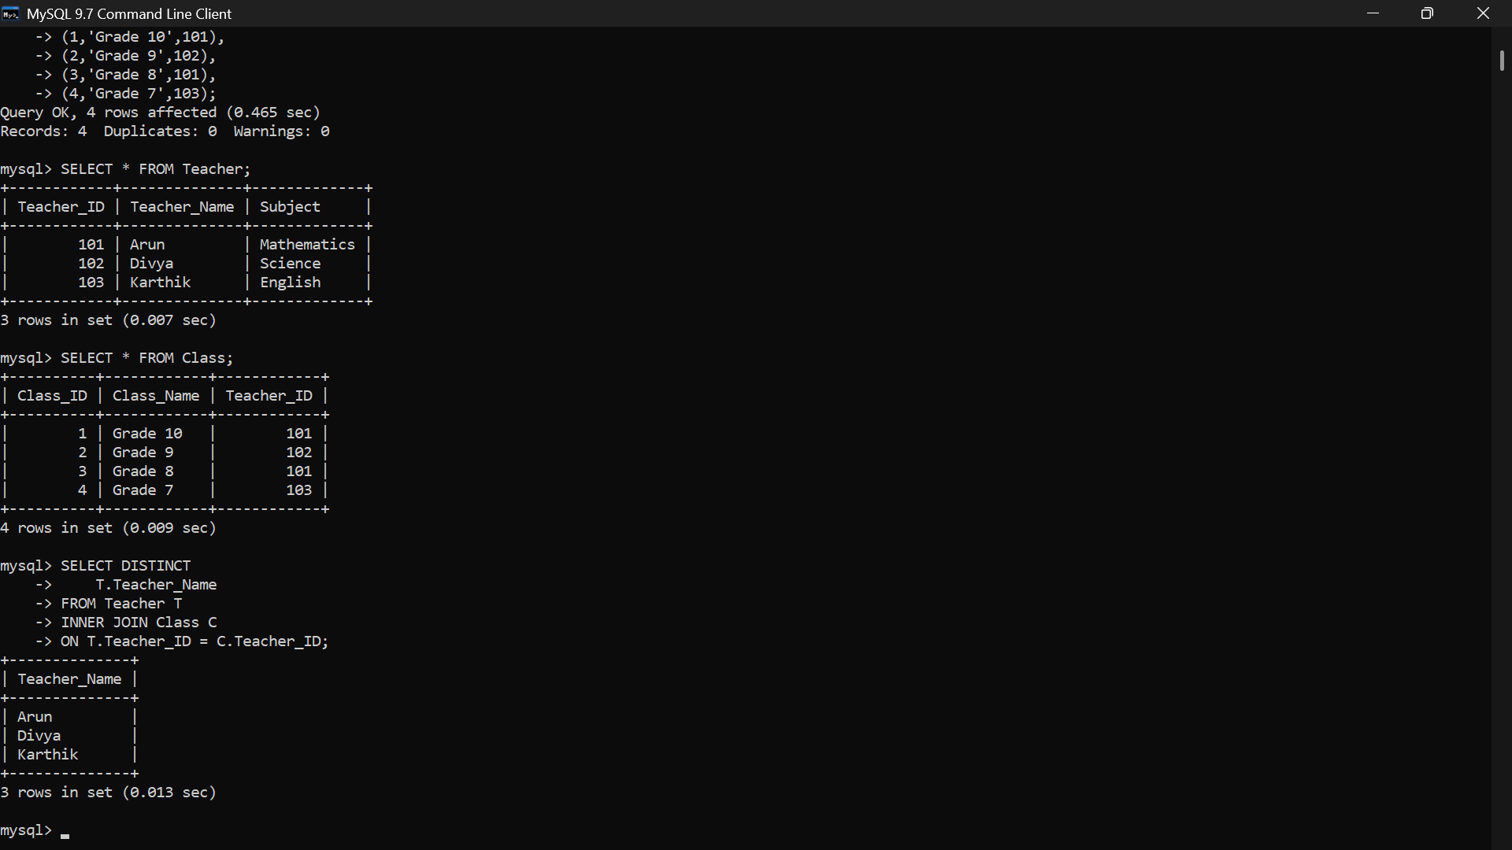

5] Given a payroll scenario, create a view showing employees whose salary is below department average and write a query to update their salary by 10%.
A] 
6] In a banking scenario, apply JOIN operations to retrieve customer account details, transaction history, and branch information.
A] 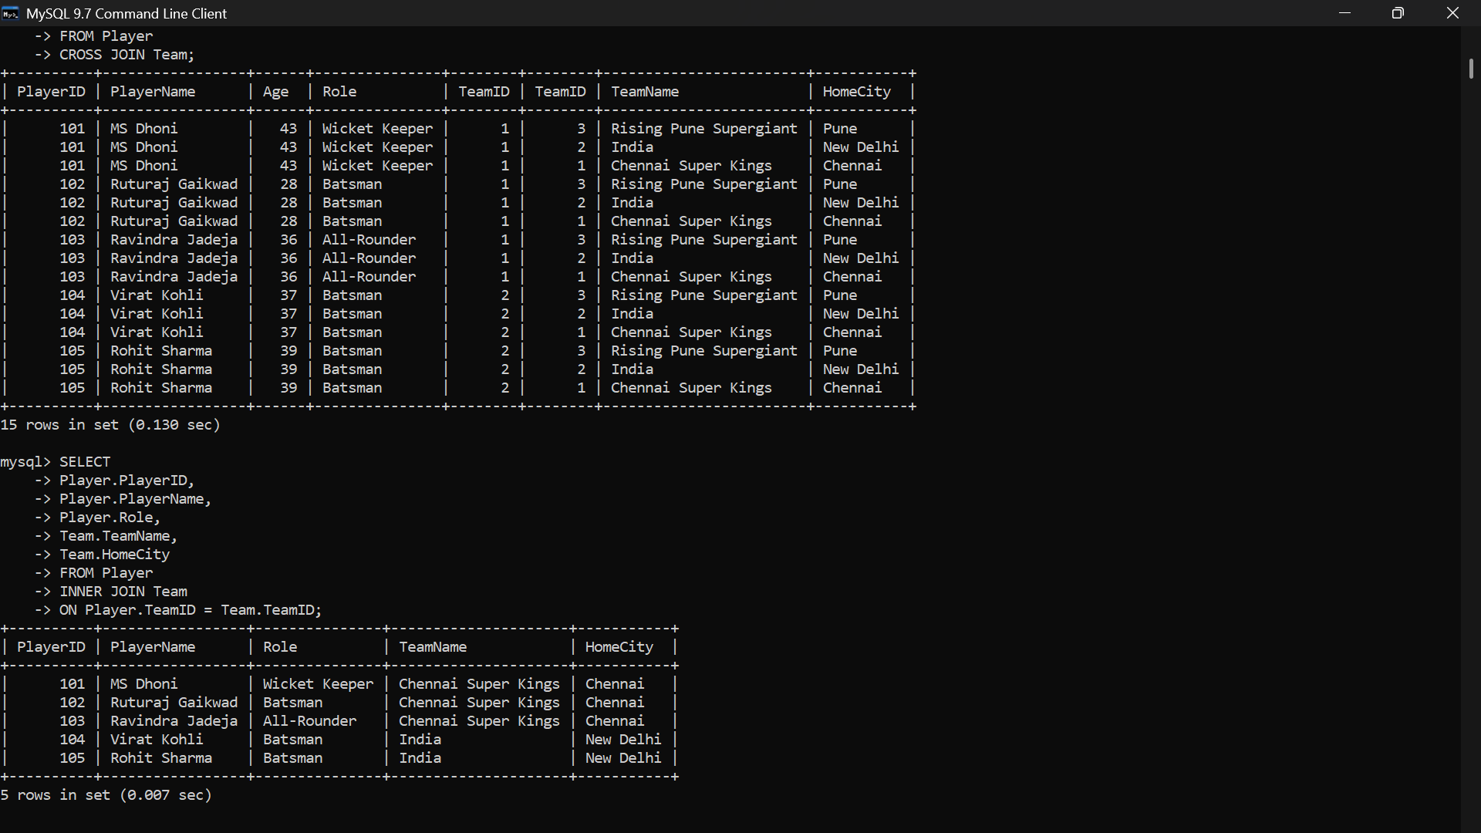

7] A retail store needs daily sales summary. Write SQL with GROUP BY and HAVING to report total sales per category exceeding Rs. 10,000.
A] 
8] For a library system scenario, construct tuple relational calculus expressions to find members who borrowed books from all genres.
A] 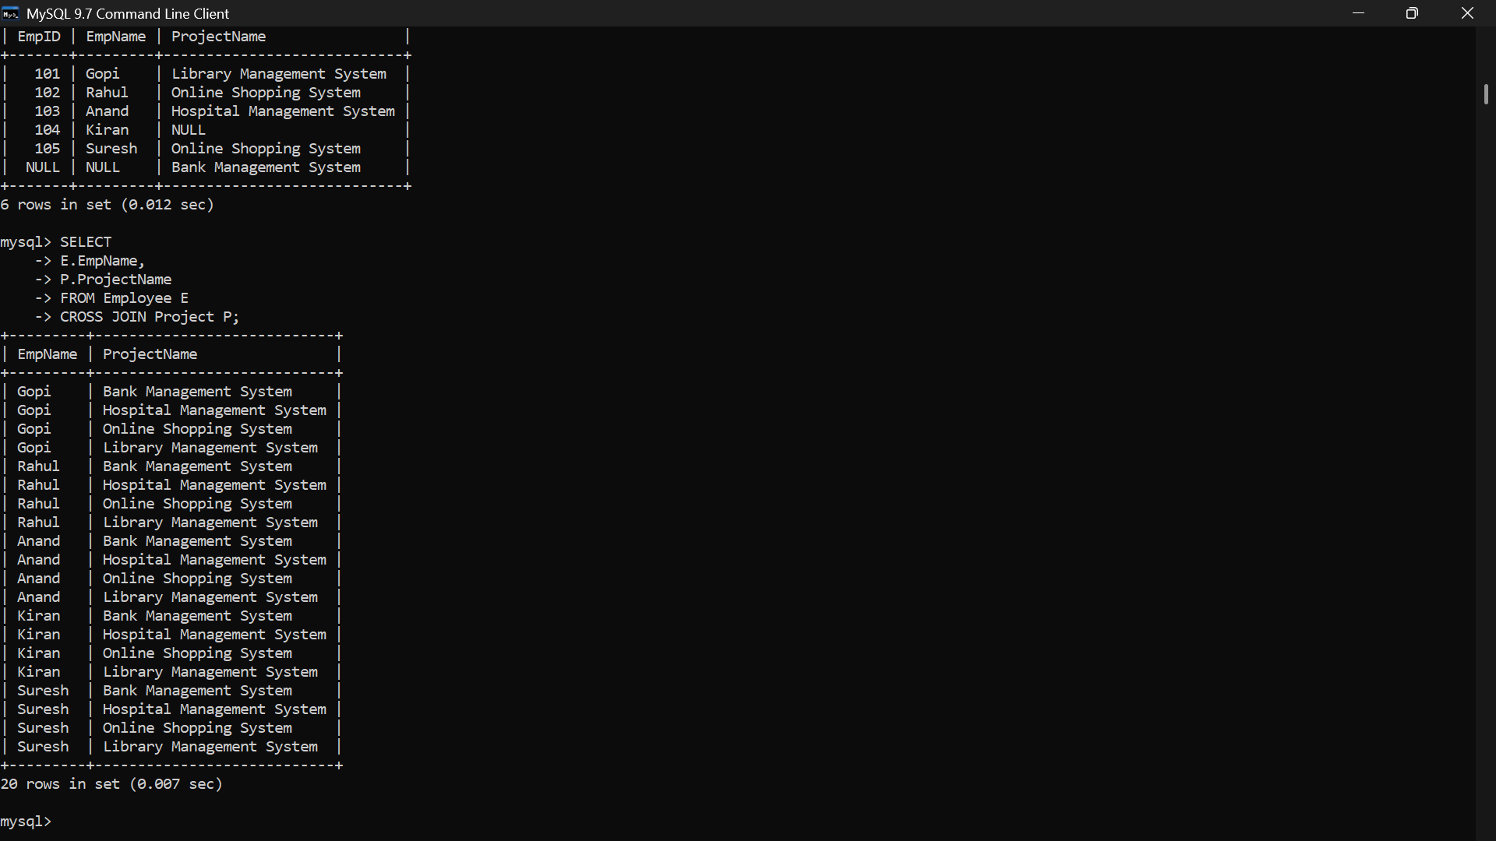

9] Given an inventory management scenario, define CHECK and FOREIGN KEY constraints and demonstrate their enforcement through SQL.
A] 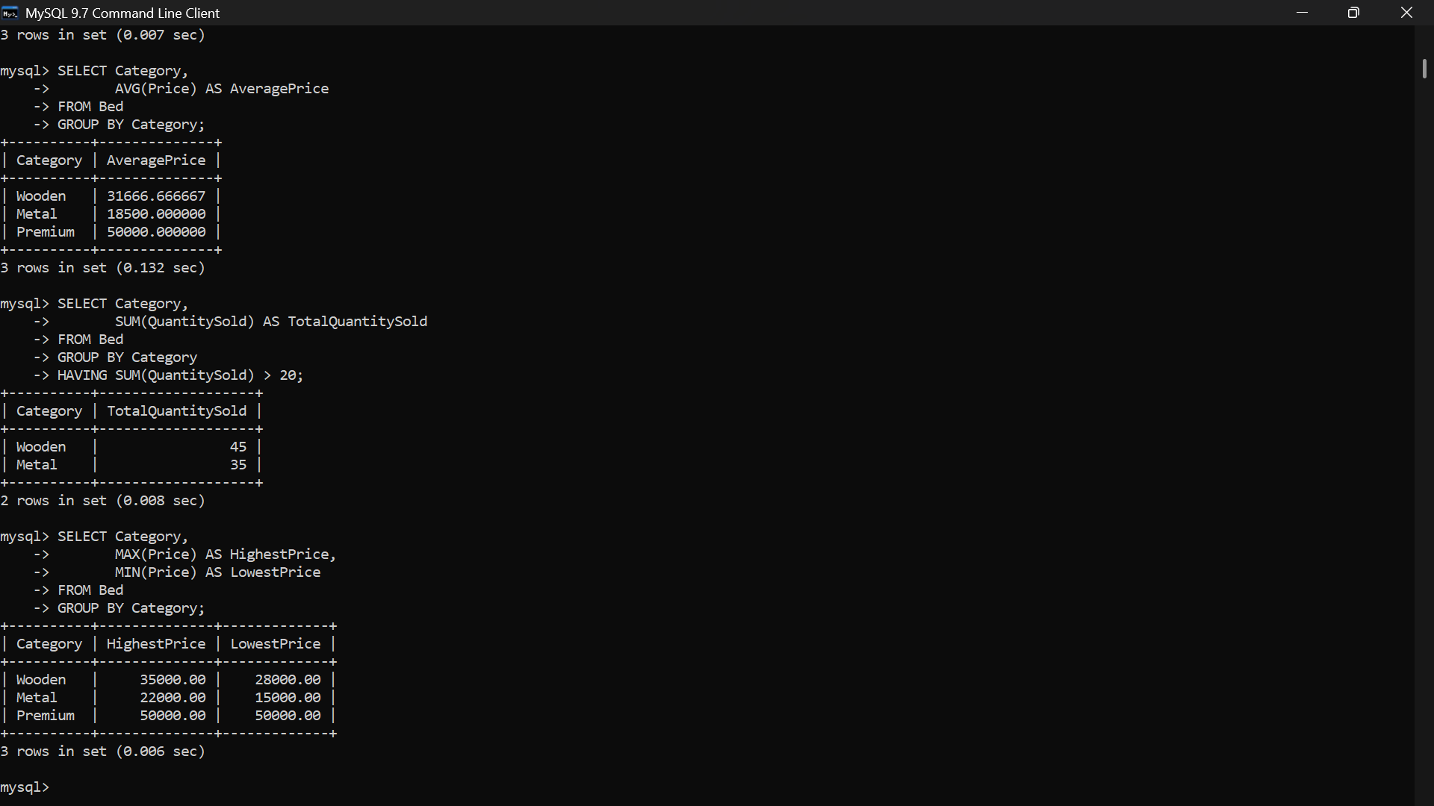
10] Design a relational schema for an HR system and create materialized views for monthly attendance and performance summaries.
A] 

