COURSE NAME: Theory of Computation COURSE CODE: CSA13

COURSE OUTCOME COVERED

CO1: Analyze fundamental mathematical concepts of automata theory for formal languages and decision problems.(BL:3)

Assessment Tool Weightage: 40%

QUESTIONS: 5 Total Marks:25
Duration : 1 Hour

Analytical Problem

Code of Conduct:

I (Name / Reg No) certify that this submission is my original work and that I have adhered to the guidelines specified for this assessment.

I understand that any violation of academic integrity rules will result in disciplinary action.

Signature of the student:

- Consider the NFA given below which accepts some language L over the alphabet 𝚺={a,b}. Construct a DFA that represents the same language L
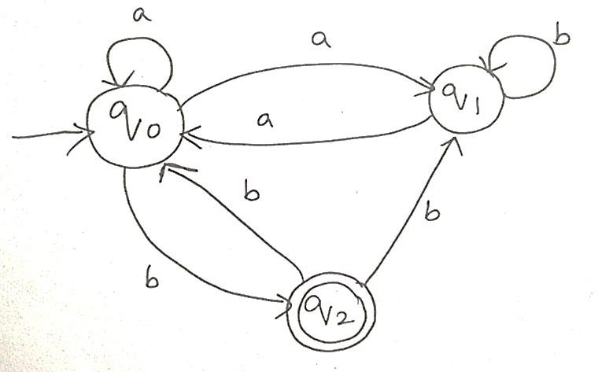
- Let L be the language of words of length atleast 2 whose last two letters are difference from each other. For example abaab is in L but not bb, Construct an NFA for L, Then draw the equivalent DFA

- Design a Nondeterministic Finite Automata (NFA) that takes a binary string as input and accepts the string only if the last two digits are the same (either 00 or 11). Write the formal definition of the NFA. Also show that the string 01011 is accepted by the NFA

- Consider the NFA given below which accepts the language representing the set of all strings having 001 as a substring over the alphabet 𝚺={0,1}. Construct a DFA that represents the same language.

- A NFA with ε-transitions is given below. Find ε-closure for each state and Design an equivalent DFA which accepts the same language. Draw its transition table and mark the initial and final states
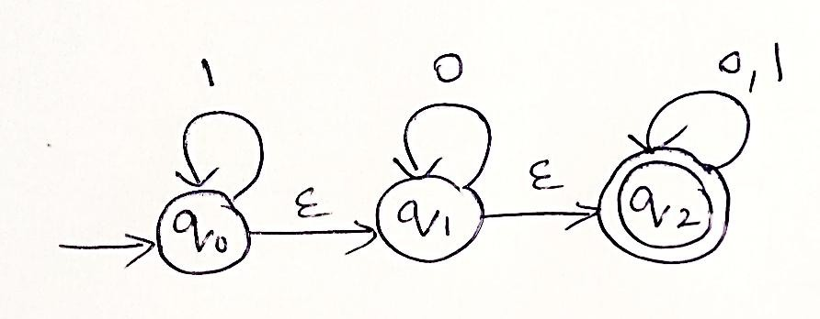

RUBRICS FOR CALCULATION

Criteria | Weightage | Level 4 –  Exemplary (5 Marks) | Level 3 –  Proficient (4 Marks) | Level 2 –  Developing (2–3 Marks) | Level 1 –  Beginning (0–1 Mark)
Conceptual Understanding | 30 | Demonstrates clear and complete understanding of  the concept | Good understanding with minor gaps | Basic understanding with some  misconceptions | Poor or incorrect understanding
Accuracy of Answer | 25 | Completely correct  answer with no errors | Mostly correct  with minor errors | Partially correct  with noticeable errors | Incorrect or  irrelevant answer
Application of Knowledge | 20 | Correctly applies concepts to solve the  question/problem | Applies concepts with minor mistakes | Limited or partially correct application | No or incorrect application
Completeness of Response | 15 | Covers all required parts of the  question | Covers most parts with minor  omissions | Covers only some parts | Incomplete or missing  response
Clarity & Presentation | 10 | Clear, concise, and  well-organized answer | Understandable  with minor issues | Somewhat unclear  or poorly structured | Difficult to understand

- Convert the given NFA into an equivalent DFA

Given
- Alphabet: $Σ=\left\{a , b\right\}$
- Initial state: $q_{0}$
- Final state: $q_{2}$
- NFA states: $Q=\left\{q_{0} , q_{1} , q_{2}\right\}$
Reading the given diagram, the transitions are:
- $q_{0}$has a self-loop on $a$.
- $q_{1}$has a self-loop on $b$.
- $q_{0}\underset{→}{a}q_{1}$
- $q_{1}\underset{→}{a}q_{0}$
- $q_{0}\underset{→}{b}q_{2}$
- $q_{2}\underset{→}{b}q_{1}$
Step 1: NFA transition table

State | Input $a$ | Input $b$
→ $q_{0}$ | $$\left\{q_{0} , q_{1}\right\}$$ | $$\left\{q_{2}\right\}$$
$$q_{1}$$ | $$\left\{q_{0}\right\}$$ | $$\left\{q_{1}\right\}$$
*$q_{2}$ | $$∅$$ | $$\left\{q_{1}\right\}$$
Step 2: Apply subset construction

Each DFA state represents a set of NFA states.
Let the DFA states be:
$$\begin{aligned}A&=\left\{q_{0}\right\} \\ B&=\left\{q_{0} , q_{1}\right\} \\ C&=\left\{q_{2}\right\} \\ D&=\left\{q_{1} , q_{2}\right\} \\ E&=∅ \\ F&=\left\{q_{1}\right\}\end{aligned}$$
The initial DFA state is $A=\left\{q_{0}\right\}$.
The final DFA states are all subsets containing $q_{2}$:
$$F_{D}=\left\{C , D\right\}$$
Step 3: DFA transition table

DFA state | Input $a$ | Input $b$
→ A | B | C
B | B | D
*C | E | F
*D | A | D
E | E | E
F | A | F
Here, $E$is the dead state. Once the DFA reaches $E$, it remains there for both inputs.
Step 4: Equivalent DFA diagram

The transition table above is the authoritative specification of the DFA; use it to draw the arrows neatly in your answer sheet.

Conclusion:
By applying the subset construction method, the given NFA is converted into an equivalent DFA. Both automata accept the same language over $\left\{a , b\right\}$.

2. Construct an NFA for strings of length at least 2 whose last two letters are different
Given
Alphabet:
$$Σ=\left\{a , b\right\}$$
The language is
$$L=\left\{w , ∈{\left\{a , b\right\}}^{*}:∣w∣≥2\text{ the last two letters differ}\right\}$$
Examples:
- Accepted: ab, ba, aab, bba, abab
- Rejected: a, b, aa, bb, aba? No — aba is accepted because its last two letters are different.
Step 1: Idea

The NFA reads any number of $a$'s and $b$'s in the initial state. It then nondeterministically guesses that the last two letters are either:
- $ab$, or
- $ba$.
Step 2: Formal definition

$$M=\left(Q , Σ , δ , q_{0} , F\right)$$
Where:
- $Q=\left\{q_{0} , q_{1} , q_{2} , q_{f}\right\}$
- $Σ=\left\{a , b\right\}$
- Initial state: $q_{0}$
- Final states: $F=\left\{q_{f}\right\}$
Step 3: Transition table
State | Input $a$ | Input $b$
→ $q_{0}$ | $$\left\{q_{0} , q_{1}\right\}$$ | $$\left\{q_{0} , q_{2}\right\}$$
$$q_{1}$$ | $$∅$$ | $$\left\{q_{f}\right\}$$
$$q_{2}$$ | $$\left\{q_{f}\right\}$$ | $$∅$$
*$q_{f}$ | $$∅$$ | $$∅$$
Step 4: State diagram

Step 5: Example — aab
The NFA follows:
$$q_{0}\underset{→}{a}q_{0}\underset{→}{a}q_{1}\underset{→}{b}q_{f}$$
Since the input finishes in the final state $q_{f}$, the string is accepted.
Conclusion
The NFA accepts exactly those strings whose length is at least 2 and whose last two letters are different.

3. Design an NFA that accepts binary strings whose last two digits are the same
Given
Alphabet:
$$Σ=\left\{0 , 1\right\}$$
The language is
$$L=\left\{w∈{\left\{0 , 1\right\}}^{*}:\text{the last two digits are }00\text{ or }11\right\}$$
Examples:
- Accepted: 00, 11, 100, 011, 01011
- Rejected: 0, 1, 01, 10, 010
Step 1: Idea
The NFA reads any sequence of binary digits in the initial state. It guesses the beginning of the final two digits.
There are two possible accepting paths:
- $q_{0}\underset{→}{0}q_{1}\underset{→}{0}q_{f}$, for strings ending in 00.
- $q_{0}\underset{→}{1}q_{2}\underset{→}{1}q_{f}$, for strings ending in 11.
Step 2: Formal definition
$$M=\left(Q , Σ , δ , q_{0} , F\right)$$
Where:
- $Q=\left\{q_{0} , q_{1} , q_{2} , q_{f}\right\}$
- $Σ=\left\{0 , 1\right\}$
- Initial state: $q_{0}$
- Final state: $F=\left\{q_{f}\right\}$
Step 3: Transition table
State | Input 0 | Input 1
→ $q_{0}$ | $$\left\{q_{0} , q_{1}\right\}$$ | $$\left\{q_{0} , q_{2}\right\}$$
$$q_{1}$$ | $$\left\{q_{f}\right\}$$ | $$∅$$
$$q_{2}$$ | $$∅$$ | $$\left\{q_{f}\right\}$$
*$q_{f}$ | $$∅$$ | $$∅$$
Step 4: State diagram

Step 5: Show that 01011 is accepted
The input is:
$$01011$$
The NFA remains in $q_{0}$while reading the prefix 010. It then follows the path for the final 11:
$$q_{0}\underset{→}{0}q_{0}\underset{→}{1}q_{0}\underset{→}{0}q_{0}\underset{→}{1}q_{2}\underset{→}{1}q_{f}$$
The final state is $q_{f}$. Therefore, 01011 is accepted.
Conclusion
The NFA accepts all binary strings of length at least two that end with 00 or 11.

4. Construct a DFA that accepts strings containing 001 as a substring
Given
Alphabet:
$$Σ=\left\{0 , 1\right\}$$
The required language is
$$L=\left\{w∈{\left\{0 , 1\right\}}^{*}:w\text{ contains }001\text{ as a substring}\right\}$$
Examples:
- Accepted: 001, 0001, 10010, 11001
- Rejected: 0, 00, 010, 1010
Note: The NFA diagram mentioned in Question 4 is not visible in the uploaded image. The following constructs an equivalent DFA directly from the specified language.
Step 1: Define the states
- $q_{0}$: No part of 001 has been matched.
- $q_{1}$: The most recent input ends in 0.
- $q_{2}$: The most recent input ends in 00.
- $q_{3}$: The substring 001 has been found.
Once the substring is found, the DFA remains in $q_{3}$for every remaining input.
Step 2: Formal definition
$$M=\left(Q , Σ , δ , q_{0} , F\right)$$
Where:
- $Q=\left\{q_{0} , q_{1} , q_{2} , q_{3}\right\}$
- $Σ=\left\{0 , 1\right\}$
- Initial state: $q_{0}$
- Final state: $F=\left\{q_{3}\right\}$
Step 3: Transition table
State | Input 0 | Input 1
→ $q_{0}$ | $$q_{1}$$ | $$q_{0}$$
$$q_{1}$$ | $$q_{2}$$ | $$q_{0}$$
$$q_{2}$$ | $$q_{2}$$ | $$q_{3}$$
*$q_{3}$ | $$q_{3}$$ | $$q_{3}$$
Step 4: State diagram

Step 5: Example — 1001
The state sequence is:
$$q_{0}\underset{→}{1}q_{0}\underset{→}{0}q_{1}\underset{→}{0}q_{2}\underset{→}{1}q_{3}$$
The substring 001 is found, and the machine reaches the final state $q_{3}$.
Therefore, 1001 is accepted.
Conclusion
The DFA accepts every binary string containing 001 at any position. Once 001 is detected, all subsequent symbols are accepted.

5. Find ε-closures and construct an equivalent DFA for the given ε-NFA
Given
The ε-NFA contains three states:
- $q_{0}$: Initial state
- $q_{1}$: Intermediate state
- $q_{2}$: Final state
The transitions shown in the diagram are:
- $q_{0}$has a self-loop on input $1$.
- $q_{1}$has a self-loop on input $0$.
- $q_{2}$has self-loops on inputs $0$and $1$.
- $q_{0}\underset{→}{ε}q_{1}$
- $q_{1}\underset{→}{ε}q_{2}$
Step 1: Find the ε-closure of each state
The ε-closure of a state is the set of states reachable from that state using zero or more ε-transitions.
ε-closure of $q_{0}$
From $q_{0}$, we can reach $q_{1}$and then $q_{2}$without consuming any input.
$$\boxed{ε\text{-closure}\left(q_{0}\right)=\left\{q_{0} , q_{1} , q_{2}\right\}}$$
ε-closure of $q_{1}$
From $q_{1}$, we can reach $q_{2}$using an ε-transition.
$$\boxed{ε\text{-closure}\left(q_{1}\right)=\left\{q_{1} , q_{2}\right\}}$$
ε-closure of $q_{2}$
There are no outgoing ε-transitions from $q_{2}$.
$$\boxed{ε\text{-closure}\left(q_{2}\right)=\left\{q_{2}\right\}}$$
Step 2: ε-closure table
State | ε-closure
$$q_{0}$$ | $$\left\{q_{0} , q_{1} , q_{2}\right\}$$
$$q_{1}$$ | $$\left\{q_{1} , q_{2}\right\}$$
$$q_{2}$$ | $$\left\{q_{2}\right\}$$
Step 3: Construct the equivalent DFA
The initial DFA state is the ε-closure of the NFA's initial state.
$$A=\left\{q_{0} , q_{1} , q_{2}\right\}$$
The reachable DFA states are:
$$\begin{aligned}A&=\left\{q_{0} , q_{1} , q_{2}\right\} \\ B&=\left\{q_{1} , q_{2}\right\} \\ C&=\left\{q_{2}\right\}\end{aligned}$$
A DFA state is final if its set contains the NFA's final state $q_{2}$.
Therefore,
$$\boxed{F_{D}=\left\{A , B , C\right\}}$$
Step 4: DFA transition table
DFA state | Input 0 | Input 1
→ *A | B | A
*B | B | C
*C | C | C
Explanation of transitions
- From $A$, input $0$reaches $B$, while input $1$returns to $A$.
- From $B$, input $0$remains in $B$, while input $1$reaches $C$.
- From $C$, both inputs remain in $C$.
Step 5: Equivalent DFA diagram

All three states are final states, so each state is drawn with a double circle.
Step 6: Minimize the DFA
Since all three states are final and every input transition leads to another final state, the DFA can be minimized to a single state.
State | Input 0 | Input 1
→ *$S$ | $$S$$ | $$S$$
The minimized DFA consists of one initial and final state with a self-loop on $0,1$.
Conclusion
The ε-NFA accepts every binary string, including the empty string, because an ε-path exists from the initial state $q_{0}$to the final state $q_{2}$. The equivalent minimized DFA therefore has one state with loops on both $0$and $1$.
Important correction to Question 1
In the Question 1 DFA transition table, the transition from $D=\left\{q_{1} , q_{2}\right\}$on input $b$must be $F=\left\{q_{1}\right\}$, not $D$. The corrected row is:
DFA state | Input $a$ | Input $b$
*D | A | F
This follows from $δ\left(q_{1} , b\right)=\left\{q_{1}\right\}$and $δ\left(q_{2} , b\right)=\left\{q_{1}\right\}$.

