CO1 AT2 Simulation: Worked Designs
P.Nitishkumar, Reg No:192311408 Course: Theory of Computation (CSA13)
Use these to understand each design, then build and test it in your simulator (JFLAP or Autosim), take your own screenshots and write the explanations in your own words, since the sheet asks for original work.

Q1. NFA for the automatic door
The sheet says "NBA", which is a typo for NFA.
- States: Q = {Closed, Opening, Open, Closing}
- Alphabet: Σ = {P, N}
- Start state: Closed
- Accepting state: Closed (a full cycle is complete and the door is back at rest)
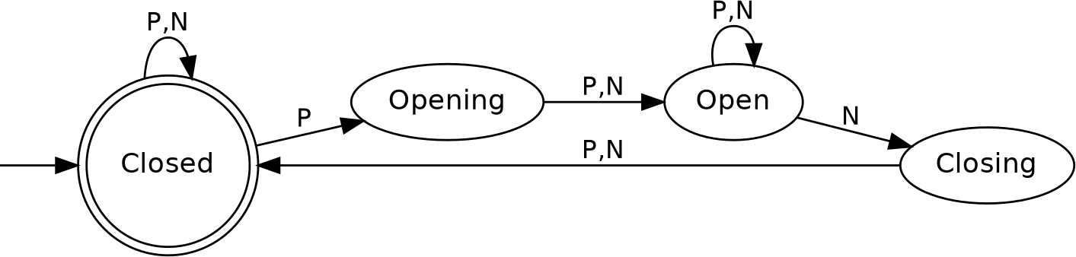
Fig 1. NFA for the automatic door

State | P | N
→*Closed | {Closed, Opening} | {Closed}
Opening | {Open} | {Open}
Open | {Open} | {Open, Closing}
Closing | {Closed} | {Closed}

Where the non-determinism is:
- In Closed on P, the door may open or stay closed (it might be a false detection).
- In Open on N, the door may stay open or start closing.
Trace for PNNN: Closed –P→ Opening –N→ Open –N→ Closing –N→ Closed. The string ends in Closed, so it is accepted.

Q2. Traffic light controller
Model: a Moore-style finite automaton where each state is an output (the light colour) and the input is a timer-expiry signal t.
- States: {Red, Green, Yellow}
- Σ: {t}

Start state: Red

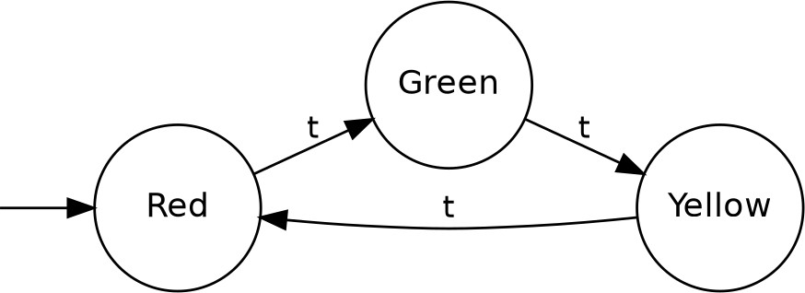
Fig 2a. Basic traffic light cycle

State | t
→Red | Green
Green | Yellow
Yellow | Red
Timing: the automaton itself has no clock. A timer outside it fires t when the current light's duration ends (for example Red 30 s, Green 25 s, Yellow 5 s). To put the timing inside the model, split each light into tick-counting sub-states (R1…R30, G1…G25, Y1…Y5) with a tick input. The sequence Red→Green→Yellow→Red repeats forever, so there is no final state.

Extensions:
- Pedestrian crossing: add the input p (button pressed) and a state PedWalk. The request is latched and served when the light reaches Red, then PedWalk runs until t and returns to the normal cycle.
- Emergency override: add the input e and a state EmergencyGreen. The signal is latched and served at the next Red, so the light always passes through Yellow→Red first. The input c (cleared) returns the machine to Red.
- Safety: never allow two conflicting directions to be green at once. Make the transition table total so every input is defined in every state.
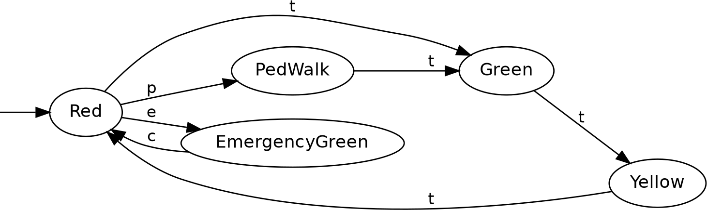
Fig 2b. Extended model with pedestrian (p) and emergency (e, c) inputs

Q3. DFA for strings ending with "ab" over {a, b}
- States: q0 (no progress), q1 (last symbol was a), q2 (last two were ab)
- Start: q0

Accepting: q2

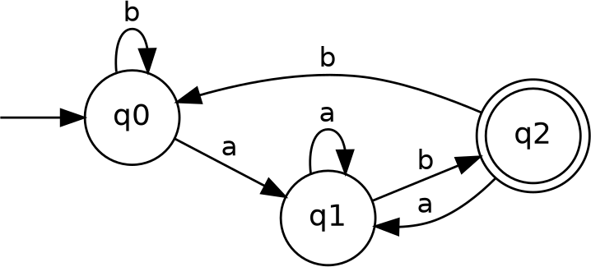
Fig 3. DFA for strings ending with ab

State | a | b
→q0 | q1 | q0
q1 | q1 | q2
*q2 | q1 | q0
Trace for w = aaabab: q0 –a→ q1 –a→ q1 –a→ q1 –b→ q2 –a→ q1 –b→ q2. It ends in q2, so it is
accepted.

Q4. DFA accepting only "c", "bc" and "bcaaa" over {a, b, c}
- States: q0 (start), q1 ("c", accepting), q2 ("b"), q3 ("bc", accepting), q4 ("bca"), q5 ("bcaa"), q6 ("bcaaa", accepting), D (dead)
- Start: q0
- Accepting: {q1, q3, q6}
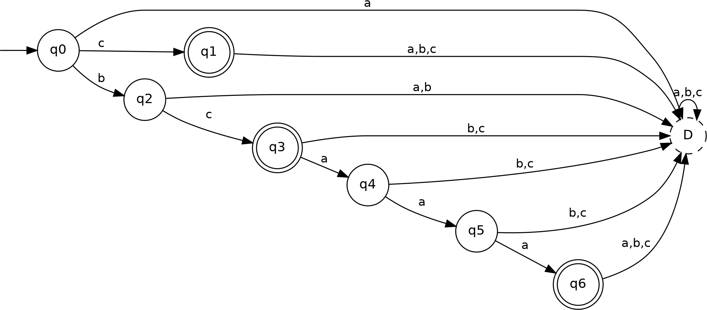
Fig 4. DFA for {c, bc, bcaaa} (dashed state is the dead state D)

State | a | b | c
→q0 | D | q2 | q1
*q1 | D | D | D
q2 | D | D | q3
*q3 | q4 | D | D
q4 | q5 | D | D
q5 | q6 | D | D
*q6 | D | D | D
D | D | D | D

Check:
- c: q0→q1, accepted.
- bc: q0→q2→q3, accepted.
- bcaaa: q0→q2→q3→q4→q5→q6, accepted.
- bca, bcaaaa, cb, ε and so on end in a non-accepting state or D, so they are rejected.

Q5. DFA for strings that begin with "a" or "b" over {a, b}
Since Σ = {a, b}, this is every non-empty string. The empty string must be rejected.
- States: q0 (start, non-accepting), q1 (accepting)
- Start: q0
- Accepting: {q1}
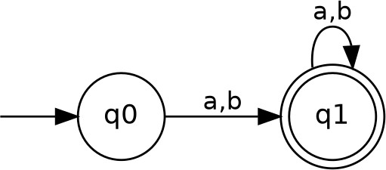
Fig 5. DFA for non-empty strings over {a, b}

State | a | b
→q0 | q1 | q1
*q1 | q1 | q1

Check:
- ε is rejected because q0 is not accepting.
- a, b, abba and bbb all reach q1 and stay there, so they are accepted.
A dead state is not needed because every symbol in Σ is already handled. If your simulator insists on one, add D with no incoming transitions.

Simulator tips
- Mark the start state with the initial-state arrow and double-circle the accepting states.

- Input your test strings (Q3 aaabab; Q4 c, bc, bcaaa plus a few rejects; Q5 a, b, abab, ε) and take screenshots of both the diagram and the accept/reject results.
- For Q1, use an NFA project type, not a DFA.

