Name:M.Nitish Kumar

Mail:nitishkumarmalleboina@gmail.com

Batch:125(10AM)

GitHUB: https://github.com/nitishmalleboina/vcube-tasks

**Task is connect S3 bucket to EC2 instance with IAM role:**

* Open aws console.
* Go to s3 and then create new bucket.

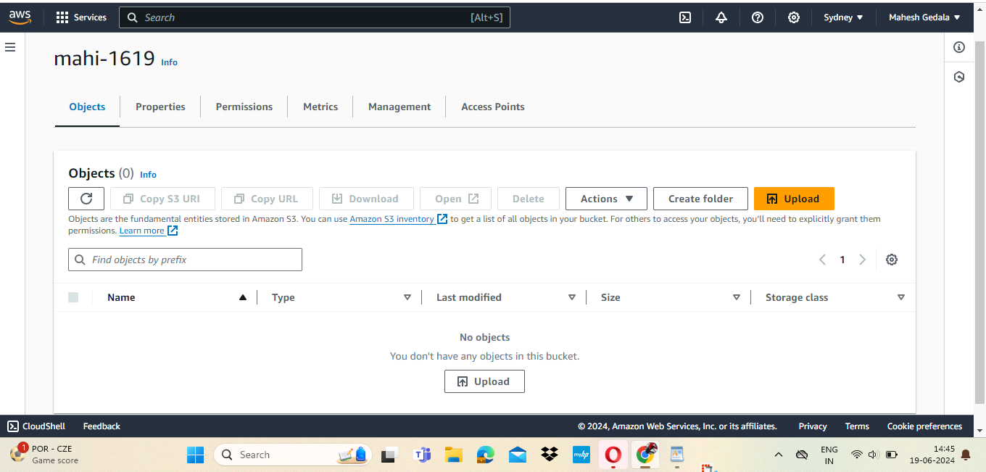

* Go to IAM and open.
* Select Roles and create roles in IAM.

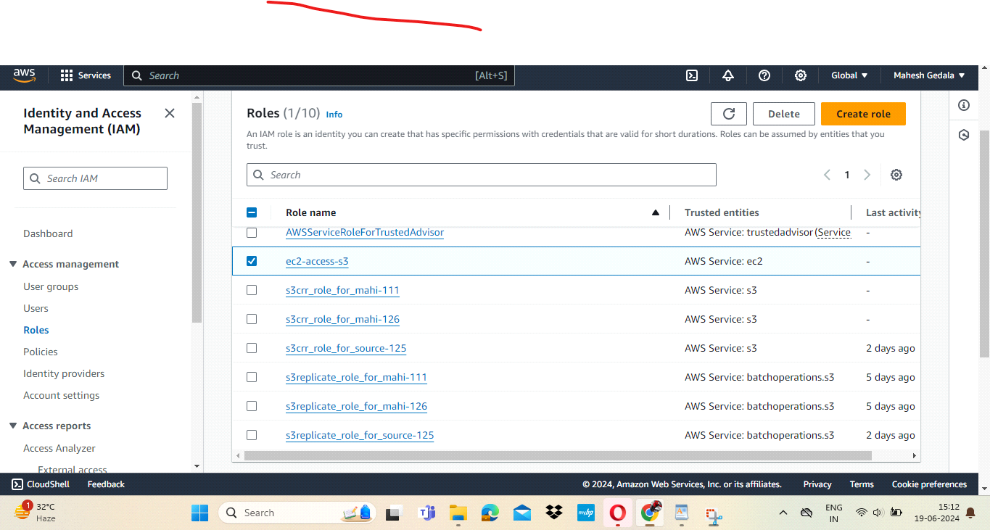

* Next create new instance and then add role in particular instance.
* Go to instance ->open actions -> select security -> and then select modify IAM role. it can be added.

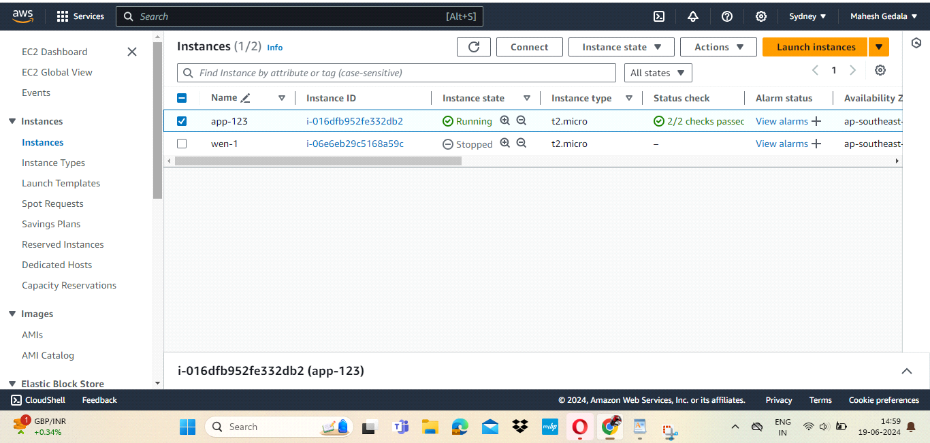

* Next go to server connect it.
* Creat one test file by using command -> touch file.txt -> ls ->file created.
* enter command -> aws s3 ls -> the created bucket name will be displayed.
* enter command -> aws s3 cp file.txt s3://mahi-1619/mahesh.
* then file will be uploaded to the s3 bucket.

