Name: M.Nitish kumar

Mail:nitishkumarmalleboina@gmail.com

Batch:125(10AM)

**Task on Encryption:**

* Open aws console
* Go to s3 and then create bucket.
* Select bucket what you created and upload file.
* go to Key Managemnet service (kms) and select the customer managed key -> create key.

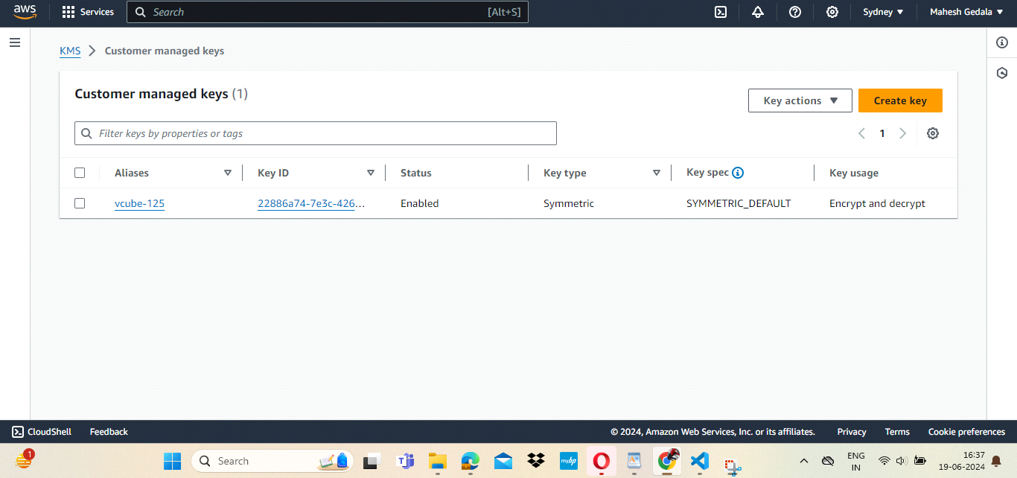

* go to bucket and open file ->choose permissions -> edit encryption and add required permissions.

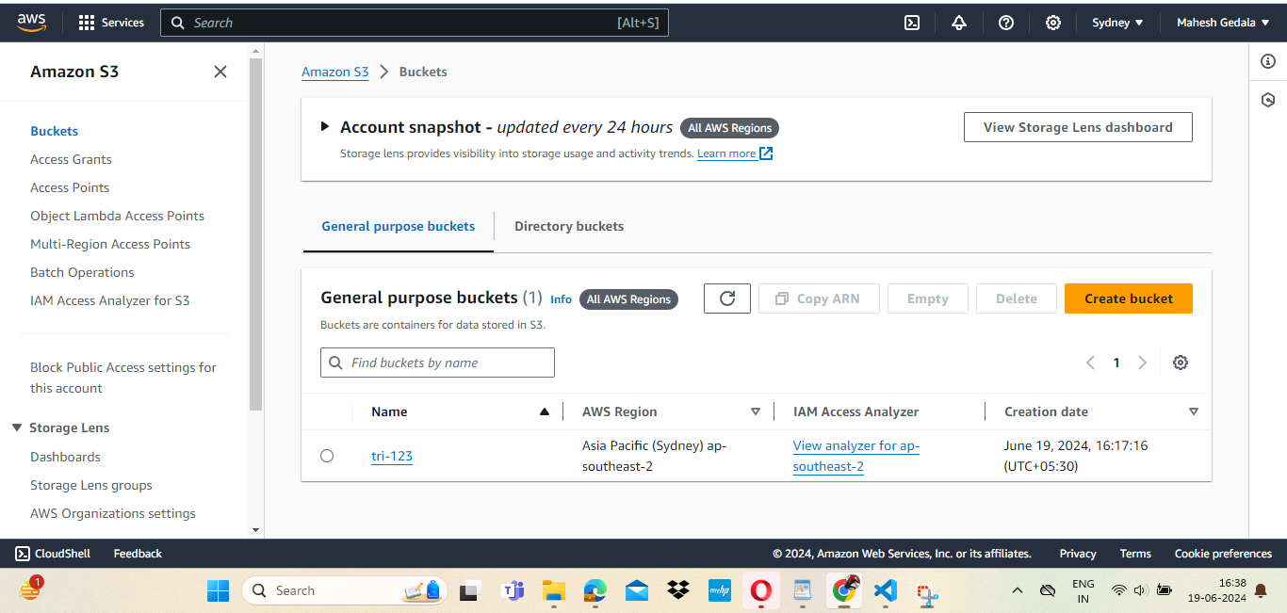

* Next go to IAM and create user.
* Then login into IAM user in new browser.
* here the bucket will be empty.

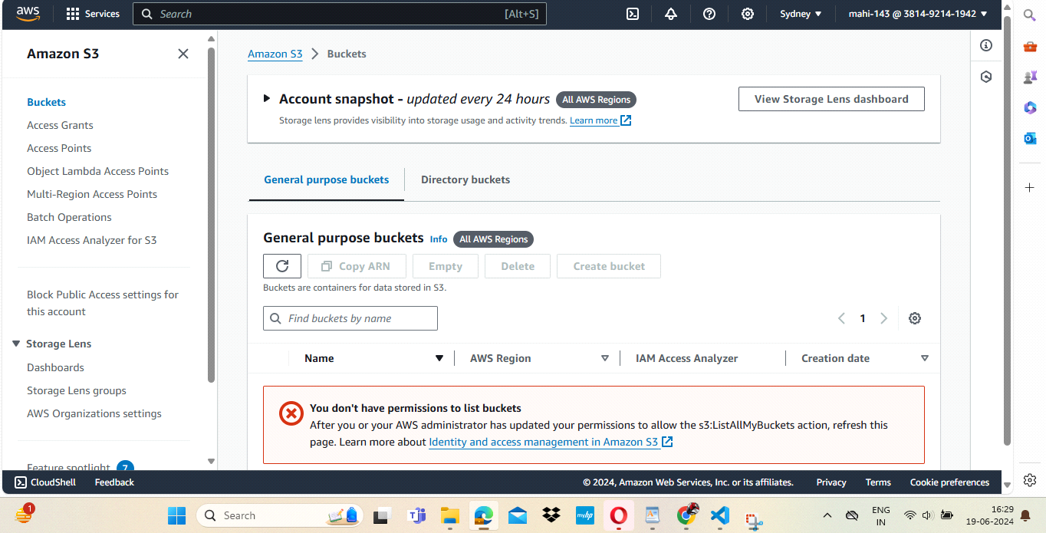

* Next go to KMS -> click on file -> key users -> add file.
* go to IAM -> users -> choose add permissions -> attach policies directly -> search s3 -> aws full access ->add permission.
* Here the data will be encrypted. so open the IAM login window.
* it will shows the bucket. then the data to be encrypted.

