CMPE207 Lab Assignment #3
Topic: Web Client and Server
Project Group 5

Server
-------------------------------------------------------------------------
README.md
-------------------------------------------------------------------------

TCP/IP client-server program. The code will be following the standard HTTP/1.0 or HTTP/1.1. The server will be sending both the header and the request. The total number of bytes received form the serve including the header is also fetched. Also, the time required to fetch the file is also listed. The client will be able to request file sizes of 1K or 2K.

Run the following command to compile the client and server programs.
$make

This, will create the executables with the name server.o and client.o

- Web client requesting the web server:

Open two terminals and run the client and server with the following commands.

In one terminal, start the server by running the nelow mentioned command-
$./server.o 127.0.0.1 (pwd path) 5370
(pwd path = /Users/neel/Desktop)

In other terminal, start the client by running the below mentioned command-
$./client.o 127.0.0.1/(filename) 5370

Screenshots:

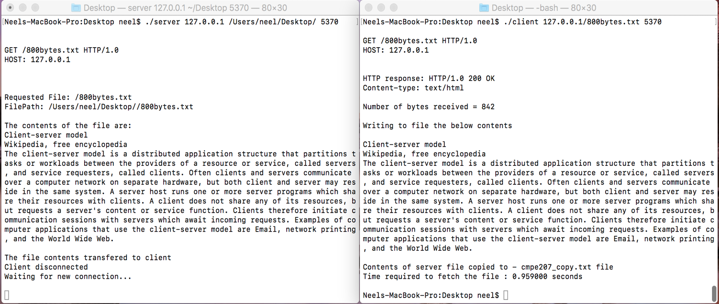

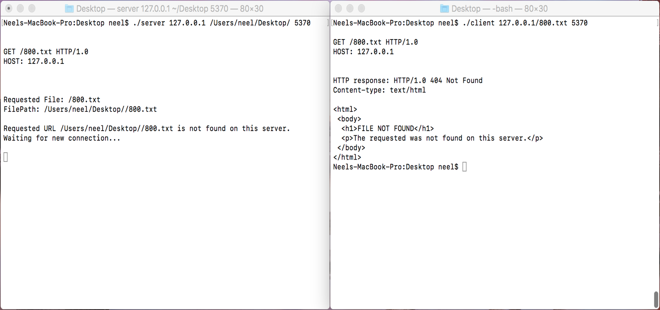

- Standard browser acting as a client requesting the web server:

Use the following command to run the server executable.
$./server.o 127.0.0.1 (pwd path) 8000
(pwd path = /Users/neel/Desktop)

Now, open the browser and enter the following URL
localhost:5370/(filename).txt

Screen shots:

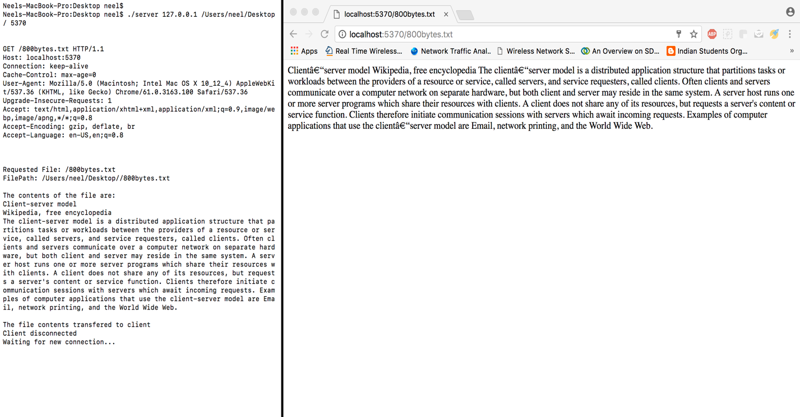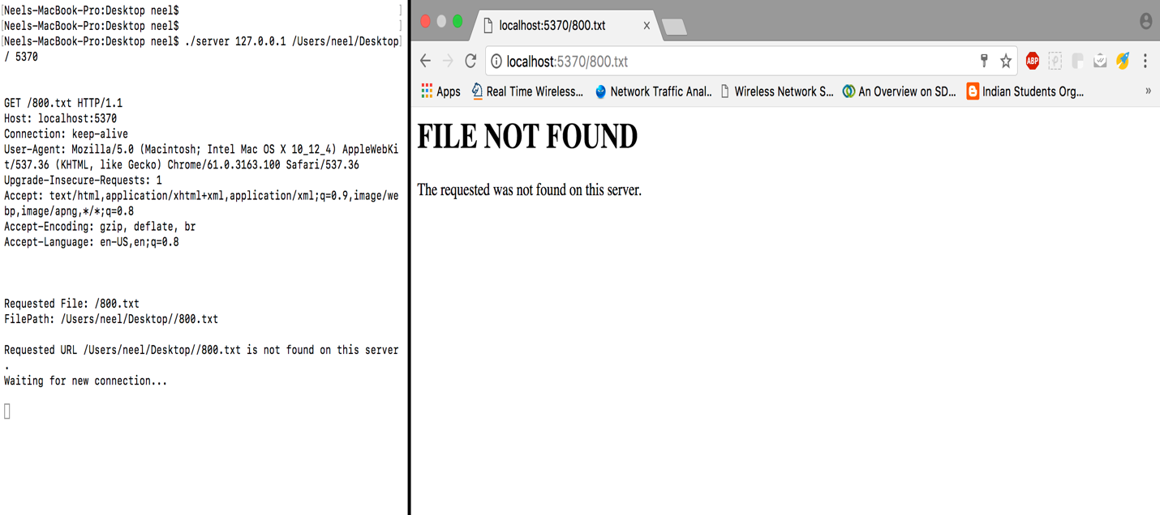

- Web client requesting the standard web browser:

Run the following command in a terminal.
$./client.o its.sjsu.edu/about/ 80
Respective contents will be displayed at the client side and a new file will be created having the contents.

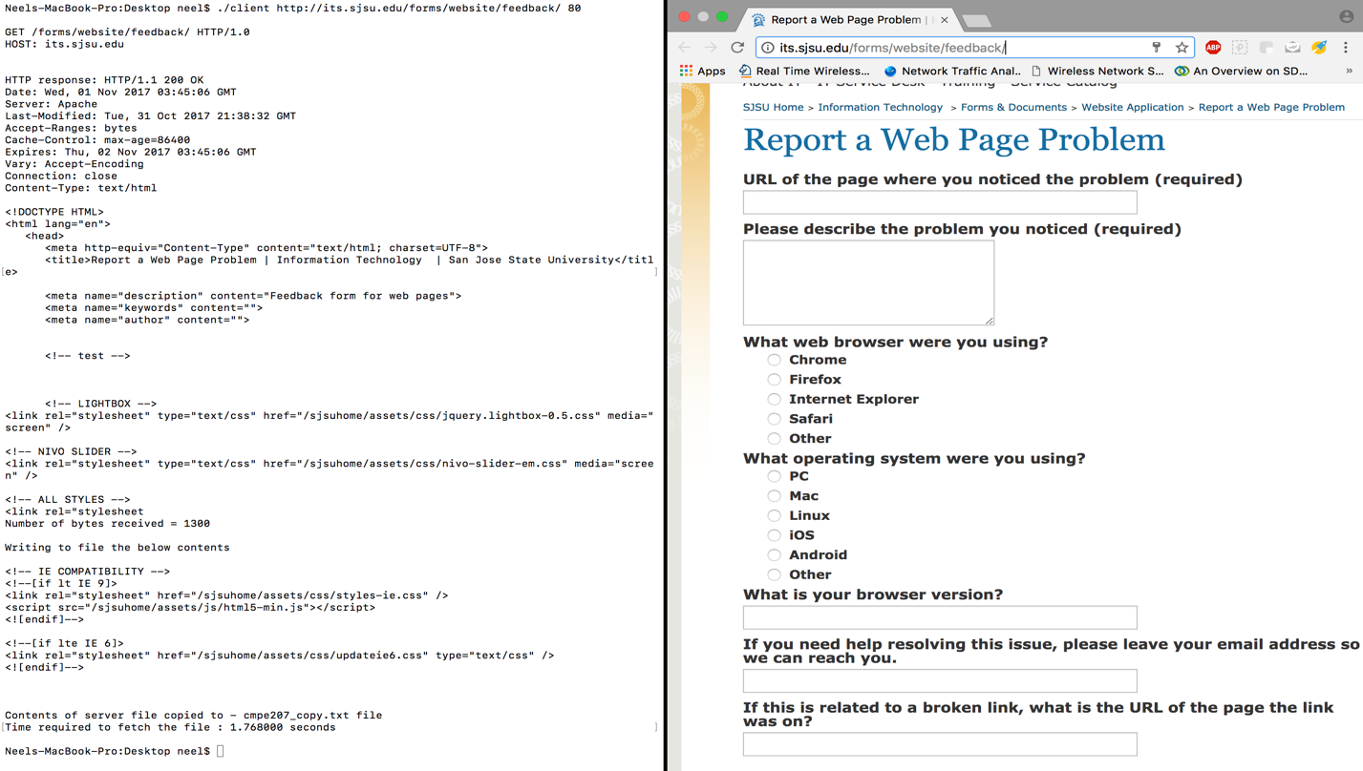

The server code as below-

-------------------------------------------------------------------------
Server.c
-------------------------------------------------------------------------
#include <stdio.h>
#include <sys/types.h>
#include <sys/socket.h>
#include <netinet/in.h>
#include <netdb.h>
#include <fcntl.h>
#include <stdlib.h>
#include <unistd.h>
#include <arpa/inet.h>
#include <sys/stat.h>
#include <errno.h>
#include <time.h>
#include <string.h>
#define BUF_SIZE 80000
#define URL_SIZE 128

static char* HTTP_ACCEPTED =
"HTTP/1.0 200 OK\n"
"Content-type: text/html\n";

static char* FILE_NOT_FOUND =
"HTTP/1.0 404 Not Found\n"
"Content-type: text/html\n"
"\n"
"<html>\n"
" <body>\n"
" <h1>FILE NOT FOUND</h1>\n"
" <p>The requested was not found on this server.</p>\n"
" </body>\n"
"</html>\n";

int main(int argc, char *argv[])
{
/*
* sockfd is the socket descriptor which is an integer value
* client_address is the struct used to specify a local or remote endpoint address of client.
*/
int sockfd, newsockfd;
struct sockaddr_in serv_addr;
int address_len = sizeof(serv_addr);
char *dir, *host;
int portno;
host = argv[1]; //Get the host address
dir = argv[2]; //Get the file directory
portno = atoi(argv[3]); //Get the port number

/*
* Socket() call takes three arguments:
* The family of protocol used/address family
* Type of socket
* Protocol number or 0 for a given family and type
*/
sockfd = socket(AF_INET, SOCK_STREAM, 0);
/*
* Socket call will return a socket descriptor on success which is an integer
* And it will return '-1' for error
*/
if (sockfd == -1)
{
printf("Error calling Socket");
exit(1);
}

/* Populating the sockaddr_in struct with the following values */
/* Assigning the AF_INET (Internet Protocol v4) address family */
serv_addr.sin_family = AF_INET;

/* Populating the Server IP address with the value of the localhost IP address */
serv_addr.sin_addr.s_addr = htons(INADDR_ANY);

/* Converting the port number received from the command line from host byte order to network byte order */
serv_addr.sin_port = htons(portno);

/*
* Bind takes three arguments: - Used to bind the local endpoint parameters to the socket
* Socket descriptor
* Server Address Structure - Local endpoint in this case
* Size of the address
*/
if(bind(sockfd,(struct sockaddr *) &serv_addr,sizeof(serv_addr)) < 0)/* Returns 0 for success and -1 for failure */
{
printf("Error binding");
exit(1);
}

/* Listen call makes the socket to be a passive type, taking two arguments:
* Socket Descriptor
* number of connection that can be queued
*/
while(1)
{
if(listen(sockfd,100) < 0)
{
printf("Error listening");
exit(1);
}

/* server accepts incoming conenction on sockfd and assigns it to newsockfd */
/*
* Accept takes three arguments:
* Socket descriptor
* Server Address Structure - Local endpoint in this case
* Size of the address
*/
newsockfd = accept(sockfd,(struct sockaddr *) &serv_addr, (socklen_t*)&address_len);

time_t timenow;
struct tm * timeinfo;
time (&timenow);
timeinfo = localtime(&timenow);
int count;
char buffer[BUF_SIZE];
char request_str[URL_SIZE];
char filename[URL_SIZE];
int fd;
char *header;
char *temp;
header = (char *)malloc(BUF_SIZE*sizeof(char));
count = read(newsockfd, buffer, BUF_SIZE-1);
buffer[count] = (char)0;
printf("\n\n%s\n\n",buffer);
if (count == 0)
{
close(newsockfd);
return 0;
}

/* Check for a HTTP GET Method */
/* If the HTTP GET is NOT FOUND, send the FILE_NOT_FOUND on the socket */
if (1 > sscanf(buffer, "GET %s", request_str))
{
send(newsockfd,FILE_NOT_FOUND,strlen(FILE_NOT_FOUND),0);
}
/* If the HTTP GET is OK, send the HTTP_ACCEPTED on the socket and
also send the file contents*/
else
{
/* File name requested by client */
printf("Requested File: %s\n", request_str);
bzero(filename, URL_SIZE);
strncpy(filename, dir, URL_SIZE);
strncat(filename, request_str, URL_SIZE);
/* Path as speficified on the command line */
printf("FilePath: %s\n\n", filename);
/* Append the date, host, location, port number and directory in header */
sprintf(header, "Date: %sHostname: %s:%d\nLocation: %s\n\n", asctime(timeinfo), host, portno, dir);

/* Opening the file */
fd = open(filename, O_RDONLY);
/* If unable to open the file, send FILE_NOT_FOUND on socket */
if (fd < 0)
{
printf("Requested URL %s is not found on this server.\n",filename);
send(newsockfd,FILE_NOT_FOUND,strlen(FILE_NOT_FOUND),0);
}
/* If the file opened successfully, send the contents on the socket */
else
{
printf("The contents of the file are:\n");
size_t readbytes,sendbytes;
while((readbytes = read(fd,buffer,80000))>0)
{
send(newsockfd,HTTP_ACCEPTED,strlen(HTTP_ACCEPTED),0);
send(newsockfd,header,strlen(header),0);
printf("%s\n",buffer);
if((sendbytes =send(newsockfd,buffer,readbytes,0)) < readbytes)
{
printf("send() failed");
exit(-1);
}
}
close(fd); // Close the file descriptor
printf("\nThe file contents transfered to client\n");
printf("Client disconnected\n");
}
}
close(newsockfd); // Close the new socket
printf("Waiting for new connection...\n\n");
}
close(sockfd); // Close the main socket
return 0;
}

---------------------------------------------------------------------------------------------------------------------------------------------------------------------------------------------------------------------------

The client code as below-

-------------------------------------------------------------------------
Client.c
-------------------------------------------------------------------------
#include <stdio.h>
#define _USE_BSD 1
#include <string.h>
#include <sys/types.h>
#include <sys/socket.h>
#include <netinet/in.h>
#include <arpa/inet.h>
#include <netdb.h>
#include <stdarg.h>
#include <stdlib.h>
#include <unistd.h>
#include <errno.h>
#include <time.h>
#include <fcntl.h>
#include <sys/stat.h>

#define BUF_SIZE 80000
int check_url(char * ip);
char path[10000];
char * ptr;

int conn_socket(const char *service,const char *host,char *url,int portnum);

/*
Arguments:
*service - service associated with desired port
*host - name of the host to which connection is desired
*transport - name of the transport protocol to use
*/

int conn_socket(const char *service,const char *host,char *url,int portnum)
{
char *transport = "tcp";
struct sockaddr_in sin;
struct hostent *hptr; //an internet endpoint address
int sockfd,type; //socket descriptor and socket type
memset(&sin,0,sizeof(sin));
sin.sin_family=AF_INET; //family name
sin.sin_port=htons(portnum); //port number

/* Determine the transport type */
if(strcmp(transport,"udp")==0)
type=SOCK_DGRAM;
else
type=SOCK_STREAM;

/* getrequest char array stores the reponse from the server */
char getrequest[1024];
/* Validate the url for valid ip address, hostname or hostname with filename */
if (check_url(url))
{
sprintf(getrequest, "GET / HTTP/1.0\nHOST: %s\n\n", url);
}
else
{
if ((ptr = strstr(url, "/")) == NULL)
{
sprintf(getrequest, "GET / HTTP/1.0\nHOST: %s\n\n", url);
}
else
{
strcpy(path, ptr);
host = strtok(url, "/");
sprintf(getrequest, "GET %s HTTP/1.0\nHOST: %s\n\n", path, url);
}
}
hptr=gethostbyname(url);
bcopy((char*)hptr->h_addr, (char*)&sin.sin_addr.s_addr,hptr->h_length);
printf("\n%s\n",getrequest);

/* sockfd is the socket descriptor which is an integer value */
sockfd=socket(AF_INET,type,0);

if((connect(sockfd,(struct sockaddr *) &sin,sizeof(sin)))<0)
printf("\nConnection successful...\n\n\n");
ptr = strtok(path, "/");
/* send HTTP GET request to the server */
write(sockfd, getrequest, strlen(getrequest));
return sockfd;
}

int main(int argc,char *argv[])
{
char *host="localhost";
ssize_t recv_bytes;
char *service="time";
int sockfd,n,portnum,portNumber;
char *url, *temp;
char buffer[BUF_SIZE],response_str[1000],header_str[1000];
clock_t start,end,total;

url = argv[1];
portNumber = atoi(argv[2]);

/* If invalid number of arguments provided on command line */
if (argc < 3)
{
printf("usage: [URL] [port number]\n");
exit(1);
}

/* append http:// or https:// to the url */
if ((temp = strstr(url, "http://")) != NULL)
{
url = url + 7;
}
else if ((temp = strstr(url, "https://")) != NULL)
{
url = url + 8;
}

/* Start the clock to record time */
start=clock();

/* call conn_socket function to the GET request to the server */
sockfd = conn_socket(service,host,url,portNumber);
memset(&buffer, 0, sizeof(buffer));
ssize_t rcvd_bytes;
int file; // File pointer to the new file
char *filename = "cmpe207_copy.txt";

/* receive the HTTP response from the server */
ssize_t head_length = recv(sockfd,response_str,sizeof(response_str),0);
printf("HTTP response: %s\n",response_str);

/* receive the header from the server */
recv(sockfd,header_str,sizeof(header_str),0);
printf("%s",header_str);
fflush(stdout);
/* receive the contents of the server file on sockfd socket */
while((rcvd_bytes = recv(sockfd,buffer,BUF_SIZE,0))>0)
{
/* delete the file if already present */
struct stat s;
int r = stat("cmpe207_copy.txt", &s);
if(r == 0)
{
remove("cmpe207_copy.txt");
}
/* Print number of bytes received */
printf("\nNumber of bytes received = %zd\n",(rcvd_bytes+head_length));
fflush(stdout);

/* create new file and open it */
FILE *file = fopen(filename,"w+");
printf("\nWriting to file the below contents\n\n");
printf("%s\n",buffer);

/* write the contents to the new file created */
fwrite(buffer,1,sizeof(buffer),file);

/* Close the file after writing */
fclose(file);

/* Print the contents on terminal */
printf("\nContents of server file copied to - %s file",filename);
close(sockfd); // close the socket

/* end the clock to stop the time */
end=clock();

/* Calculate total time required to fetch and store the file */
total=(double)(end-start);
printf("\nTime required to fetch the file : %f seconds\n\n", (double)total/1000);
}
return 0;
}

/* Check if the url is valid or not */
int check_url(char * ip)
{
struct sockaddr_in addr;
int valid = inet_pton(AF_INET, ip, &(addr.sin_addr));
return valid != 0;
}

---------------------------------------------------------------------------------------------------------------------------------------------------------------------------------------------------------------------------

-------------------------------------------------------------------------
Makefile
-------------------------------------------------------------------------
all: server.o client.o

client.o: client.c
gcc client.c -o client.o

server.o: server.c
gcc server.c -o server.o

--------------------------------------------------------------------------------------------------------------------------------------------------

