CMPE207 Lab Assignment #4
Topic: RPC
Project Group 5

RPC TCP
---------------------------------------------------------------------------------------------------------------------
Readme
---------------------------------------------------------------------------------------------------------------------

TCP/IP client-server program. The code will be following the RPC mechanism. The server will copy the file contents and send to the client when the client requests for it. The client will be able to request for the file it wants and also specify the path where it wants to store it.

Run the following command to compile the programs.
Unzip RPC-tcp.tar.gz

There is only one make file for all files. Type the following command.
make –f Makefile.frpc

Open two terminals one for server other for client.

Server Program:- frpc_server.c
Run the server using following command.

./frpc_server

Client Program:- frpc_client.c
Run the client using following command.

./frpc_client localhost

Type whatever is asked on the terminal

Screenshots:

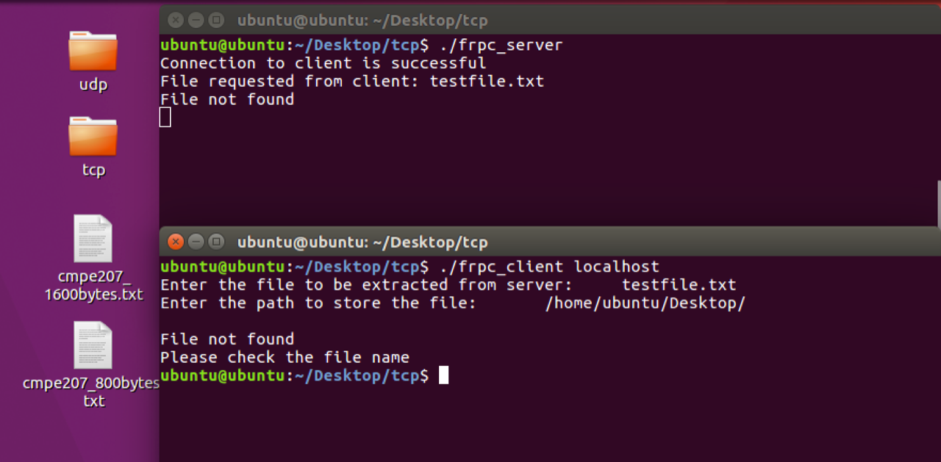

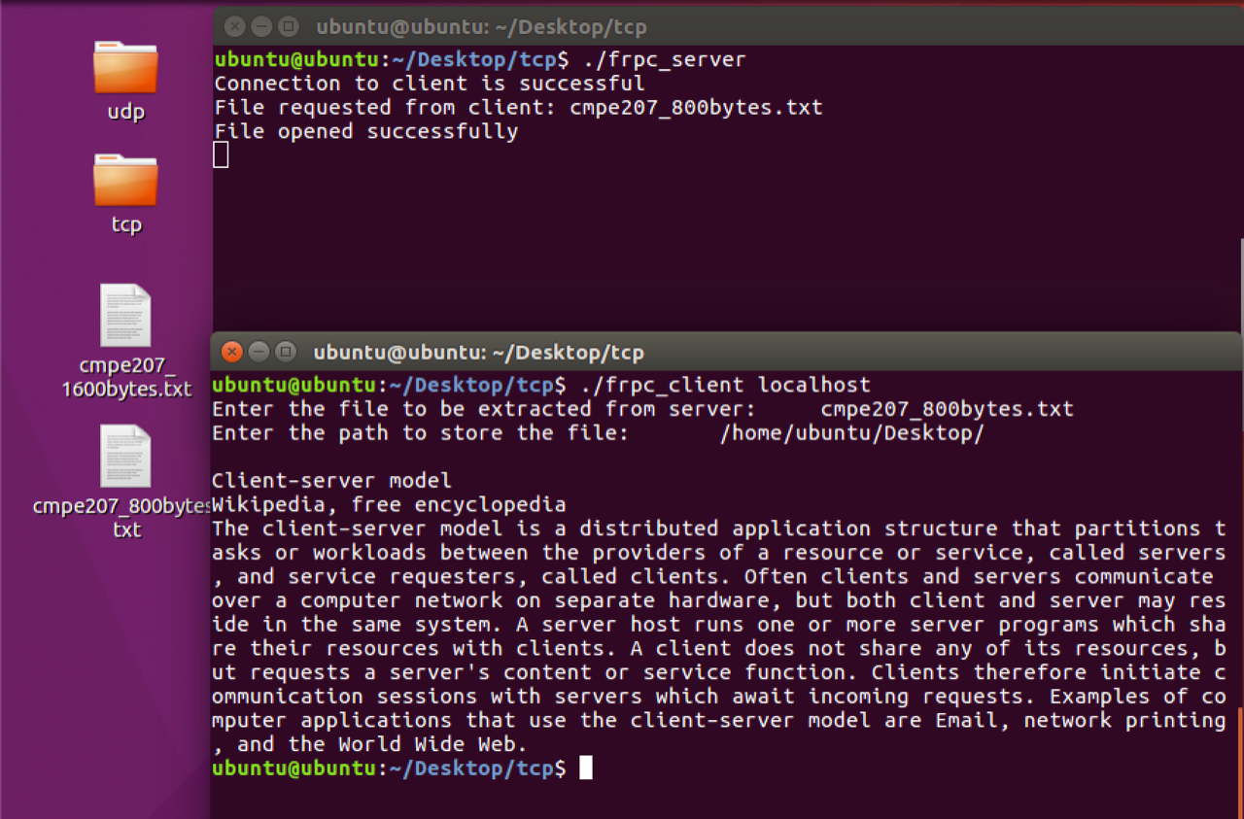

-------------------------------------------------------------------------------------------------------------------------------
frpc.x
-------------------------------------------------------------------------------------------------------------------------------
struct file{
char filename[2000];
};

program FILESERVER{

version FILESERVER_1{
file FILES(file)=1;
}=1;

}=0x2fffffff;
-------------------------------------------------------------------------------------------------------------------------------
frpc_server.c
-------------------------------------------------------------------------------------------------------------------------------
/*
* This is sample code generated by rpcgen.
* These are only templates and you can use them
* as a guideline for developing your own functions.
*/

#include "frpc.h"
#include <fcntl.h>
#include<unistd.h>

#define MAX_SEND_BUF 2000

file *
files_1_svc(file *argp, struct svc_req *rqstp)
{
static file result;

/*
* insert server code here
*/
printf("Connection to the client is successful\n");
printf("File requested from client: %s\n",argp->filename);

int file;
if((file = open(argp->filename,O_RDONLY)) < 0)
{
printf("File not found\n");
strcpy(result.filename,"File not found\nPlease check the file name");
return &result;
}
else
{
printf("File opened successfully\n");
ssize_t read_bytes;
while( (read_bytes = read(file,result.filename,MAX_SEND_BUF)) > 0 )
{
// printf("%s",result.filename);
}
return &result;
}

}
-------------------------------------------------------------------------------------------------------------------------------
frpc_client.c
-------------------------------------------------------------------------------------------------------------------------------
/*
* This is sample code generated by rpcgen.
* These are only templates and you can use them
* as a guideline for developing your own functions.
*/

#include "frpc.h"
#include <fcntl.h>
#include <unistd.h>

void
fileserver_1(char *host)
{
CLIENT *clnt;
file *result_1;
file files_1_arg;

#ifndef DEBUG
clnt = clnt_create (host, FILESERVER, FILESERVER_1, "tcp");
if (clnt == NULL) {
clnt_pcreateerror (host);
exit (1);
}
#endif /* DEBUG */

printf("Enter the file to be extracted from server:\t");
scanf("%s",files_1_arg.filename);
char file_name[1000];
printf("Enter the path to store the file:\t");
scanf("%s",file_name);
result_1 = files_1(&files_1_arg, clnt);
printf("\n%s\n",result_1->filename);
strcat(file_name, files_1_arg.filename);

if(strcmp(result_1->filename,"File not found\nPlease check the file name") !=0)
{
int fd;
if((fd=open(file_name,O_WRONLY|O_CREAT,0644)) < 0)
{
printf("Please enter a valid path (Example - '/home/ubuntu/Desktop/')\n");
}
write(fd,result_1->filename,strlen(result_1->filename));
}

if (result_1 == (file *) NULL) {
clnt_perror (clnt, "call failed");
}
#ifndef DEBUG
clnt_destroy (clnt);
#endif /* DEBUG */
}

int
main (int argc, char *argv[])
{
char *host;

if (argc < 2) {
printf ("usage: %s server_host\n", argv[0]);
exit (1);
}
host = argv[1];
fileserver_1 (host);
exit (0);
}

RPC UDP
-------------------------------------------------------------------------------------------------------------------------------
Readme
-------------------------------------------------------------------------------------------------------------------------------
UDP client-server program. The code will be following the RPC mechanism. The server will copy the file contents and send to the client when the client requests for it. The client will be able to request for the file it wants and also specify the path where it wants to store it.

Run the following command to compile the programs.
Unzip RPC-udp.tar.gz

There is only one make file for all.
make –f Makefile.frpc

Open two terminals one for server other for client.

Server Program:- frpc_server.c
Run the server using following command.

./frpc_server

Client Program:- frpc_client.c
Run the client using following command.

./frpc_client localhost

Type whatever is asked on the terminal

Screenshots:

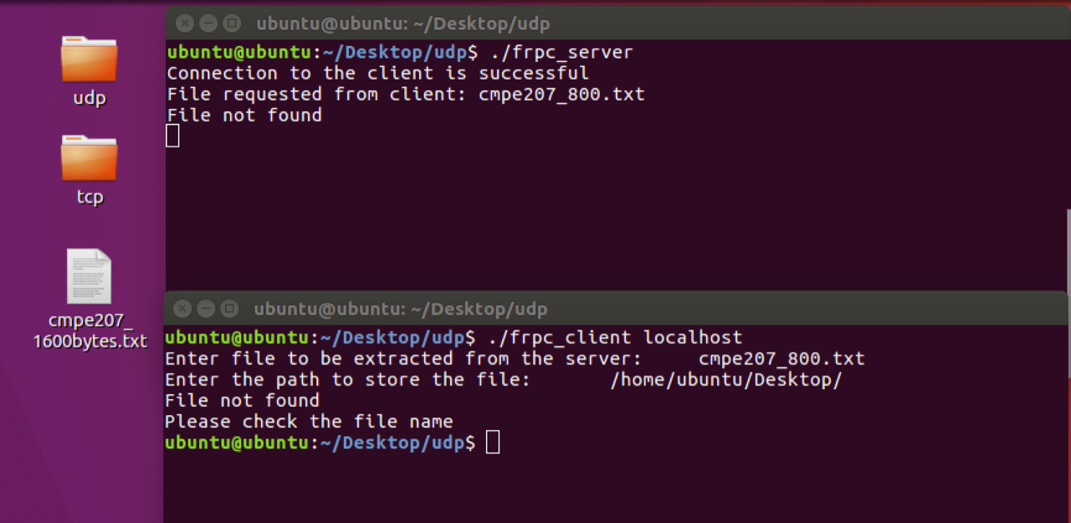
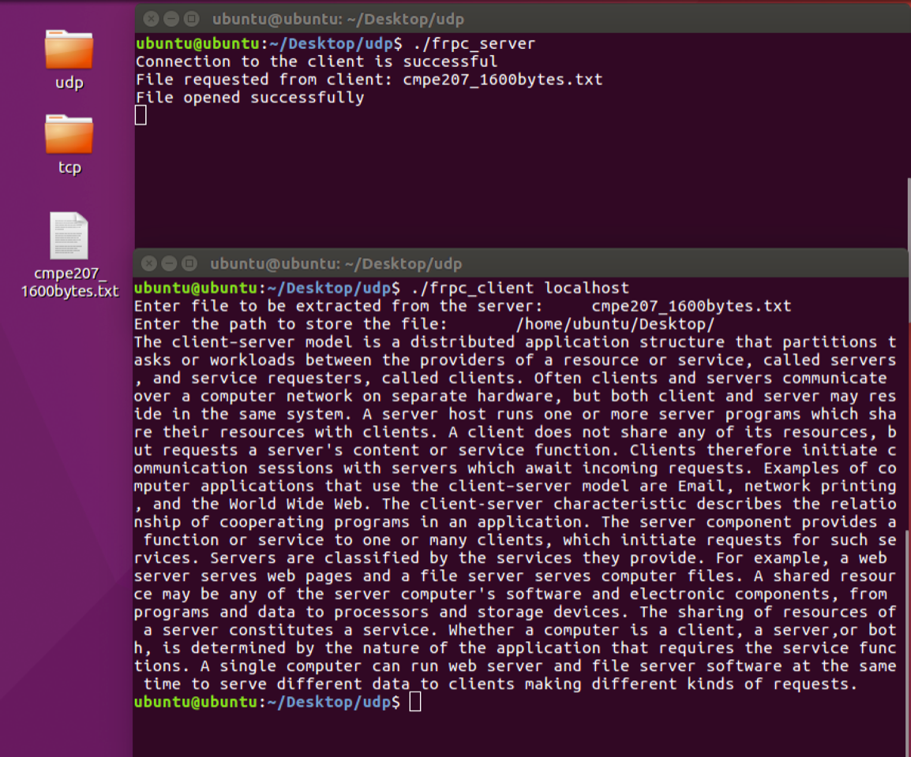
-------------------------------------------------------------------------------------------------------------------------------
frpc.x
-------------------------------------------------------------------------------------------------------------------------------

struct file{
char filename[2000];
};

program FILESERVER{

version FILESERVER_1{
file FILES(file)=1;
}=1;

}=0x2fffffff;
-------------------------------------------------------------------------------------------------------------------------------
frpc_server.c
-------------------------------------------------------------------------------------------------------------------------------
/*
* This is sample code generated by rpcgen.
* These are only templates and you can use them
* as a guideline for developing your own functions.
*/

#include "frpc.h"
#include <fcntl.h>
#include<unistd.h>

#define MAX_SEND_BUF 2000

file *
files_1_svc(file *argp, struct svc_req *rqstp)
{
static file result;

/*
* insert server code here
*/
printf("Connection to the client is successful\n");
printf("File requested from client: %s\n",argp->filename);

int file;

if((file = open(argp->filename,O_RDONLY))<0)
{
printf("File not found\n");
strcpy(result.filename,"File not found\nPlease check the file name");
return &result;
}
else
{
printf("File opened successfully\n");
ssize_t read_bytes;
while( (read_bytes = read(file, result.filename,MAX_SEND_BUF)) > 0 )
{
//printf("%s",result.filename);
}
return &result;
}
}
-------------------------------------------------------------------------------------------------------------------------------
frpc_client.c
-------------------------------------------------------------------------------------------------------------------------------
/*
* This is sample code generated by rpcgen.
* These are only templates and you can use them
* as a guideline for developing your own functions.
*/

#include "frpc.h"
#include <fcntl.h>
#include<unistd.h>

void
fileserver_1(char *host)
{
CLIENT *clnt;
file *result_1;
file files_1_arg;

#ifndef DEBUG
clnt = clnt_create (host, FILESERVER, FILESERVER_1, "udp");
if (clnt == NULL) {
clnt_pcreateerror (host);
exit (1);
}
#endif /* DEBUG */

printf("Enter file to be extracted from the server:\t");
scanf("%s",files_1_arg.filename);
char file_name[1000];
printf("Enter the path to store the file:\t");
scanf("%s",file_name);

result_1 = files_1(&files_1_arg, clnt);

printf("%s\n",result_1->filename);
strcat(file_name, files_1_arg.filename);

if(strcmp(result_1->filename,"File not found\nPlease check the file name"))
{
int fd;
if((fd=open(file_name,O_WRONLY|O_CREAT,0644))<0)
{
printf("Please enter a Valid path (Example - '/home/ubuntu/Desktop/')\n");
}
write(fd,result_1->filename,strlen(result_1->filename));
}

if (result_1 == (file *) NULL) {
clnt_perror (clnt, "call failed");
}
#ifndef DEBUG
clnt_destroy (clnt);
#endif /* DEBUG */
}

int
main (int argc, char *argv[])
{
char *host;

if (argc < 2) {
printf ("usage: %s server_host\n", argv[0]);
exit (1);
}
host = argv[1];
fileserver_1 (host);
exit (0);
}

