**Assignment 2** - **Nitish Ramkumar, Stephan Du Toit, Yvonne Tong Yi, Baihan Chen**

1a 1

1b 2

1c 3

2a 3

2b 4

2c 5

3a 6

3b 7

3c 8

3d 9

4a 9

4b 9

4c 9

4d 12

4e 15

4f 16

5a 16

5b 17

5c 18

5d 19

## 1a

clear  
clc  
S0 = 100;%Initial stock price  
T = 0.25;%Maturity years  
K = 100;%Strike  
r = 0.05; %IR  
sigma=0.2; %SD  
delta = 0;  
h = 1/(360*96); %every 5 minutes, which is 1/96 of a day  
  
randn('seed',0);  
  
NoOfSim = 5;  
stockPrices = zeros((T/h)+1,5);  
for counter = 1:5  
 stockPrices(:,counter) = GenerateStockPath(S0,r,T,h,sigma);  
end  
plot(stockPrices)  
title('Stock path plots')  
legend('1','2','3','4','5','Location','northwest')

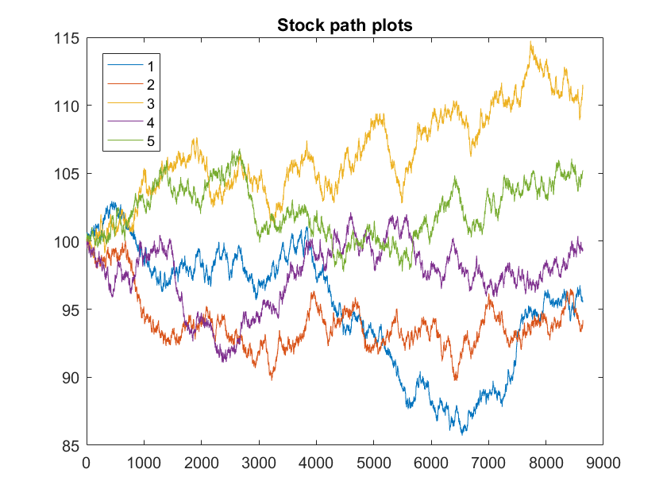

## 1b

S0 = 100;%Initial stock price  
T = 0.25;%Maturity in days  
K = 100;%Strike  
r = 0.05; %IR  
sigma=0.2; %SD  
delta = 0;  
h = 1/(360*96); %every 5 minutes, which is 1/96 of a day  
c1 = BlackScholes(S0,K,r,sigma,T,'Call')

c1 =  
  
 4.6150

## 1c

S0 = 100;%Initial stock price  
T = 0.25;%Maturity in days  
K = 100;%Strike  
r = 0.05; %IR  
sigma=0.2; %SD  
delta = 0;  
  
randn('seed',0);  
NoOfPaths = [100 1000 1000000 100000000];  
N = length(NoOfPaths);  
priceResult = zeros(N,3);  
for count = 1:size(priceResult,1)  
 priceResult(count,:) = MonteCarloSim(S0,r,T,K,sigma,NoOfPaths(count));  
end  
priceResult  
  
%The price approaches black scholes value  
%The spread reduces.

priceResult =  
  
 4.8810 3.7779 5.9840  
 4.6464 4.2452 5.0476  
 4.5923 4.5802 4.6044  
 4.5876 4.5864 4.5888

## 2a

S0 = 100;%Initial stock price  
T = 0.25;%Maturity in days  
K = 95;%Strike  
r = 0.05; %IR  
sigma=0.2; %SD  
delta = 0;  
Sb = 75;  
h = 1/(360*96);  
NoOfSim = 1000;  
  
randn('seed',0);  
MCResult = MonteCarloDownOut(S0,r,T,K,sigma,NoOfSim,h,Sb)  
PutOption = BlackScholes(S0,K,r,sigma,T,'Put')

MCResult =  
  
 1.5858  
 1.3785  
 1.7930  
 5.0000  
  
  
PutOption =  
  
 1.5343

## 2b

S0 = 100;%Initial stock price  
T = 0.25;%Maturity in days  
K = 95;%Strike  
r = 0.05; %IR  
delta = 0;  
Sb = 75;  
h = 1/(360*96);  
NoOfSim = 1000;  
sigma = [0.05 0.1 0.15 0.2 0.25 0.3 0.35 0.4];  
  
randn('seed',0);  
results = zeros(length(sigma),4);  
for count = 1:length(sigma)  
 results(count,:) = MonteCarloDownOut(S0,r,T,K,sigma(count),NoOfSim,h,Sb);  
end  
  
plot(sigma,results(:,4))  
title('Plot of no. of outs wrt to volatility')  
xlabel('Volatility')  
ylabel('Number of outs')  
  
%We can observe that the number of outs increases with volatility.  
%This makes sense because with an increase in volatility, we have a higher  
%change of going out of the cutoff.

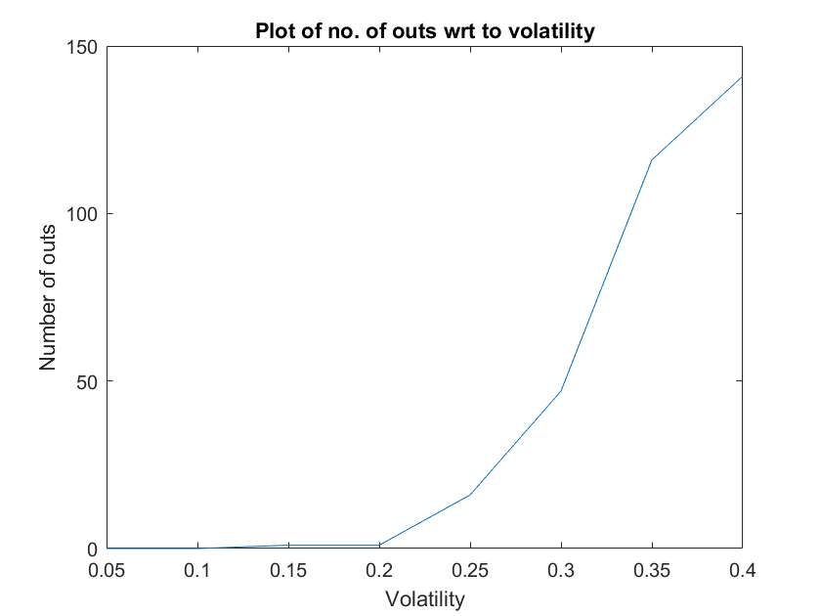

## 2c

S0 = 100;%Initial stock price  
T = 0.25;%Maturity in days  
K = 95;%Strike  
r = 0.05; %IR  
delta = 0;  
Sb = 75;  
h = 1/(360*96);  
NoOfSim = 1000;  
sigma = [0.05 0.1 0.15 0.2 0.25 0.3 0.35 0.4];  
  
randn('seed',0);  
results = zeros(length(sigma),4);  
for count = 1:length(sigma)  
 results(count,:) = MonteCarloDownOut(S0,r,T,K,sigma(count),NoOfSim,h,Sb);  
end  
bsPrice = BlackScholes(S0,K,r,sigma,T,'Put');  
errorbar(sigma,results(:,1),results(:,3)-results(:,1))  
title('Plot of Monte Carlo put price with error bar and black scholes price')  
xlabel('Volatility')  
ylabel('price of Put')  
hold on  
scatter(sigma,bsPrice)  
hold off

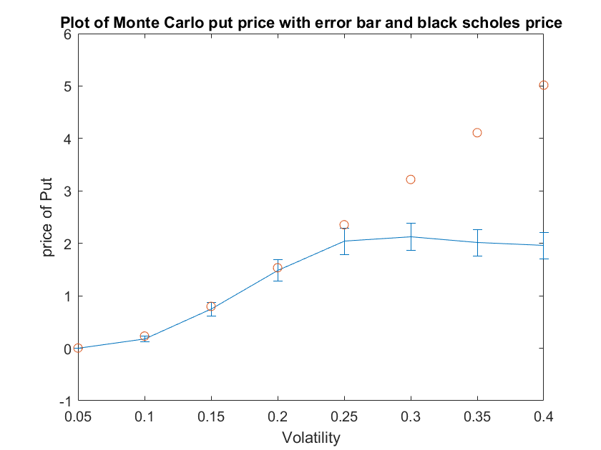

## 3a

r0 = 0.05;  
beta = 0.05;  
alpha = 0.6;  
delta = 0.1;  
T = 1;  
h = 1/250;  
  
randn('seed',0);  
db1 = randn(T/h,1).*sqrt(h);  
NoOfSim = 1000;  
rTRes = zeros(NoOfSim,1);  
for i = 1:NoOfSim  
 rt = IR(r0,alpha,beta,delta,db1,T,h);  
 rTRes(i) = rt(length(rt));  
end  
histogram(rt)

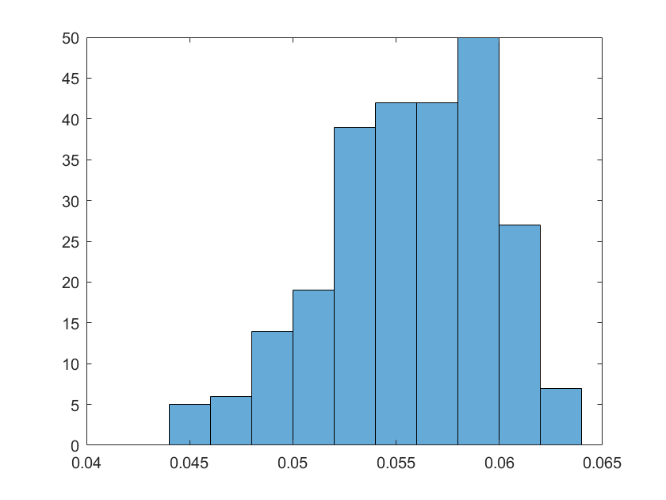

## 3b

r0 = 0.05;  
beta = 0.05;  
alpha = 0.6;  
delta = 0.1;  
T = 100;  
h = 1/52;  
randn('seed',0);  
db1 = randn(T/h,1).*sqrt(h);  
rt = IR(r0,alpha,beta,delta,db1,T,h);  
plot(rt)

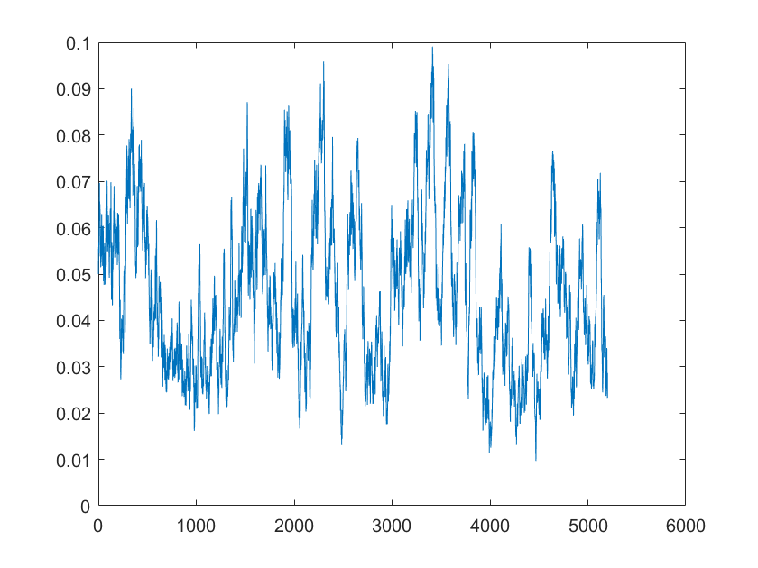

## 3c

r0 = 0.05;  
beta = 0.05;  
alpha = 0.6;  
sigma11 = 0.1;  
sigma12 = 0.2;  
S10 = 10;  
delta = 0.1;  
T = 0.5;  
h = 1/250;  
K = 10;  
NoofSim = 10000;  
  
randn('seed',0);  
results = MonteCarloExotic_1(r0,S10,T,h,K,sigma11,sigma12,alpha,beta,delta,NoofSim);  
results(1)

ans =  
  
 0.6842

## 3d

r0 = 0.05;  
beta = 0.05;  
alpha = 0.6;  
sigma11 = 0.1;  
sigma12 = 0.2;  
sigma21 = 0.3;  
S10 = 10;  
S20 = 10;  
delta = 0.1;  
T = 0.5;  
h = 1/250;  
K = 10;  
NoofSim = 10000;  
  
randn('seed',0);  
results = MonteCarloMaxExotic(r0,S10,S20,T,h,K,sigma11,sigma12,sigma21,alpha,beta,delta,NoofSim);  
results(1)

ans =  
  
 1.2799

## 4a

S0=100;  
K = 100;  
T=60/365;  
h = 1/(96*365);  
r = 0.05;  
sigma = 0.3;  
mu = 0.2;  
delta = 0;  
randn('seed',0);  
stockPricesAll = GenerateStockPath(S0,mu,T,h,sigma);  
periodsReq = (30/365)/h;  
stockPrices = stockPricesAll(1:(periodsReq+1));

## 4b

blackScholesPrices = BlackScholes(stockPrices,K,r,sigma,(T:-h:30/365)','Call');

## 4c

deltas = BlackScholesDelta(stockPrices,K,r,sigma,(T:-h:30/365)','Call');  
[replicatingPort,riskFree] = DeltaHedging(stockPrices,blackScholesPrices,deltas,r,h,0);  
  
figure(1)  
plot(stockPrices)  
title('Underlying')  
  
figure(2)  
plot(blackScholesPrices)  
hold on  
plot(replicatingPort)  
legend('Call Option','Replicating Portfolio','location','southwest')  
title('Replicating portfolio and blackScholes')  
hold off  
  
figure(3)  
plot(deltas)  
title('Delta')

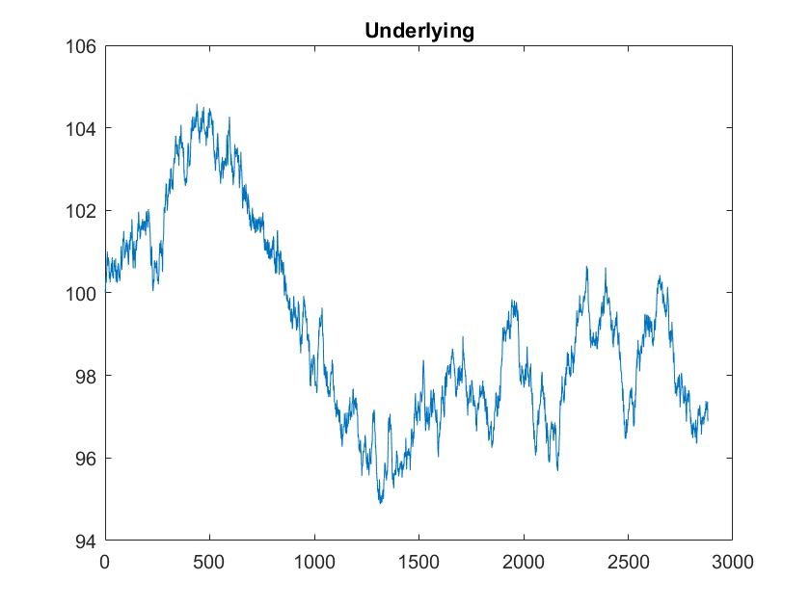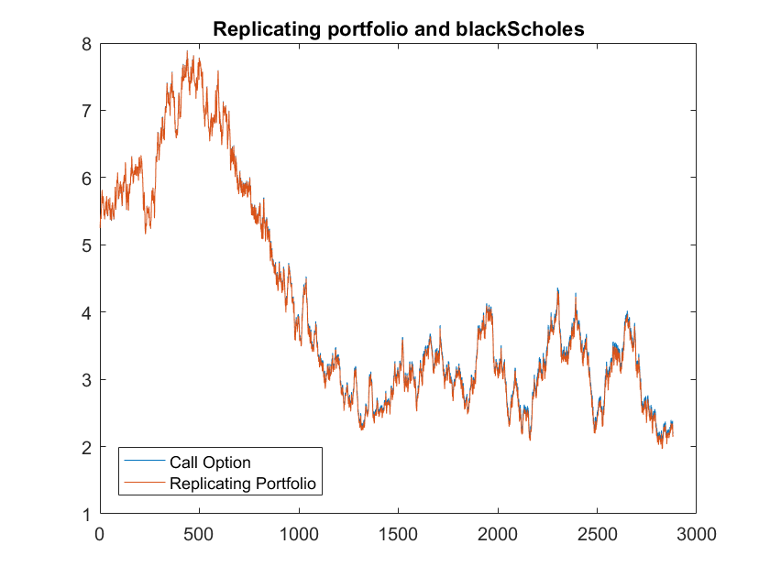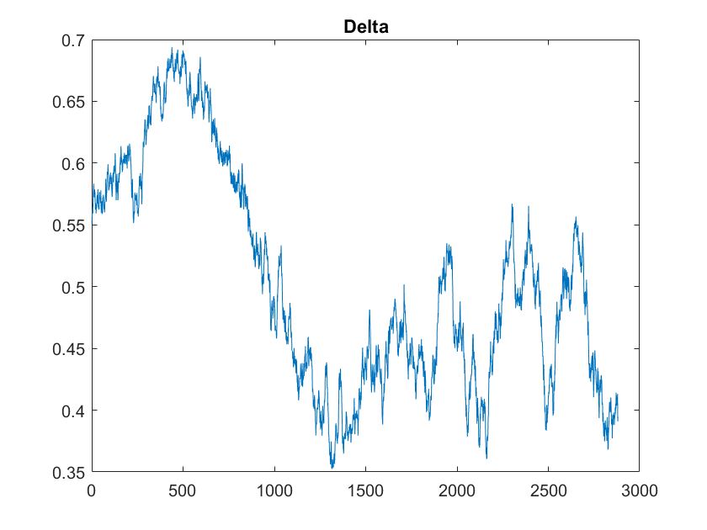

## 4d

randn('seed',0);  
stockJumpAll = GenerateStockPathWithJump(S0,mu,T,h,sigma,-0.1,0.5);  
stockJump = stockJumpAll(1:(periodsReq+1));  
BSJump= BlackScholes(stockJump,K,r,sigma,(T:-h:30/365)','Call');  
deltasJump = BlackScholesDelta(stockJump,K,r,sigma,(T:-h:30/365)','Call');  
[repPortJump,rfJump] = DeltaHedging(stockJump,BSJump,deltasJump,r,h,0);  
  
figure(1)  
plot(stockJump)  
title('Underlying')  
  
figure(2)  
plot(BSJump)  
hold on  
plot(repPortJump)  
legend('Call Option','Replicating Portfolio','location','southwest')  
title('Replicating portfolio and blackScholes')  
hold off  
  
figure(3)  
plot(deltasJump)  
title('Delta')

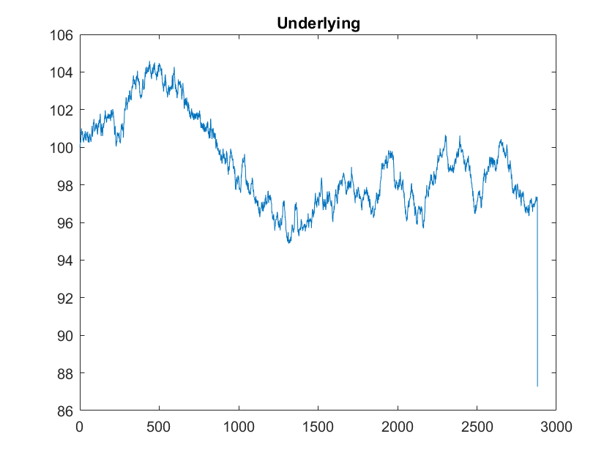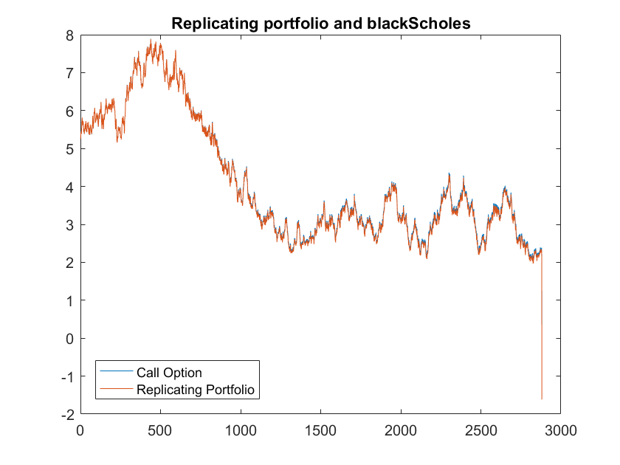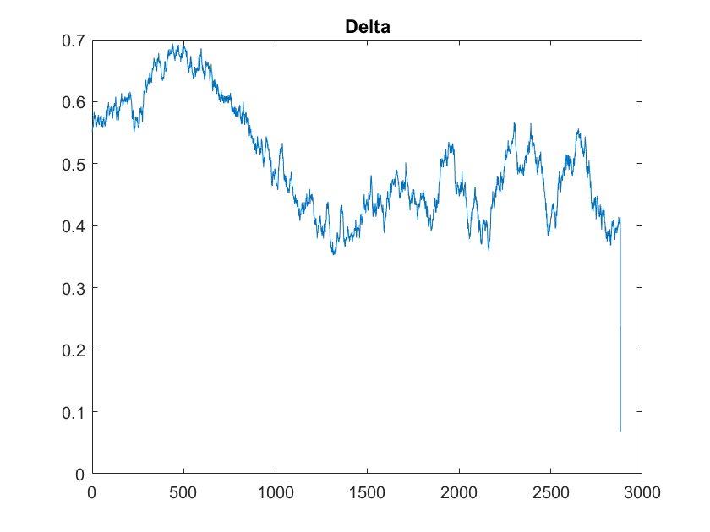

## 4e

randn('seed',0);  
stockJumpAll1 = GenerateStockPathWithJump(S0,mu,T,h,sigma,0.1,0.5);  
stockJump1 = stockJumpAll1(1:(periodsReq+1));  
BSJump1= BlackScholes(stockJump1,K,r,sigma,(T:-h:30/365)','Call');  
deltasJump1 = BlackScholesDelta(stockJump1,K,r,sigma,(T:-h:30/365)','Call');  
[repPortJump1,rfJump1] = DeltaHedging(stockJump1,BSJump1,deltasJump1,r,h,0);  
  
figure(1)  
plot(stockJump1)  
title('Underlying')  
  
figure(2)  
plot(BSJump1)  
hold on  
plot(repPortJump1)  
legend('Call Option','Replicating Portfolio','location','southwest')  
title('Replicating portfolio and blackScholes')  
hold off  
  
figure(3)  
plot(deltasJump1)  
title('Delta')

## 4f

[repPortTrans,rfTrans] = DeltaHedging(stockPrices,blackScholesPrices,deltas,r,h,0.002);  
figure(1)  
plot(stockPrices)  
title('Underlying')  
  
figure(2)  
plot(blackScholesPrices)  
hold on  
plot(repPortTrans)  
legend('Call Option','Replicating Portfolio','location','southwest')  
title('Replicating portfolio and blackScholes')  
hold off  
  
figure(3)  
plot(deltas)  
title('Delta')

## 5a

S0 = 100;%Initial stock price  
T = 0.5;%Maturity in days  
K = 100;%Strike  
r = 0.04; %IR  
sigma = 0.3;  
rho = -0.5;  
v0 = 0.01;  
k=6;  
theta = 0.02;  
lambda = 0;  
  
bsprice = BlackScholes(S0,K,r,sqrt(theta),T,'Call')  
price2 = HestonModel(S0,v0,r,T,0,K,rho,sigma,lambda,k,theta)  
%price = call_heston_cf(S0, v0, theta, k, sigma, r, rho, T, K)

bsprice =  
  
 5.0170  
  
  
price2 =  
  
 4.6833

## 5b

T = 0.5;%Maturity in days  
K = 100;%Strike  
r = 0.04; %IR  
sigma = 0.3;  
rho = -0.5;  
v0 = 0.01;  
k=6;  
theta = 0.02;  
lambda = 0;  
  
bsprices = BlackScholes(70:130,K,r,sqrt(theta),T,'Call');  
hestonprices = zeros(length(70:130),1);  
for St = 70:130  
 hestonprices(St-69) = HestonModel(St,v0,r,T,0,K,rho,sigma,lambda,k,theta);  
end  
  
plot(70:130,bsprices)  
title('Plot of Black Scholes and heston based on underlying price')  
xlabel('Underlying price')  
ylabel('Option price')  
hold on  
plot(70:130,hestonprices)  
legend('Black Scholes Price','Heston Price')

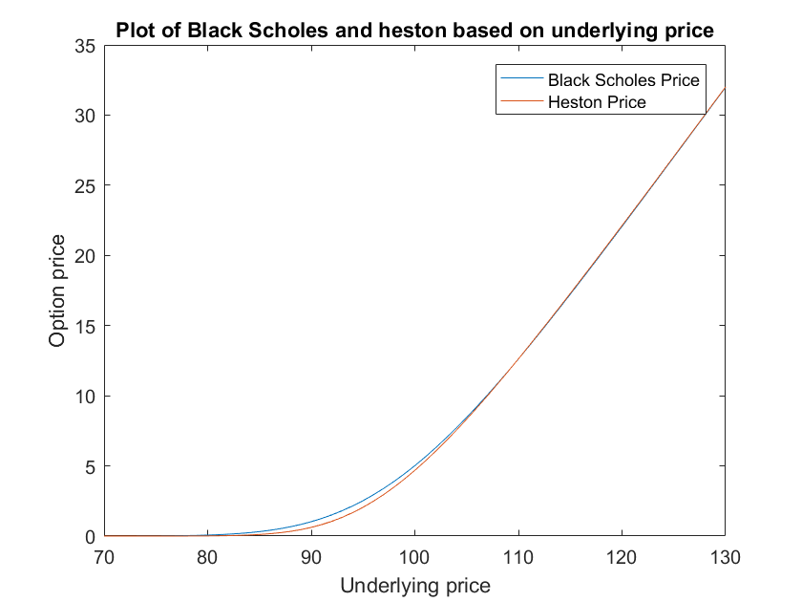

## 5c

S0 = 100;%Initial stock price  
T = 0.5;%Maturity in days  
K = 100;%Strike  
r = 0.04; %IR  
sigma = 0.3;  
rho = -0.5;  
v0 = 0.01;  
k=6;  
theta = 0.02;  
lambda = 0;  
St = 70:130;  
  
ImpliedVol = zeros(length(hestonprices),1);  
for i = 1:length(hestonprices)  
 ImpliedVol(i) = blsimpv(St(i),K,r,T,hestonprices(i));  
end  
  
plot(ImpliedVol)  
title('Implied Volatility for various stockPrices,rho=-0.5')  
xlabel('Stock Prices')  
ylabel('Implied Volatility')

## 

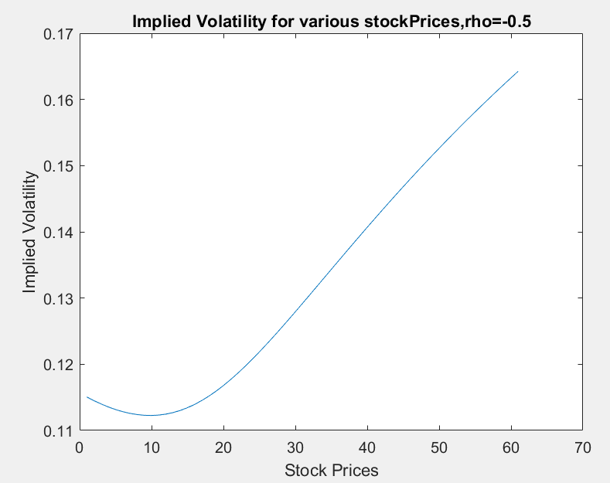

## 5d

T = 0.5;%Maturity in days  
K = 100;%Strike  
r = 0.04; %IR  
sigma = 0.3;  
rho = 0.5;  
v0 = 0.01;  
k=6;  
theta = 0.02;  
lambda = 0;  
StockPrices = 70:130;  
  
hestonprices = zeros(length(St),1);  
for St = 70:130  
 hestonprices(St-69) = HestonModel(St,v0,r,T,0,K,rho,sigma,lambda,k,theta);  
end  
  
ImpliedVol = zeros(length(hestonprices),1);  
for i = 1:length(hestonprices)  
 ImpliedVol(i) = blsimpv(StockPrices(i),K,r,T,hestonprices(i));  
end  
  
plot(ImpliedVol)  
title('Implied Volatility for various stockPrices,rho=0.5')  
xlabel('Stock Prices')  
ylabel('Implied Volatility')

