Assignment 1
Nitish Ramkumar, Stephan Du Toit, Yvonne Tong Yi, Baihan Chen

1a
The straddle price is 18.4891
clear
clc
global S0 r sigma T K
S0=100; %Initial stock price
K=90; %Strike price
r=0.02; %risk-free rate
h=0.25; %length of the period in years
T=4; %# of periods
u=exp((r*h)+0.2*sqrt(h)); %up move
d=exp((r*h)-0.2*sqrt(h)); %down move
% Straddle is long call and long put on the same strike.
% The sum of the two values should lead to value of straddle
[~,optionprice1,hedgeportfoliostock1,hedgeportfolioriskfree1]=...
EuropeanPricing(S0,@CallPayoff,r,h,u,d,T,0,[]);
[~,optionprice2,hedgeportfoliostock2,hedgeportfolioriskfree2]=...
EuropeanPricing(S0,@PutPayoff,r,h,u,d,T,0,[]);
straddlePrice = optionprice1{T+1,1} + optionprice2{T+1,1};
straddlePrice

1b

The straddle price is 17.7555
S0=100;
K=90;
T = 40;
r=0.02;
h = 0.025;
u=exp((r*h)+0.2*sqrt(h));
d=exp((r*h)-0.2*sqrt(h));
[~,optionprice1,hedgeportfoliostock1,hedgeportfolioriskfree1]=...
EuropeanPricing(S0,@CallPayoff,r,h,u,d,T,0,[]);
[stockprice2,optionprice2,hedgeportfoliostock2,hedgeportfolioriskfree2]=...
EuropeanPricing(S0,@PutPayoff,r,h,u,d,T,0,[]);
straddlePrice = optionprice1{T+1,1} + optionprice2{T+1,1}
1c
The binary call option price is 0.6363 (Assuming payoff as 1)
%Binary Payoff - If above K, option returns is K. If less than K, option
%returns 0s
S0=100; %Initial stock price
K=90; %Strike price
r=0.02; %risk-free rate
h=0.25; %length of the period in years
T=4; %# of periods
u=exp((r*h)+0.2*sqrt(h)); %up move
d=exp((r*h)-0.2*sqrt(h)); %down move
[stockprice1,optionprice1,hedgeportfoliostock1,hedgeportfolioriskfree1]=...
EuropeanPricing(S0,@BinaryPayoff,r,h,u,d,T,0,[]);
binaryCallPrice = optionprice1{T+1,1}

2a
American Option
Price of American Call Option is 0.5286
Price of American Call Option is 0.4653
K=10;
r = 0.01;
h = 1/365;
S0 = 10;
T=250;
u=exp((r*h)+0.15*sqrt(h));
d=exp((r*h)-0.15*sqrt(h));
[~,callPrices,hedgeportfoliostock,hedgeportfolioriskfree,exerciseDate]=...
AmericanPricing(S0,@CallPayoff,r,h,u,d,T,0,[]);
callPrices{T+1,1}
[~,putPrices,hedgeportfoliostock1,hedgeportfolioriskfree1,exerciseDate1]=...
AmericanPricing(S0,@PutPayoff,r,h,u,d,T,0,[]);
putPrices{T+1,1}

3a
Discrete Dividends Option
American Put option with dividend is worth 1.456
American Call option with dividend is worth 0.3399

S0=10; %Initial stock price
K=10; %Strike price
r=0.02; %risk-free rate
h=1/365; %length of the period in years
T=200; %# of periods
u=exp(0.2*sqrt(h)); %up move
d=exp(-0.2*sqrt(h)); %down move
delta = 0.05;
DivDate = [50,100,150];
[stockprice,putPrice,hedgeportfoliostock,hedgeportfolioriskfree,exerciseDate]=...
DiscreteDividendsPricing(S0,@PutPayoff,'American',r,h,u,d,DivDate,delta,T);
putPrice{T+1,1}
[stockprice1,callPrice,hedgeportfoliostock1,hedgeportfolioriskfree1,exerciseDate1]=...
DiscreteDividendsPricing(S0,@CallPayoff,'American',r,h,u,d,DivDate,delta,T);
callPrice{T+1,1}

3b

The American straddle price with dividend is 1.642. It is less than the sum of call and put american option with dividend. This is because the when looked at it seperately, we can excercise the put and call at seperate dates to maximize the returns, which is not possible in a straddle, as we exercise both components at the same time

S0=10; %Initial stock price
K=10; %Strike price
r=0.02; %risk-free rate
h=1/365; %length of the period in years
T=200; %# of periods
u=exp(0.2*sqrt(h)); %up move
d=exp(-0.2*sqrt(h)); %down move
delta = 0.05;
DivDate = [50,100,150];
[stockprice1,straddlePrice,hedgeportfoliostock,hedgeportfolioriskfree,exerciseDate]=...
DiscreteDividendsPricing(S0,@StraddlePayoff,'American',r,h,u,d,DivDate,delta,T);
straddlePrice{T+1,1}

4
Asian Options
The Monte Carlo price for Asian option is 3.25
The Confidence interval at 95% confidence is (3.1948,3.3052)

S0=200; %Initial stock price
K=220; %Strike price
r=0.02; %risk-free rate
sigma = 0.2; %standard deviation
h=1/365; %length of the period in years
T=1; %# of periods
NoOfPaths = 100000;
randn('seed',0);
pathPayoffs = zeros(NoOfPaths,1);
for path = 1:NoOfPaths
stockPrices = GenerateStockPath(S0,r,T,h,sigma);
pathPayoffs(path) = max(mean(stockPrices(2:end))-K,0);
end
montecarloprice = mean(pathPayoffs) * exp(-r * T)
sd = std(pathPayoffs * exp(-r * T))/sqrt(length(pathPayoffs));
CIInterval = [montecarloprice - (1.96*sd),montecarloprice + (1.96*sd)]

5a
American Option LMC
Price from the Least squares calculation for American Option with N=250 and No Of Paths=100,000 is 27.5691
S0=200; %Initial stock price
K=220; %Strike price
r=0.1; %risk-free rate
sigma = 0.3; %standard deviation
N=250; %length of the period in years
T=1; %# of periods
NoOfPaths = 100000;
randn('seed',0);
price = LSLeastSquares(N,NoOfPaths)

5b

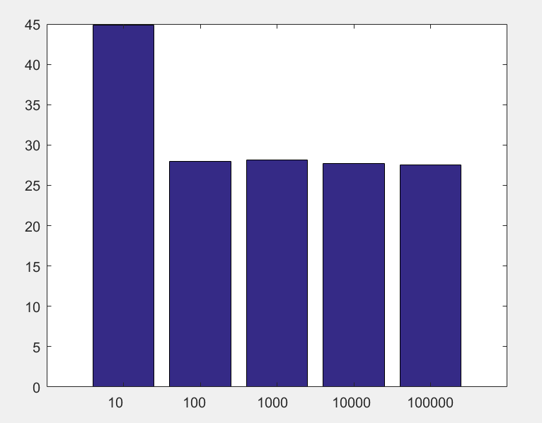

No of Paths | Price
10 | 44.8298
100 | 27.9546
1000 | 28.1244
10000 | 27.6665
100000 | 27.5485

S0=200; %Initial stock price
K=220; %Strike price
r=0.1; %risk-free rate
sigma = 0.3; %standard deviation
N=250; %length of the period in years
T=1; %# of periods
NoOfPaths = [10 100 1000 10000 100000];
priceResult = zeros(5,2);
priceResult(:,1) = NoOfPaths;
for pathCount = 1:length(priceResult)
priceResult(pathCount,2) = LSLeastSquares(N,priceResult(pathCount,1));
end
bar(priceResult(:,2))
set(gca,'xticklabel',NoOfPaths)

5c

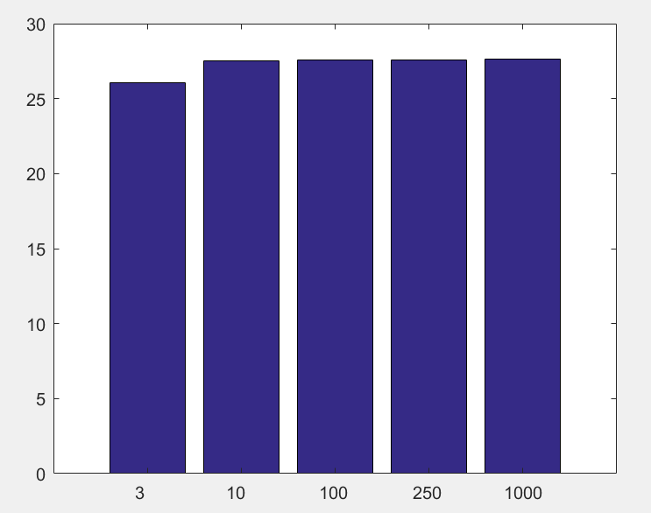

Value of N | Price
3 | 26.0654
10 | 27.5309
100 | 27.5746
250 | 27.6059
1000 | 27.6494

S0=200; %Initial stock price
K=220; %Strike price
r=0.1; %risk-free rate
sigma = 0.3; %standard deviation
NoOfPaths=100000; %length of the period in years
T=1; %# of periods
N = [3 10 100 250 1000];
priceResult = zeros(5,2);
priceResult(:,1) = N;
for pathCount = 1:length(priceResult)
priceResult(pathCount,2) = LSLeastSquares(priceResult(pathCount,1),NoOfPaths);
end
bar(priceResult(:,2))
set(gca,'xticklabel',N)

