IAQF

Fixed Income

## DATA RETRIEVAL

## BARCLAYS AGGREGATE

## $`83_84`  
## X10YrGovtRet BarcAggr  
## means 0.0001511765 0.001447059  
## sds 0.0008685540 0.004551390  
## annualizedReturnsAvg 0.0012876265 0.012283628  
## annualizedSd 0.0137330444 0.071963788  
## sharpeRatio 0.0937611816 0.170691788  
##   
## $`88_89`  
## X10YrGovtRet BarcAggr  
## means -5.407767e-05 0.0001271845  
## sds 6.047807e-04 0.0010583185  
## annualizedReturnsAvg -2.790285e-03 0.0065816810  
## annualizedSd 9.562422e-03 0.0167334849  
## sharpeRatio -2.917969e-01 0.3933239847  
##   
## $`94_95`  
## X10YrGovtRet BarcAggr  
## means 6.566802e-05 8.906883e-05  
## sds 6.872564e-04 6.870477e-04  
## annualizedReturnsAvg 8.162472e-03 1.112131e-02  
## annualizedSd 1.086648e-02 1.086318e-02  
## sharpeRatio 7.511607e-01 1.023763e+00  
##   
## $`99_00`  
## X10YrGovtRet BarcAggr  
## means 2.262443e-05 4.434389e-05  
## sds 5.832288e-04 5.018395e-04  
## annualizedReturnsAvg 2.487919e-03 4.898002e-03  
## annualizedSd 9.221657e-03 7.934779e-03  
## sharpeRatio 2.697908e-01 6.172828e-01  
##   
## $`04_06`  
## X10YrGovtRet BarcAggr  
## means 1.122754e-05 2.235529e-05  
## sds 4.760467e-04 4.085330e-04  
## annualizedReturnsAvg 1.871175e-03 3.739465e-03  
## annualizedSd 7.526959e-03 6.459474e-03  
## sharpeRatio 2.485964e-01 5.789116e-01  
##   
## $Recession  
## X10YrGovtRet BarcAggr  
## means -2.509707e-05 -2.367021e-05  
## sds 7.649375e-04 7.454779e-04  
## annualizedReturnsAvg -4.694764e-03 -4.485108e-03  
## annualizedSd 1.209472e-02 1.178704e-02  
## sharpeRatio -3.881663e-01 -3.805118e-01  
##   
## $Now  
## X10YrGovtRet BarcAggr  
## means -5.644023e-06 -7.846235e-06  
## sds 5.519930e-04 4.135183e-04  
## annualizedReturnsAvg -1.196104e-03 -1.661342e-03  
## annualizedSd 8.727776e-03 6.538299e-03  
## sharpeRatio -1.370456e-01 -2.540940e-01

## $`83_84`  
## X10YrGovtRet BarcAggr  
## X10YrGovtRet 1.0000000 0.2667834  
## BarcAggr 0.2667834 1.0000000  
##   
## $`88_89`  
## X10YrGovtRet BarcAggr  
## X10YrGovtRet 1.0000000 0.3848871  
## BarcAggr 0.3848871 1.0000000  
##   
## $`94_95`  
## X10YrGovtRet BarcAggr  
## X10YrGovtRet 1.0000000 0.9186311  
## BarcAggr 0.9186311 1.0000000  
##   
## $`99_00`  
## X10YrGovtRet BarcAggr  
## X10YrGovtRet 1.0000000 0.9206738  
## BarcAggr 0.9206738 1.0000000  
##   
## $`04_06`  
## X10YrGovtRet BarcAggr  
## X10YrGovtRet 1.0000000 0.9319208  
## BarcAggr 0.9319208 1.0000000  
##   
## $Recession  
## X10YrGovtRet BarcAggr  
## X10YrGovtRet 1.0000000 0.8380541  
## BarcAggr 0.8380541 1.0000000  
##   
## $Now  
## X10YrGovtRet BarcAggr  
## X10YrGovtRet 1.0000000 0.8919201  
## BarcAggr 0.8919201 1.0000000

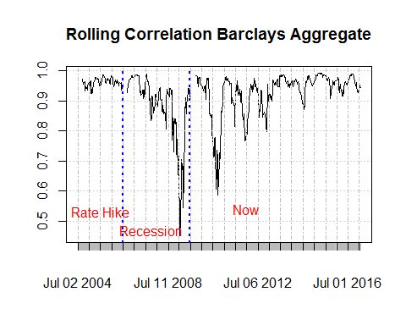

## GOVT INFLATION INDEXED 10 year

## $`83_84`  
## NULL  
##   
## $`88_89`  
## NULL  
##   
## $`94_95`  
## NULL  
##   
## $`99_00`  
## X10YrGovtRet GovtII10  
## means 2.165217e-05 7.826087e-06  
## sds 5.717802e-04 1.603886e-04  
## annualizedReturnsAvg 2.477887e-03 9.014624e-04  
## annualizedSd 9.040639e-03 2.535967e-03  
## sharpeRatio 2.740831e-01 3.554709e-01  
##   
## $`04_06`  
## X10YrGovtRet GovtII10  
## means 9.752399e-06 8.080614e-06  
## sds 4.670240e-04 4.036956e-04  
## annualizedReturnsAvg 1.689635e-03 1.401555e-03  
## annualizedSd 7.384298e-03 6.382988e-03  
## sharpeRatio 2.288145e-01 2.195767e-01  
##   
## $Recession  
## X10YrGovtRet GovtII10  
## means -2.181505e-05 -1.153061e-05  
## sds 7.506345e-04 6.953970e-04  
## annualizedReturnsAvg -4.258551e-03 -2.297081e-03  
## annualizedSd 1.186857e-02 1.099519e-02  
## sharpeRatio -3.588090e-01 -2.089169e-01  
##   
## $Now  
## X10YrGovtRet GovtII10  
## means -5.454775e-06 -6.937847e-06  
## sds 5.408082e-04 4.566432e-04  
## annualizedReturnsAvg -1.204855e-03 -1.524089e-03  
## annualizedSd 8.550928e-03 7.220162e-03  
## sharpeRatio -1.409035e-01 -2.110879e-01

## $`83_84`  
## X10YrGovtRet GovtII10  
## X10YrGovtRet NA NA  
## GovtII10 NA NA  
##   
## $`88_89`  
## X10YrGovtRet GovtII10  
## X10YrGovtRet NA NA  
## GovtII10 NA NA  
##   
## $`94_95`  
## X10YrGovtRet GovtII10  
## X10YrGovtRet NA NA  
## GovtII10 NA NA  
##   
## $`99_00`  
## X10YrGovtRet GovtII10  
## X10YrGovtRet 1.0000000 0.4104358  
## GovtII10 0.4104358 1.0000000  
##   
## $`04_06`  
## X10YrGovtRet GovtII10  
## X10YrGovtRet 1.0000000 0.8653163  
## GovtII10 0.8653163 1.0000000  
##   
## $Recession  
## X10YrGovtRet GovtII10  
## X10YrGovtRet 1.0000000 0.7977249  
## GovtII10 0.7977249 1.0000000  
##   
## $Now  
## X10YrGovtRet GovtII10  
## X10YrGovtRet 1.0000000 0.8170651  
## GovtII10 0.8170651 1.0000000

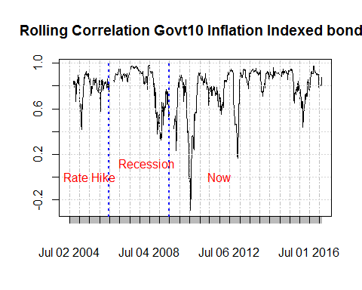

## GOVT INFLATION INDEXED 5 year

## $`83_84`  
## NULL  
##   
## $`88_89`  
## NULL  
##   
## $`94_95`  
## NULL  
##   
## $`99_00`  
## X10YrGovtRet GovtII5  
## means 2.165217e-05 3.739130e-06  
## sds 5.717802e-04 2.354609e-04  
## annualizedReturnsAvg 2.477887e-03 4.270229e-04  
## annualizedSd 9.040639e-03 3.722964e-03  
## sharpeRatio 2.740831e-01 1.146997e-01  
##   
## $`04_06`  
## X10YrGovtRet GovtII5  
## means 7.702703e-06 2.198842e-05  
## sds 4.666728e-04 4.793307e-04  
## annualizedReturnsAvg 1.326589e-03 3.798626e-03  
## annualizedSd 7.378745e-03 7.578884e-03  
## sharpeRatio 1.797851e-01 5.012118e-01  
##   
## $Recession  
## X10YrGovtRet GovtII5  
## means -2.181505e-05 -1.867347e-05  
## sds 7.506345e-04 8.249424e-04  
## annualizedReturnsAvg -4.258551e-03 -3.696223e-03  
## annualizedSd 1.186857e-02 1.304349e-02  
## sharpeRatio -3.588090e-01 -2.833770e-01  
##   
## $Now  
## X10YrGovtRet GovtII5  
## means -5.429221e-06 -0.0000069818  
## sds 5.409437e-04 0.0004834038  
## annualizedReturnsAvg -1.198721e-03 -0.0015392062  
## annualizedSd 8.553071e-03 0.0076432855  
## sharpeRatio -1.401509e-01 -0.2013801819

## $`83_84`  
## X10YrGovtRet GovtII5  
## X10YrGovtRet NA NA  
## GovtII5 NA NA  
##   
## $`88_89`  
## X10YrGovtRet GovtII5  
## X10YrGovtRet NA NA  
## GovtII5 NA NA  
##   
## $`94_95`  
## X10YrGovtRet GovtII5  
## X10YrGovtRet NA NA  
## GovtII5 NA NA  
##   
## $`99_00`  
## X10YrGovtRet GovtII5  
## X10YrGovtRet 1.0000000 0.1816883  
## GovtII5 0.1816883 1.0000000  
##   
## $`04_06`  
## X10YrGovtRet GovtII5  
## X10YrGovtRet 1.0000000 0.7129488  
## GovtII5 0.7129488 1.0000000  
##   
## $Recession  
## X10YrGovtRet GovtII5  
## X10YrGovtRet 1.0000000 0.6989494  
## GovtII5 0.6989494 1.0000000  
##   
## $Now  
## X10YrGovtRet GovtII5  
## X10YrGovtRet 1.0000000 0.6162173  
## GovtII5 0.6162173 1.0000000

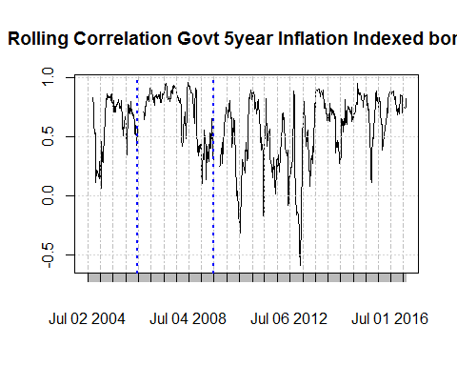

## Govt 30 YEAR

## $`83_84`  
## X10YrGovtRet data.returns  
## means 6.235988e-05 4.955752e-05  
## sds 8.786190e-04 8.516090e-04  
## annualizedReturnsAvg 1.056612e-02 8.380656e-03  
## annualizedSd 1.389219e-02 1.346512e-02  
## sharpeRatio 7.605802e-01 6.223974e-01  
##   
## $`88_89`  
## X10YrGovtRet data.returns  
## means 9.255319e-06 1.985816e-06  
## sds 6.430132e-04 6.112902e-04  
## annualizedReturnsAvg 1.287976e-03 2.560204e-04  
## annualizedSd 1.016693e-02 9.665347e-03  
## sharpeRatio 1.266829e-01 2.648849e-02  
##   
## $`94_95`  
## X10YrGovtRet data.returns  
## means 7.277992e-05 5.571429e-05  
## sds 6.822563e-04 6.008268e-04  
## annualizedReturnsAvg 9.500402e-03 7.254202e-03  
## annualizedSd 1.078742e-02 9.499905e-03  
## sharpeRatio 8.806928e-01 7.636078e-01  
##   
## $`99_00`  
## X10YrGovtRet data.returns  
## means 2.165217e-05 1.956522e-06  
## sds 5.717802e-04 5.387249e-04  
## annualizedReturnsAvg 2.477887e-03 2.159189e-04  
## annualizedSd 9.040639e-03 8.517989e-03  
## sharpeRatio 2.740831e-01 2.534858e-02  
##   
## $`04_06`  
## X10YrGovtRet data.returns  
## means 9.752399e-06 -2.264875e-06  
## sds 4.670240e-04 4.362284e-04  
## annualizedReturnsAvg 1.689635e-03 -3.950899e-04  
## annualizedSd 7.384298e-03 6.897377e-03  
## sharpeRatio 2.288145e-01 -5.728118e-02  
##   
## $Recession  
## X10YrGovtRet data.returns  
## means -2.181505e-05 -1.214286e-05  
## sds 7.506345e-04 6.684224e-04  
## annualizedReturnsAvg -4.258551e-03 -2.345580e-03  
## annualizedSd 1.186857e-02 1.056869e-02  
## sharpeRatio -3.588090e-01 -2.219368e-01  
##   
## $Now  
## X10YrGovtRet data.returns  
## means -5.452020e-06 -6.404040e-06  
## sds 5.406715e-04 5.363179e-04  
## annualizedReturnsAvg -1.204855e-03 -1.413492e-03  
## annualizedSd 8.548768e-03 8.479931e-03  
## sharpeRatio -1.409391e-01 -1.666868e-01

## $`83_84`  
## X10YrGovtRet data.returns  
## X10YrGovtRet 1.0000000 0.9591237  
## data.returns 0.9591237 1.0000000  
##   
## $`88_89`  
## X10YrGovtRet data.returns  
## X10YrGovtRet 1.0000000 0.9634574  
## data.returns 0.9634574 1.0000000  
##   
## $`94_95`  
## X10YrGovtRet data.returns  
## X10YrGovtRet 1.0000000 0.9700733  
## data.returns 0.9700733 1.0000000  
##   
## $`99_00`  
## X10YrGovtRet data.returns  
## X10YrGovtRet 1.0000000 0.8944599  
## data.returns 0.8944599 1.0000000  
##   
## $`04_06`  
## X10YrGovtRet data.returns  
## X10YrGovtRet 1.0000000 0.9463274  
## data.returns 0.9463274 1.0000000  
##   
## $Recession  
## X10YrGovtRet data.returns  
## X10YrGovtRet 1.0000000 0.9372764  
## data.returns 0.9372764 1.0000000  
##   
## $Now  
## X10YrGovtRet data.returns  
## X10YrGovtRet 1.0000000 0.9434978  
## data.returns 0.9434978 1.0000000

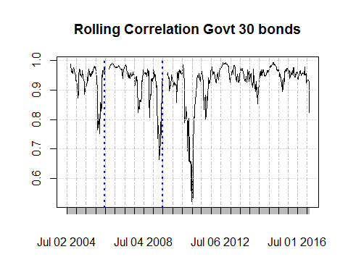

## 1Y-10Y yield curve check vs 1Y-10Y-20Y vol check vs Credit check

## $`83_84`  
## X1Y10Y SP500  
## means -3.073529e-06 0.0001935987  
## sds 8.228312e-04 0.0080350058  
## annualizedReturnsAvg -5.506298e-04 0.0279470465  
## annualizedSd 1.301010e-02 0.1270445968  
## sharpeRatio -4.232324e-02 0.2199782373  
##   
## $`88_89`  
## X1Y10Y SP500  
## means -5.554965e-05 0.0007624146  
## sds 5.695226e-04 0.0085824614  
## annualizedReturnsAvg -7.800221e-03 0.1082195929  
## annualizedSd 9.004943e-03 0.1357006302  
## sharpeRatio -8.662154e-01 0.7974877693  
##   
## $`94_95`  
## X1Y10Y SP500  
## means -0.0000567600 -6.775786e-05  
## sds 0.0004732899 6.166537e-03  
## annualizedReturnsAvg -0.0070529473 -1.018329e-02  
## annualizedSd 0.0074833702 9.750151e-02  
## sharpeRatio -0.9424827472 -1.044424e-01  
##   
## $`99_00`  
## X1Y10Y SP500  
## means -3.190583e-05 0.0004549637  
## sds 4.018609e-04 0.0134329846  
## annualizedReturnsAvg -3.559339e-03 0.0424904244  
## annualizedSd 6.353979e-03 0.2123941353  
## sharpeRatio -5.601748e-01 0.2000546028  
##   
## $`04_06`  
## X1Y10Y SP500  
## means -4.280396e-05 0.0002472076  
## sds 3.571271e-04 0.0066800892  
## annualizedReturnsAvg -7.175991e-03 0.0387814552  
## annualizedSd 5.646676e-03 0.1056214842  
## sharpeRatio -1.270835e+00 0.3671739274  
##   
## $Recession  
## X1Y10Y SP500  
## means 4.043783e-05 -0.000231457  
## sds 6.752011e-04 0.018479030  
## annualizedReturnsAvg 7.644799e-03 -0.048372087  
## annualizedSd 1.067587e-02 0.292179125  
## sharpeRatio 7.160823e-01 -0.165556272  
##   
## $Now  
## X1Y10Y SP500  
## means -5.890110e-06 0.0005234479  
## sds 5.105367e-04 0.0098046933  
## annualizedReturnsAvg -1.252996e-03 0.1101116701  
## annualizedSd 8.072295e-03 0.1550258129  
## sharpeRatio -1.552218e-01 0.7102795853

## $`83_84`  
## NULL  
##   
## $`88_89`  
## NULL  
##   
## $`94_95`  
## X10YrGovtRet VolCheck  
## means 7.277992e-05 3.629344e-05  
## sds 6.822563e-04 6.116623e-04  
## annualizedReturnsAvg 9.500402e-03 4.701379e-03  
## annualizedSd 1.078742e-02 9.671230e-03  
## sharpeRatio 8.806928e-01 4.861201e-01  
##   
## $`99_00`  
## X10YrGovtRet VolCheck  
## means 2.165217e-05 1.756522e-05  
## sds 5.717802e-04 5.781167e-04  
## annualizedReturnsAvg 2.477887e-03 2.002885e-03  
## annualizedSd 9.040639e-03 9.140828e-03  
## sharpeRatio 2.740831e-01 2.191142e-01  
##   
## $`04_06`  
## X10YrGovtRet VolCheck  
## means 9.752399e-06 3.908445e-05  
## sds 4.670240e-04 4.507658e-04  
## annualizedReturnsAvg 1.689635e-03 6.803124e-03  
## annualizedSd 7.384298e-03 7.127234e-03  
## sharpeRatio 2.288145e-01 9.545252e-01  
##   
## $Recession  
## X10YrGovtRet VolCheck  
## means -2.181505e-05 -0.0000311148  
## sds 7.506345e-04 0.0008710143  
## annualizedReturnsAvg -4.258551e-03 -0.0061390654  
## annualizedSd 1.186857e-02 0.0137719454  
## sharpeRatio -3.588090e-01 -0.4457660280  
##   
## $Now  
## X10YrGovtRet VolCheck  
## means -5.364462e-06 4.519939e-06  
## sds 5.405490e-04 5.949864e-04  
## annualizedReturnsAvg -1.186187e-03 9.786764e-04  
## annualizedSd 8.546831e-03 9.407561e-03  
## sharpeRatio -1.387868e-01 1.040308e-01

## $`83_84`  
## NULL  
##   
## $`88_89`  
## NULL  
##   
## $`94_95`  
## NULL  
##   
## $`99_00`  
## X10YrGovtRet CreditCheck  
## means 0.0000220524 -1.572052e-05  
## sds 0.0005730005 1.638812e-04  
## annualizedReturnsAvg 0.0025128822 -1.796549e-03  
## annualizedSd 0.0090599330 2.591189e-03  
## sharpeRatio 0.2773621214 -6.933300e-01  
##   
## $`04_06`  
## X10YrGovtRet CreditCheck  
## means 1.009091e-05 1.160542e-06  
## sds 4.688013e-04 1.552649e-04  
## annualizedReturnsAvg 1.734838e-03 1.981365e-04  
## annualizedSd 7.412399e-03 2.454953e-03  
## sharpeRatio 2.340454e-01 8.070889e-02  
##   
## $Recession  
## X10YrGovtRet CreditCheck  
## means -2.301292e-05 -3.152455e-05  
## sds 7.550191e-04 9.425618e-04  
## annualizedReturnsAvg -4.434604e-03 -6.029458e-03  
## annualizedSd 1.193790e-02 1.490321e-02  
## sharpeRatio -3.714727e-01 -4.045744e-01  
##   
## $Now  
## X10YrGovtRet CreditCheck  
## means -5.504601e-06 0.0000140593  
## sds 5.419983e-04 0.0002306483  
## annualizedReturnsAvg -1.201544e-03 0.0030753193  
## annualizedSd 8.569745e-03 0.0036468704  
## sharpeRatio -1.402076e-01 0.8432762958

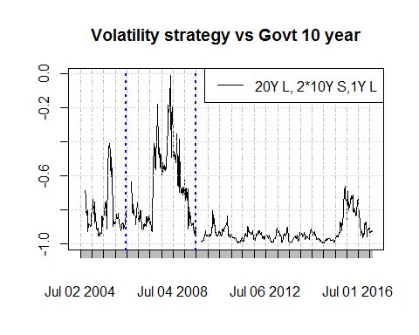

## COVARIANCE MATRIX BASED ON WEIGHTS

## Warning: 1 failed to parse.

|  |  |  |  |  |  |
| --- | --- | --- | --- | --- | --- |
|  | Enrgy | Telcm | Hlth | Oil | Gold |
| Enrgy | 0.0016192 | 0.0004823 | 0.0004660 | 0.0008618 | 0.0001516 |
| Telcm | 0.0004823 | 0.0009243 | 0.0006120 | -0.0001676 | -0.0000762 |
| Hlth | 0.0004660 | 0.0006120 | 0.0010111 | -0.0002246 | -0.0000961 |
| Oil | 0.0008618 | -0.0001676 | -0.0002246 | 0.0052529 | 0.0004342 |
| Gold | 0.0001516 | -0.0000762 | -0.0000961 | 0.0004342 | 0.0010153 |

## BUILDING PORTFOLIO using MVE

|  |  |  |  |  |
| --- | --- | --- | --- | --- |
| Enrgy | Telcm | Hlth | Oil | Gold |
| 1.474948 | 2.072665 | 0.8310341 | 1.111288 | -0.0178693 |

## [,1]  
## [1,] 0.2331487

$SharpeRatio_{MVE}=(R_{avg,exc})′ΣR_{avg,exc}$ where $R_{avg,exc}$ 
 is the average excess returns of the assets $Σ$ 
 is the covariance matrix of the assets

#Tactical  
dailyReturnOfPortfolio <- ExcessReturns[,-ncol(ExcessReturns)]%*%weightsOfAssets[[1]]  
dailyReturnOfPortfolio.xts <- xts(dailyReturnOfPortfolio,index(ExcessReturns))  
  
strat2 <- do.call(rbind,Strat2.HikePeriods.Daily[hikePeriodNames])  
compdata <- merge.xts(dailyReturnOfPortfolio.xts,strat2[,1])%>%na.omit  
cor(compdata)

## dailyReturnOfPortfolio.xts X10YrGovtRet  
## dailyReturnOfPortfolio.xts 1.0000000 -0.1259407  
## X10YrGovtRet -0.1259407 1.0000000