# IAQF Fixed Income

As part of the Fixed Income asset class, Barclays Aggregate Index, Inflation Index 10-year treasury (TIPS) and 30-year government bonds were chosen as possible investment opportunities. Each of these assets have been analyzed separately below.

## Historical Performance

### Barclays Aggregate Index

The Bloomberg Barclays Global Aggregate Index is a measure of global investment grade debt from twenty-four local currency markets. This multi-currency benchmark includes treasury, government-related, corporate and securitized fixed-rate bonds from both developed and emerging markets issuers.

The historical annualized return, standard deviation and sharpe ratio during past rate hike periods, recession and present data are below:

|  |  |  |  |  |  |  |  |
| --- | --- | --- | --- | --- | --- | --- | --- |
| **Data** | **1983-84** | **1988-89** | **1994-95** | **1999-2000** | **2004-2006** | **Recession** | **Now** |
| Annualized Mean | 1.23% | 0.6% | 1.11% | 0.49% | 0.37% | -0.44% | -0.1% |
| Annualized SDeviation | 7.2% | 1.67% | 1.09% | 0.79% | 0.65% | 1.17% | 0.65% |
| Sharpe Ratio | 0.1707 | 0.393 | 1.024 | 0.617 | 0.579 | -0.381 | -0.254 |

As it can be seen from the positive (and too small) Sharpe ratio, the Barclays Aggregate Index has done well during rate hike periods. This might be due to the in-built diversification in this index.

In the 1 week rolling correlation graph between the annualized returns and the 10-year government bond returns, we can see a positive correlation between them during the rate hike period.

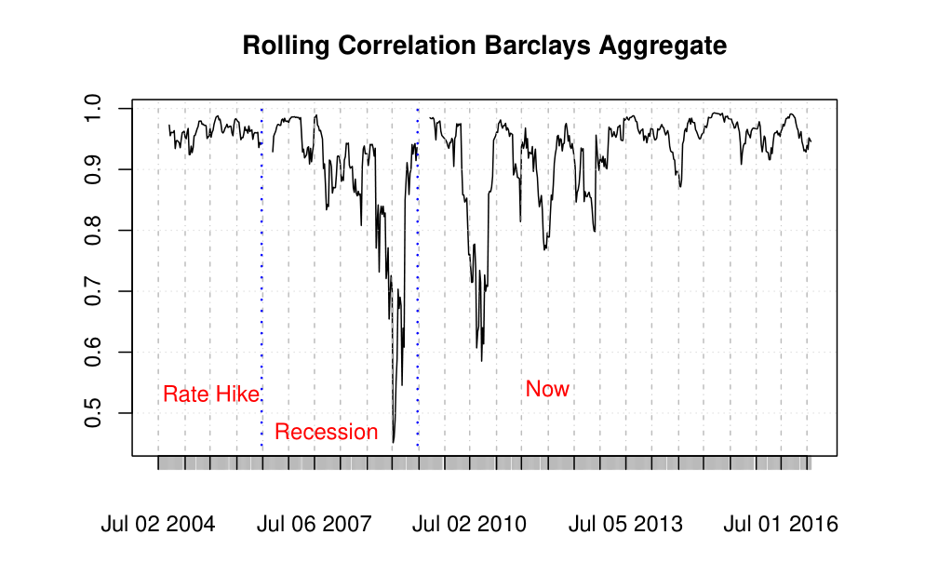

### Inflation Indexed 10-year Treasury

The inflation-indexed bonds (also called linkers) are bonds where the principal is linked to inflation in terms of the CPI value. The historical performance for the Inflation Index treasury can be found below

|  |  |  |  |  |
| --- | --- | --- | --- | --- |
| **Data** | **1999-2000** | **2004-2006** | **Recession** | **Now** |
| Annualized Mean | 0.09% | 0.14% | -0.23% | -0.15% |
| Annualized SDeviation | 0.25% | 0.64% | 1.1% | 0.72% |
| Sharpe Ratio | 0.355 | 0.22 | -0.209 | -0.211 |

As can be seen from the results, the linker performed decently during the rate hike periods, but had negative Sharpe ratio during the recession period. The Sharpe ratio for the linkers aren’t as high as the Barclays Aggregate Index during the rate hike periods. Also, it hasn’t started recovering after the recession, which the Index has successfully done. This make the Barclays Index a better investment than in the Inflation Indexed 10-year treasury.

### 30-Year Treasury

30-year Treasuries were chosen due to the long timeframe involved in the asset. This would help in assessing the long-term sentiment in the market.

The historical performance of the 30-year treasury is as below:

### 

|  |  |  |  |  |  |  |  |
| --- | --- | --- | --- | --- | --- | --- | --- |
| **Data** | **1983-84** | **1988-89** | **1994-95** | **1999-2000** | **2004-2006** | **Recession** | **Now** |
| Annualized Mean | 0.8% | 0.02% | 0.725% | 0.022% | -0.03% | -0.2% | -0.14% |
| Annualized SDeviation | 0.135% | 0.1% | 0.95% | 0.85% | 0.69% | 1.05% | 0.85% |
| Sharpe Ratio | 0.62 | 0.026 | 0.76 | 0.025 | -0.057 | -0.22 | -0.16 |

Even though there were some good performances, the 3-year treasury has underperformed the Barclays Aggregate Index in terms of sharpe ratio over majority of the rate hike periods.

Based on the historical performances and statistics, it can be concluded that an investment in the Barclays Aggregate Index would be the best fixed income strategy for rate hike periods.