ROW_Momentum

Nitish Ramkumar

# Trend trade

## 1 Data Collection

Data can be collected using yahoo through quantmod. A plot of the monthly returns of the currency can be found below. 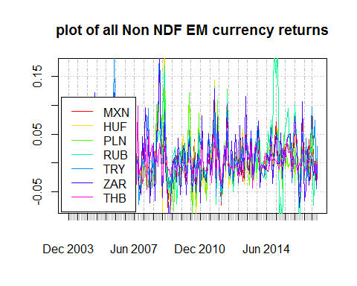 As can be seen, most of the non-ndf currencies are wavering between the -5% and 5% range. The zloty had a big jump in returns during 2014. This was because of a major announcement by the finance minister about the possibility of joining the EURO.

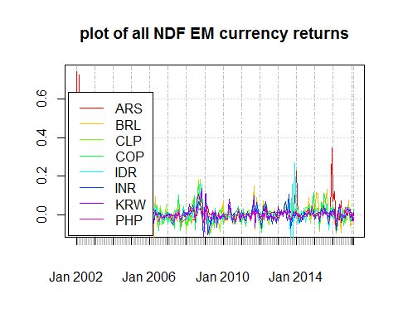 Most of the NDFs have been returning hovering just around the 0% return mark. The Argentenian peso gave high returns in 2016 due to the political problems in the country, which brought the currency down a lot.

## 2 Directional Signal

Long the currencies which have gone up compared to the look back period and short the currencies which have gone down compared to the same period.

Direction Signal:2002-2007

|  |  |  |  |  |  |  |  |  |  |  |  |  |
| --- | --- | --- | --- | --- | --- | --- | --- | --- | --- | --- | --- | --- |
|  | 1 | 2 | 3 | 4 | 5 | 6 | 7 | 8 | 9 | 10 | 11 | 12 |
| Annualized Mean | 0.21 | 0.17 | 0.17 | 0.17 | 0.18 | 0.16 | 0.17 | 0.16 | 0.14 | 0.14 | 0.13 | 0.13 |
| SD | 0.20 | 0.19 | 0.12 | 0.11 | 0.13 | 0.13 | 0.14 | 0.12 | 0.13 | 0.11 | 0.11 | 0.13 |
| Sharpe Ratio | 1.03 | 0.90 | 1.41 | 1.61 | 1.39 | 1.24 | 1.18 | 1.27 | 1.11 | 1.23 | 1.18 | 1.05 |

Direction Signal:2007-2011

|  |  |  |  |  |  |  |  |  |  |  |  |  |
| --- | --- | --- | --- | --- | --- | --- | --- | --- | --- | --- | --- | --- |
|  | 1 | 2 | 3 | 4 | 5 | 6 | 7 | 8 | 9 | 10 | 11 | 12 |
| Annualized Mean | 0.28 | 0.28 | 0.28 | 0.28 | 0.29 | 0.28 | 0.29 | 0.31 | 0.29 | 0.28 | 0.29 | 0.35 |
| SD | 0.19 | 0.18 | 0.20 | 0.22 | 0.20 | 0.22 | 0.22 | 0.23 | 0.24 | 0.26 | 0.26 | 0.25 |
| Sharpe Ratio | 1.50 | 1.54 | 1.36 | 1.28 | 1.43 | 1.31 | 1.35 | 1.38 | 1.19 | 1.10 | 1.12 | 1.39 |

Direction Signal:2011-Present

|  |  |  |  |  |  |  |  |  |  |  |  |  |
| --- | --- | --- | --- | --- | --- | --- | --- | --- | --- | --- | --- | --- |
|  | 1 | 2 | 3 | 4 | 5 | 6 | 7 | 8 | 9 | 10 | 11 | 12 |
| Annualized Mean | 0.23 | 0.23 | 0.21 | 0.22 | 0.21 | 0.19 | 0.22 | 0.19 | 0.20 | 0.19 | 0.18 | 0.22 |
| SD | 0.18 | 0.21 | 0.19 | 0.19 | 0.18 | 0.17 | 0.19 | 0.19 | 0.18 | 0.20 | 0.20 | 0.21 |
| Sharpe Ratio | 1.24 | 1.06 | 1.14 | 1.15 | 1.21 | 1.16 | 1.17 | 1.02 | 1.13 | 0.97 | 0.91 | 1.04 |
| As can be seen, 2 | - 5 mon | th look | back s | eems to | be pro | viding | good sh | arpe ra | tio. |  |  |  |

## 3 Consistency Filter

We will consider a 3 month look back for the consistency filter.

Direction Signal With filter:2002-2007

|  |  |  |  |  |  |  |  |  |  |  |  |  |
| --- | --- | --- | --- | --- | --- | --- | --- | --- | --- | --- | --- | --- |
|  | 1 | 2 | 3 | 4 | 5 | 6 | 7 | 8 | 9 | 10 | 11 | 12 |
| Annualized Mean | 0.18 | 0.13 | 0.13 | 0.12 | 0.12 | 0.11 | 0.10 | 0.10 | 0.09 | 0.09 | 0.08 | 0.08 |
| SD | 0.12 | 0.17 | 0.10 | 0.09 | 0.09 | 0.09 | 0.09 | 0.08 | 0.09 | 0.07 | 0.06 | 0.07 |
| Sharpe Ratio | 1.54 | 0.78 | 1.27 | 1.41 | 1.27 | 1.26 | 1.10 | 1.18 | 0.99 | 1.29 | 1.43 | 1.12 |

Direction Signal With filter:2007-2011

|  |  |  |  |  |  |  |  |  |  |  |  |  |
| --- | --- | --- | --- | --- | --- | --- | --- | --- | --- | --- | --- | --- |
|  | 1 | 2 | 3 | 4 | 5 | 6 | 7 | 8 | 9 | 10 | 11 | 12 |
| Annualized Mean | 0.28 | 0.25 | 0.20 | 0.21 | 0.20 | 0.18 | 0.18 | 0.18 | 0.15 | 0.14 | 0.15 | 0.16 |
| SD | 0.19 | 0.17 | 0.16 | 0.16 | 0.15 | 0.15 | 0.14 | 0.14 | 0.14 | 0.14 | 0.14 | 0.13 |
| Sharpe Ratio | 1.54 | 1.42 | 1.30 | 1.30 | 1.34 | 1.23 | 1.29 | 1.23 | 1.14 | 1.03 | 1.07 | 1.29 |

Direction Signal With filter:2011-Present

|  |  |  |  |  |  |  |  |  |  |  |  |  |
| --- | --- | --- | --- | --- | --- | --- | --- | --- | --- | --- | --- | --- |
|  | 1 | 2 | 3 | 4 | 5 | 6 | 7 | 8 | 9 | 10 | 11 | 12 |
| Annualized Mean | 0.22 | 0.19 | 0.17 | 0.16 | 0.15 | 0.13 | 0.14 | 0.13 | 0.14 | 0.13 | 0.14 | 0.14 |
| SD | 0.17 | 0.16 | 0.15 | 0.15 | 0.14 | 0.13 | 0.14 | 0.14 | 0.14 | 0.15 | 0.16 | 0.16 |
| Sharpe Ratio | 1.35 | 1.15 | 1.12 | 1.11 | 1.06 | 0.95 | 1.00 | 0.89 | 0.96 | 0.88 | 0.87 | 0.87 |

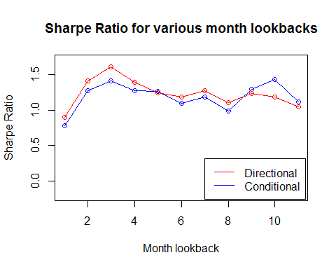

# Carry trade

Carry trade can be replicated using the Barclays GEMS index. This data can be retrieved out of Bloomberg. We can observe the correlation between the GEMS return and the SP500 return during non-recession and recession periods.

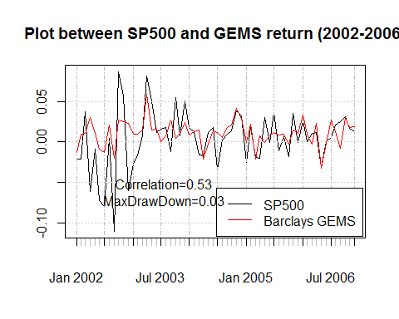 We can observe a low correlation between the SP500 and the Barclays GEMS during non-recession period. This will assist in diversification of a traditional portfolio.

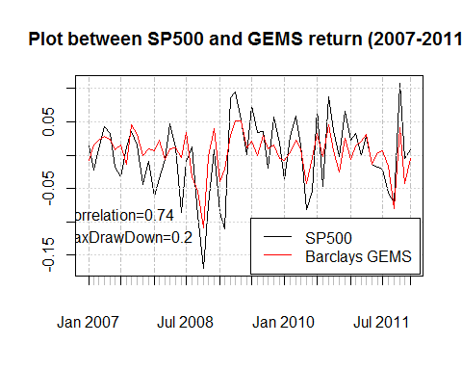 During recession environment, the correlation increases. This needs to be considered while investing in the carry trade, especially because of the very high maximum draw down value.

The GEMS index is expected to have a risk aversion index embedded in it, to make sure that the risk of market stress is taken into consideration. We can double check this, by finding its correlation with the Financial Stress Index (FSI).

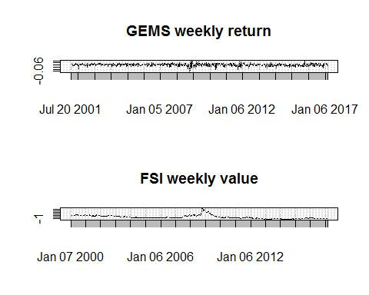 As you can see, in 2008-2009, the FSI value goes up exponentially and the GEMS return falls in an equally drastic fashion. Such a trend can be noticed in other periods as well. This shows that the GEMS risk aversion component doesnt do a good job of predicting the possible recessions.

# Backwardation Indices

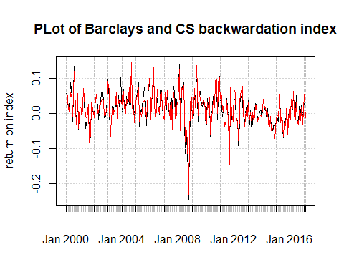

## monthly.returns  
## monthly.returns 0.9611211