A

Project Report

on

“Hostel Room Allocation System”

By

Nitish Kumar Rathour

Roll No: 205119063



Submitted to

Dr. U. Vignesh

Department of Computer Application

Hostel Room Allocation System

Software Design Description

Table Of Contents

1. **Introduction 2**
   1. Purpose 2
   2. Objective 3
   3. Scope of the Project 3
   4. Overview of Project 3
2. **Data Design 3**
   1. Entity Relationship Diagram 3
   2. Conceptual Schema 4
3. **Entities and Attributes 5**
   1. Hostel 5
   2. Administrator 6
   3. Student 6
   4. Room 7
   5. Visitors 7
   6. Furniture 8
4. Introduction

The Software Design Document is a document to provide documentation which will be used to aid in software development by providing the details for how the software should be built. Within the Software Design Document is narrative and graphical documentation of the software design for the project including ER Diagrams, Conceptual Schema, and other supporting requirement information.

* 1. Purpose

The purpose of the Software Design Document is to provide a description of the design of a system fully enough to allow for software development to proceed with an understanding of what is to be built and how it is expected to build. The Software Design Document provides information necessary to provide the description of the details for the software and system to be built.

* 1. Objective
     + To deal with Hostel Management System in an easy and an efficient manner.
     + Create strong and secrete database that allows for any connection in a secret way, to prevent any outside or inside attacks.
  2. Scope of the Project
     + Hostel Management System is designed for Hostel (like schools, Universities).
     + There will be predefined criteria for the Reservation to the hostels.
     + He/She checks the attested application forms of the students obtained from the internet and verify it with the student database.
     + If the students are found eligible then they are allotted to the hostel Room.
  3. Overview of Project

Hostel Room Allocation System is a web application which aims at computerization of the current procedure of allocating hostel rooms. Currently, the process involves students filling up the forms and submitting them in respective hostel offices which involves a lot of paperwork, hence less efficient.

1. Data Design
   1. Entity Relationship Diagram

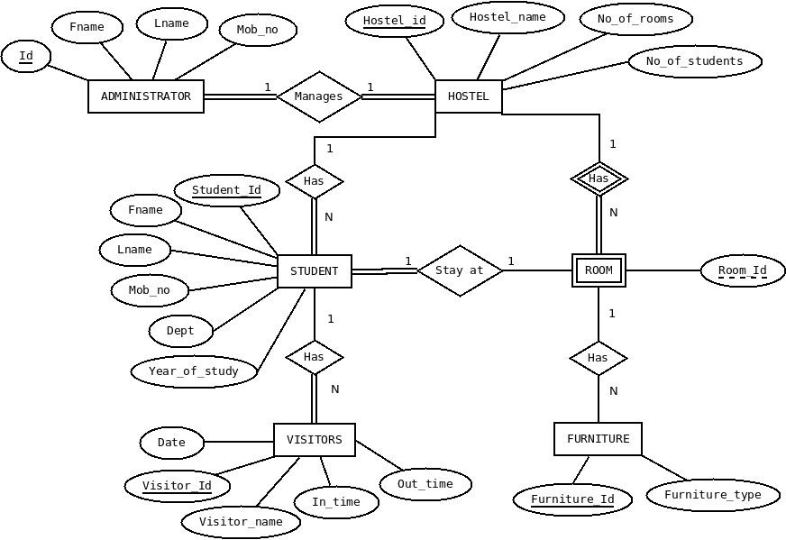

* 1. Conceptual Schema

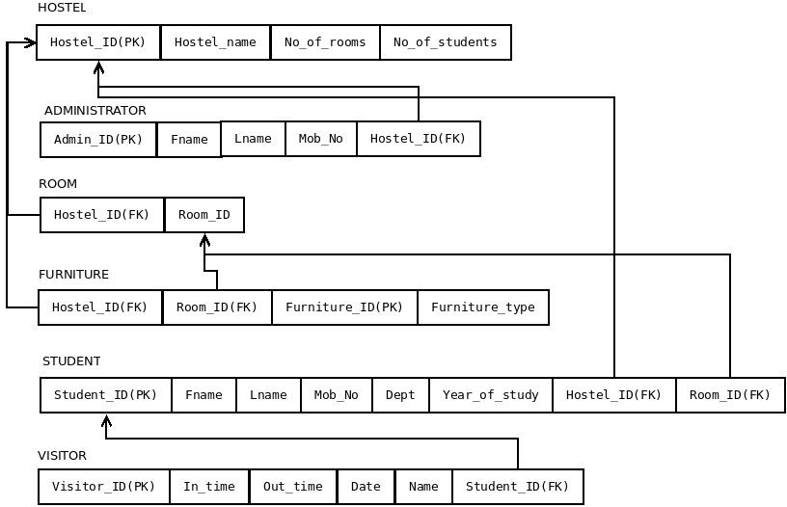

1. Entities and Attributes

This section of the document explains the entities used in the project, their attributes and how they will work together. Basically, this is intended to make the design more easy and understandable for everyone.

**Entities**

1. Hostel
2. Administrator
3. Student
4. Room
5. Visitor
6. Furniture
   1. Hostel

An Institution has many hostels and each hostel is represented using this ‘Hostel’ entity. Hostel model takes part in the following relationships.

* + 1. Administrator manages **Hostel**.
    2. **Hostel** has Students.
    3. **Hostel** has Rooms.

**Attributes**

|  |  |  |
| --- | --- | --- |
| **Name** | **Data Type** | **Type** |
| Hostel_ID | integer | Primary Key attribute |
| Hostel_name | string | Non_key attribute |
| No_of_rooms | integer | Non_key attribute |
| no_of_students | integer | Non_key attribute |

* 1. Administrator

Every hostel has an administrator and is represented using the ‘administrator’ entity. Administrator entity takes part in following relationships.

* + 1. **Administrator** manages Hostel.

**Attributes**

|  |  |  |
| --- | --- | --- |
| **Name** | **Data Type** | **Type** |
| ID | integer | Primary Key attribute |
| Fname | string | Non_key attribute |
| Lname | string | Non_key attribute |
| Mob_No | string | Non_key attribute |
| Hostel_id | integer | Foreign Key attribute |

* 1. Student

Every hostel has students and they are represented by the ‘student’ entity. Student entity participates in the following relationships.

* + 1. Hostel has **Students**.
    2. **Student** has visitor.
    3. **Students** stay at room

**Attributes**

|  |  |  |
| --- | --- | --- |
| **Name** | **Data Type** | **Type** |
| Student_ID | integer | Primary Key attribute |
| Fname | string | Non_key attribute |
| Lname | string | Non_key attribute |

|  |  |  |
| --- | --- | --- |
| Mob_No | string | Non_key attribute |
| Dept | string | Non_key attribute |
| Year_of_study | integer | Non_key attribute |
| Hostel_id | integer | Foreign Key attribute |
| Room_id | integer | Foreign Key attribute |

* 1. Room

Every Hostel has rooms and they are represented using ‘room’ entity. Room entity participates in the following relationships.

* + 1. Hostel has **Rooms**.
    2. Student stays at **room**.
    3. **Room** has Furniture.

**Attributes**

|  |  |  |
| --- | --- | --- |
| **Name** | **Data Type** | **Type** |
| Hostel_ID | integer | Foreign Key attribute |
| Room_ID | integer | Partial Key attribute |

* 1. Visitors

Every student has visitors and they are represented using ‘Visitor’ entity. Visitor entity participates in the following relationships.

* + 1. Student has **visitors**.

**Attributes**

|  |  |  |
| --- | --- | --- |
| **Name** | **Data Type** | **Type** |
| Visitor_ID | integer | Primary Key attribute |
| In time | Date-time field | Non_key attribute |

|  |  |  |
| --- | --- | --- |
| Out time | Date-time field | Non_key attribute |
| Date | Date-time field | Non_key attribute |
| Name | string | Non_key attribute |
| Student_id | integer | Foreign Key attribute |

* 1. Furniture

Every room has furniture and they are represented using ‘furniture’ entity. Furniture participated in following relationships.

* + 1. Room has **Furniture**.

**Attributes**

|  |  |  |
| --- | --- | --- |
| **Name** | **Data Type** | **Type** |
| Furniture_ID | integer | Primary Key attribute |
| Room_ID | integer | Foreign Key attribute |
| Hostel_ID | integer | Foreign Key attribute |
| Furniture_type | string | Non_key attribute |

Hostel Room Allocation System

Software Requirement Specification

Table Of Contents

1. **Introduction 2**
   1. Purpose 3
   2. Objective 3
   3. Scope of the Project 3
   4. Overview of Project 4
2. **Overall Description 4**
   1. System Requirement 4
3. **User Requirements Definition 4**
4. **System Requirement Specification 5**
   1. Functional System Requirement 5

Administrator module 5

User module 5

Application module 5

* 1. Non-Functional System Requirements: 6
     1. Performance Requirements 6
     2. Safety Requirements 6
     3. Security Requirements 6

1. **Hardware Requirements 7**
2. **Software Requirements 7**
3. Introduction
   1. Purpose

The Software Requirements Specification (SRS) will provide a detailed description of requirements for the Hostel Management System (HMS). This SRS will be helpful for complete understanding what is to be expected from the newly introduced system which is to be constructed. The clear understanding of the system and its functionality will allow for the correct software to be developed for the end user and will be used for the development of the future stages of the project.This SRS will provide the foundation of the project. From this SRS, the Hostel Management System can be designed, constructed and finally tested.

The Project team will use the SRS to fully understand the expectations of the HMS to construct the appropriate software. The hostel end users will be able to use the SRS as a “test” to see if the constructing team will be constructing the system to their expectations.

* 1. Objective
     + To deal with Hostel Management System in an easy and an efficient manner.
     + Create strong and secrete database that allow for any connection in a secret way, to prevent any outside or inside attacks.
  2. Scope of the Project
     + Hostel Management System is designed for Hostel (like schools, Universities).
     + There will be predefined criteria for the Reservation to the hostels.
     + He/She checks the attested application forms of the students obtained

from the internet and verify it with the student database.

* + - If the students are found eligible then they are allotted to the hostel Room.
  1. Overview of Project

Hostel Room Allocation System is a web application which aims at computerization of current procedure of allocating hostel rooms. Currently the process involves students filling up the forms and submitting them in respective hostel offices which involves a lot of paperwork, hence less efficient.

1. Overall Description
   1. System Requirement

The Web Application has two main parts:

1. Hostel Administrators
2. Students

The student can select among the allocated hostel to a specified batch and the Hostel Administrator can assign the room number in the specific hostel that the student has selected upon the availability.

1. User Requirements Definition

The user requirement for this system is to make the system fast, flexible, less prone to error, reduce expenses and save the time.

1. Less human error
2. Strength and strain of manual labor can be reduced
3. High security
4. Data redundancy can be avoided to some extent
5. Data consistency
6. Easy to handle
7. Easy data updating
8. Easy record keeping
9. Backup data can be easily generated.
10. System Requirement Specification
    1. Functional System Requirement

This section gives a functional requirement that applicable to the HMS. These are sub modules in this phase.

* + - Administrator module.
    - User Module
    - Application Module

**The functionality of each module is as follows:**

* + - Administrator module:

The Administrator can :

1. Allot different students to the different hostels.
2. Vacate the students from the hostels.
3. Edit the details of the students & modify the student records.
   * + User module:
4. Can submit the application form
5. Can view the notice board
6. Can submit the vacating form.
   * + Application module:

This section provides a form to the students which can be filled by them, and a copy of the filled page can be taken in the printed form. This is later submitted to the Hostel authorities can be verified by them before allotting them to the respective hostels Rooms.

* 1. Non-Functional System Requirements:
     1. Performance Requirements

Some Performance requirements identified is listed below:

* + - 1. The database shall be able to accommodate around thousand records to store.
      2. The software shall support use of multiple users at a time.
    1. Safety Requirements

The database may get crashed at any certain time due to virus or operating system failure. Therefore, it is required to take the database Backup.

* + 1. Security Requirements

Some of the factors that are identified to protect the software from accidental or malicious access, use, modification, destruction, or disclosure are described below. Keep specific log or history data sets

1. Assign certain functions to different modules
2. Restrict communications between some areas of the program
3. Check data integrity for critical variables
4. Later version of the software will incorporate encryption
5. techniques in the user/license authentication process.
6. Hardware Requirements
   * Processor: Pentium or greater
   * RAM: 512MB
   * Hard Disk: Depends on how much data is stored in DATABASE (min 1GB)
   * Keyboard
   * Monitor
7. Software Requirements
   * OS: Linux
   * Database: SQL

Hostel Room Allocation System

User Manual

1. Login Page

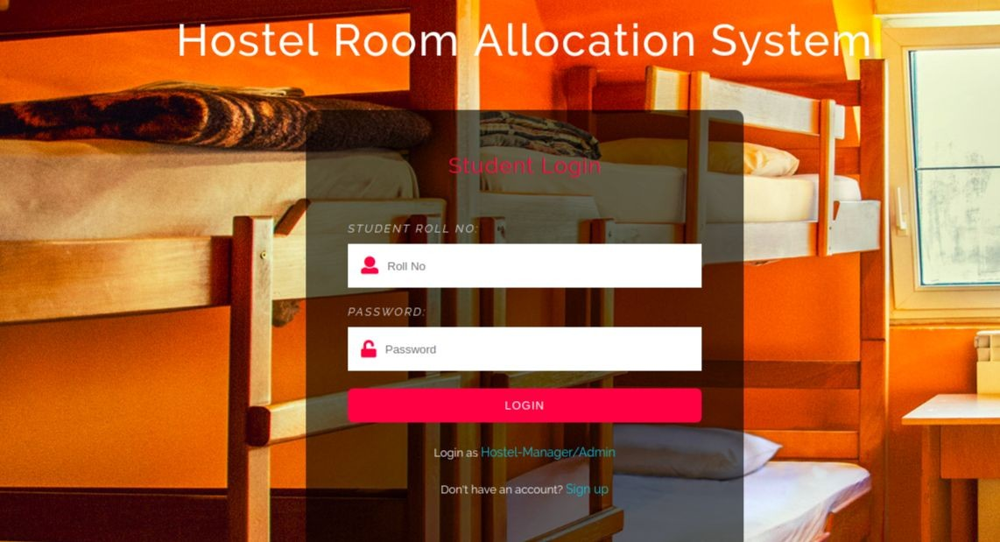

Users who have previously registered for the Hostel Room Allocation System Web Application must login by:

* 1. Entering their Username/Roll No.
  2. Entering their Password.

Selecting Login to advance to the next screen and begin using the application.

1. Sign Up Page

Students who have not previously registered for the Hostel Room Allocation System Web Application must select “Register to use the site” to access the “New User Registration” page. There they can enter all the required details and register themselves in the portal.

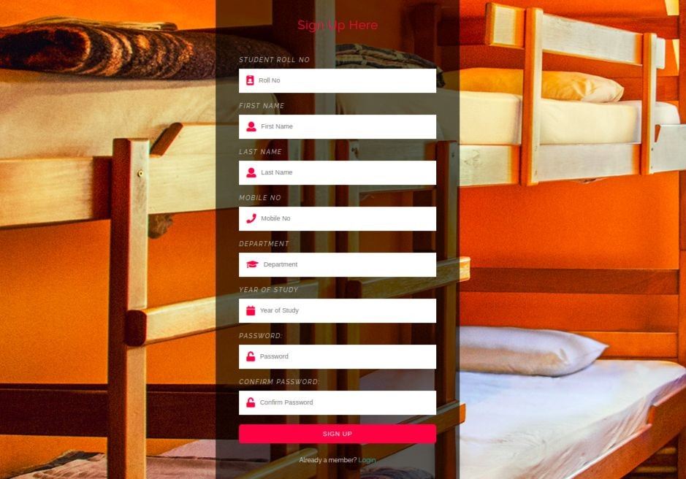

There are 3 different home pages

* 1. User Homepage
  2. Hostel Manager Homepage
  3. Admin Homepage

The homepage basically cointains a navigation bar which takes the user to different pages to perform different activities.

1. Hostel Page

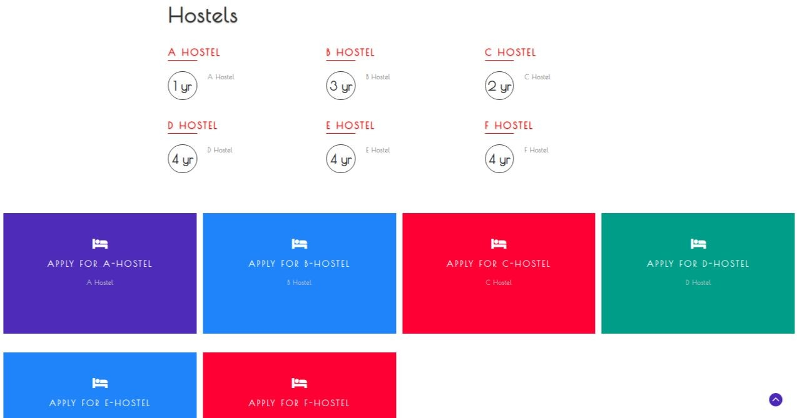

Hostel Page is accessible only to students and they can request for room in any hostel by just clicking on the corresponding hostel link and confirming by entering their password.

1. User Profile

This is again of 3 types

* + 1. Student user profile
    2. Hostel manager user profile
    3. Admin user profile

For a student his user profile will also contain the hostel details and hostel manager info if he is allocated a room.

1. Applications Received

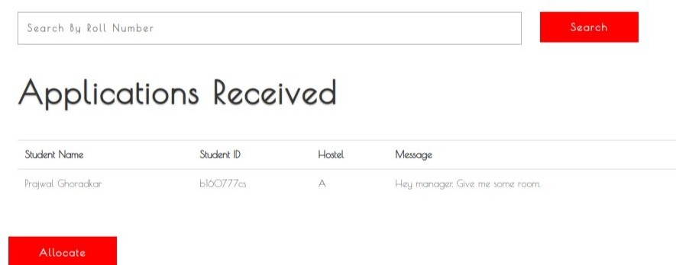

This tab can only be accessed by hostel manager. He can view all the applications his hostel received and allocate rooms accordingly.

1. Allocated and Empty Rooms

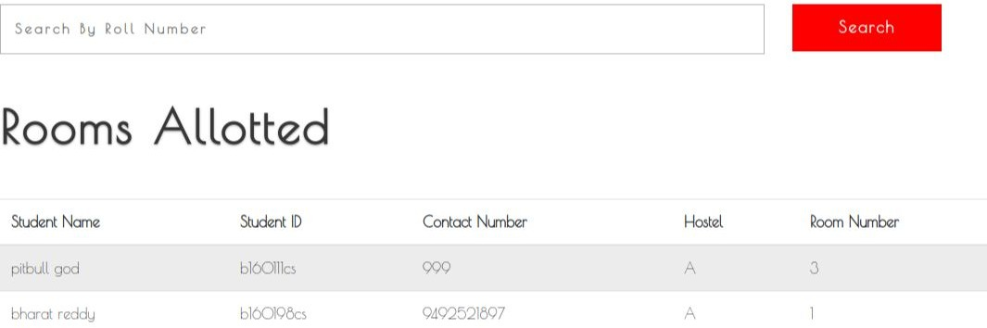

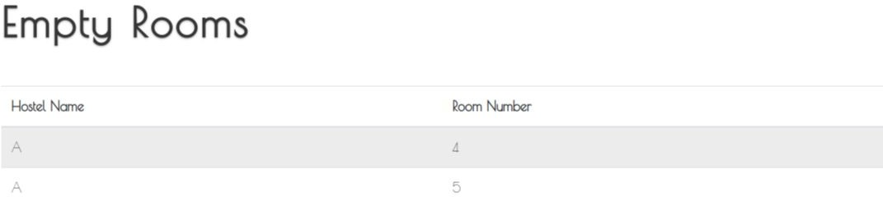

Each hostel manager can look at the list of allocated rooms and empty rooms in his/her hostel by going to this tab.

1. Vacate Rooms

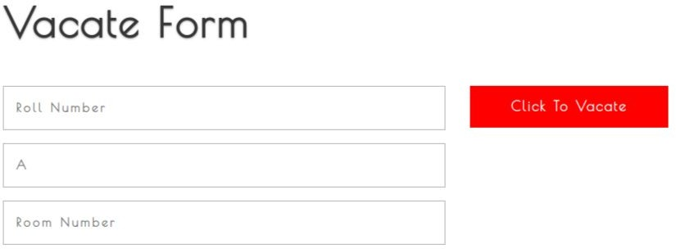

Hostel Manager can vacate an allocated room by filling the student and room details in this form and clicking on “click to vacate” button.

1. 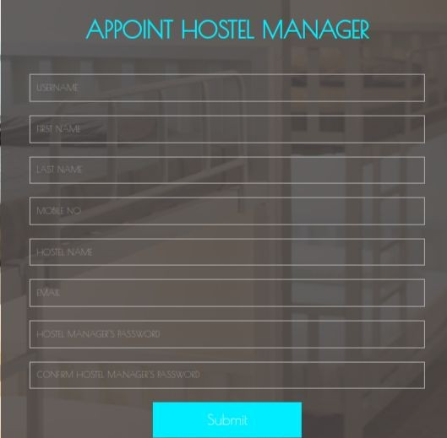Appoint/Remove Hostel Manager

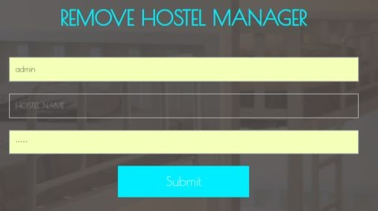

This page can only be accessed by hostel admin. He can allocate a new hostel admin or remove an existing hostel manager.

1. Students Page

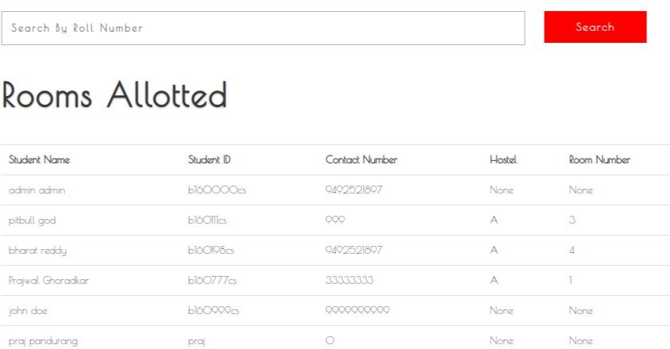

In this page the admin can see list of all the students, their details and the hostel allocated to them along with the room.

1. Contact Form

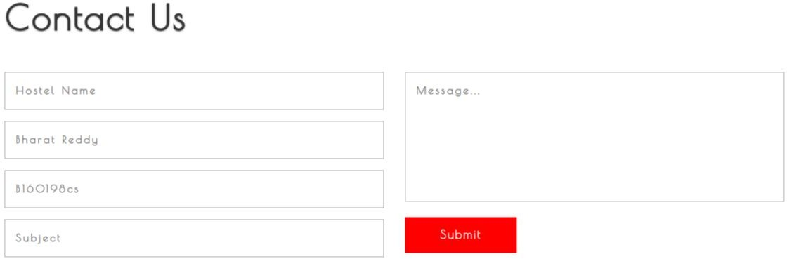

Students can send messages to hostel manager using this form and vice versa.

1. Messages Received Page

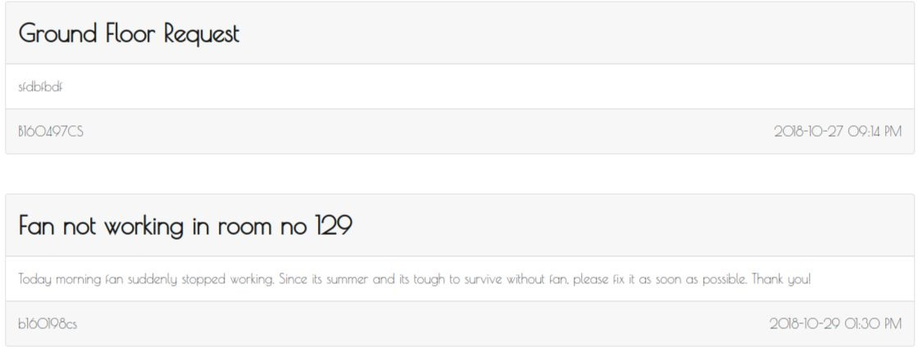

This page cointains messages received by the respective user(either host).