Project-Based Assessment Report
Domain-Specific AI Chatbot Using APIs
HealthPulse AI: AI Chatbot to Track Public Health Data
1. Introduction
This project implements HealthPulse AI, a domain-specific chatbot for tracking public health data. The purpose of the project is to make official public health indicators easier to access through natural-language questions instead of forcing users to search raw data portals, indicator codes, and structured API filters.
The chatbot is designed for public health data exploration. It can answer questions such as comparing malaria incidence in India and Brazil, forecasting tuberculosis incidence in India, checking whether maternal mortality is improving, and comparing life expectancy across countries. The answer is not limited to text; when useful, the response also includes chart-ready time-series data, calculated insights, citations, and limitations.
The assessment emphasizes:
• Practical AI skills through a working chatbot interface and backend query model.
• Creativity and innovation through natural-language access to public health datasets.
• Responsible and domain-aware AI usage through source citations, limitations, and no medical diagnosis.
• Societal impact by helping students and users understand disease trends and health-system indicators.
2. Assessment Objective
The objective of this project is to design and implement a serious chatbot-first application that can track public health data from trusted public sources. The application is built as a full-stack web system with a React and TypeScript frontend, FastAPI backend, API clients, query understanding logic, analytics, and tests.
The project objectives are to:
• Identify a meaningful real-world problem in the public health domain.
• Apply AI and NLP techniques to convert user questions into structured public health queries.
• Use WHO Global Health Observatory API as the primary data source.
• Return explainable responses with values, trends, charts, and compact source citations.
• Demonstrate technical competence in API-based systems, frontend design, backend design, and validation.
• Communicate design choices and limitations clearly in the report.
3. Project Description
Domain-Specific AI Chatbot
HealthPulse AI is a chatbot tailored to the public health analytics domain. Unlike a dashboard, it does not require the user to select indicators, countries, start years, and chart types from many controls. The user simply asks a question in plain English. The backend then identifies the intent, country or countries, health indicator, year range, and whether a forecast is requested.
The chatbot uses official public health data rather than fixed sample values. WHO Global Health Observatory is the primary source because it provides globally comparable public health indicators. Our World in Data is used only for COVID time-series situations where its dataset is more suitable for daily and yearly COVID values. World Bank remains a fallback for selected broad development or health-system indicators when WHO is not the most suitable source.
Supported question types include:
• Comparison questions, for example: Compare malaria incidence in India and Brazil.
• Forecast questions, for example: Forecast TB in India for 3 years.
• Trend questions, for example: Is maternal mortality improving in India?
• Year-range questions, for example: Compare life expectancy in India and USA since 2010.
• COVID questions, for example: Show COVID cases in India and Brazil from 2020 to 2023.
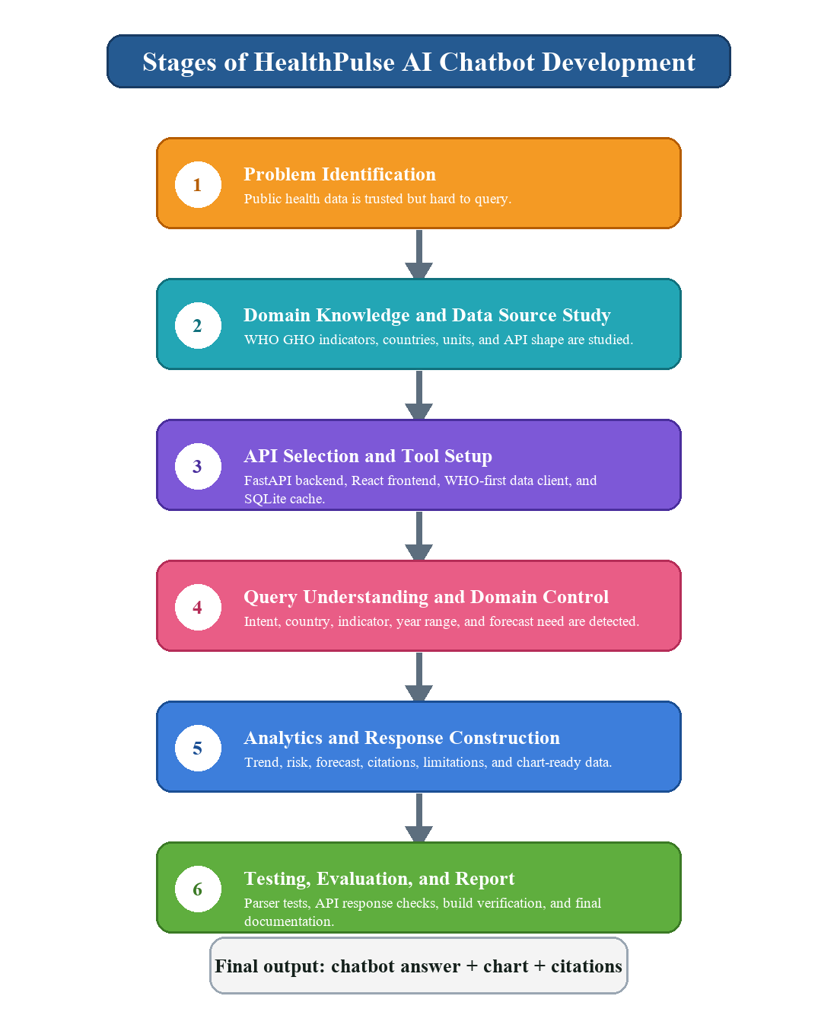
Figure 1: Stages followed in the HealthPulse AI chatbot project.
4. Scope and Requirements
Mandatory Requirements
• Clear domain definition: Public health data tracking and analysis.
• API-based system: WHO GHO API as the primary public health source.
• Domain-constrained responses: The chatbot answers public health data questions and avoids unrelated topics.
• Working prototype: A React frontend and FastAPI backend run locally.
• Simple user interface: Chatbot-first design without a cluttered sidebar.
• Explainable output: Each answer includes values, trend interpretation, and source citations.
Optional Enhancements Included
• Conversation memory through short-session chat history.
• Forecasting for selected indicator series using a damped trend method.
• Risk and trend interpretation based on indicator polarity.
• Compact charts inside chatbot responses when they improve understanding.
• SQLite caching of API responses to make repeated queries faster.
• Model/parser and API response tests.
Project Boundaries
The chatbot is not a doctor and does not provide diagnosis, treatment, or clinical recommendations. It is an educational public data exploration system. Forecasts are analytical estimates based on recent historical trends and should not be treated as official predictions.
5. Tools and Technologies
The technology stack was selected to support a serious but understandable college project. The application needed a clean web interface, a structured backend, external API access, data cleaning, local AI/NLP behavior, charts, and tests.
The tools and technologies used are:
• Frontend: React, TypeScript, Vite, Recharts, and Lucide icons.
• Backend: Python, FastAPI, Pydantic models, async API clients, and Uvicorn.
• AI/NLP: TF-IDF vectorization, logistic regression intent classifier, country extraction, indicator matching, and parser rules.
• Analytics: Trend slope, latest value, year-over-year change, risk interpretation, and damped-trend forecasting.
• Data sources: WHO GHO API, Our World in Data COVID dataset, World Bank API fallback, and local SQLite cache.
• Testing: Pytest backend tests and TypeScript/Vite frontend build verification.
FastAPI is suitable because the backend must validate request and response bodies, expose clean endpoints, and work with external API calls. React is suitable because the frontend has dynamic chat messages, charts, follow-up questions, loading states, and source panels.
6. Data Collection and Domain Knowledge Preparation
The project does not train a medical model. Instead, domain knowledge preparation is done through source study, indicator selection, and query design. This is important because public health terms in natural language do not always match API indicator codes. For example, a user may write TB, tuberculosis, malaria, maternal deaths, hospital beds, or life expectancy. The backend must map such phrases to the correct indicator metadata.
Data collection and domain preparation include:
• Studying WHO Global Health Observatory API structure and OData response format.
• Identifying public health indicators useful for a student project.
• Mapping common phrases such as malaria, TB, maternal mortality, COVID, and life expectancy to indicator IDs.
• Studying country names and country codes so users can ask for India, Brazil, USA, China, or similar names.
• Preparing realistic sample questions and expected response structure.
• Checking the shape of live API responses before connecting them to the frontend.
The purpose of this preparation is to make the chatbot reliable. Without domain mapping, a chatbot may understand the sentence but still fetch the wrong public health series. In this project, domain knowledge directly influences query planning, API selection, response wording, and chart rendering.
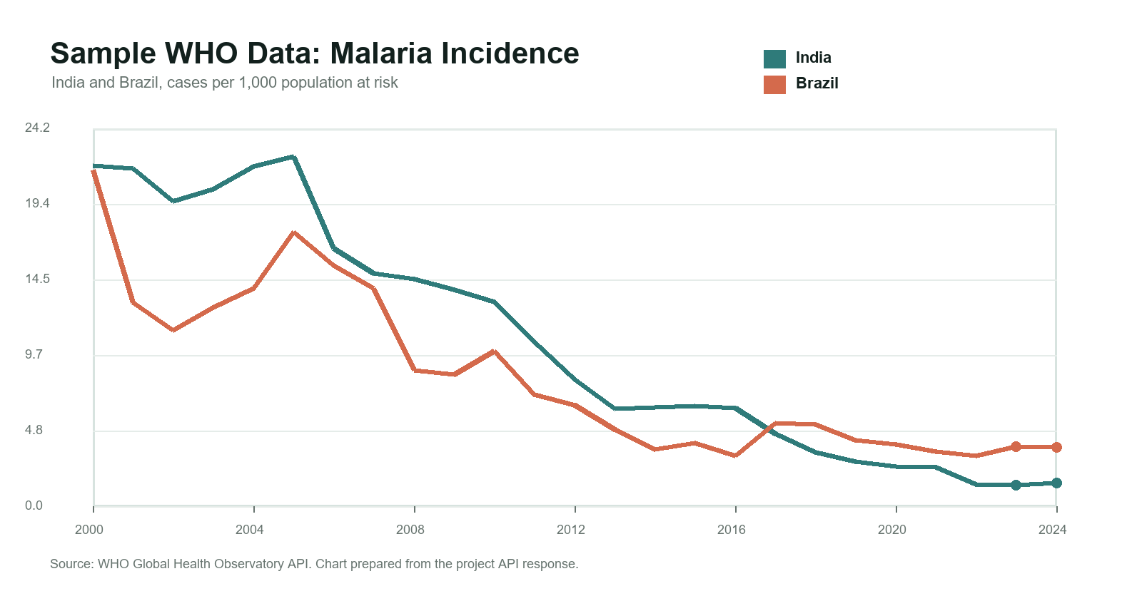
Figure 2: Example public health indicator chart used in chatbot responses.
7. Model Configuration Awareness
The reference manual asks students to understand model behavior control parameters such as temperature and top-p. HealthPulse AI keeps core calculations deterministic because public health answers should be stable and explainable. However, the project still documents how these settings would be used if an optional language-model explanation layer is added.
Temperature
Temperature controls randomness in language model responses. A low value produces more deterministic, factual, and repeatable output. A high value creates more varied wording but can increase the chance of unsupported statements. For this project, if a language model is used for final wording, a low temperature such as 0.1 to 0.3 is appropriate because public health data answers should not be creatively invented.
Top-p
Top-p, also called nucleus sampling, controls how broad the model's token selection can be. Lower top-p restricts the answer to safer and more likely wording, while higher top-p allows broader expression. For HealthPulse AI, a top-p around 0.8 or lower would be suitable for controlled explanations.
Project Decision
The current implementation uses local query understanding and deterministic analytics for the core answer. This makes the system easier to test and explain. The response values come from the selected public data source, not from a language model. A future improvement can add a controlled explanation layer, but the numeric analysis should remain deterministic.
8. System Architecture and Data Flow
The architecture separates the browser interface, backend API routes, query planning, data clients, analytics, and response construction. This separation makes the project easier to explain and maintain. The frontend does not need to know WHO API syntax; it sends the user's natural-language question to the backend and renders the structured response.
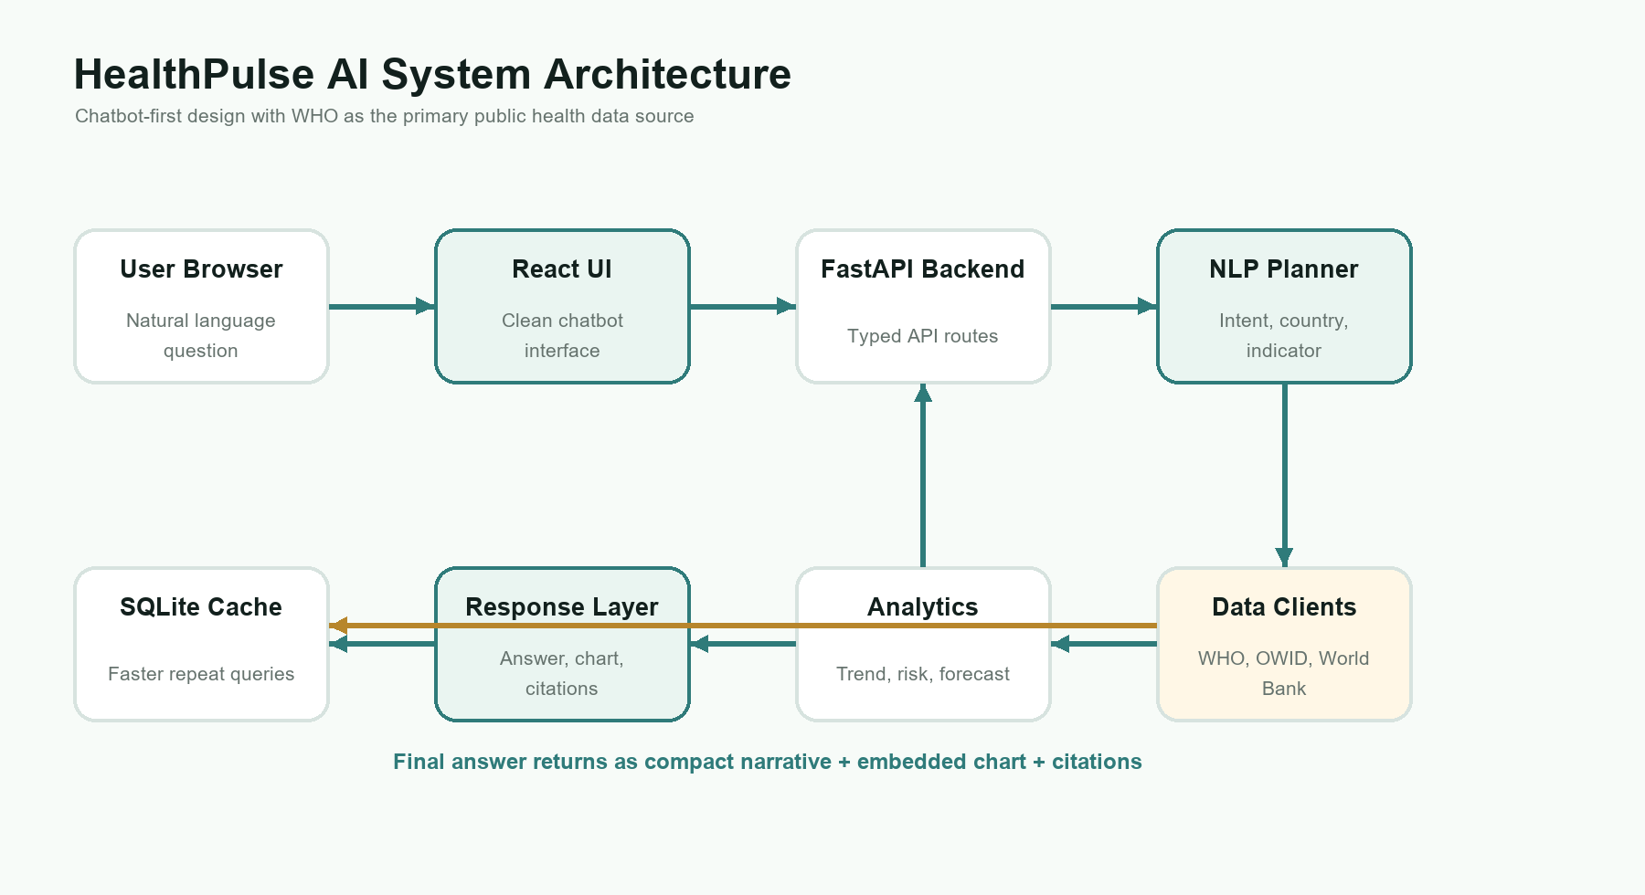
Figure 3: Overall system architecture of HealthPulse AI.
The data flow begins with a natural-language question. The backend creates a query plan, retrieves the correct public health series, cleans and groups the data, performs analytics, and returns a structured response. The frontend then displays the answer, chart, source citations, limitations, and follow-up questions.
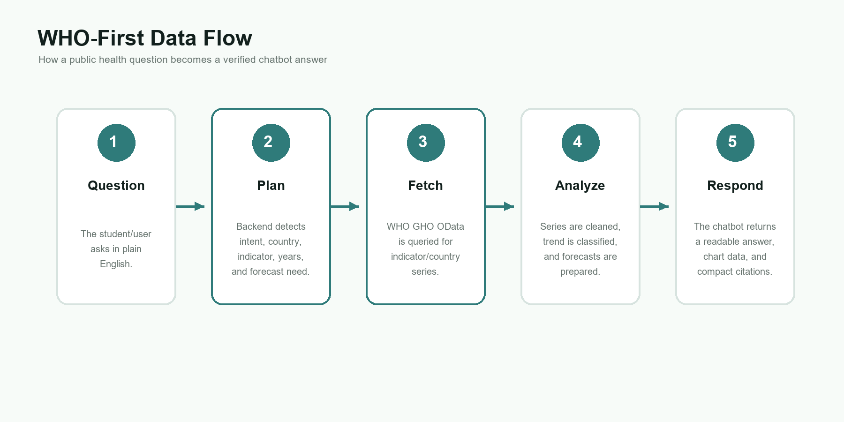
Figure 4: Data flow from user question to chatbot response.
9. Backend Design and API Integration
The backend is the intelligence layer of the application. It receives chat requests, validates the request body, builds a query plan, contacts public APIs, normalizes the returned data, applies analytics, and returns a typed response model. The most important route is POST /api/chat.
Chat Endpoint
POST /api/chat
Request body:
{ "message": "Compare malaria incidence in India and Brazil" }
Main response fields:
answer, plan, metric, series, insights, citations,
follow_up_questions, limitations, needs_clarification
WHO Global Health Observatory API
The WHO GHO API is used as the primary public health source. The backend sends a request for a selected indicator and country code, then converts the response into an internal Series format. Each series includes country, year, value, unit, and source metadata.
Other Sources
• Our World in Data is used for COVID questions because it provides convenient COVID time-series data.
• World Bank is available as a fallback for selected system or development indicators when WHO is not suitable.
• The source choice is included in the response so the user can see where the answer came from.
10. Chatbot Query Understanding
The chatbot uses a local AI/NLP query planner. The planner converts the user's sentence into a structured plan. This plan is important because public health APIs require indicator IDs, country codes, and filters, while users naturally ask in everyday language.
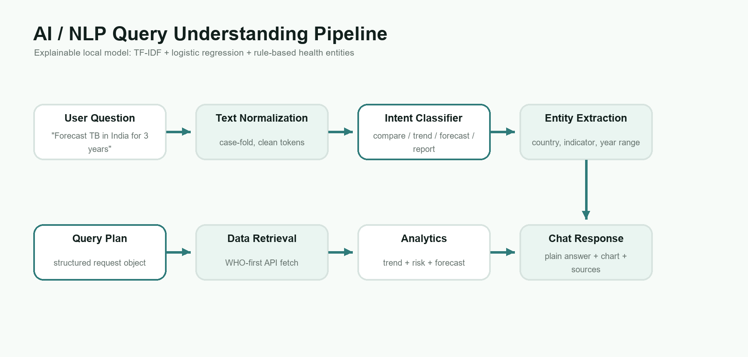
Figure 5: Query understanding pipeline used by the backend.
The query planner detects:
• Intent: compare, forecast, trend, risk, report, or general information.
• Countries: country names and aliases such as India, Brazil, USA, United States, China, and others.
• Indicator: malaria incidence, tuberculosis incidence, maternal mortality, life expectancy, COVID cases, or hospital beds.
• Year range: explicit years such as 2010 to 2022, or recent available years when no range is supplied.
• Forecast need: phrases such as next 3 years, forecast, predict, or future trend.
If a question is too vague, the backend can ask for clarification rather than guessing. For example, if the user asks only 'compare health in India', the system should request a specific indicator such as malaria, life expectancy, tuberculosis, or hospital beds.
11. Forecasting and Risk Analysis
Forecasting and risk analysis are included to make the chatbot more useful than a simple data lookup. The forecast uses recent historical direction with damping. Damping is important because public health indicators should not be projected aggressively from a single year of change.
Trend Analysis
Trend analysis checks whether the selected series is increasing, decreasing, or stable. It also calculates latest value, latest year, and recent year-over-year change. The interpretation depends on indicator polarity. For harmful indicators such as disease incidence or mortality, a decrease is usually improving. For beneficial indicators such as life expectancy or immunization coverage, an increase is usually improving.
Risk Interpretation
Risk interpretation uses the latest value, recent change, and indicator meaning. If malaria incidence is increasing, the chatbot can flag concern. If tuberculosis incidence is decreasing, the chatbot can describe the trend as improving. The system avoids overclaiming by showing source and limitations.
Forecasting
The forecast is not an official public health prediction. It is an analytical estimate used for educational trend exploration. The answer clearly states that the forecast is damped and based on recent data.
12. Frontend Interface and User Experience
The frontend was intentionally simplified after dashboard-style designs became too cluttered. The final interface is chatbot-first. There is no left sidebar, no large filter panel, and no confusing controls. The user sees a clear title, a central question input, suggested questions, and the conversation output.
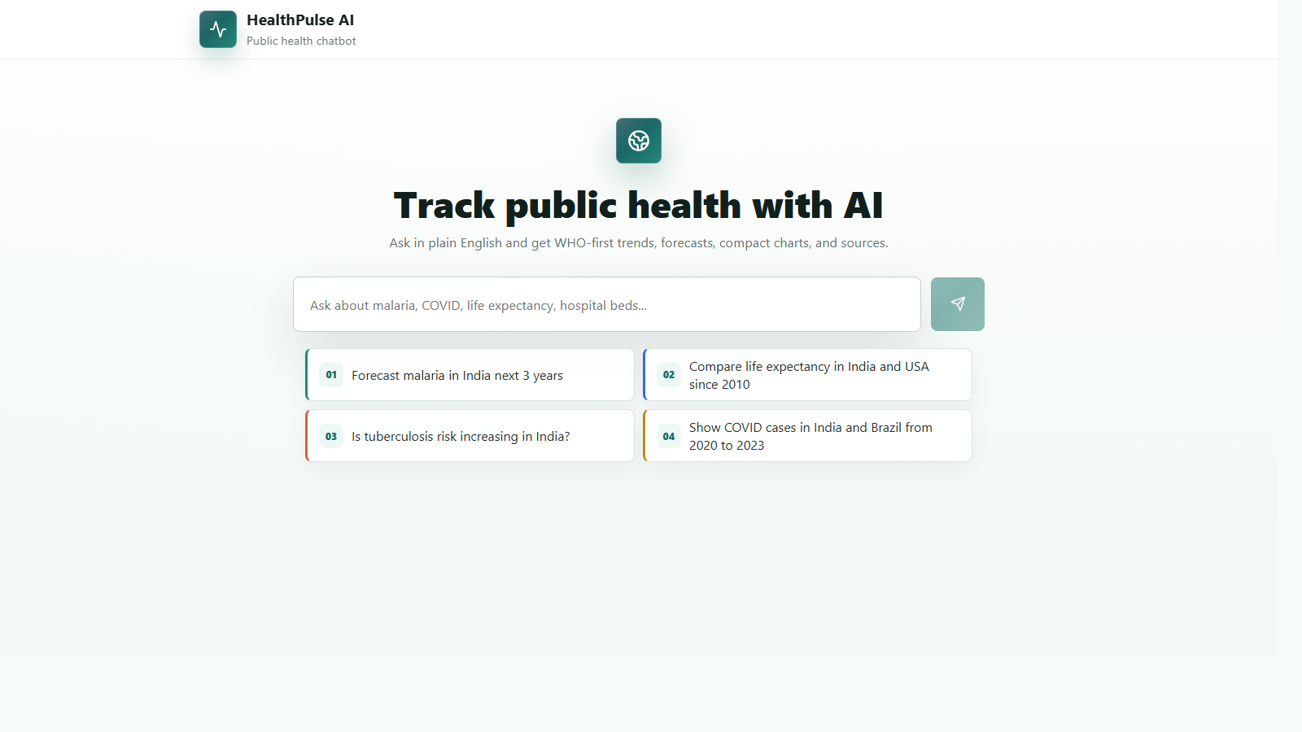
Figure 6: HealthPulse AI chatbot-first web interface.
When the backend returns a response, the frontend displays the answer inside the conversation. If chart data is useful, the chart appears inside that chatbot response. This keeps the interface simple while still showing enough evidence for academic evaluation.
Frontend design principles:
• Make the chatbot input the primary interaction.
• Use suggested questions only as examples, not as a dashboard replacement.
• Show charts only when they clarify the answer.
• Keep citations compact and close to the answer.
• Avoid cluttered filters and sidebars.
13. Implementation Evidence
The following evidence was collected from the running backend. It shows that the project uses live API-backed series rather than fixed placeholder answers.
Evidence 1: Compare malaria incidence in India and Brazil
Intent: compare
Indicator: Malaria incidence
Source: WHO
Answer: Brazil has the highest latest value for Malaria incidence: 3.75 cases per 1,000 population at risk in 2024. Brazil: 3.75 in 2024, India: 1.48 in 2024.
Evidence 2: Forecast TB in India for 3 years
Intent: forecast
Indicator: Tuberculosis incidence
Source: WHO
Answer: For India, the latest Tuberculosis incidence value is 187.00 cases per 100,000 people in 2024. The selected series is decreasing. From a public-health view, this looks improving. The latest year-over-year change is -2.6%. The 3-year damped trend forecast reaches 175.78 cases per 100,000 people by 2027.
Evidence 3: Is maternal mortality improving in India?
Intent: trend
Indicator: Maternal mortality ratio
Source: WHO
Answer: For India, the latest Maternal mortality ratio value is 80.48 deaths per 100,000 live births in 2023. The selected series is decreasing. From a public-health view, this looks improving. The latest year-over-year change is -10.2%.
Representative API Response Structure
{
"answer": "Brazil has the highest latest value for malaria incidence...",
"plan": {
"intent": "compare",
"indicator_id": "malaria_incidence",
"countries": ["IND", "BRA"],
"chart": "bar"
},
"metric": {
"source": "WHO",
"source_id": "MALARIA_EST_INCIDENCE"
},
"series_count": 2
}
14. Testing and Validation
Testing is important because a public health chatbot must answer consistently. Backend tests focus on parser behavior, query planning, and response structure. Frontend build verification checks that the React and TypeScript code compiles into a working production bundle.
• Backend test result: 9 passed using pytest.
• Frontend build result: TypeScript and Vite build completed successfully.
• Runtime check: Backend serves on 127.0.0.1:8765 and frontend serves on 127.0.0.1:5175.
• Known warning: The Recharts bundle is larger than 500 kB. This is a build-size warning, not a functional failure.
Backend tests:
......... [100%]
9 passed
Frontend:
tsc && vite build
Build completed successfully
15. Deliverables
The project deliverables are:
• Project report in the INT428 manual format.
• Source code for frontend and backend.
• Working local application link.
• API integration evidence and sample response.
• UI screenshot and architecture diagrams.
• Backend tests and frontend build evidence.
• Run instructions for local execution.
Local Application Links
• Frontend: http://127.0.0.1:5175
• Backend: http://127.0.0.1:8765
• Main backend endpoint: POST http://127.0.0.1:8765/api/chat
16. Evaluation Criteria Mapping
1. Problem Identification and Innovation (10 Marks)
• Problem clarity and relevance: Public health data is important but difficult to access through raw portals and APIs.
• Domain specificity and originality: The chatbot is constrained to public health indicators and uses WHO-first data retrieval.
• Societal impact: The system helps users understand disease trends, mortality indicators, life expectancy, and health-system data.
2. Technical Execution and Skill Demonstration (10 Marks)
• API integration and system design: FastAPI backend, React frontend, public API clients, query model, cache, and charts.
• Prompt/query engineering and domain control: Natural-language questions are converted into structured query plans.
• Model configuration understanding: The report explains temperature, top-p, deterministic design, and optional language-model use.
3. Presentation and Q&A (10 Marks)
• Clarity of explanation: The report explains system architecture, data flow, API usage, and limitations.
• Runtime effectiveness: The user can run the app locally and ask realistic questions.
• Depth of understanding: The project includes testing, evidence, and clear explanation of design decisions.
17. Academic Integrity, Responsible Use, and Conclusion
The project uses public APIs and cites the main data sources. It should be presented as an educational public health data exploration tool, not as a clinical decision system. The application should not be used for diagnosis, treatment decisions, or official public health policy decisions.
HealthPulse AI satisfies the main goal of a domain-specific AI chatbot project. It converts natural-language questions into structured public health data queries, retrieves trusted public data, performs explainable analytics, and returns chatbot responses with charts and citations. The final system is stronger than a normal dashboard because it allows the user to ask public health questions directly in natural language.
References
• World Health Organization. Global Health Observatory API. https://ghoapi.azureedge.net/api/
• World Health Organization. GHO OData API information. https://www.who.int/data/gho/info/gho-odata-api
• Our World in Data. COVID-19 datasets. https://ourworldindata.org/
• World Bank Data API. https://data.worldbank.org/
• FastAPI documentation. https://fastapi.tiangolo.com/
• React documentation. https://react.dev/
• scikit-learn documentation. https://scikit-learn.org/

18. Chatbot-Based Project Evaluation Questionnaire (INT428)
Student Name: ____________________________
Roll Number: ____________________________
Branch & Semester: ____________________________
Project Title: HealthPulse AI - Public Health Data Chatbot
Guide/Faculty Name: ____________________________
Section A: Project Overview
Q1. Type of Chatbot Developed: Domain-specific public health data chatbot.
Q2. Deployment Platform: Local web application using React frontend and FastAPI backend.
Q3. Deployment Link: Frontend: http://127.0.0.1:5175, Backend: http://127.0.0.1:8765
Q4. API Type Used: Public REST/OData APIs. WHO Global Health Observatory is primary; OWID COVID and World Bank are limited secondary sources.
Section B: Model and Configuration
Q5. Model Name: HealthPulse local public health query understanding model.
Q6. Model Version: 1.0.0 project version.
Q7. Contextual Memory: Short-session chat history on the frontend; no private long-term user memory.
Q8. Data Flow: Question -> query plan -> API fetch -> analytics -> chatbot response.
Q9. Model Parameters: TF-IDF features, logistic regression intent classifier, deterministic parser rules, conservative forecast damping.
Q10. Thinking Level / Role: Acts as a public health data analyst and not as a doctor.
Section C: Technical Submission
Q11. Technology Stack: React, TypeScript, Vite, FastAPI, Pydantic, scikit-learn, SQLite, Recharts.
Q12. API Call Screenshot / Code: Included under API Integration and Appendix Evidence.
Q13. UI Screenshot: Included in the Frontend Interface section.
Q14. Repository Link: To be filled after GitHub upload.

