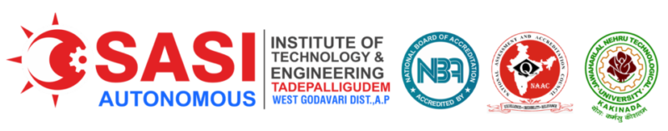
Department of Applied Sciences and Humanities
Academic Year 2025-26
Branch : CSE Year : 2025-26 Semister : 1-2 Wef : 2/2/2026

Day/period | 9.00 to 10.00 | 10.00 to 11.00 | 11.00 to 12.00 | 12.00 to 1.00 | 1.00 to 1.50 | 1.50 to 2.40 | 2.40 to 2.50 | 2.50 to 3.40 | 3.40 to 4.30
Monday | EG | EP | DS | B  R  E  A  K | BEEE | DEVC | B  R  E  A  K | DS | R/C
Tuesday | EG LAB |  |  |  | DS | BEEE |  | DEVC | LIB
Wednesday | DEVC | NSS | EP |  | EG | EEE/EP |  | EEE/EP LAB
Thursday | EP/EEE LAB |  |  |  | BEEE | EP |  | VT
Friday | EP | DS | BEEE |  | DEVC | DS |  | DS LAB
Saturday | DEVC | BEEE | EP |  | DS | ITWS |  | ITWS LAB

