**CSC 573 – INTERNET PROTOCOLS**

**PROJECT #2 FALL 2021**

**Aayush Indrapratap Singh, asingh48 Nitish Pravin Talekar, ntaleka**

1. **IMPLEMENTING GO BACK N**

**Files:**

Sender.py - Uploads the File to FTP Server

Receiver.py - Receives File

**Steps to Run:**

1. **Run Receiver.py in Terminal 1**

python Reciever.py 7735 data/output.txt <PROB_LOSS>

**#** Gives <SERVER_HOST>

# Waits 5Sec for a connection to establish.

1. **Run Sender.py in Terminal 2**

python Sender.py <SERVER_HOST> 7735 data/input.txt <N> <MSS>

# Starts sending Data from file to Reciever

**Example:**

Terminal 1: python Receiver.py 7735 data/input.txt 0.01

Terminal 2: python Sender.py Aayushs-MBP.lan 7735 data/input.txt 8 512

**Output Expected:**

Packets being shown lost in Terminal 1 (Receiver.py)

Timeout being printed in Terminal 2 (Server.py)

1. **IMPLEMENTING TASKS 1, 2, 3**

**Files:**

Task_Sender.py - Acts as Sender for each Task

Task_Receiver.py - Acts as Receiver for each Task

**Steps to Run:**

1. **Run Task_Receiver.py in Terminal 1**

python Task_Reciever.py 7735

# Waits 5Sec for a connection to establish.

1. **Run Task_Sender.py in Terminal 2**

python Task_Sender.py

# Starts sending Data from file to Receiver

These codes implement Task 1 2 3 sequentially in coordination with each other. Output of graphs is obtained in outputs folder.

**Example:**

Terminal 1: python Task_Receiver.py

Terminal 2: python Task_Sender.py

**Task 1: Effect of Window Size N**

* Each value is in Seconds

|  |  |  |  |  |  |  |
| --- | --- | --- | --- | --- | --- | --- |
| N | Transmit 1 | Transmit 2 | Transmit 3 | Transmit 4 | Transmit 5 | Average |
| 1 | 9.774863 | 9.91823506 | 8.60867 | 8.78685808 | 9.34976506 | 9.28767824 |
| 2 | 8.42079306 | 9.85144663 | 9.02333593 | 7.72389817 | 8.20120716 | 8.64413619 |
| 4 | 9.00532818 | 8.6229949 | 9.42322731 | 8.56465983 | 8.26101422 | 8.77544489 |
| 8 | 8.38827634 | 8.44750071 | 9.12760711 | 7.92363787 | 8.04503298 | 8.386411 |
| 16 | 7.72719002 | 8.15718818 | 8.58365297 | 7.88149095 | 8.65931177 | 8.20176678 |
| 32 | 8.20436478 | 8.59465194 | 8.38811707 | 9.25314879 | 9.83768702 | 8.85559392 |
| 64 | 7.30492902 | 8.48442888 | 7.20666218 | 8.6877408 | 7.37965202 | 7.81268258 |
| 128 | 7.51196218 | 6.33308721 | 9.07572818 | 7.50896573 | 7.48800802 | 7.58355026 |
| 256 | 8.00184917 | 7.71371317 | 7.98575306 | 6.6490922 | 7.5714519 | 7.5843719 |
| 512 | 7.25316811 | 6.32377529 | 7.02749324 | 8.284132 | 8.59128499 | 7.49597073 |
| 1024 | 9.87658882 | 8.04588079 | 8.21311522 | 7.72742105 | 7.86043906 | 8.34468899 |

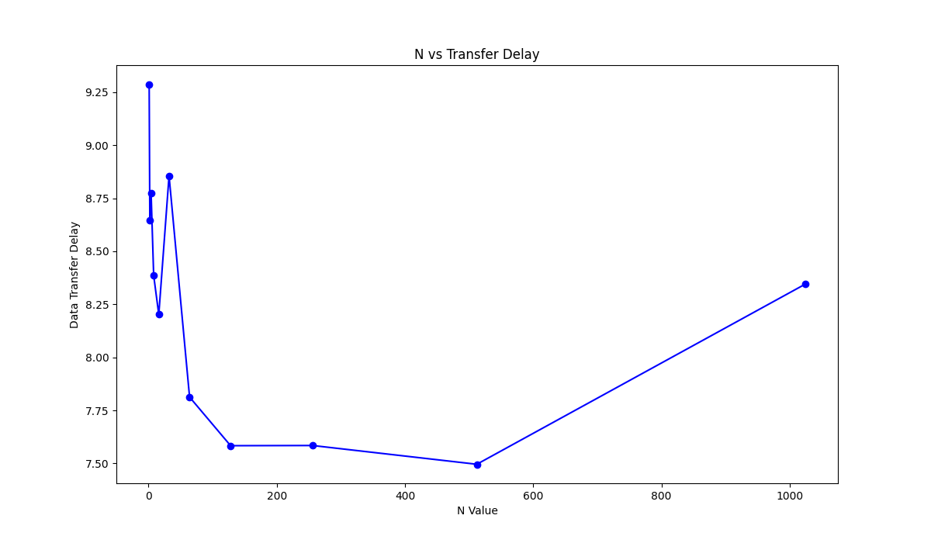

**Observation:**

The graph of N vs Average Transmission Delay is graph similar to parabolic curve where we see higher values of delay on extreme values of N.

**Reason:**

Smaller value of N helps in faster retransmission but small amount of packet transfer at a given time.

Thus, this results in high overall Transmission Delay.

Higher value of N implies higher number of packet transfer at a given time, but leads to slower retransmission if a packet is dropped. This again leads to higher Transmission Delay.

Values of N which are not too small or big help us keep the transmission delay and packet drops well-balanced and thus we get smaller transmission delays.

**Task 2: Effect of MSS**

* Each value is in Seconds

|  |  |  |  |  |  |  |
| --- | --- | --- | --- | --- | --- | --- |
| MSS | Transmit 1 | Transmit 2 | Transmit 3 | Transmit 4 | Transmit 5 | Average |
| 100 | 39.83781099 | 39.24486613 | 37.94376802 | 39.50162196 | 40.11788392 | 39.32919021 |
| 200 | 18.20690703 | 20.47037792 | 20.80181599 | 21.11461401 | 19.33801317 | 19.98634562 |
| 300 | 13.72897816 | 11.79656792 | 12.81402278 | 13.00163412 | 13.12758708 | 12.89375801 |
| 400 | 10.46794605 | 9.473315239 | 9.144143105 | 10.80568099 | 9.491830111 | 9.876583099 |
| 500 | 9.191089869 | 8.276691914 | 7.428396225 | 7.828085899 | 8.241970062 | 8.193246794 |
| 600 | 6.375527143 | 6.99002099 | 8.526383877 | 6.525587082 | 7.10576725 | 7.104657269 |
| 700 | 6.407234907 | 6.07425189 | 5.223448038 | 5.373620987 | 6.16852808 | 5.84941678 |
| 800 | 4.938368082 | 5.048585892 | 5.146148682 | 4.640244961 | 4.372987032 | 4.82926693 |
| 900 | 4.500380039 | 4.604979277 | 5.044509888 | 4.342978001 | 4.572220802 | 4.613013601 |
| 1000 | 3.701091051 | 3.568786144 | 4.163603067 | 3.276177883 | 3.602416039 | 3.662414837 |

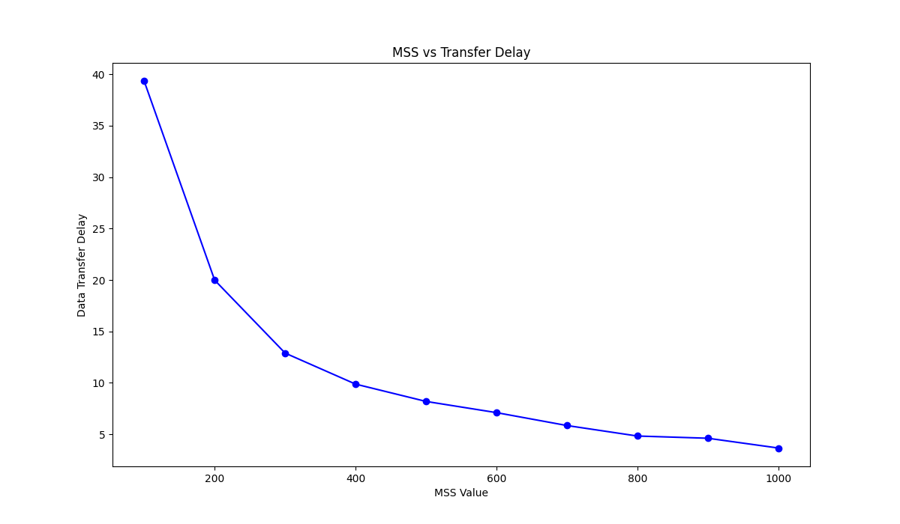

**Observation:**

The graph of MSS vs Average Transmission Delay is a decreasing curve where the transmission delay decreases as the MSS value increases

**Reason:**

As MSS increases, we are able to transfer more data and reduce total number of packets which are to-be sent. Thus, resulting in faster delivery of File.

**Task 3: Effect of Loss Probability p**

* Each value is in Seconds

|  |  |  |  |  |  |  |
| --- | --- | --- | --- | --- | --- | --- |
| PROB_LOSS | Transmit 1 | Transmit 2 | Transmit 3 | Transmit 4 | Transmit 5 | Average |
| 0.01 | 2.85155296 | 2.44306684 | 2.92854214 | 2.5183537 | 2.10535812 | 2.56937475 |
| 0.02 | 3.52420807 | 3.7870388 | 3.25171304 | 3.63815188 | 3.38462806 | 3.51714797 |
| 0.03 | 4.30210614 | 5.89367914 | 5.23707795 | 4.77297783 | 5.51045489 | 5.14325919 |
| 0.04 | 6.68921399 | 5.67826104 | 5.70769382 | 7.320297 | 7.2155931 | 6.52221179 |
| 0.05 | 7.69587398 | 7.03787589 | 7.7772429 | 8.75358582 | 8.73395991 | 7.9997077 |
| 0.06 | 9.56681514 | 10.5013261 | 9.61319208 | 10.0273883 | 9.71605706 | 9.88495574 |
| 0.07 | 9.50333691 | 11.8575311 | 10.496294 | 10.6174841 | 11.173836 | 10.7296964 |
| 0.08 | 12.1278281 | 11.7120628 | 12.024421 | 12.6416583 | 13.2873631 | 12.3586667 |
| 0.09 | 14.700702 | 15.513921 | 14.0530691 | 14.5191629 | 13.0189979 | 14.3611706 |
| 0.1 | 15.9669991 | 14.9324441 | 15.1792681 | 14.9334829 | 15.9520867 | 15.3928562 |

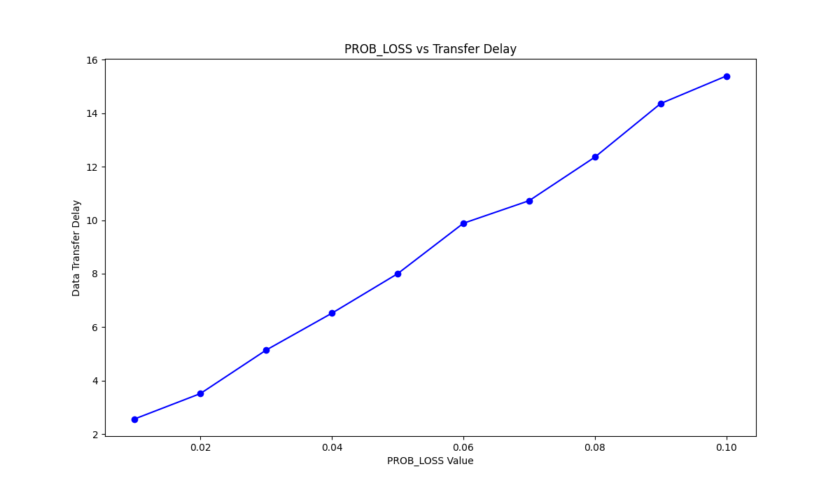

**Observation:**

The graph of Prob_Loss vs Average Transmission Delay is similar to an increasing line where the transmission delay increases as the Probability of packet drop increases.

**Reason:**

We observe more packets drops when the Prob_Loss value is high and this results in a higher amount of retransmission. Thus, we transmit higher number of packets than required, resulting in higher delay.