**CSC 573 – INTERNET PROTOCOLS**

**PROJECT #2 FALL 2021**

**Aayush Indrapratap Singh, asingh48 Nitish Pravin Talekar, ntaleka**

1. **IMPLEMENTING SELECTIVE REPEAT**

**Files:**

Sender.py - Uploads the File to FTP Server

Receiver.py - Receives File

**Steps to Run:**

1. **Run Receiver.py in Terminal 1**

python Reciever.py 7735 data/output.txt <PROB_LOSS>

**#** Gives <SERVER_HOST>

# Waits 5Sec for a connection to establish.

1. **Run Sender.py in Terminal 2**

python Sender.py <SERVER_HOST> 7735 data/input.txt <N> <MSS>

# Starts sending Data from file to Reciever

**Example:**

Terminal 1: python Receiver.py 7735 data/input.txt 0.01

Terminal 2: python Sender.py Aayushs-MBP.lan 7735 data/input.txt 8 512

**Output Expected:**

Packets being shown lost in Terminal 1 (Receiver.py)

Timeout being printed in Terminal 2 (Server.py)

1. **IMPLEMENTING TASKS 1, 2, 3**

**Files:**

Task_Sender.py - Acts as Sender for each Task

Task_Receiver.py - Acts as Receiver for each Task

**Steps to Run:**

1. **Run Task_Receiver.py in Terminal 1**

python Task_Reciever.py 7735

# Waits only 5Sec for a connection to establish.

1. **Run Task_Sender.py in Terminal 2**

python Task_Sender.py

# Starts sending Data from file to Receiver

These codes implement Task 1 2 3 sequentially in coordination with each other. Output of graphs is obtained in outputs folder.

**Example:**

Terminal 1: python Task_Receiver.py

Terminal 2: python Task_Sender.py

**Task 1: Effect of Window Size N**

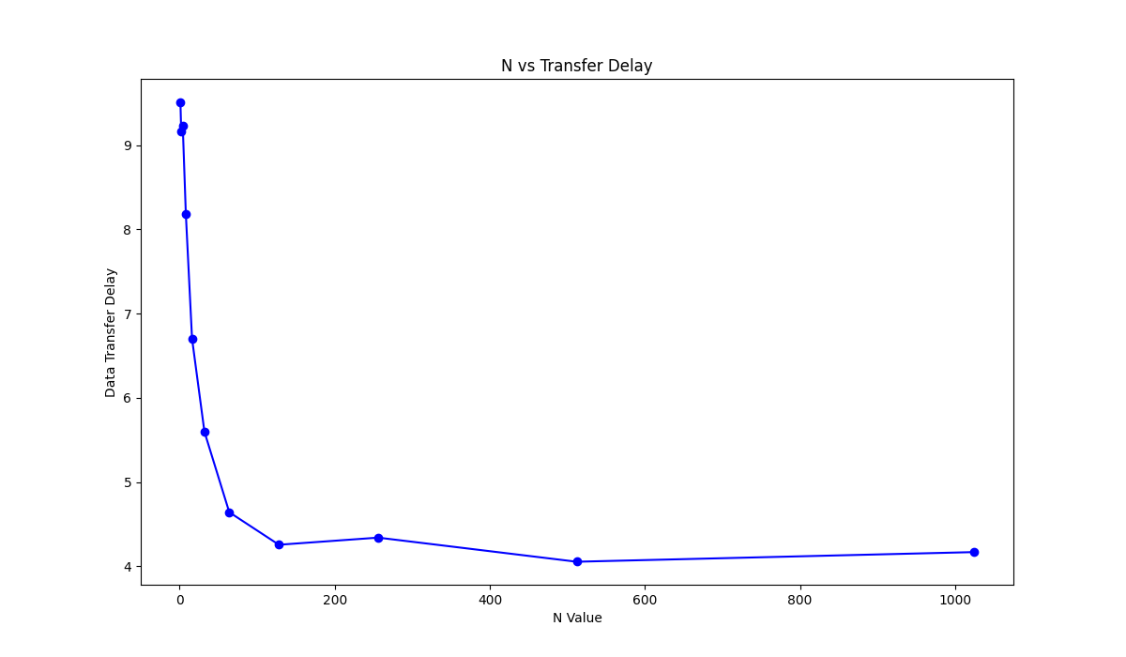

**Task 2: Effect of MSS**

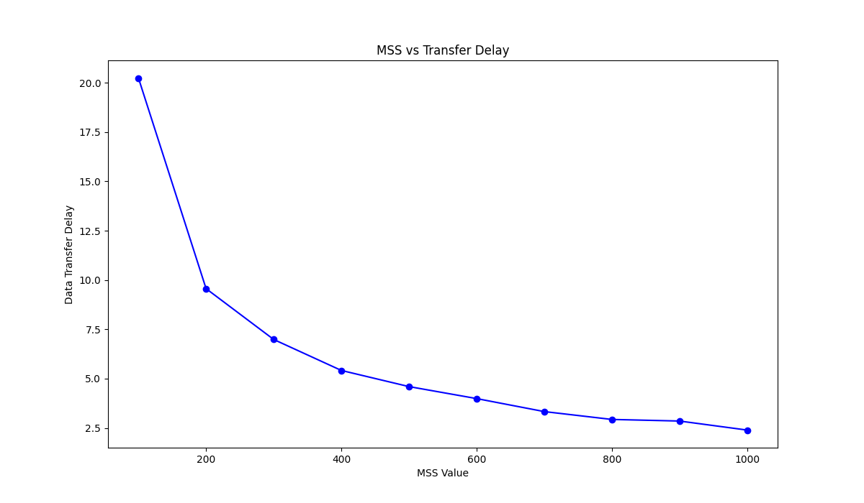

**Task 3: Effect of Loss Probability p**

