1. Project Abstract

The exponential growth of urban populations and vehicular density has rendered conventional traffic monitoring systems inadequate for modern smart city requirements. Traditional approaches relying on manual surveillance and fixed sensor networks suffer from limited coverage, delayed response times, and an inability to process the sheer volume of visual data generated by distributed camera infrastructures. This project presents a Multi-Agent Traffic Analysis System with Real-Time Streaming, a web-based platform that addresses these limitations through the orchestration of specialized AI agents operating on live IP camera feeds.

The system ingests video streams from multiple cameras via the RTSP protocol and employs a distributed agent architecture to perform concurrent analysis tasks. Four distinct AI agents operate in parallel: an Object Detection agent utilizing YOLOv8 for vehicle classification and tracking, a License Plate Recognition agent powered by EasyOCR, a Face Detection agent, and a Motion Tracking agent for behavioural analysis. This modular multi-agent approach enables independent scaling and optimization of each analytical component, mirroring the distributed nature of real-world traffic ecosystems.

Processed video is streamed to web browsers using HLS(Hypertext Live Streaming) protocol, while a React-based dashboard provides real-time monitoring and control capabilities through WebSocket communication with the FastAPI backend. The platform generates actionable traffic intelligence including vehicle counts, congestion metrics, violation alerts, and automated reports, transforming raw visual data into decision-ready information. Docker containerisation ensures portability across deployment environments including Render and Railway. By integrating computer vision, multi-agent coordination, and modern web technologies, this system demonstrates a scalable solution for intelligent transportation management in smart cities.

2. Problem Statement

Urban traffic congestion and inefficient monitoring represent significant challenges for modern metropolitan areas, with economic and environmental consequences. Existing traffic surveillance systems predominantly rely on passive CCTV monitoring, manual observation, and fixed timer-based control mechanisms that fail to adapt to dynamic traffic conditions. The inability to process multiple video streams simultaneously, detect violations in real-time, and generate actionable insights creates critical gaps in traffic management and emergency response.

Current systems lack integration between detection, recognition, and analytics capabilities, operating as isolated components rather than coordinated solutions. The absence of real-time visual feedback and interactive dashboards prevents traffic controllers from making informed decisions promptly. Furthermore, traditional approaches cannot scale across growing camera networks, resulting in fragmented workflows and limited analytical coverage. There exists a clear need for an integrated, scalable platform that can ingest multiple video streams, perform concurrent AI-driven analysis, and present processed intelligence through an intuitive interface.

3. Objectives

1. To design and implement a multi-agent video processing pipeline for concurrent traffic analysis
The system shall employ independent AI agents for object detection, license plate recognition, face detection, and motion tracking, operating in parallel on incoming video streams. This modular architecture enables individual agent scaling and optimisation without disrupting other analytical components.

2. To develop real-time video streaming capabilities using HLS protocol
Processed video with AI-generated annotations shall be delivered to web browsers with low latency through HLS streaming. FFmpeg will be utilised for video transcoding and segment generation, ensuring compatibility across diverse client devices and network conditions.

3. To build an interactive React-based dashboard for monitoring and control
The frontend application shall display live video feeds, detection overlays, traffic analytics, and system status in real-time. WebSocket communication with the FastAPI backend will provide instantaneous updates without page reloads. Users shall have control over camera selection, detection parameters, and alert configurations.

4. To integrate multiple AI models for comprehensive traffic intelligence
YOLOv8 shall provide vehicle detection and classification across seven vehicle classes, while EasyOCR performs automated license plate extraction for violation identification. The combination of object detection and OCR enables comprehensive traffic rule enforcement and data logging.

5. To ensure system scalability and portability through containerisation
Docker containers shall encapsulate backend services, AI models, and frontend applications, enabling seamless deployment across platforms including Render and Railway. This design supports future expansion to additional camera feeds and analytical capabilities.

4. Scope and Limitations Scope
The project encompasses the complete development of a functional traffic analysis platform with the following inclusions:
Integration with up to four concurrent IP cameras via RTSP protocol
YOLOv8-based object detection for vehicle classification and counting
EasyOCR-based license plate recognition from detected vehicle regions
Face detection for driver/passenger identification
Motion tracking for speed estimation and behavioural analysis
HLS streaming of processed video to web browsers
React dashboard with live video feeds, analytics visualisation, and controls
WebSocket-based real-time communication
Docker containerisation and deployment configuration for Render/Railway
The system shall generate traffic reports including vehicle counts, speed violations, and plate records.

Limitations
System performance is dependent on available computational resources; real-time processing of multiple high-resolution streams may require GPU acceleration
License plate recognition accuracy is affected by environmental factors including lighting conditions, camera angles, and plate visibility
Face detection capabilities are limited to frontal faces visible within camera frames
The system does not include traffic signal control integration or predictive analytics
Mobile device compatibility is not guaranteed beyond modern web browsers supporting HLS.js
The project does not address privacy preservation mechanisms such as face blurring or data anonymisation

5. Target Audience and Real-World Applications
Target Audience
Traffic Management Authorities:
Urban traffic controllers and municipal transportation departments seeking real-time monitoring and violation detection capabilities
Smart City Infrastructure Planners:
Urban developers and city planners requiring traffic data for infrastructure improvements and congestion mitigation strategies
Law Enforcement Agencies: Traffic police departments needing automated violation detection and evidence collection for enforcement actions
Academia and Research Institutions: Universities and research centres studying intelligent transportation systems, multi-agent AI, and computer vision applications
Traffic Analytics Professionals: Mobility service providers and logistics companies requiring traffic intelligence for route optimisation and operational planning
Real-World Applications
Urban Traffic Management and Control
The system can be deployed at major intersections to monitor vehicle flow, detect congestion, and identify traffic violations in real-time. Detected violations including overspeeding and rule-breaking trigger immediate alerts to traffic control centres for appropriate action.
Smart City Surveillance Infrastructure
As part of broader smart city initiatives, the platform can integrate with existing camera networks to provide intelligent monitoring across metropolitan areas. The multi-agent architecture supports city-wide scalability, enabling continuous traffic intelligence collection.
Automated Violation Enforcement
License plate recognition capabilities enable automated identification of violating vehicles for enforcement purposes. The system can log plate numbers, violation types, and timestamps, generating evidence for citation issuance.
Emergency Vehicle Prioritisation
Motion tracking and detection agents can identify emergency vehicles and automatically adjust traffic signal timing to create green corridors, reducing emergency response times and improving public safety.
Traffic Analytics and Planning
The system generates structured reports containing vehicle flow distributions, speed patterns, and congestion hotspots. These analytics support transportation planners in infrastructure decisions, traffic light timing optimisation, and road network improvements
System Architecture
The system follows a microservices-inspired modular architecture with clear separation of concerns across three primary layers: Frontend, Backend, and AI Processing. The architecture is designed for scalability, real-time performance, and maintainability.

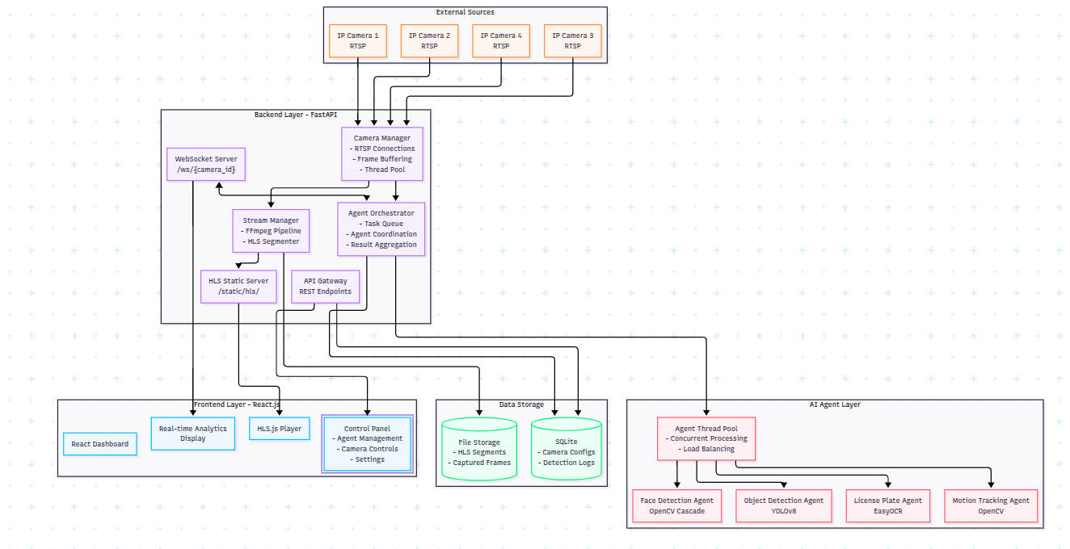
System high level architecture
2. Component-Level Architecture with Interactions
2.1 Backend Layer Components
Camera Manager
Responsibilities: Manage RTSP connections, frame acquisition, and buffering
Components:
RTSPConnector: Handles OpenCV VideoCapture connections
FrameBuffer: Circular buffer storing recent frames (configurable size)
ThreadPoolManager: Allocates worker threads for each camera stream
HealthMonitor: Checks camera connectivity and stream health
Interactions:
Provides frames to Agent Orchestrator and Stream Manager
Updates camera status in SQLite
Stream Manager
Responsibilities: RTSP to HLS conversion and streaming

Components:
FFmpegPipeline: Manages FFmpeg subprocess for transcoding
HLSSegmenter: Creates HLS segments (.ts) and manifests (.m3u8)
SegmentCleaner: Removes old segments to manage storage
Interactions:
Receives raw frames from Camera Manager
Writes HLS segments to static file directory
Updates manifest with new segments

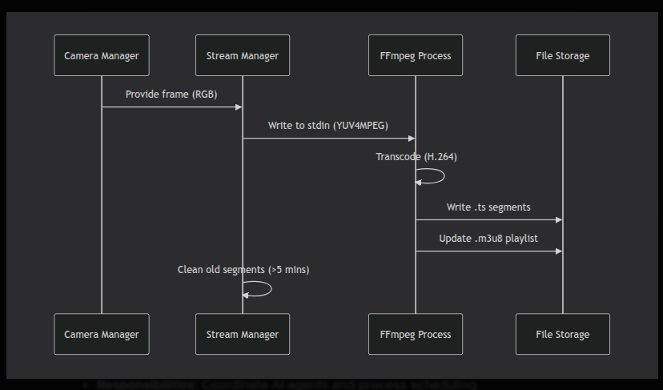
Agent Orchestrator
Responsibilities: Coordinate AI agents and process scheduling

Components:

TaskQueue: Priority queue of processing tasks

AgentRegistry: Manages available agents and their status

ResultAggregator: Combines results from multiple agents

Scheduler: Determines processing frequency per camera

Interactions:

Receives frames from Camera Manage
Distributes frames to appropriate agents
Aggregates and formats results
Pushes results to WebSocket server and database

