**Extract mobile number from group chat**

This is a python program to extract mobile numbers from whatsapp chat.

It has a huge opportunity if your corporate offices requires a lot of whatsapp groups that exchanges number on different basis and they are currently not saved in your directory.

This program is a one-stop solution to extract all unique numbers that are present inside the chat and save it in excel file.

You can also save it as .vcf file so that you can import it to your mobile “Contacts” list.

The steps taken are:

**Step1:** Export the whatsapp chat as text file in a folder. Also, create an excel file to just copy and paste the text file data into excel file to work with our python code.

Text file could be used too but in current file, it is desired to be 2 dimension data set. Although text file is containing 12 dimension data set.

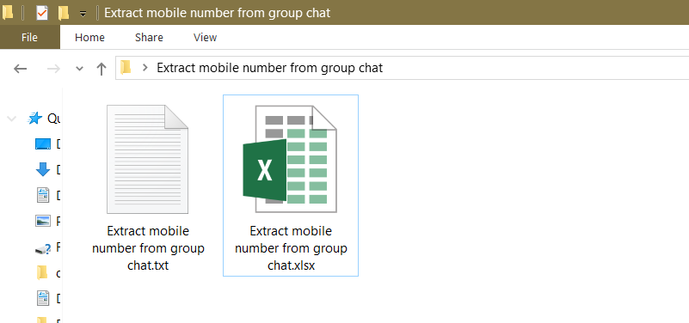

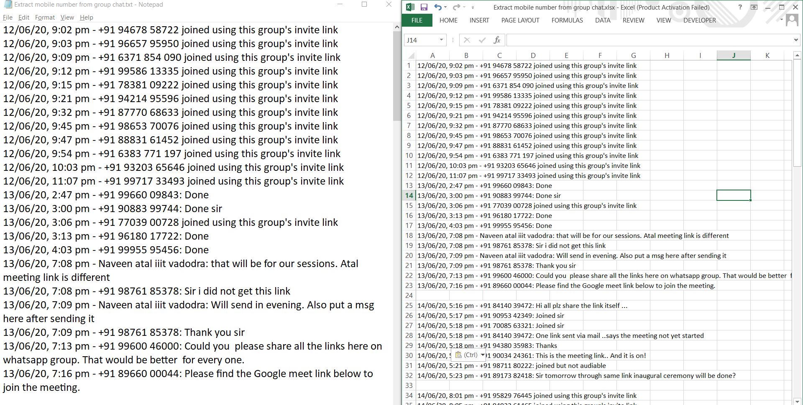

On the left side is the text file and on the right side is the excel file that contains the same chat.

**Step2:** Run the python program to extract data from excel file and create another csv file to save unique numbers.

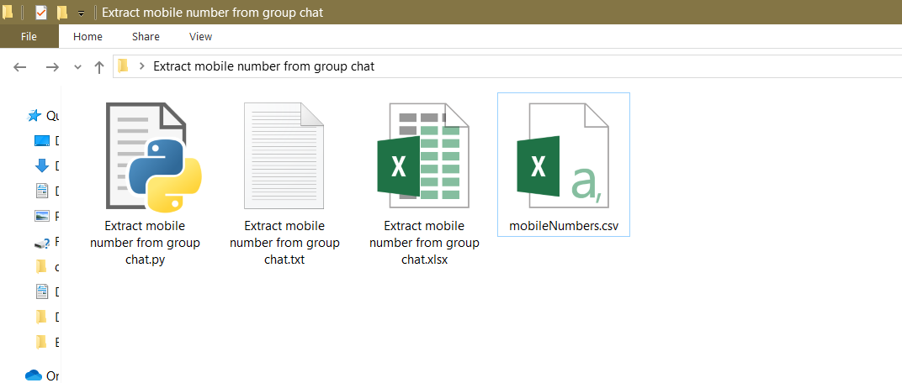

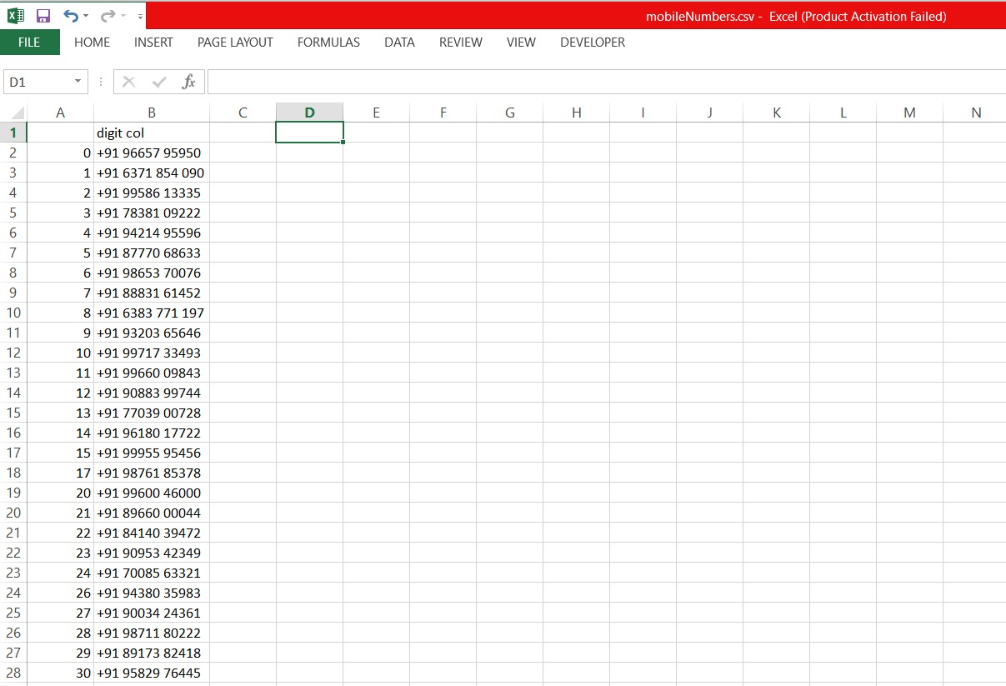

This is how a smooth file is extracted by running the program to get unique phone numbers that are included in the chat.

You just have to change the filename in the code so that it refers to your desired excel file