**Generate QR from Excel Data**

This is a useful application if you want to generate different QR code for the entire population of the dataset.

**Step1:**

Here, a simple file is taken as input that contains student data.

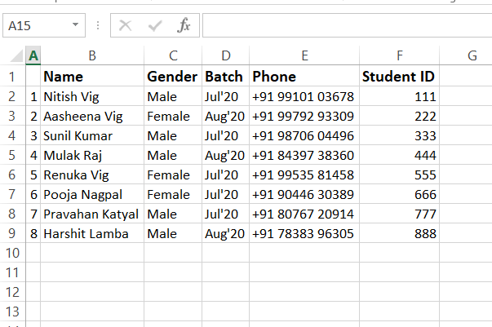

**Step 2:**

From this dataset, a unique QR code is generated that displays the output featuring Name-Student ID-websiteName.

Use the python file “generate_QR_from_excel_data” to generate the QR codes

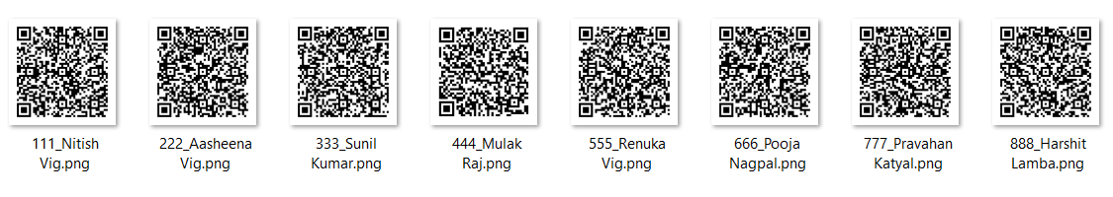

**Step 3:**

Check the QR code with mobile camera and you will get the details.



**Step 4:**

Now, if you have an Image and you want to extract details from your existing dataset.

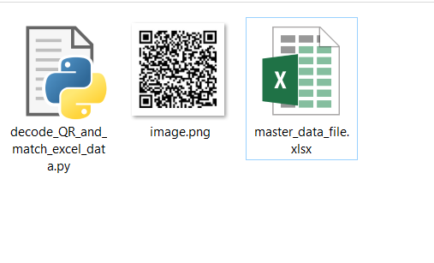

**Step 5:**

Run the file “decode_QR_and_match_excel_data” and get details in your console window

