We often comes with a task to send regular email updates to customers.

The data can be taken from excel file and sent to personal email ids.

In this program, a small sample is shown.

The data is taken from excel file as shown below-

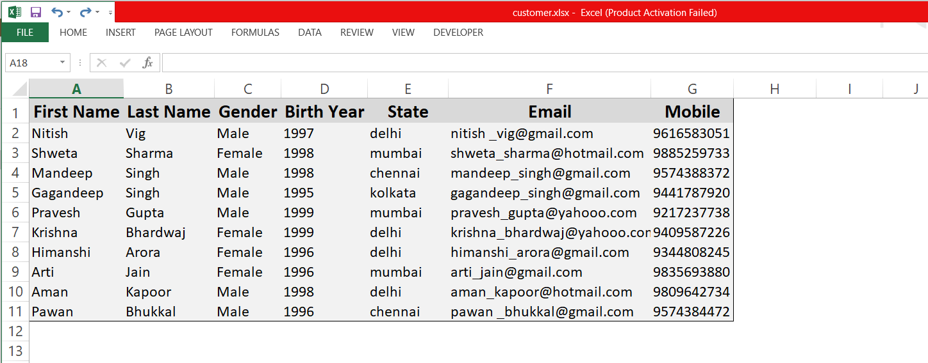

The python code will take data from the excel file and send a common message sent to each name. In this program, instead of separate email, separate text files are created as shown below.

The message includes customer’s name, gender, email, mobile from excel file, along with company’s link and random 8 letter password that is generated at same time.

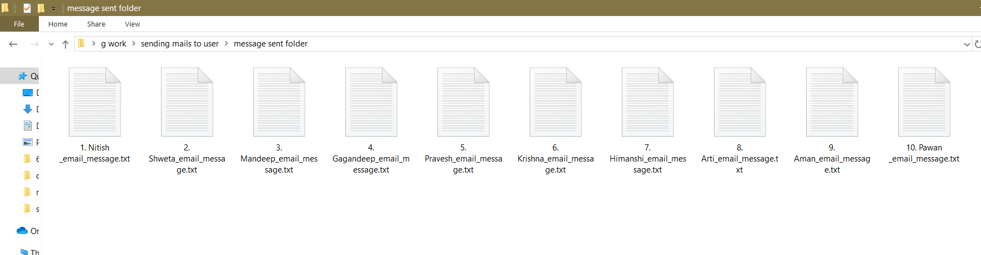

All these separate files contains same message but with different customer information.

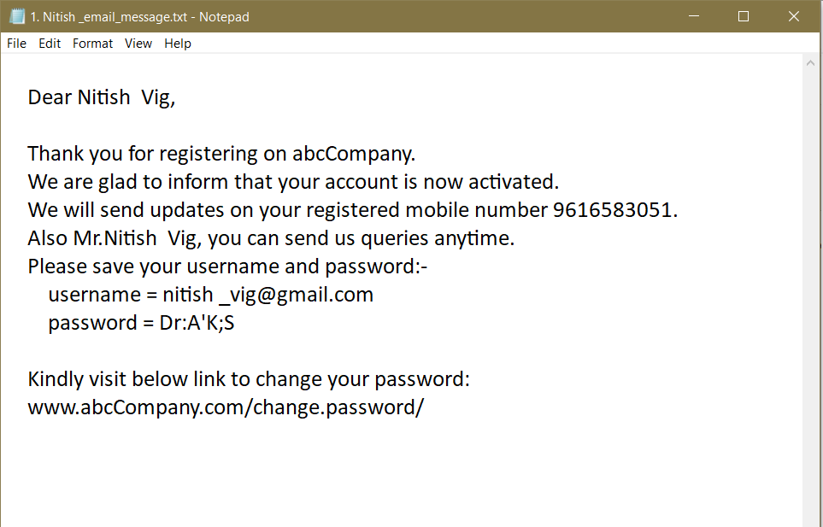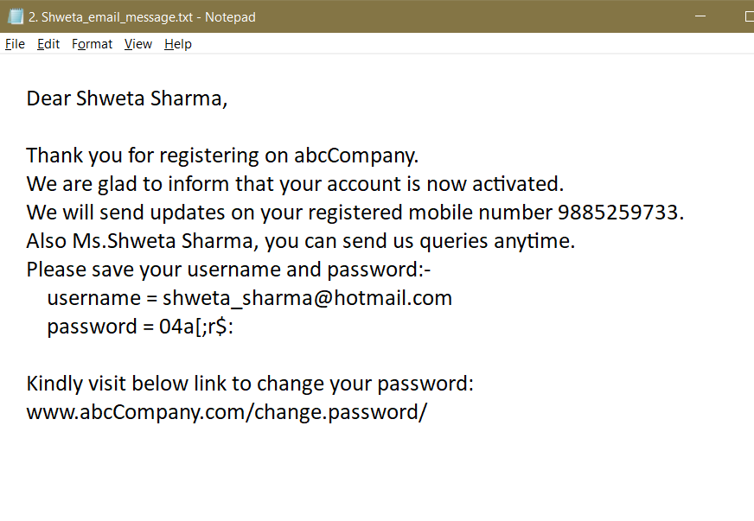

Below pic shows the highlighted part that is taken from the excel file and in-built data.

